Lesson Plan - Activity Based Template

Topic:
My Favorite Sports

Instructor:  JUNE  (Hyunju Cho) | Students Age and Level:  6~7 years old,  intermediate | Number of Students:  10 | Lesson Length:  30 min
Materials:
Pictures (baseball, swim, ski, ice skate, run, basketball, volleyball)
Color pencils, vocabulary pictures
10 piece of worksheets
Song

Objective/Aims of Lesson:
- To understand target vocabulary and sentences’ meaning
- To review target vocabulary (nouns, verbs) and sentences with pictures
- To practice and improve speaking and listening skills
- To get massage from the students and be aware of cooperation with friends

Language Skills

- Speaking: Ss answering T questions, participating in classroom.
- Reading: Paper cards
- Writing: Make cards
- Listening: T questions, participating in classroom activities

Target Sentences :
What is your favorite sport?
I like (You/They like // She/ he likes) baseball.
I play (You/They play // She/ he plays) basketball.

Target vocabulary :
- Noun : baseball, swim, ice skate, run, ski, basketball, volleyball:
- Verb : like, play, be verb (am, is, are)

Assumptions:
- Ss already learned about target question sentence. “ what is your favorite sports?”
- Ss have already herd many sports names, but do not know all the names and correct letters
- Ss can use color pencils to paint a picture
- Ss can read simple word

Anticipated Errors and Solutions:
- If the lesson time is too short,
- >Ss more time to decorate the picture,
- > check what they learnt with worksheet.
- If the lesson time is too long, skip or simplified wrap-up and give them assignments with worksheet.

References:
Picture cards : google image

PREPARATION-FAMILIARIZATION PART
Materials:
Pictures (baseball, swim, ski, ice skate, run, basketball, volleyball)
Time: | Classroom Set Up: | Student Activity and Goals: | Teacher Procedure:
5 min | whole class | Greeting  Ss listen to the T's introduction : what kinds of sports are there with song | Greeting  Introduce sports and how to play them. Listen and sing a song after me.  Song  I like sports I play sports  I like baseball I like baseball  I play basketball I play basketball  I like ski I like ski  I play volleyball I play volleyball  I like swim I play stake  I like sports I play sports

MAIN ACTIVITY PART
Materials:
Pictures (baseball, swim, ski, ice skate, run, basketball, volleyball)
vocabulary pictures
Time: | Classroom Set Up: | Student Activity and Goals: | Teacher Procedure:
10 min | whole class | Ss listen and express their answer  Ss learn how to spell those words and read aloud | what is your favorite sport?  -> I like ....  what do they do?  ->they play .......  (show the vocabular pictures)  listen and then repeat  CCQ :  How to read it?  Is that correct the spell?

FOLLOW-UP PHASE AND CONSOLIDATION PHASE PART
Materials:
Pictures (baseball, swim, ski, ice skate, run, basketball, volleyball,
Color pencils
10 piece of worksheets
Time: | Classroom Set Up: | Student Activity and Goals: | Teacher Procedure:
10 min | small group | Ss introduce their favorite sports and get one picture  Wirte down sports spell on the picture | Who like baseball? raise up your hand  (make small group)  (give picture)  What is your favorite color?  (choose color pencils)  color your picture  I will give you 5 min and paint your paper.  (give 5 min)  CCQ:  how many min do you have?  Do you paint it?  are you done?  ok, wirte down sport name under the picture  CCQ:  wher do you write dow sport name?

WRAP-UP PART
Materials:
Materials:
Pictures (baseball, swim, ski, ice skate, run, basketball, volleyball,
10 piece of worksheets
song
Time: | Classroom Set Up: | Student Activity and Goals: | Teacher Procedure:
5 min | whole class | sing a song with actions | Now! It tis time to sing a song again.  Let's sing a song with sports. Listen and sing a song after me.  What are you doing?  I am playing basketball  I like plalying basketball  let the class repeat the song 3 times

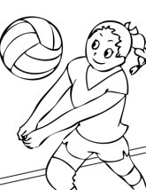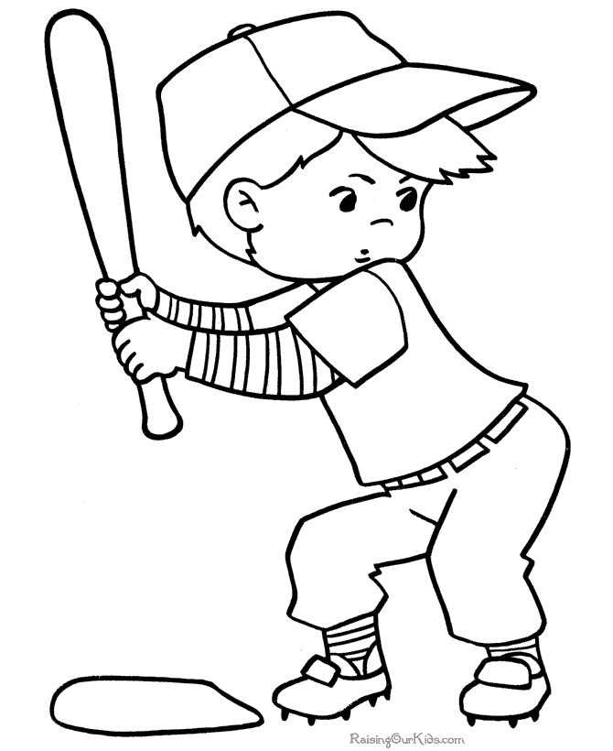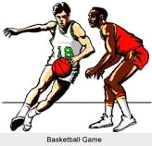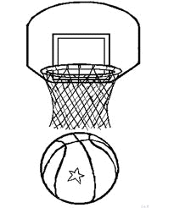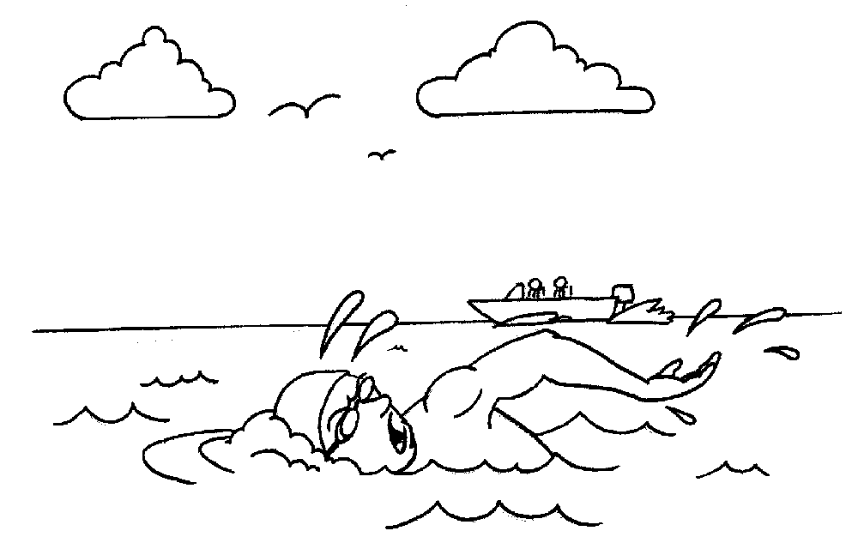

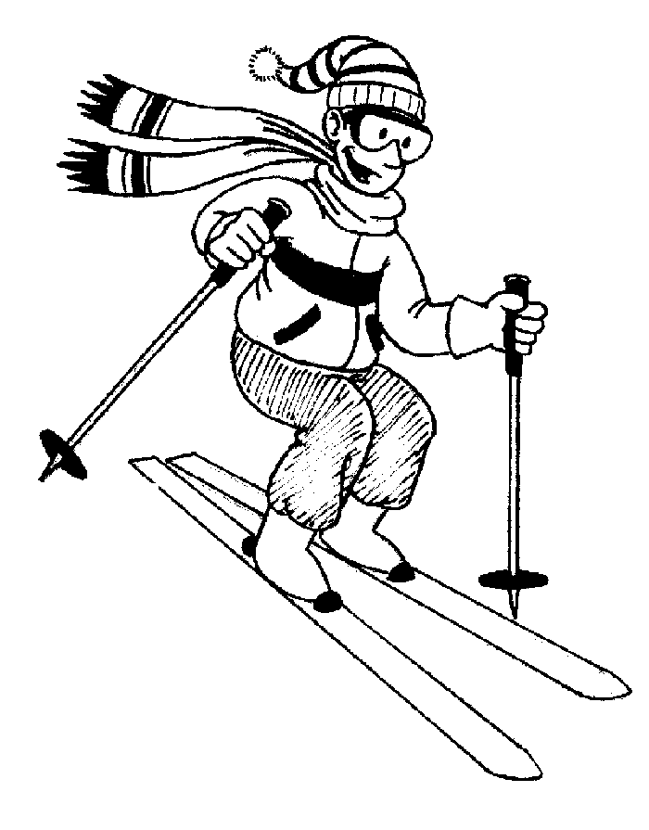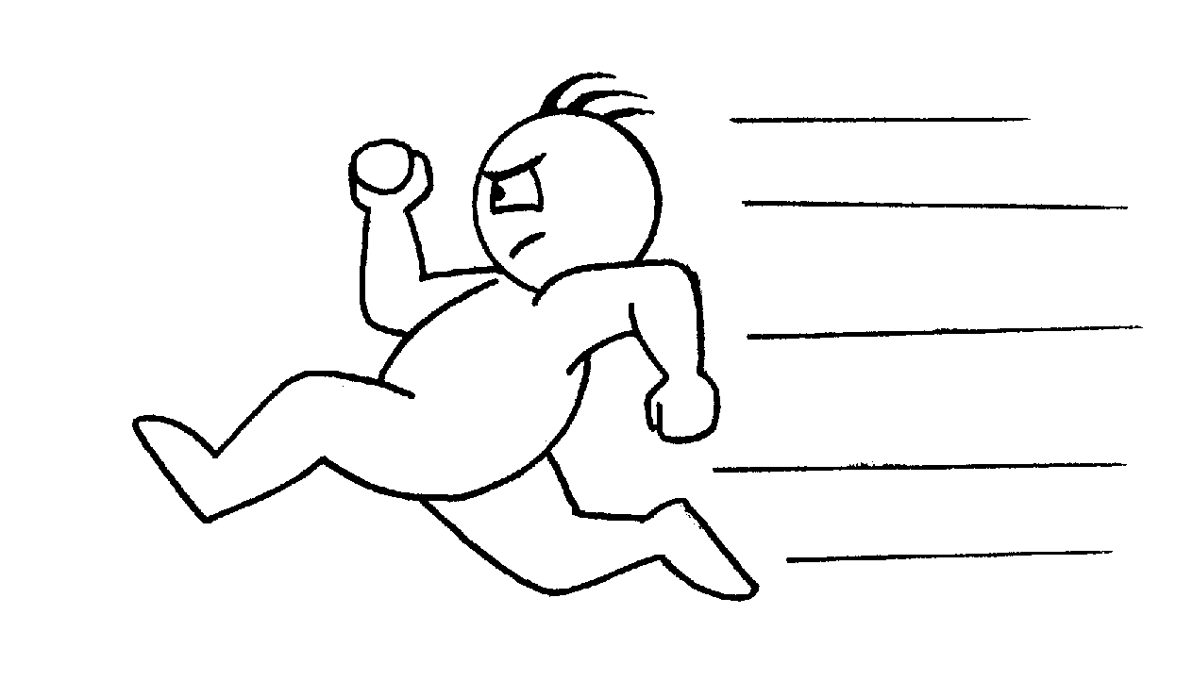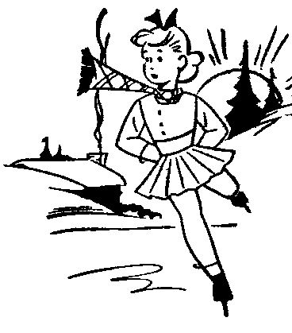
Baseball, basketball, volleyball, skate, ski, swim,

