Listening Speaking Reading Grammar Writing
Topic: What is your favorite cuisine?

Instructor: Kimi  (Kim Hee Joo) | Level: Upper intermediate | Students:13 | Length:  30 Minutes

Materials:
-Visual aid(Cuisine, Cooking tool)
-Role playing characters picture
-13 of Bing-go sheets
-White board, board makers

Aims:
-Main aim: To enable students to improve speaking skills by having students talk about
their favorite cuisines.
-Second aim: To learn vocabulary and expressions for describing their favorite cuisine
by doing role play, talking favorite cuisines
-Personal aim: I want to get more student talking time (STT) by reducing teacher’s
talking time and commentary.

Language Skills:
-Listening : Students can listen the other students cuisine recipe and favorite food
-Speaking : Students can talk their favorite food and how to make it
-Reading : Students are reading Idioms worksheet
-Writing : Students can write some recipes before they do role play

Language Systems:
-Lexis : Idioms used in describing recipe of cuisine
-Function : None to discuss
-Discourse : Discuss how to play role play game in a restaurant
-Grammar : None to discuss
-Phonology : Listening and watching classmate’s roll play game

Assumptions:
Student already know :
-How to class is set up and run
-Most students have their favorite cuisine and it’s recipe and cooking tool.

Anticipated Problems and Solutions:
-Students may not be able to talk about recipe in roll play game easily.
: Help them to talk about easy food such as noodle.
-Students may not know about vocabulary about cooking
:Write down some words on white word(Boil, Broil, Bake, Stream)

References:
-YouTube video (http://www.youtube.com/watch?v=zVV40X55SoY)
-Google images (https://www.google.co.kr/webhp?hl=ko&tab=ii)

Lead-In
Materials: Bored, Marker
Time | Set Up | Student Activity | Teacher Talk
1min | Whole class | Talking about their weekend and food. | Hello everyone, Good afternoon~!!  Eunmi, how was your Friday?  Andrea, Is there anything you bought this week?

Pre-Activity
Materials: cooking tool picture, marker, board
Time | Set Up | Student Activity | Teacher Talk
9min | Whole class  pairs | Eliciting and Answering  Answering CCQs  Understanding how to do the activity  Answering ICQs  Talking about their favorite foods | Eliciting  What is this? Looks delicious huh? Is this snack or food? What is more fancy word of food? Yes, It is cuisine.  CCQ  What is cuisine? Can you buy at supermarket? Is cuisine cheap like noodle and ttokbokki? How about a water. How about this one?  Yes, this steak is cuisine  Instruction  I am going to give you a one piece of paper each one of you. I don’t know what it is. But I want you to look and think about what you like to eat  with this with your partner.  Modeling/Demonstration  I want you to talk about food that you would like to eat with your partner for 4minutes. For example,  I have this picture. It is a knife. Well, I would like to eat steak with this. It reminds me beef steak. So from now on Let’s begins.  ICQ  What we are going to do?  How many minutes do we have?  Who do you work with?  Explicit ICQ  Are you going to touch the paper when I give you?  Are you going to touch the paper when I say go?  Running Activity  Who has the fork picture? Ok, let us know what would you like to eat?

Main Activity
Materials: Picture of 3 characters in restaurant, Board.
Time | Set Up | Student Activity | Teacher Talk
11min | Whole class  Groups | Eliciting and CCQ of cuisine and cooking tool  Listening instruction  Watching and Listening Demonstration of role play  Answering explicit ICQ  Role play game | Eliciting  How many times do you go to restaurant in a week? What kind of people are there in the restaurant?  Customer, and chef, owner. Yes.  Instruction  From now on, you will be the customer chef, and owner. And talk about what’s your favorite cuisine and how to make it and how much do you pay for it.  Let’s do role play game for 5minuats. Let’s say ‘Roll’ ‘Play’ ‘Game’  Demonstration  Waiter: Hello sir how many?  Customer: Just two.  Waiter: Follow me please  Customer: Ok.  Waiter: What would you like to order?  Customer: I heard this restaurant is famous for steak. Is it?  Waiter: Yes,  Casher: It’s 20$ sir How was the food?  Customer : It was good~ Thanks  ICQ  What are we going to do?  How many minutes do we have?  Are you working individually?  Explicit ICQ  Can you be a waitress?  Can you be a couple in a restaurant?  Running Activity  Let’s start!!!

Post Activity
Materials: Board, 13 of Bing-go sheets
Time | Set Up | Student Activity | Teacher Talk
9min | Whole calss  Individually | Understanding instruction  Watching demonstration  Answering ICQ questions  Doing Bing-go Activity | Instruction  Tell me the name of cuisine one by one.  And then Draw 9 squires and make Bing-go sheet. The winner of this game is who finish Bing-go game first  Modeling/Demonstration  So there are various cuisine  like( 비빔밥, 닭볶음탕… so on )  If I finish Bing-go 2 lines first, I am the  winner of this game.  ICQ  What are we going to do?  Are you working alone?  Are you working individually?  Explicit ICQ  How many words can we choose?  How many lines should we finish in  Bing-go game?  Running Activity  Let’s start!!!! Binggo Game  Error correction  I heard any errors so unscramble this word Cuisine  Finishing  Good jobs today See you guys  tomorrow

Eliciting Material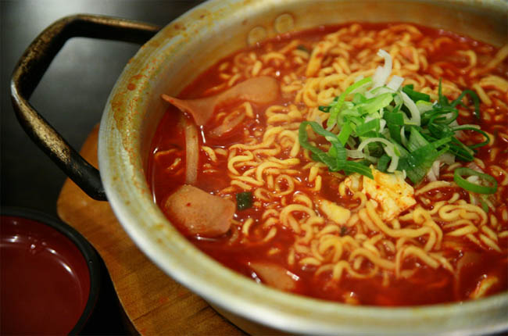
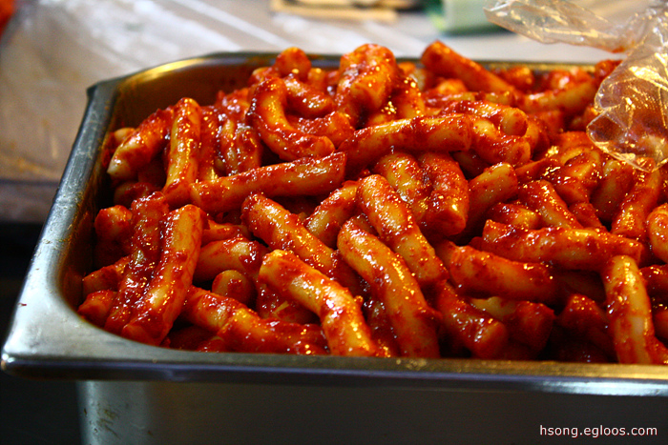

CCQ Material
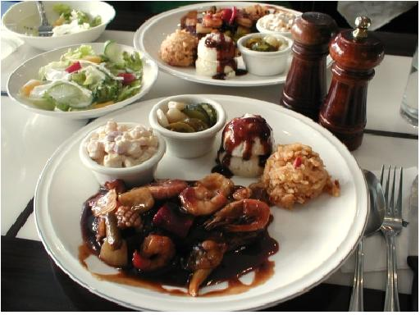
Main Activity Material

