Listening Speaking Reading Grammar Writing

Topic: The Princess Bride

Instructor:  Hansol Lee | Level:  Upper Intermediate | Students:  13 | Length:  30 Minutes

Materials:
- White board, board markers & tape
- Visual aid of “Princess” and “Bride
- 14 Vocabulary worksheets
- 14 Reading excerpt and comprehension worksheets
- 14 Blank Papers

Aims:
- Main Aim: To enable students to improve their reading skills by having them read an excerpt from the “The Princess Bride”
- Secondary Aim: Students will match definitions, complete worksheets, and write a sequel for the story
- Personal Aim: I want to improve my demonstration, monitoring, gesture, and timing

Language Skills:
- Reading: Students will read an excerpt from a book
- Listening: Students will listen to other students’ opinions
- Speaking: Students will speak about their interpretation of said text
- Writing: Students will write their opinion and interpretation

Language Systems:
- Phonology: None to discuss
- Lexis: “literature”, “protagonist”, “antagonist” among other vocabularies
- Function: Relationship of words
- Grammar: None to discuss
- Discourse: Story

Assumptions:
- Students already know:
  - How the class is set up and run
  - The teacher’s style of teaching and the pace of the course
- All the students are degree holders
- Most students have a sense of humour
- Students are adults (age 20 and up)
- Students can read
- Students have basic interpretative skills

Anticipated Problems and Solutions:
- Students may find the topic boring
  - Make it interesting
- Students may not understand complex vocabulary
  - Model
- Students may not have enough time for the Main Activity
  - Give additional time and cut time from the Post Activity

References:
- Learning Teaching by Jim Scrivenener
- Teaching & Principles in Language Teaching by Diane Larsen-Freeman and Marti Anderson
- The Princess Bride by William Goldman

Lead-In
Materials: Board
Time | Set Up | Student Activity | Teacher Talk
1 min | Whole Class | Answering teacher’s questions | Hello everyone! How was everyone this week?  _____, are you excited for today’s micro-teaching?  _____, have you read any good books recently?

Pre-Activity
Materials: Board, Visual Aids, Vocabulary Definition Worksheet
Time | Set Up | Student Activity | Teacher Talk
5 min  3 min  2 min | Whole Class  Group | Answers elicited questions + CCQs  Students begin worksheet  Students will present | Elicit the word, ‘Princess’ and ‘Bride’  - Put up first three visuals  - “What do these people have in common?”  - Put up second visual  - “What would you call her?”  “Today’s class will be on a famous ‘literature’ called, ‘The Princess Bride’.”  Model ‘literature’  Pre-teach  “In a novel or a movie, what do you call the main characters of the story? It starts with a ‘pro’, and ends with a ‘-ist’.”  <Write ‘protagonist’>  “Now what would the opposite be? The characters who goes against your protagonists?”  <Write ‘antagonist’>  “A general rule of thumb would be the protagonists being the good guy while the antagonists being the bad guy, although there are exceptions.”  Give an example of a popular protagonist and antagonist  CCQ  - “Are protagonists typically a villain?”  - “Is the role of a protagonist usually played by a hero?”  - “Was Harry Potter the antagonist?”  - “In the same film series was the Dark Lord Voldermort the main antagonist?”  Word Match  Instructions  “I will be handing each of you a worksheet, where you will have to match the word and the definition together.”  Demonstration  Give a simple example  “You will be working in groups and have three minutes.”  <Divide the class into “Princess” and “Bride” then divide each group again>  ICQ  - So what are we doing?  - Are we working individually?  - Are we working in groups?  - How much time do you have?  “Now please do not touch this paper before I say go”  - Are you going to touch this paper soon as I give you the paper?  - Are you going to start when I say go?  (Distribute worksheets)  “Begin”  Monitoring  Monitor discreetly. Answer students if they ask questions.  Give time warning: 1 minute; 30 seconds; 10 seconds. Be flexible with time. Give students 1 more minute if they need it.  “Time’s up”  Ask students to present

Main Activity
Materials: Board, Reading Excerpt and Comprehension Worksheet
Time | Set Up | Student Activity | Teacher Talk
1 min  7 min  2 min | Pairs | Listening  Students begin reading and then do the worksheet  Students gives answers | Reading Comprehension  Instructions  “We are now all going to read an excerpt from the book, ‘The Princess Bride’ and once you’re finished reading, you can start on the worksheet provided. You will work in pairs and will have seven minutes.”  <Pair everyone>  “You may look at these as soon as you get them.”  - Can you look at these when I hand it to you?  <Hand out worksheets>  Demonstration  “If you look at the first question and quickly scan through the reading material, what do you think the answer would be?”  ICQ  - So what are we doing?  - Are we working individually?  - Are we working in pairs?  - How much time do you have?  “You may begin”  Monitoring  Monitor discreetly. Answer students if they ask questions.  Give time warning: 3 minutes; 1 minute; 30 seconds; 10 seconds. Be flexible with time. Give students 1 more minute if they need it.  “Time’s up”  Ask students to answer

Post Activity
Materials: Board, Blank Pieces of Paper
Time | Set Up | Student Activity | Teacher Talk
7 min  3 min | Individually | Listening  Students begin writing the next chapter  Students present their stories | Creative Writing  Instruction  “You are now the author of this book and as such need to write the next chapter and conclude the story. You will be working individually and will have seven minutes. You may add new characters to the story.  Demonstration  “For example; my story will be that Wesley goes to prison and never gets to see Buttercup for the rest of his life, the end”  ICQ  - So what are we doing?  - Are we working in a team?  - Are we working individually?  - How much time do you have?  - Can you add new characters to the story?  “You may now begin”  Monitoring  Monitor discreetly. Answer students if they ask questions.  Give time warning: 3 minutes; 1 minute; 30 seconds; 10 seconds. Be flexible with time. Give students 1 more minute if they need it.  “Time’s up”  Ask individual students to present  Error correction and/or word scramble “literature”  “This concludes my reading micro-teaching; I will be followed by an interlude, have a nice day.”
SOS Activities
Materials: None Required
Time | Set Up | Student Activity | Teacher Talk
1 min  2 min  30 sec | Groups | Listening  Students do worksheet  Students share | Dramatic Theatrics  Instruction  “Now we are actors and script writers for the movie adaption of this book. So in groups I would like you to write a quick script where you will have to act it out. You will have two minutes.”  ICQ  - So what are we doing?  - Are we working individually?  - Are we working in groups?  - How much time do you have?  “Now begin”  Monitoring  Monitor discreetly. Answer students if they ask questions.  Give time warning: 1 minute; 30 seconds; 10 seconds. Be flexible with time.  “Time’s up”  Ask students to share

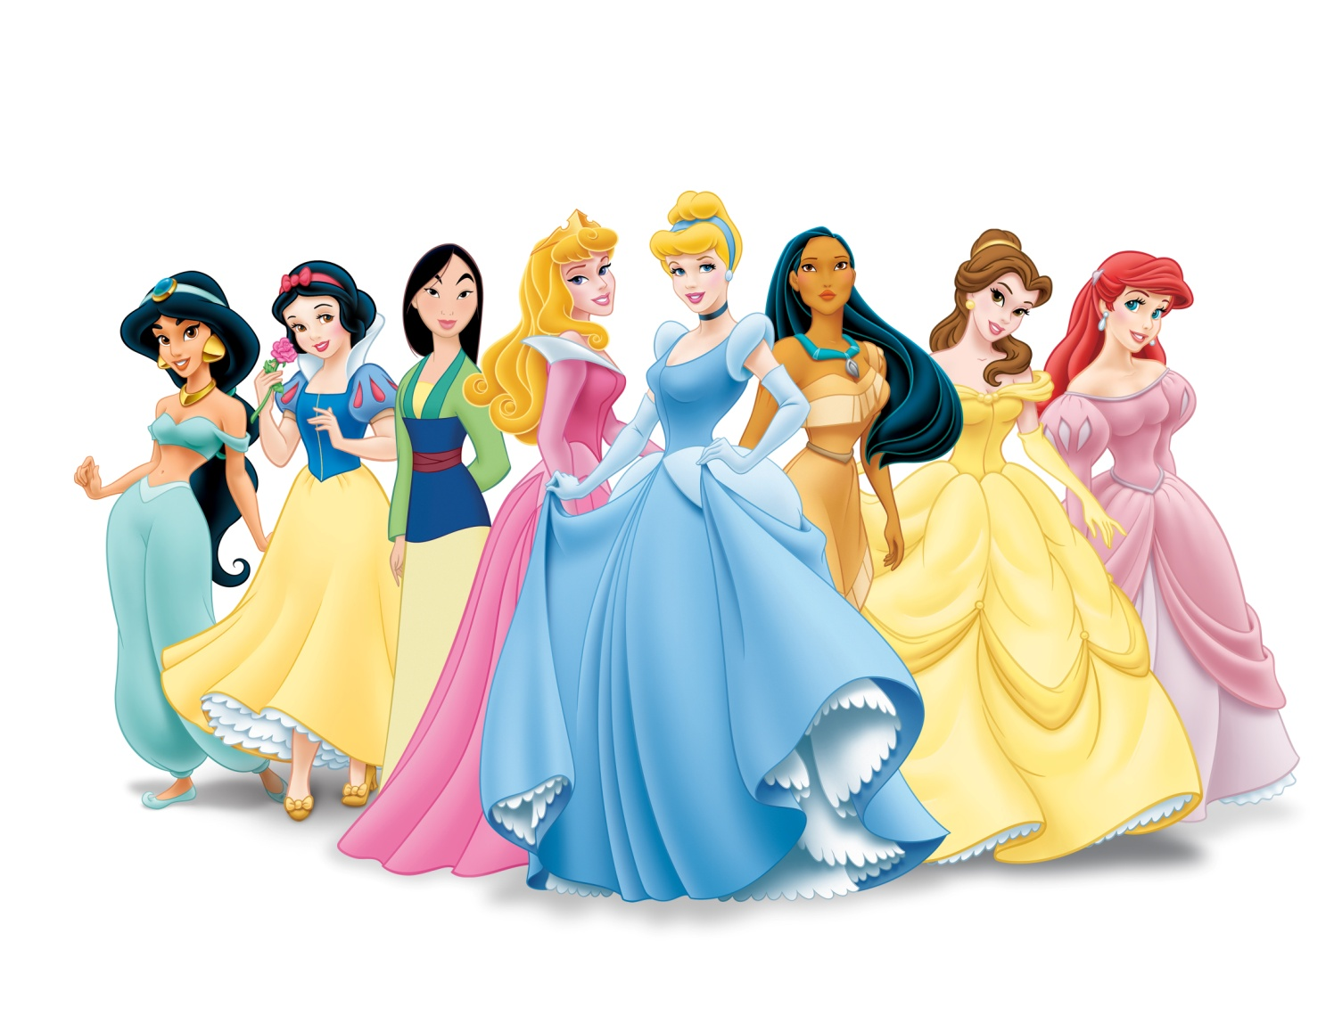

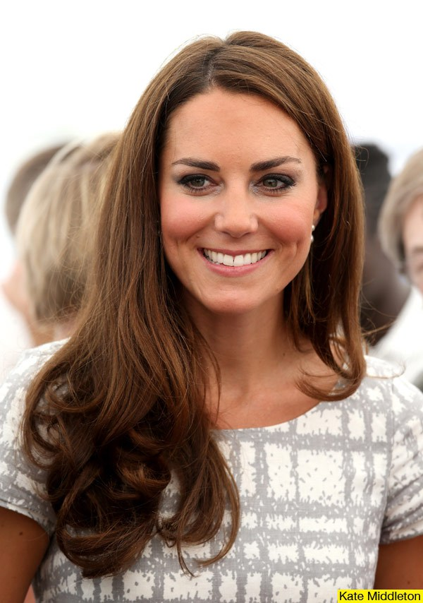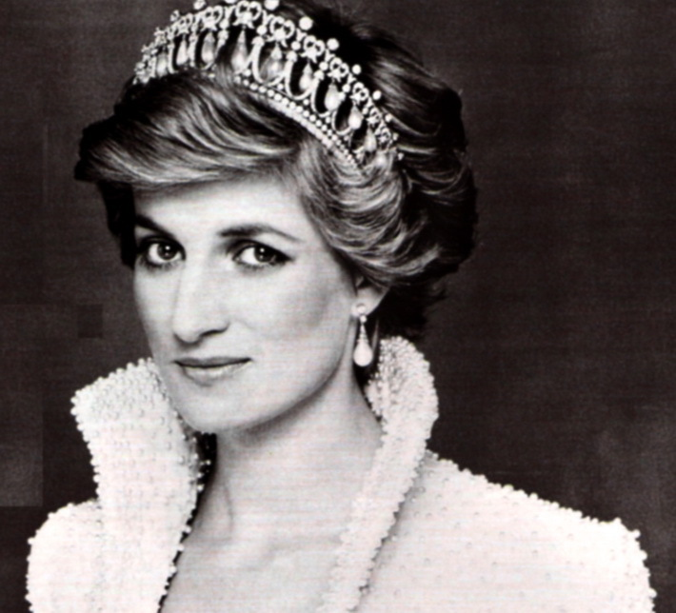
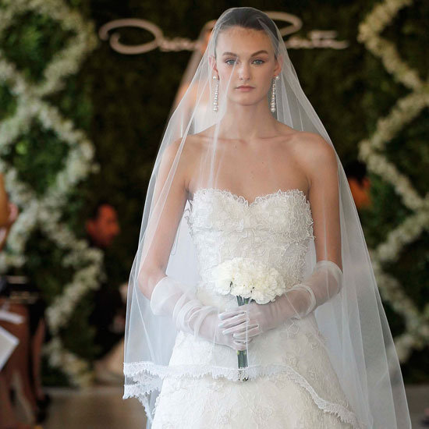
Words & Definition Matchup

Agony
Anxious
Armada
Caking
Confines
Deformity
Dusk
Fatigue
Glazed
Inconvenience
Perspire
Ruffian
Spectate
Swear/Swore
Wound
An injury
A very large fleet of warships
Having something become glassy
Elements that restrain someone
A deceitful and unreliable person
Weariness caused by exhaustion (being overly tired)
Extreme pain of mind and/or body
Layering some on a surface to crust
To observe or watch
To emit sweat
To take an oath
A state of something that is disfigured
Very desirous/restless, akin to impatient
A period of time occurring after sunset
Something that is of a bother or discomfort

Reading Comprehension
- What were the things the protagonists fought in the Fire Swamp?
- A) Who were the protagonists of the story?
B) Who were the antagonists of the story?
- How many horsemen did Prince Humperdinck bring?
- Why do you think the protagonists took too long in the crossing?
- What did the antagonists demand upon meeting the protagonists?
- Why do you think Buttercup decided to surrender?
- What was the name of the ship Wesley belonged to?
- What do you think the Zoo of Death is?
- What did Prince Humperdinck swear to do?
- What did Wesley go through for Buttercup?
- What was unusual about Count Rugen?
- If you were Buttercup, would you have made a different choice? Why?

The Princess Bride, end of Chapter 5, page 155-158, paragraph 3, line 10
Buttercup ripped her clothes into patches and ties, and they worked at the wound, caking the blood with mud from the floor of the Fire Swamp, then bandaging and rebandaging over it.
“We’ll know soon enough,” Wesley said, because two more rats were watching them. Wesley stood, sword in hand. “If they charge, they smell it,” he whispered. The giant rats stood watching.
“Come,” Wesley whispered.
Two more giant rats joined the first pair.
Without warning, Wesley’s sword flashed, and the nearest rat was bleeding. The other three contented themselves with that for a while. Wesley took Buttercup’s hand and again they started to move.
“How bad are you?” she said.
“I am in something close to agony but we can talk about that later. Hurry now.” They hurried. They had been in the Fire Swamp for one hour, and it turned out to be the easiest one they had of the six it took to cross it. But they crossed it. Alive and together. Hand very much in hand.
It was nearly dusk when they at last saw the great ship Revenge far out in the deepest part of the bay. Wesley, still within the confines of the Fire Swamp, sank, beaten, to his knees.
For between him and his ship were more than a few inconveniences. From the north sailed in half the great Armada. From the south now, the other half. A hundred mounted horsemen, armored and armed. In front of them the Count. And out alone in front of all, the four whites with the Prince astride the leader. Wesley stood. “We took too long in crossing. The fault is mine.”
“I accept your surrender,” the Prince said.
Wesley held Buttercup’s hand. “No one is surrendering,” he said.
“You’re acting silly now,” the Prince replied. “I credit you with bravery. Don’t make yourself a fool.”
“What is so foolish about winning?” Wesley wanted to know. “It’s my opinion that in order to capture us, you will have to come into the Fire Swamp. We have spent many hours here now; we know where the Snow Sand waits. I doubt that you or your men will be any too anxious to follow us in here. And by morning we will have slipped away.”
“I doubt that somehow,” said the Prince, and he gestured out to sea. Half the Armada had begun to give chase to the great ship Revenge. And the Revenge, alone, was sailing, as it had to do, away. “Surrender,” the Prince said.
“It will not happen.”
“SURRENDER!” the Prince shouted.
“DEATH FIRST!” Wesley roared.
“… will you promise not to hurt him… ?” Buttercup whispered. “What was that?” the Prince said.
“What was that?” Wesley said.
Buttercup took a step forward and said, “If we surrender, freely and without struggle, if life returns to what it was one dusk ago, will you swear not to hurt this man?”
Prince Humperdinck raised his right hand: “I swear on the grave of my soon-to-be-dead father and the soul of my already-dead mother that I shall not hurt this man, and if I do, may I never hunt again though I live a thousand years.”
Buttercup turned to Wesley. “There,” she said. “You can’t ask for more than that, and that is the truth.” “The truth,” said Wesley, “is that you would rather live with your Prince than die with your love.”
“I would rather live than die, I admit it.”
“We were talking of love, madam.” There was a long pause. Then Buttercup said it:
“I can live without love.”
And with that she left Wesley alone.
Prince Humperdinck watched her as she began the long cross to him. “When we are out of sight,” he said to Count Rugen, “take that man in black and put him in the fifth level of the Zoo of Death.” The Count nodded. “For a moment, I believed you when you swore.”
“I spoke truth; I never lie,” the Prince replied. “I said I would not hurt him. But I never for a moment said he would not suffer pain. You will do the actual tormenting; I will only spectate.” He opened his arms then for his Princess.
“He belongs to the ship Revenge,” Buttercup said. “He is—” she began, about to tell Wesley’s story, but that was not for her to repeat—”a simple sailor and I have known him since I was a child. Will you arrange that?”
“Must I swear again?”
“No need,” Buttercup said, because she knew, as did everyone, that the Prince was more forthright than any Florinese. “Come along, my Princess.” He took her hand.
Buttercup went away with him.
Wesley watched it all. He stood silently at the edge of the Fire Swamp. It was darker now, but the flame spurts behind him outlined his face. He was glazed with fatigue. He had been bitten, cut, gone without rest, had assaulted the Cliffs of Insanity, had saved and taken lives. He had risked his world, and now it was walking away from him, hand in hand with a ruffian prince.
Then Buttercup was gone, out of sight.
Wesley took a breath. He was aware of the score of soldiers starting to surround him, and probably he could have made a few of them perspire for their victory. But for what point?
Wesley sagged.
“Come, sir.” Count Rugen approached. “We must get you safely to your ship.” “We are both men of action,” Wesley replied. “Lies do not become us.”
“Well spoken,” said the Count, and with one sudden swing, he clubbed Wesley into insensitivity.
Wesley fell like a beaten stone, his last conscious thought being of the Count’s right hand; it was six-fingered, and Wesley could never quite remember having encountered that deformity before….

