Topic: I’m Hungry

Instructor:  Eugene | Level: 6years old  Elementary beginners | Students:  12 | Length:  40min

Target Vocabulary:
Hay(hay) , fly(flies), meat(meats), worm(worms), leaf(leaves), mouse(mice), carrot(carrots)

Target Sentences:
“ ~ is hungry”
“What’s for lunch?”
“ ~ eats ~”

Materials:
Pictures (hay, carrot, fly, meat, worm, leaf, mouse), scotch-tape, Puppet(Hobi), castanets, a book(I’m Hungry), Flashcards( hey, fly, meat, worm, leaf, mouse),
Match and Trace over worksheets, a poster of all animals

Aims/Objectives:
-Ss can match several animals and foods through chant and worksheet.
-Ss can make the single to plural by adding –s or -es.
-Ss can memorize target sentence and words by chant and group activity.

Assumptions:
-Students already know the words such as hungry, eat and lunch.
-Ss can make short sentences with vocabulary used in the lesson.
-Ss know how to trace over.
-Ss already know animals.

Anticipated Errors and Solutions:
- Students may have problem pronunciation with new vocabulary
→ Clearly read the vocabulary and make them to read several times.
- If Ss finish their tasks earlier than expected.
→ make two groups of animals and foods share the roles and do matching activity.
- If time is short.
→ Assign the final part to do at home.

References:
I’m Hungry (Written by G. K. Ferrar Illustrated by Sim Mia) Unibooks, 2007

Lead-In
Materials:
Hobi( the Puppet)
Time | Set Up | Student Activity | Teacher Talk
5min | Individually | Listen and look at Hobi  Say what they ate. | With “routine” get Ss’ attention.  Greetings with Hobi  Hobi : I ate Kimchi and rice, bread and milk. I’m full now.  Ask Ss what they ate for lunch.

Pre-Activity
Materials:
Flashcards( hey, fly, meat, worm, leaf, mouse), a book(I’m Hungry), castanets

Time | Set Up | Student Activity | Teacher Talk
12min | Individually | Learn about today’s vocabulary  See the book.  Ss listen and chant together. | Stick the flashcards of foods and read those loud and let Ss repeat.  Explain single and plurals.  (Showing a book, with castanets T chants next sentences one by one.)  The cow is hungry. Cow eats hay.  The rabbit is hungry. Rabbit eats carrots.  The spider is hungry. Spider eats flies.  The lion is hungry. Lion eats meat.  The bird is hungry. Bird eats worms.  The giraffe is hungry. Giraffe eats leaves.  The cat is hungry. Cat eats mice.  I’m hungry. I want lunch.  Let Ss listen and repeat

Main Activity
Materials: worksheets(12copies)

Time | Set Up | Student Activity | Teacher Talk
13min | Group  Individually | Each S takes 2 animals and practice to chant.  Trace over and match animals with foods they eat. | Make 3 groups,  Let the group members take two animals and practice the sentences with group members for 3min.  ICQ  -How many roles each person is supposed to do?  -How many minutes do you have?  Give a time warning (1min left.)  Let the all groups do presentation in turns.  Demonstrate how to match and trace over on the worksheet for 3min.  ICQ  -How many minutes do you have?  -Would you do it in your group or individually?  Distribute matching and trace over worksheets  Show and tell the answers.

Post Activity
Materials: A poster of animals

Time | Set Up | Student Activity | Teacher Talk
5min | Individually | Ss came out and answer to questions  “~ is hungry.”  “ ~ eats ~”  Stick a food on an animal’s mouse. | T ask several questions  Showing an animal “who is hungry?”  “What’s for lunch?”  Whenever Ss answer, T let Ss get food picture and stick that on animal’s mouth.
Wrap-Up
Materials: Hobi, castanets
Time | Set Up | Student Activity | Teacher Talk
5min | Individually | Chant | (Give compliments of the works)  Hold on…Hobi is saying he has a problem. Let’s hear Hobi.  Hobi: Today, we learned about what cow, rabbit spider, lion, bird, giraffe and cat eat when they are hungry.  Do you remember what they eat?  I don’t know. Can you help me?  If we chant again Hobi would remember..  Let’s chant again ~  You’re so nice and great jobs!  We will do a lot of games with these animals and foods. See you next time~.

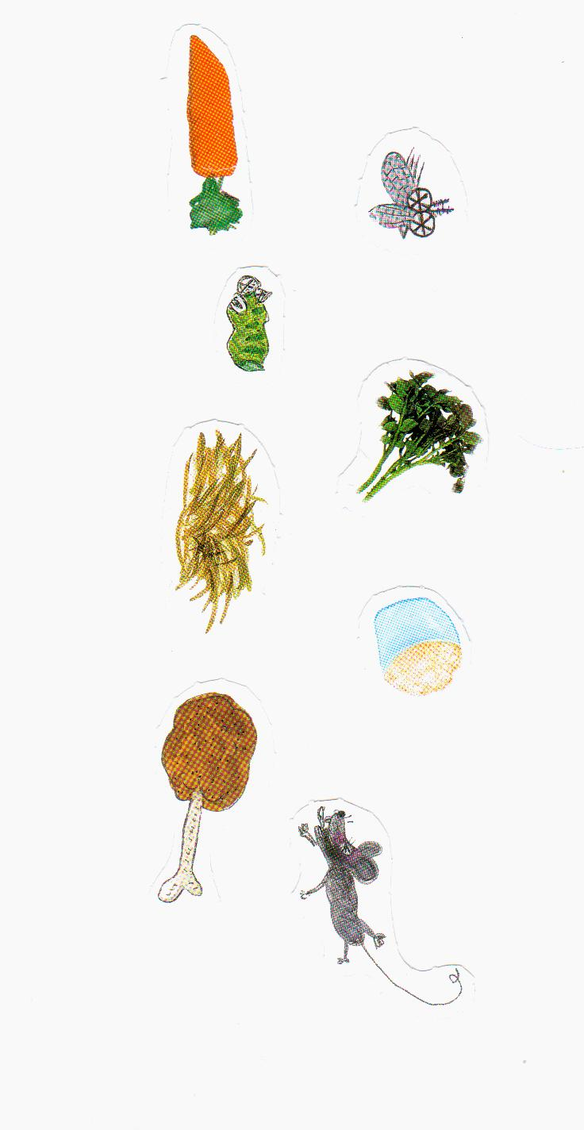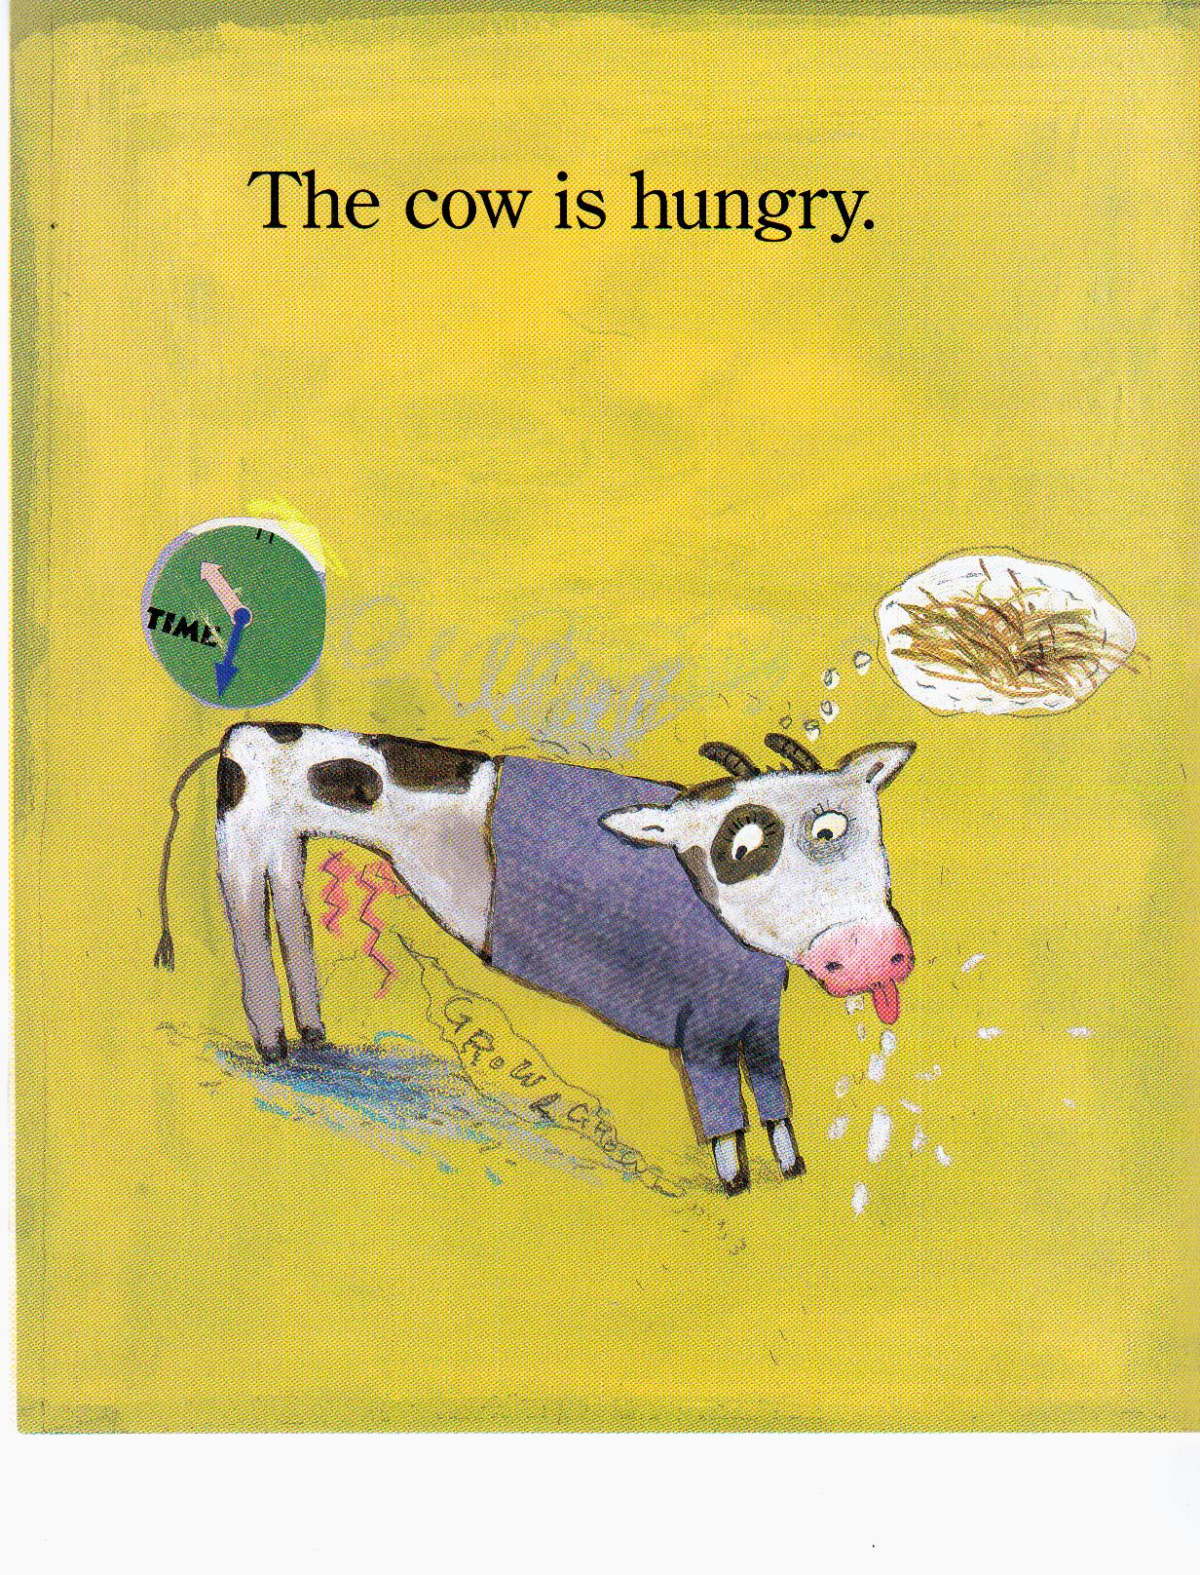
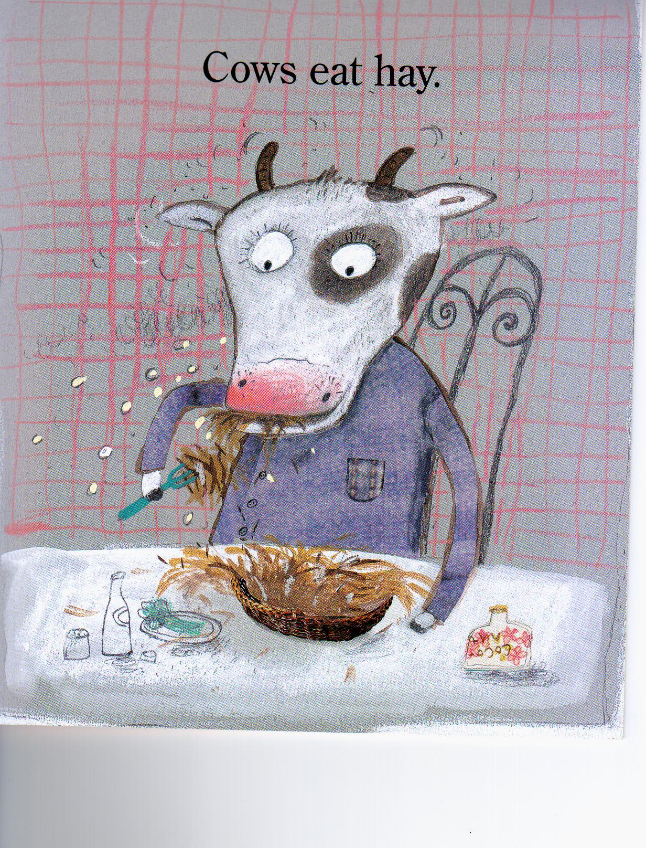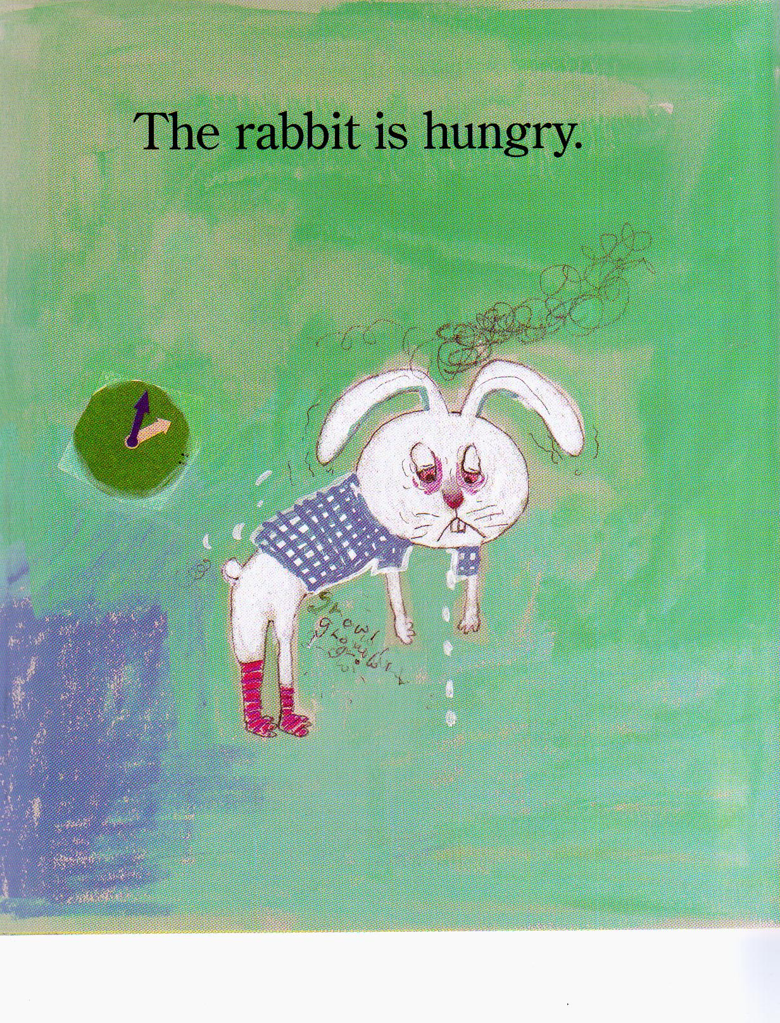
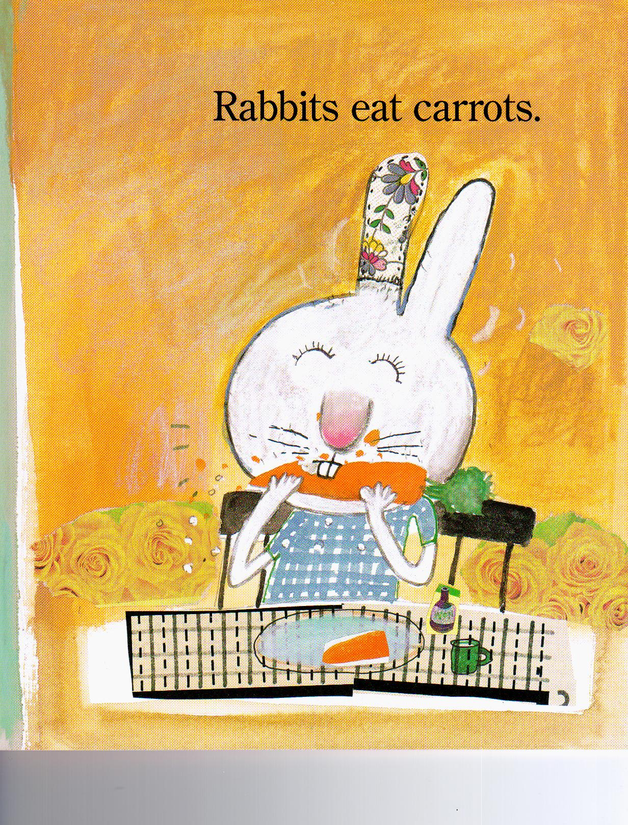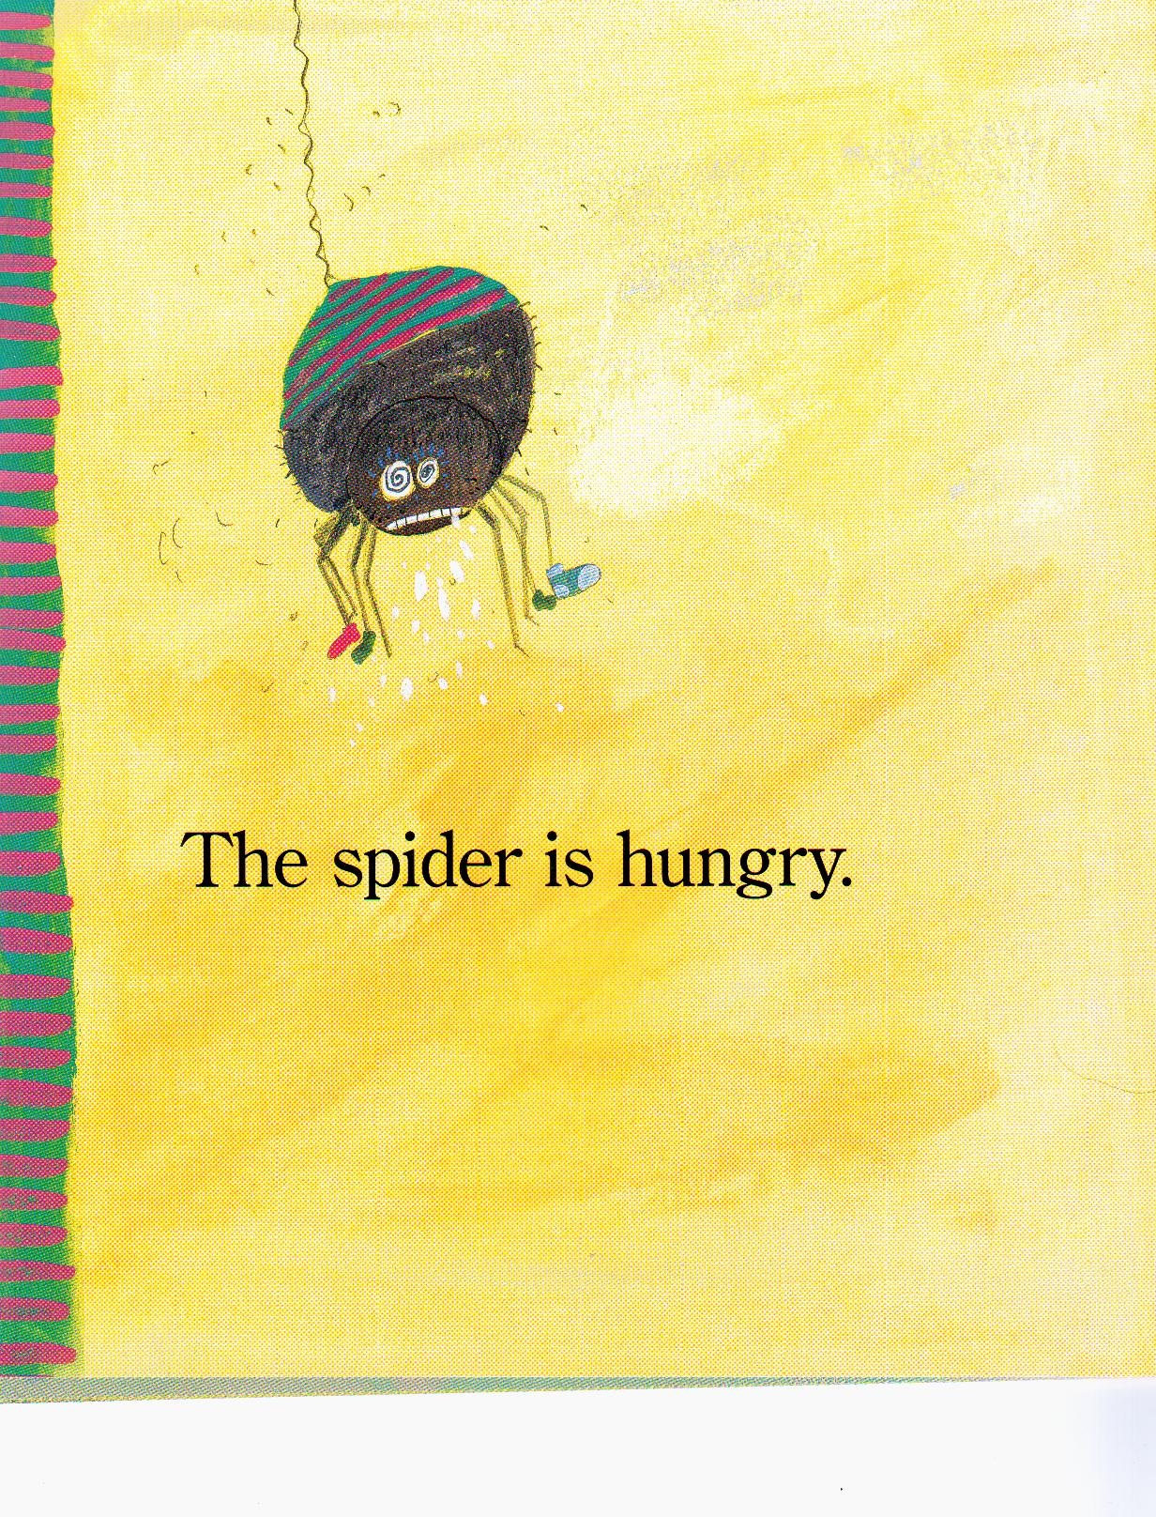
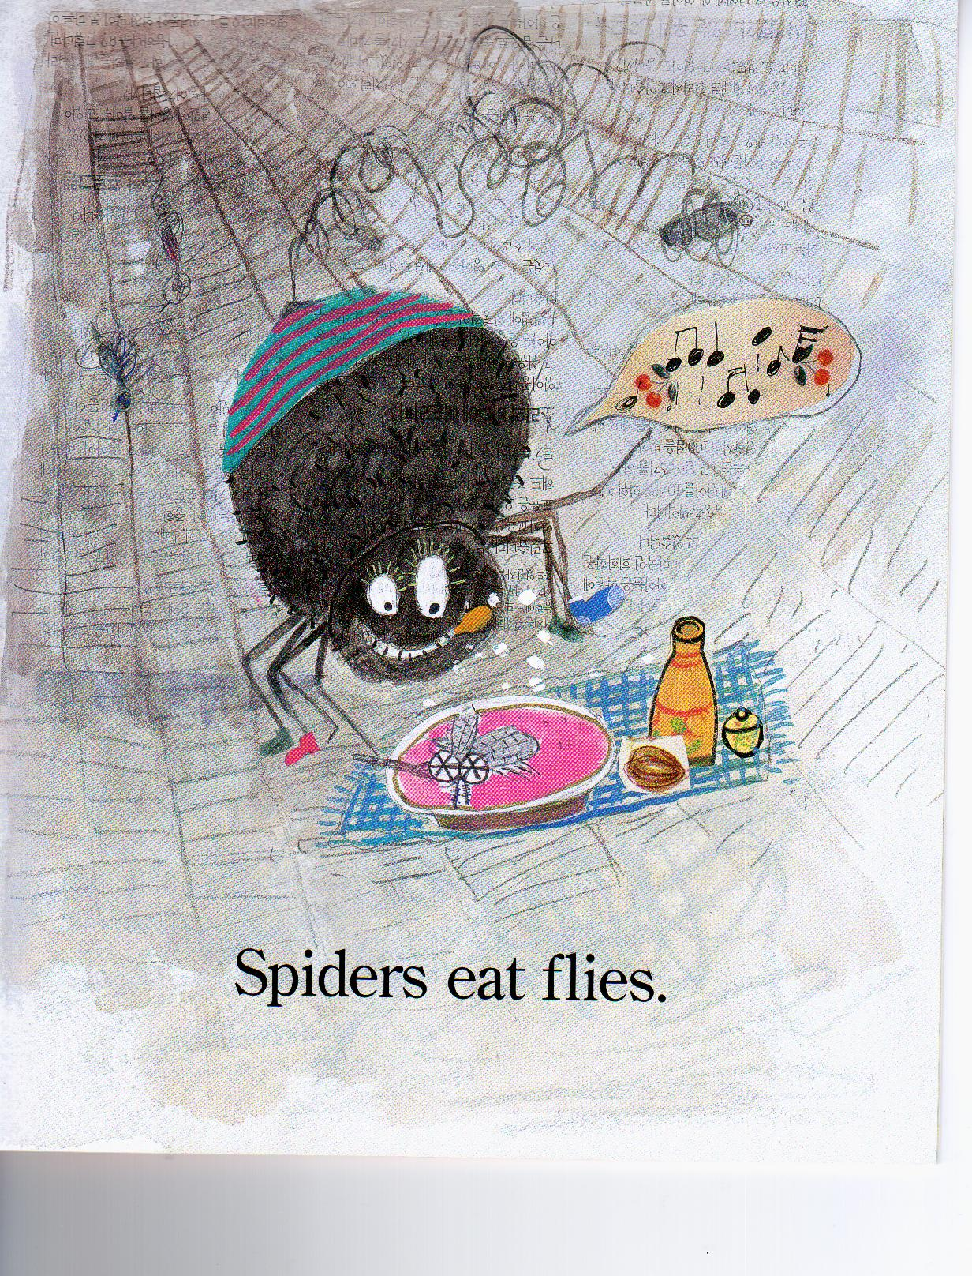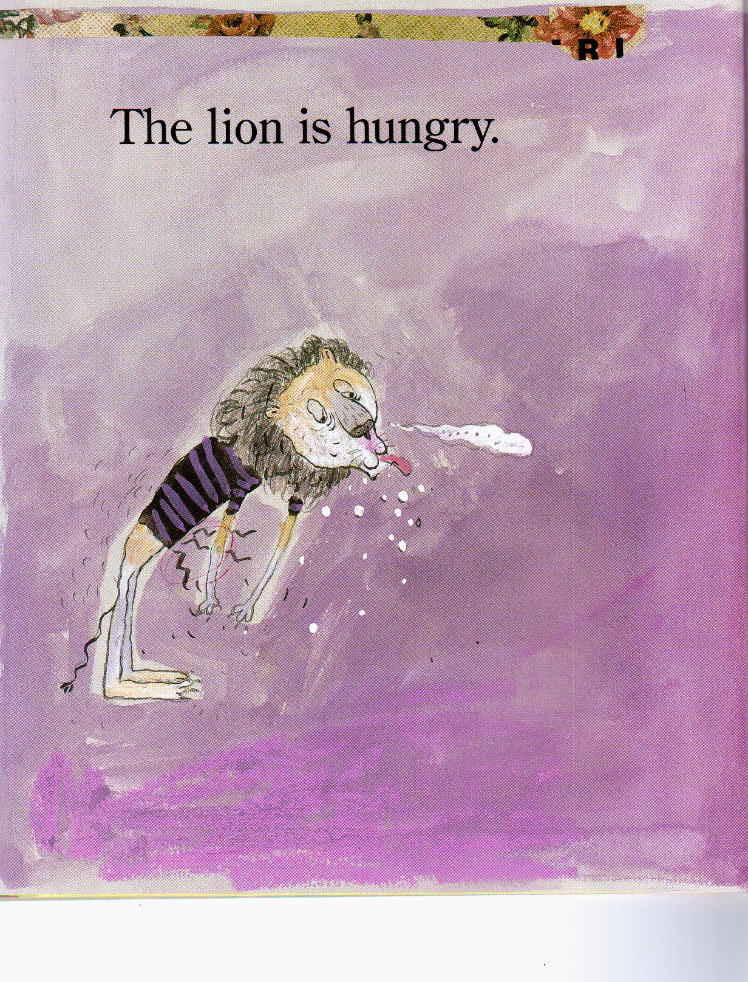
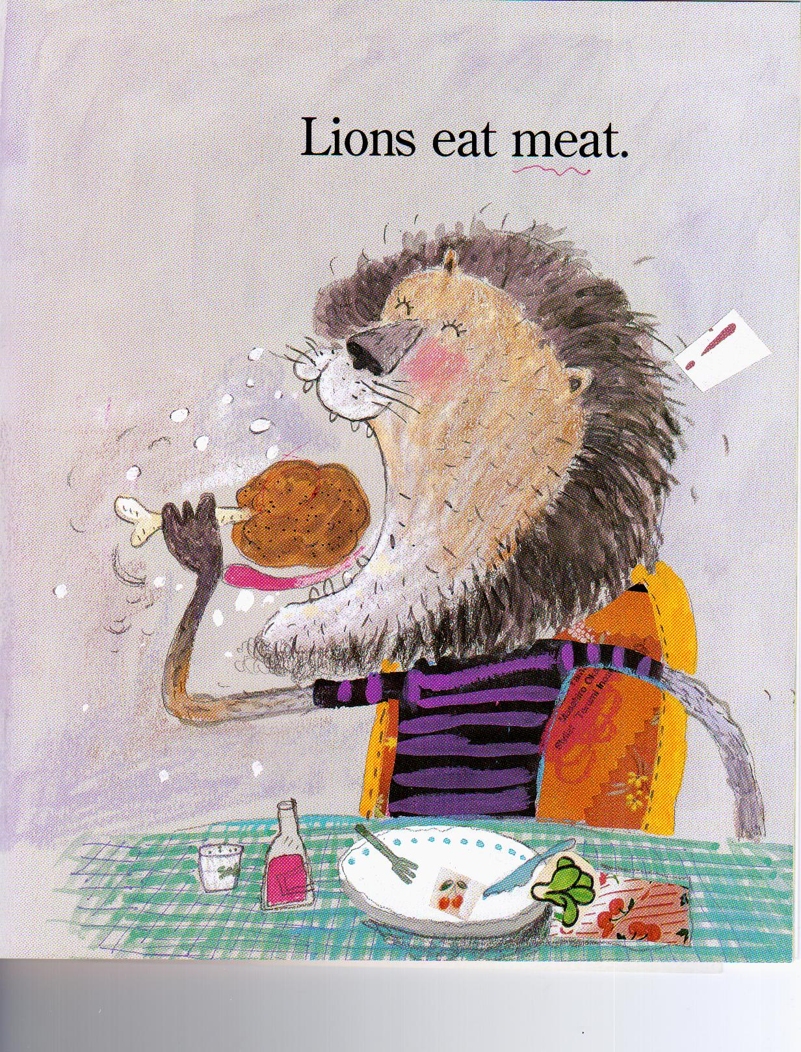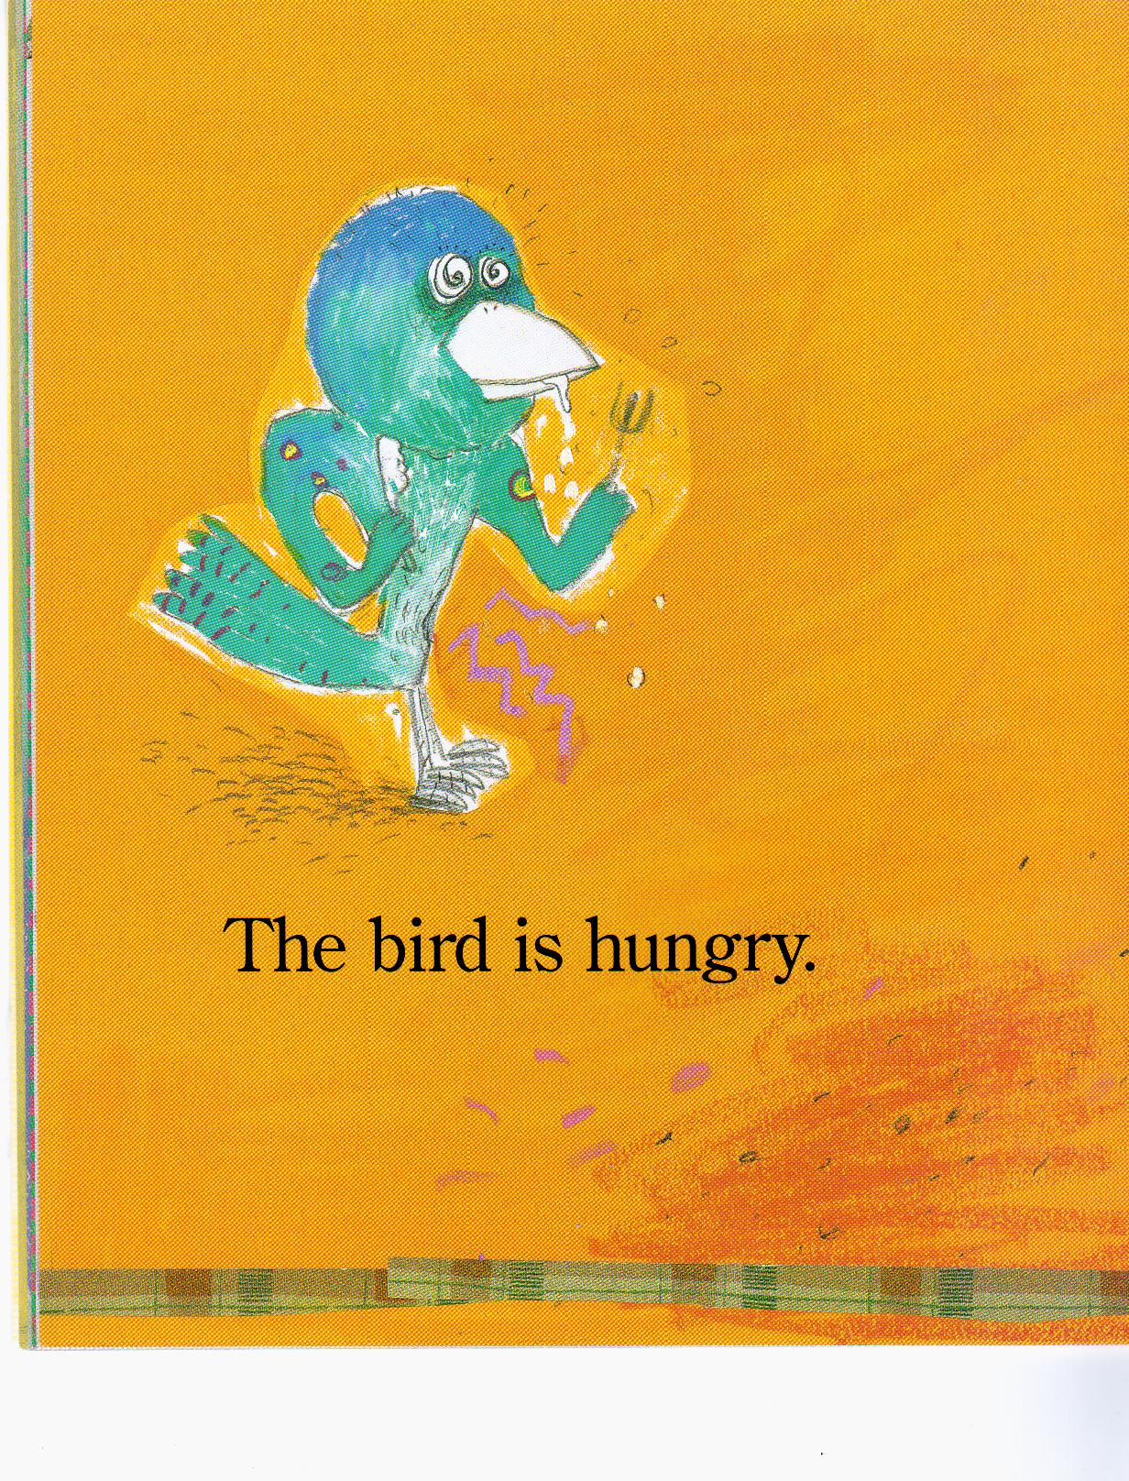

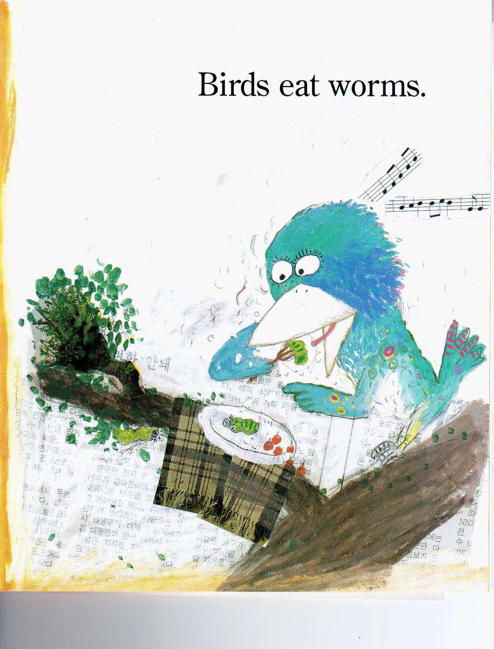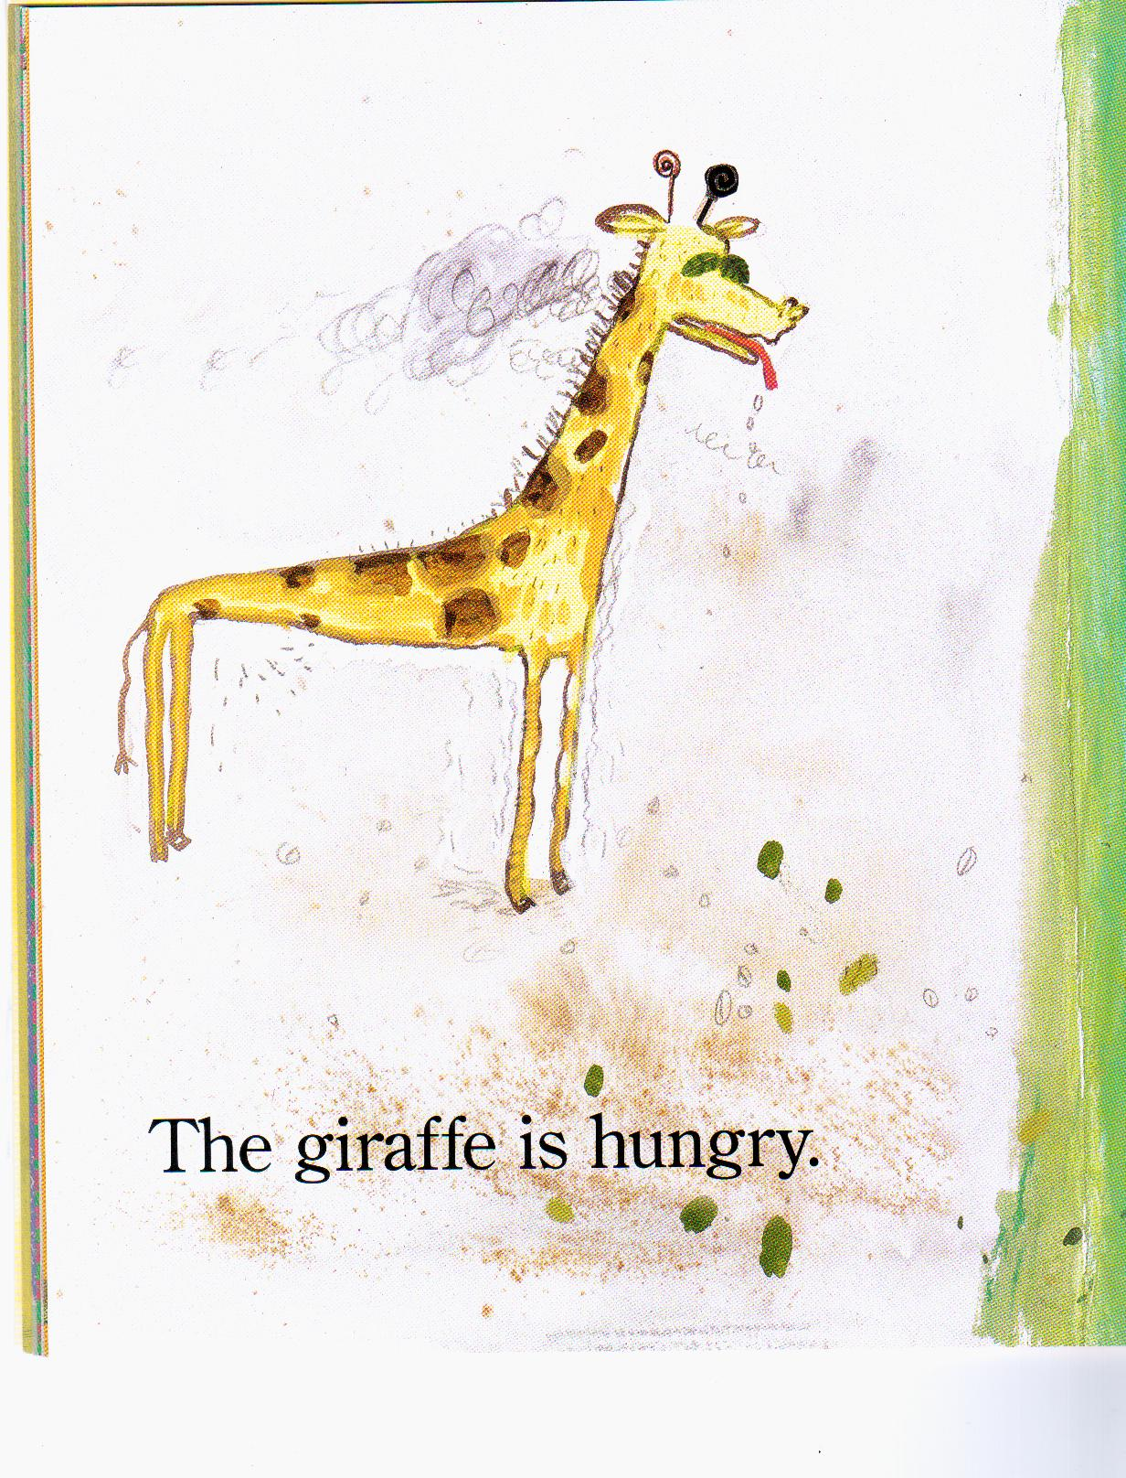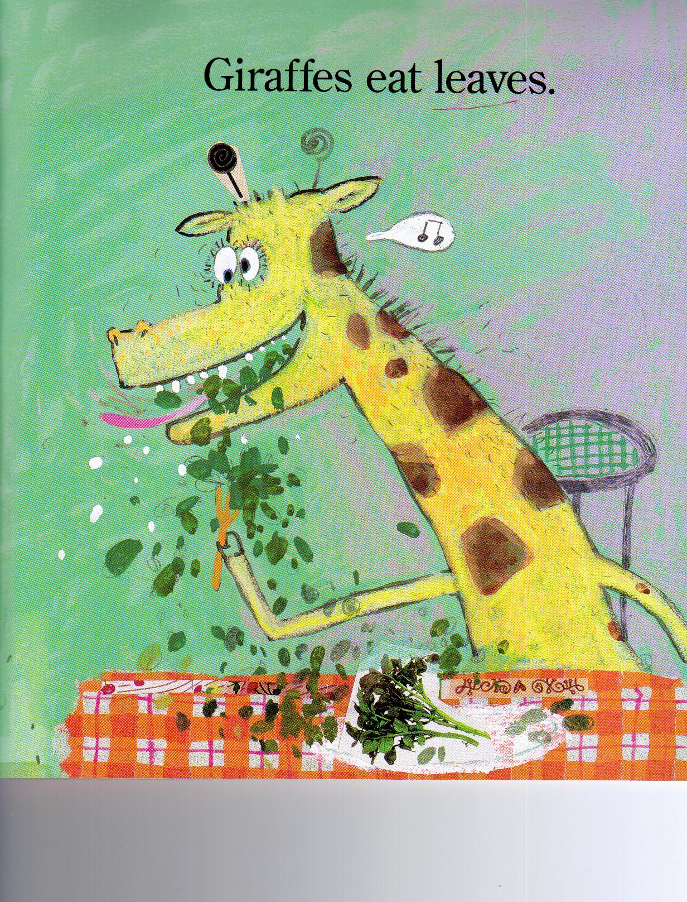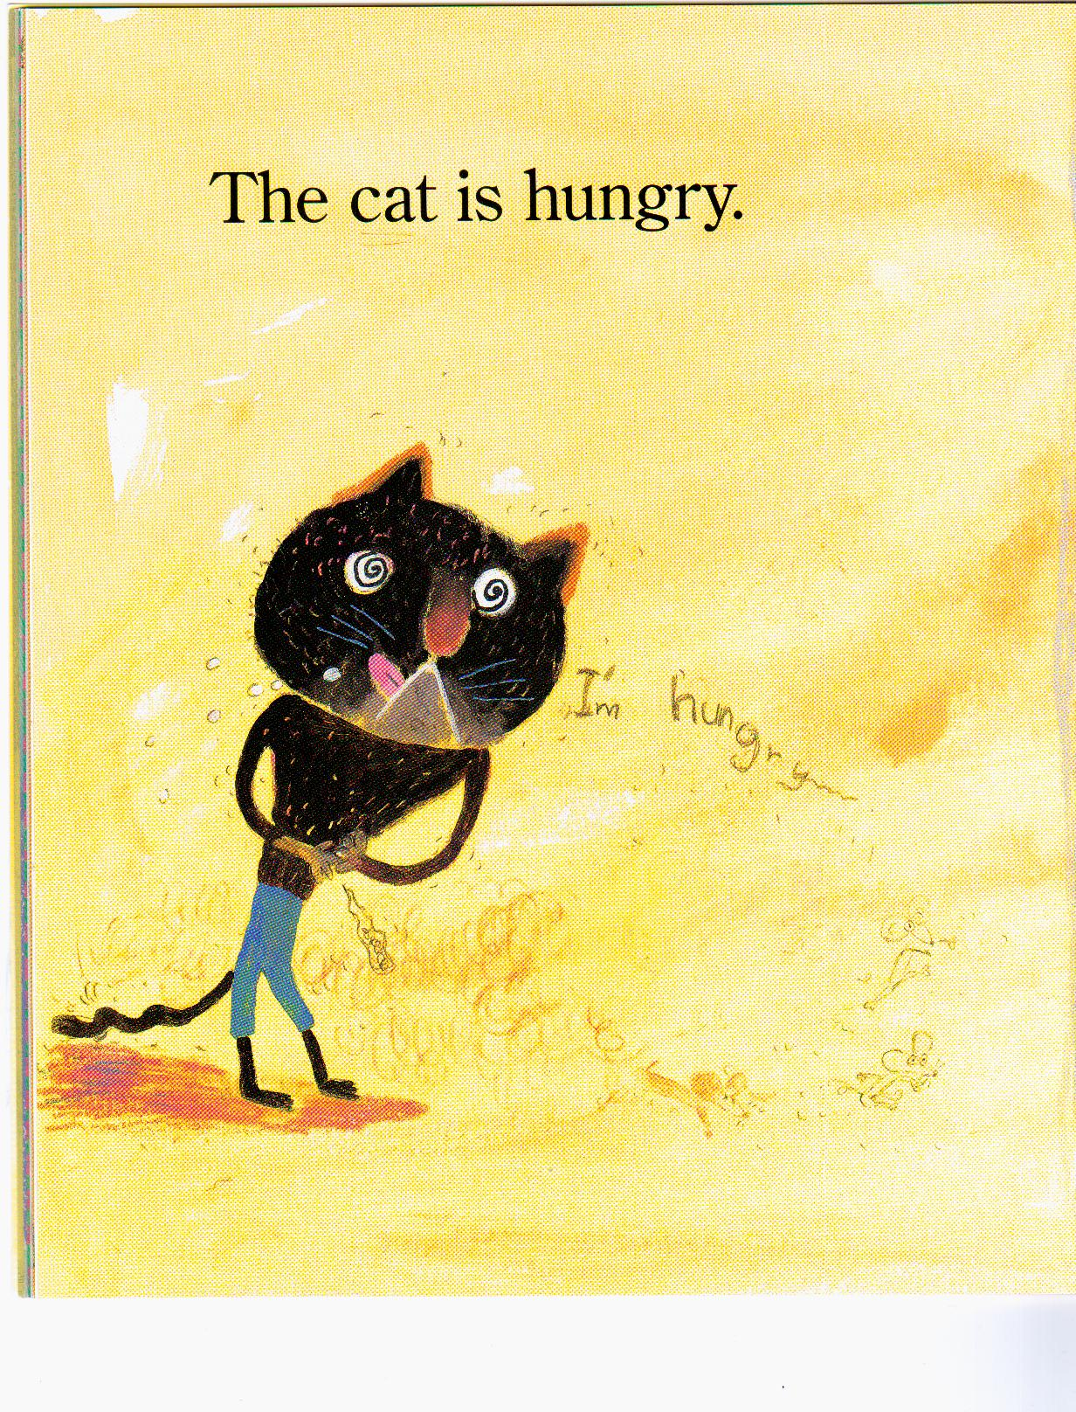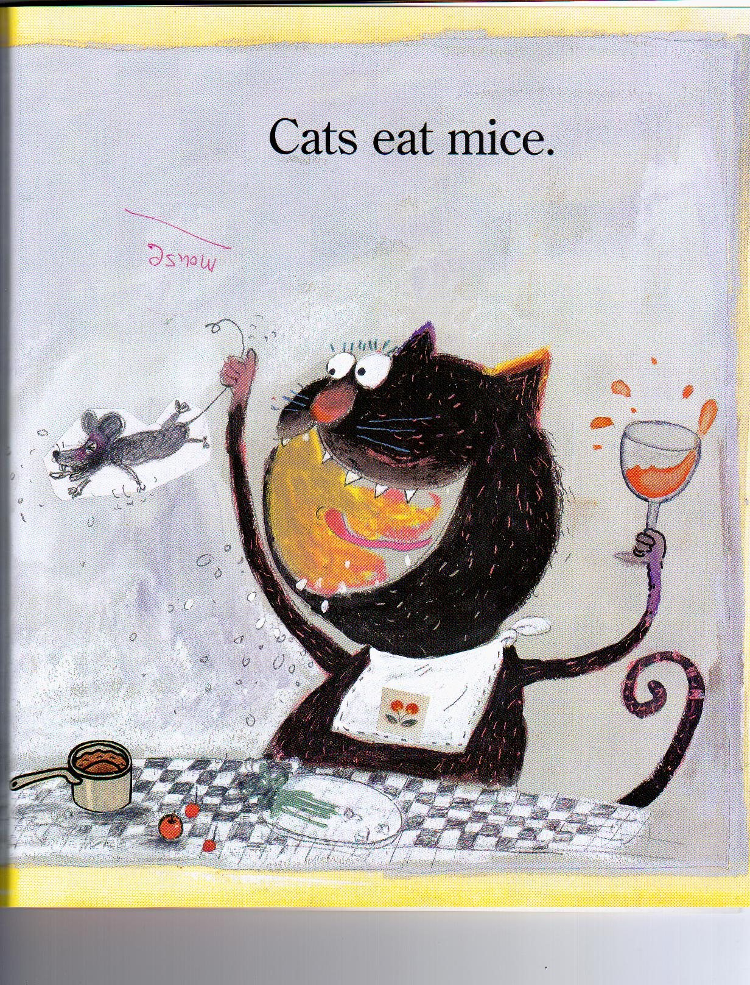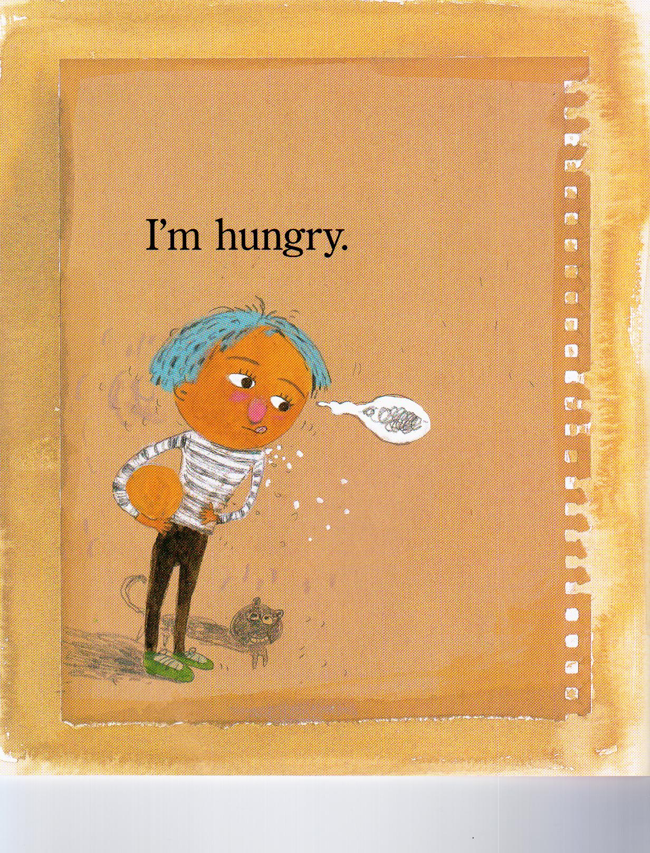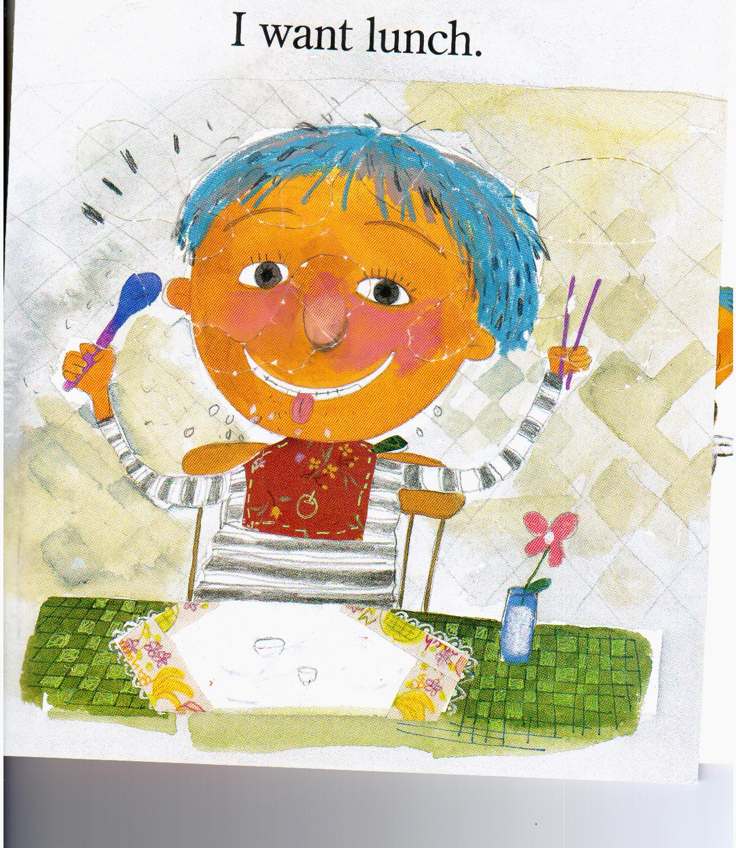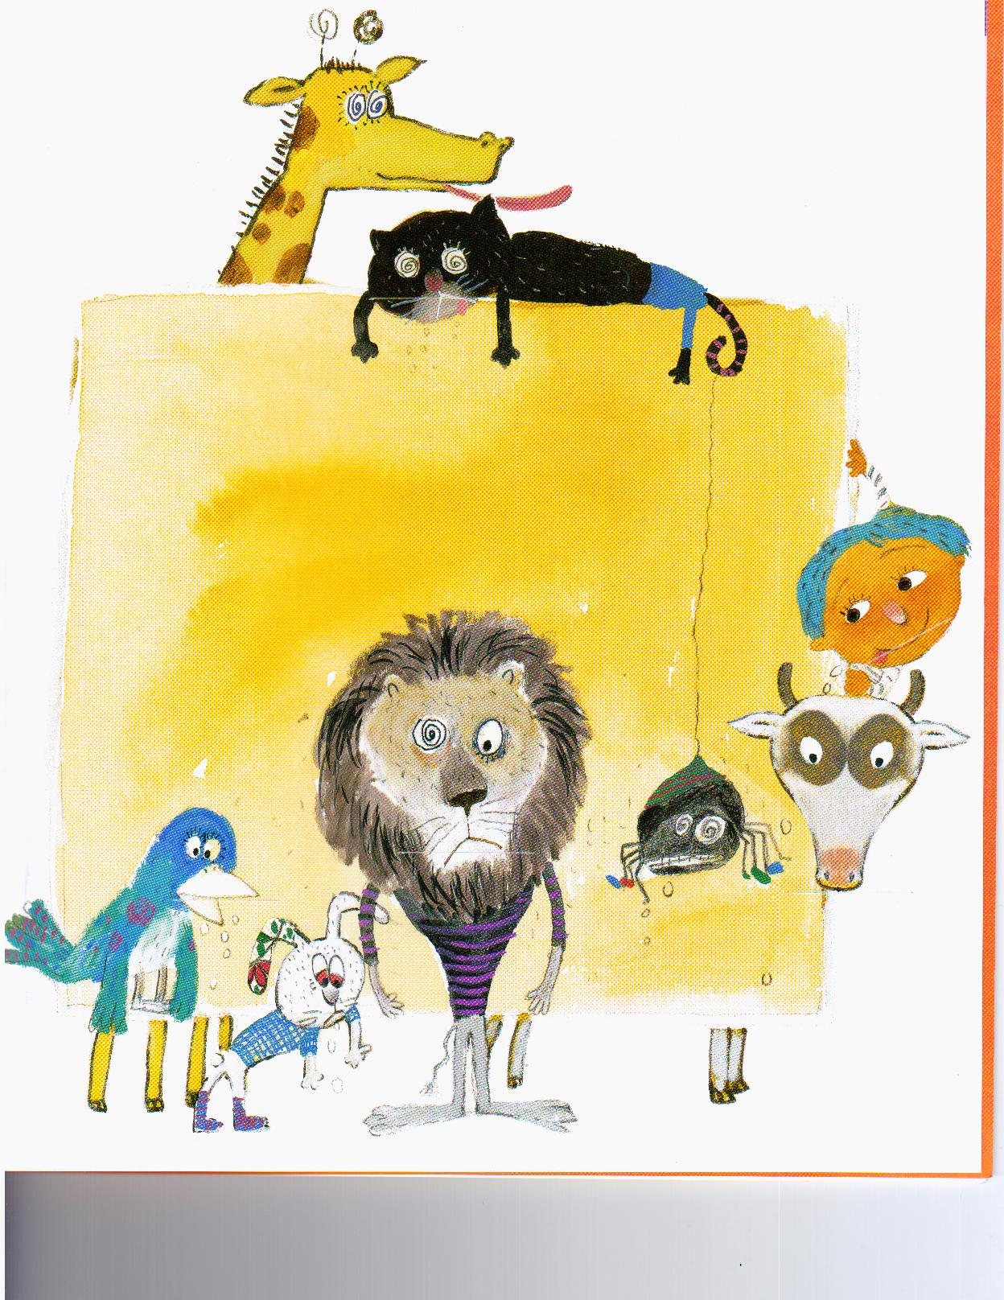

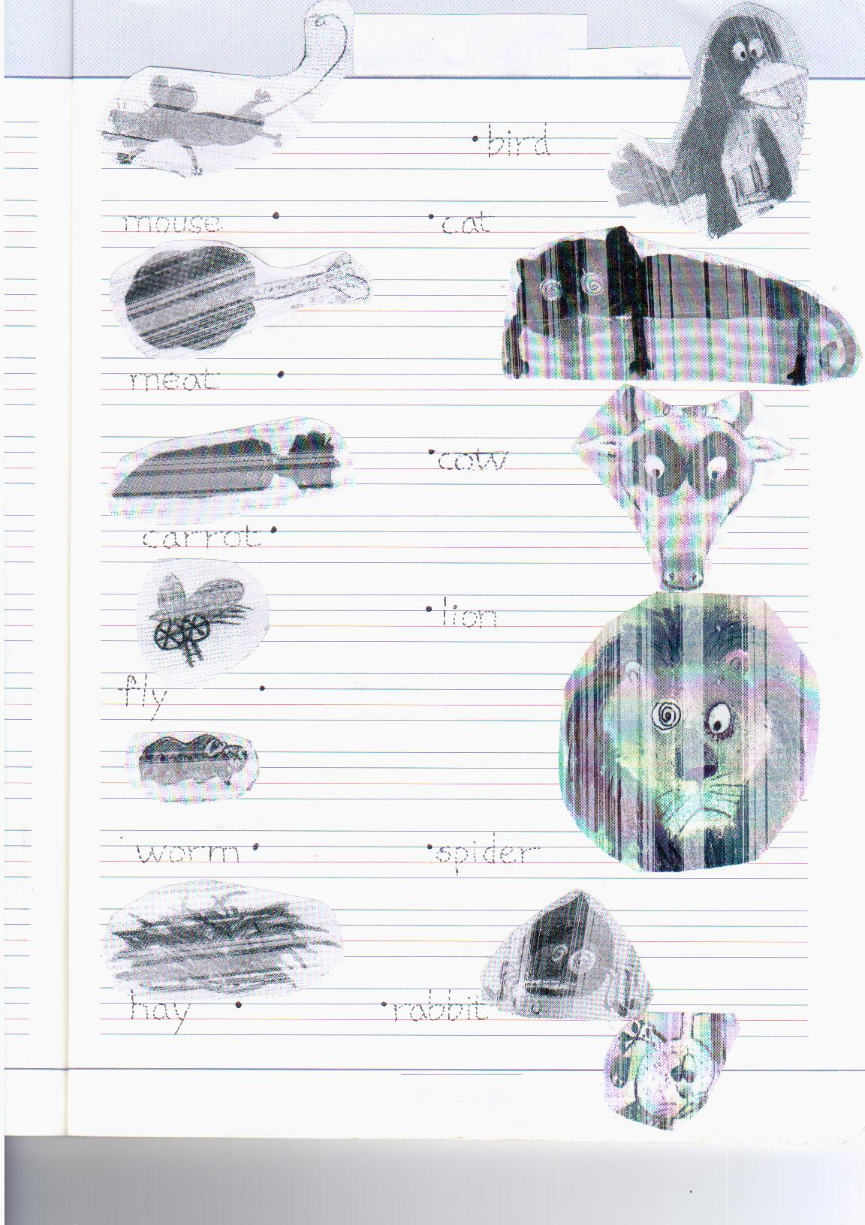
fly | leaf | mouse
meat | worm | hay
<Flash cards>
There are pictures of foods on the reverse sides.

