Speaking Lesson Plan

Topic : Compliment

Length:

25 minutes

es

Students:

19

Level:

Intermediate

Instructor:

Ms. Kim, Tiffany

**Materials:**

* 4 copies of picture for role play
* Blown-up pictures of compliment for Prediction
* White board, board markers & tape
* Huge paper which explained some lexis
* 2 boxes for drawing lots

**Aims:**

- Primary sentence: Teacher enables to develop speaking skills by doing lots of activities regarding compliment

- Secondary sentence: Students can understand and use compliment effectively when they teach in the future, it will make their lesson cheerful and successful

- Personal aim: Speak loudly and clearly, Well prepared time management,

Do not leave a material when I confirm with students by post activity

Grouping exactly

**Language Skills:**

* Reading: Students will read some sentences during main activity
* Listening: Students will listen about other groups presentations
* Speaking: Students will keep speaking when they are concentrate on every activity
* Writing: Student will make sentences during main activity

**Language Systems:**

* Discource : Discuss and prepare for group presentation
* Function : Question & Answer by drawing lots
* Grammar : None to discuss
* Lexis : stunning [**|**stʌnɪŋ] stupendous [stu:|pendəs], etc

- Phonology : stunning [**|**stʌnɪŋ] stupendous [stu:|pendəs], etc

**Assumptions:**

Students already know:

* Main system is speaking
* All students are female (Age 22 and up)
* Lesson time is limited in 25minutes

**Anticipated Problems and Solutions:**

* Students may not understand my instruction

🡪 Try to re confirm with student often and make full use of well prepared materials

* If students finish their tasks earlier than anticipated,

🡪 Ask for speaking as many students as if possible about their idea and use SOS

* Students may not get involved the task

🡪 Speak louder and give some compliment stickers who are participating well

**References:**

* <http://kerlynb.hubpages.com/hub/Complement-and-Compliment-Common-Mistakes-in-English-as-a-Second-Language-ESL>
* http://voices.yahoo.com/how-compliment-praise-students-256161.html?cat=4

|  |  |  |
| --- | --- | --- |
| **Lead-In** | | |
| Materials: **None to prepare** | | |
| Time  1 min | Set Up  Whole Class | **Procedure:**  Lead in )  *Hello everyone, how are you today ?*  What makes you happy? ( ask 3 students)  What makes you energetic*? ( ask 2 students)* |

|  |  |  |
| --- | --- | --- |
| **Pre-Activity** | | |
| Materials: **2 pictures for eliciting, Huge paper including every student’s name** | | |
| Time  2 min  5 min | Set Up  Whole class  Whole class | **Procedure:**   1. **Eliciting**   Show 2 pictures for eliciting and ask questions  [http://www.ilchi.com/wp-content/uploads/2010/09/IlchiLee_Thumbs_up_400h](http://www.google.co.kr/url?sa=i&rct=j&q=compliment&source=images&cd=&cad=rja&docid=zBZDa3phTwm7FM&tbnid=FKjzuSY1a9Cr9M:&ved=0CAUQjRw&url=http://www.ilchi.com/blog/journal/compliments-vs-criticism/&ei=_ZNhUfG4DYSyiQeV_4C4DA&bvm=bv.44770516,d.aGc&psig=AFQjCNFFk9wBOkX5Ob3qHJM75Rb4TWBcYA&ust=1365435301874193)  What can you see in this picture?  What can you guess about this picture?  *Alright, students*  *Today’s topic is “ Compliment”*  *As you know, meaning of compliment is* politely praise for something or someone  *Then let’s think about “compliment” as today’s topic and how to apply for your class in the future and your daily life*  CCQ   * Do you love receiving compliments?   **2. Give a compliment to your friends -speaking**  “ Then, let’s get into pre activity !  (Attach huge paper on the board which including student’s names)  You will give one sentence with compliment to your next person. Who is your next student?  I already made a turn for easy progress  So Amy will start first and give a compliment to next person and keep complimenting till finishing by last student yumi.  Do you understand?  ICQ)  What are we going to do?  How many sentences can you speak? |
| **Main Activity** | | |
| Materials: **prepared huge paper regarding lexis, 4 pictures for role play** | | |
| Time  1min  13min | Set Up  Whole Class  Group activity | **Procedure:**   1. **Explaining some words and synonyms**   Explain some useful words for next main activity,  Attach prepared huge paper for teaching   1. **Role play for improving speaking skill**   Instruction- Role play  *Please keep 4 groups, I will hand out 4 pictures.*  *First Look at the picture and related situation and make a story with compliments , Second present a 2 minutes role play . I will give you 3 minutes .*  I want you to start at the same time, don’t look at your paper before I say start  *ICQ :* What are we going to do?  *How much time do you have?*  How long does role play take?  4 group’s role play will be continued |

|  |  |  |
| --- | --- | --- |
| **Post-Activity** | | |
| Materials: [**drawing**](javascript:endicAutoLink('drawing');)[**lots**](javascript:endicAutoLink('lots');) **, 2 boxes , 19 copies of SOS sheets** | | |
| Time  3min | Set Up  Whole Class | **Procedure:**  **Instructions –Drawing lots game**  Drawing lots – Confirm understanding from this lesson  *I have two boxes , This box has student’s name, another box has some questions*  *First I will draw lots a student name randomly*  *The student who chosen will pick up 1 question and give an answer ,and she will keep drawing*  *ICQ- What are we going to do?*  *What is in the left box?*  **SOS**  In case, prepare SOS program “ word search”  “Let’s find all the compliments I´ve hidden in the word search”  **Conclude lesson:**  Before finishing lesson, any question about this lesson?  **Thank you for your cooperation**  **[출처]** [[다이어트영어] 다이어트와 관련된 영어표현들 (On a diet)](http://blog.naver.com/jhellen7/140118083413) |**작성자** [당당한 그녀](http://blog.naver.com/jhellen7)  Give homework  *Please compliment one of your family after finishing this lesson* |

**You are great game “ – Group activity**

Instructions – ice breaker & students can understand a concept of compliment

*“ I will make four groups and will give one sentence with compliment . I will show you an example.*

*Please* select most closely **matched person** in your next group *and complete the sentence*

*Do you understand? I will give you 1 minute “*

**Explicit ICQ’s**

*What are you going to do?*

*How much time do you have?*

*“ Team 1, Please read your sentence with a name and the chosen person will start action as an instruction”*

**Each team will find the best person and student who was selected will act as sentences**

*1 > Alright, students*

*Today’s topic is “ Compliment”*

*As you know, meaning of compliment is* politely praise for something or someone

*Then let’s think about “compliment” as today’s topic and how to apply for your class in the future and your daily life*

CCQ

* Do you love receiving compliments?

2> “ Then, let’s get into pre activity !

(Attach huge paper on the board which including student’s names)

Please give one sentence with compliment to your next person. Who is your next student? I already made a turn for easy progress

So Amy will start first and give a compliment to next person and keep complimenting till finishing by last student yumi.

Do you understand?

ICQ) What are we going to do?

How many sentences can you speak?

3>

1. Explaining some words and synonyms

Explain some useful words for next main activity,

Attach prepared huge paper for teaching

1. Role play for improving speaking skill

Instruction- Roll play

*Please keep 4 groups, I will hand out 4 pictures.*

*First Look at the picture and related situation and make a story with compliments , Second present a 2 minutes role play . I will give you 3 minutes .*

Don’t look at your paper before I start.

*ICQ :* What are we going to do?

*How much time do you have?*

How long does role play take?

4> Drawing lots – Confirm understanding from this lesson

*I have two boxes , This box has student’s name, another box has some questions*

*First I will draw lots a student name randomly*

*The student who chosen will pick up 1 question and give an answer ,and she will keep drawing*

*ICQ- What are we going to do?*

*What is in the left box?*

**Conclude lesson:**

Before finishing lesson, any question about this lesson?

**Thank you for your cooperation**

**[출처]** [[다이어트영어] 다이어트와 관련된 영어표현들 (On a diet)](http://blog.naver.com/jhellen7/140118083413) |**작성자** [당당한 그녀](http://blog.naver.com/jhellen7)

Give homework

*Please compliment one of your family after finishing this lesson*



[](http://www.google.co.kr/url?sa=i&rct=j&q=dance&source=images&cd=&cad=rja&docid=Z9xcv4VfCjG1DM&tbnid=v8D7qcIKpWIiAM:&ved=0CAUQjRw&url=http://www.powerfulintentions.org/group/dance&ei=_cVhUZDhBeePiAfy0oCwDg&bvm=bv.44770516,d.aGc&psig=AFQjCNEJ3KFvVBTBqfa775gv1cKHrLOTMw&ust=1365448566092610)



1. Pre activity – Ice breaker & Understanding

EX ) ________ ,

You are looking gorgeous today !

Can you _____________________?

1._________ , <- ( Choose one Student from group # 2)

You’ve got the most beautiful voice in our class !

Can you__________________? <-(make a complete sentence)

2._______ , <- ( Choose one Student from group # 3)

Gee… your hair looks fantastic !

Can you___________________? <-(make a complete sentence)

3.__________ , <- ( Choose one Student from group # 4)

You are looking amazing today!

Can you____________________? <-(make a complete sentence)

4.__________ , <- ( Choose one Student from group # 1)

You’ve got the most infectious laugh !

Can you__________________? <-(make a complete sentence)

Main activity

* How to Compliment and Praise effectively

**One-Word Synonyms to Say "Good"**

wow, terrific, brilliant, outstanding, exceptional, fabulous, superb, impressive, incredible, extraordinary, splendid, sensational

1. stunning [**|**stʌnɪŋ] - person or thing is extremely beautiful or impressive

ex) You look really stunning in that dress!

2)stupendous [stu:|pendəs] - surprisingly impressive or large.

**Using a people's Name**

Use sentences that place a people's name into it.

This points shows that we are paying attention to who is doing good work and not just saying "good job" randomly.

*I like the way you're working, Jenny.*

*Sophia, you really outdid yourself today*

Main activity 2)- Role play

Team # 1 )

[](http://www.google.co.kr/url?sa=i&rct=j&q=compliment&source=images&cd=&cad=rja&docid=46dbbIFUd4lPFM&tbnid=eRRJ9qcTh58RbM:&ved=0CAUQjRw&url=http://www.geekosystem.com/emergency-compliment-generator/&ei=O41hUeTKCOSZiAfI14GAAg&bvm=bv.44770516,d.aGc&psig=AFQjCNH-OKiPgnrgvgFyDEuRq0j5DSQWDA&ust=1365433397798771)



Team # 2)

[](http://www.google.co.kr/url?sa=i&rct=j&q=compliment&source=images&cd=&cad=rja&docid=46dbbIFUd4lPFM&tbnid=OI5c9XRixA_VFM:&ved=0CAUQjRw&url=http://www.funny-pics-space.com/img/138/&ei=eo1hUea-GM2ziQfw3YDQDA&bvm=bv.44770516,d.aGc&psig=AFQjCNH-OKiPgnrgvgFyDEuRq0j5DSQWDA&ust=1365433397798771)

**[](http://gsmtweet.com/wp-content/uploads/2012/11/How-To-Compliment-A-Girl.jpg)**

Team # 3 )

[](http://www.google.co.kr/url?sa=i&rct=j&q=compliment&source=images&cd=&cad=rja&docid=fvgU7XIOfbNkqM&tbnid=R39KP2dhsy3YDM:&ved=0CAUQjRw&url=http://www.kamerican.com/GNC/new/secondary_contents.php?article_no=8&no=243&ei=8rRhUbSjMOaaiQeYvoCQAw&bvm=bv.44770516,d.aGc&psig=AFQjCNH1RCYNN2YLG_3UanBSys7Cq896qw&ust=1365444181506893)

[](http://www.google.co.kr/url?sa=i&rct=j&q=student+compliment&source=images&cd=&cad=rja&docid=I6u6NAfd8DlveM&tbnid=Kq_V7IevPBNF_M:&ved=0CAUQjRw&url=http://collaborizeclassroom.com/blog/&ei=v5BhUcPvIuS1iQeFm4DQDg&bvm=bv.44770516,d.aGc&psig=AFQjCNEu2qH1T3lfpQRcPpqwpxJeWWBBeQ&ust=1365434869577014)

Team # 4 )

[](http://www.google.co.kr/url?sa=i&rct=j&q=family+compliment&source=images&cd=&cad=rja&docid=46dbbIFUd4lPFM&tbnid=IuM7Ipb_ydlH5M:&ved=0CAUQjRw&url=http://www.geekosystem.com/emergency-compliment-generator/&ei=wpFhUeruG-ujiAeo6oH4Dg&bvm=bv.44770516,d.aGc&psig=AFQjCNHBr8ogJaPNtXoqAQeYPtbr_6djqA&ust=1365435155296007)

[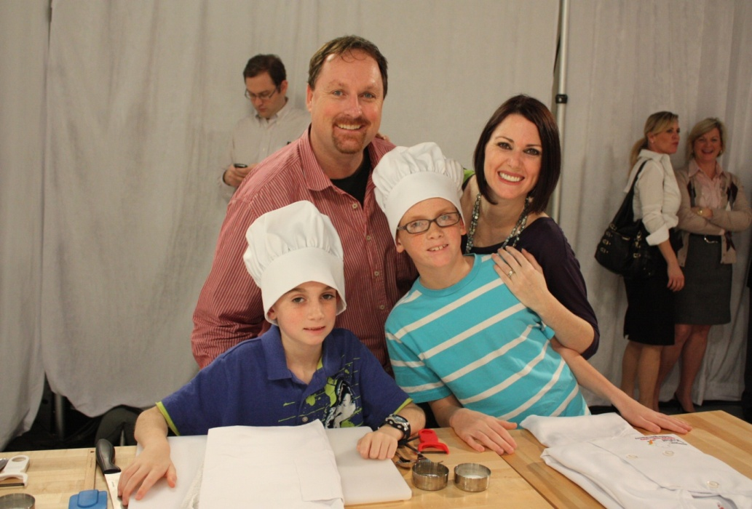](http://www.google.co.kr/url?sa=i&rct=j&q=family+compliment&source=images&cd=&cad=rja&docid=vrajjQCw2KjEIM&tbnid=NltKw3IASphFAM:&ved=0CAUQjRw&url=http://blogs.babycenter.com/mom_stories/jyl-johnson-pattee-changing-the-world-one-mom-at-a-time/&ei=25FhUcHDDa6eiAfN2IHYBQ&bvm=bv.44770516,d.aGc&psig=AFQjCNHBr8ogJaPNtXoqAQeYPtbr_6djqA&ust=1365435155296007)

SOS – 19 copies

In case, prepare SOS program “ word search”

