Lesson Plan Template PPP Based
Listening Speaking Reading Grammar Writing
Topic: Baby Box
Instructor:  Cindy | Level:  Intermediate | Students:  12 | Length:  50 Minutes
Materials:
Video clip “Adoption Placement 3/13/12”)
Board and markers,
Vocabulary Flash cards(Mandatory, Abandon, Desperate)
Article-“South Korea "Baby box" pastor says new law brings more babies”
Jeopardy Game board,
Question Cards,
Sample Question Worksheet

Aims:
Students will be familiar with key vocabulary through Teacher’s explanation
Students will be able to get the main idea by skimming the article
Students will improve scanning skills by answering true and false questions
Students will improve speaking and listening skills by sharing ideas in a group

Language Skills:
Reading: reading text “South Korea "Baby box" pastor says new law brings more babies”
Writing: taking notes of group discussion
Speaking: sharing ideas in a group
Listening: listening to teacher’s explanation, instruction, and classmates’ ideas

Language Systems:
Lexis: mandatory, abandon, desperate
Phonology: mandatory, abandon, desperate

Assumptions:
Students have some idea about adoption and abandoned child
Students are used to work in a group of 4
Students know how to skim and scan

Anticipated Errors and Solutions:
Students may not understand the some words
-Explain and give details
Students may need more time for discussion
-Give more time for discussion, and rearrange time for other step
Group is tied in Jeopardy Game
-Prepare extra question for unexpected situation

References:
http://articles.chicagotribune.com/2012-10-07/news/sns-rt-us-korea-babiesbre89602u-20121006_1_unwanted-infants-pastor-lee-jong-rak-babies

Lead-In
Materials:
Computer, Video “Adoption Placement”
Time | Set Up | Student Activity | Teacher Talk
1 min  4 min | Whole  Whole | Greet teacher  Listen | Greet students  Show video clip  & Introduce topic for today

Pre-Activity
Materials: Board and markers

Time | Set Up | Student Activity | Teacher Talk
6 min | Whole | Listen and repeat | Introduce new vocabularies  Write, Read, and make students repeat  *Mandatory: required, commanded, obligated  It is mandatory to serve in the army as a man in Korea.  *Abandon: withdraw one's support or help from, give up by leaving  You had a boyfriend who studied to be a doctor. You bought him many things he needed and supported him. When he finally became a doctor, he got married with a pretty young girl and he didn’t want to be with you anymore. In this situation, you can say that you are abandoned from him.  *Desperate: having lost all hope  When you broke up with your boyfriend, lost your job and your health, and everything around you is terrible, you can say “I am desperate.”

Main Activity
Materials:
12 Article-“South Korea "Baby box" pastor says new law brings more babies”
Jeopardy Game board,
13 Question Cards

Time | Set Up | Student Activity | Teacher Talk
5 min  13min  2min | Whole  Whole  Whole | Read  Listen and participate  Listen | Pass out article and run the task  & Facilitate Students  Jeopardy Game  (Instruction: Assign groups (3 groups)  Pick one question from four levels. You can pick any color of any level. You solve the problem with your group member. If you are correct, you get the points. Group which has most points will win and get prize. )  Feedback

Post Activity
Materials:
3 Sample questions sheet for group discussion

Time | Set Up | Student Activity | Teacher Talk
10min  8min  1 min | Whole  Group  Whole | Discuss in a group  Present their opinion  Goodbye to teacher | Group Discussion, and hand out sample questions for encouraging discussion.  (Instruction: All of you will be mother and father in someday. Discuss with your group and decide whether you support new law or you don’t support new law. )  Let groups present their opinion  Closing and Dismiss class

< Article>

South Korea "Baby box" pastor says new law brings more babies
A South Korean pastor who runs a "baby box" where mothers can leave unwanted infants has seen a sharp increase in the number of newborns being left there because, the pastor says, of a new law aimed at protecting the rights of children.
The law that took effect in August is aimed at ensuring adoption is more transparent and makes it mandatory for parents to register newborns if they want to give them up. But the regulation aimed at seeing more thorough records are kept, though well intentioned, has sparked a surge of undocumented babies being abandoned, said Pastor Lee Jong-rak. "If you look at the letters that mothers leave with their babies, they say they have nowhere to go, and it's because of the new law," Lee told Reuters Lee, who opened his "baby box" for unwanted infants three years ago, said he had seen the number being left there shoot up from an average of five a month to 10 in August and 14 in September.
Despite the new law, Lee said he never forced mothers to provide information about the babies they leave in the box, built into the wall of his church in Nangok, a tough working-class neighborhood in the capital, Seoul. Many of the babies abandoned in the box have physical or mental disabilities. Lee has adopted 10 of them himself and is in the process of adopting four more.
On a recent sunny afternoon, a bell rang in his church to signal a new baby had been left in the box, a boy about two weeks old wrapped in a blanket. "In the past, babies used to be abandoned at night but nowadays babies are abandoned in the daytime as well," Lee said with a sigh. At the moment, Lee is looking after 20 children, aged between 2 and 26, in his cramped two-story house.
But a Ministry of Health and Welfare official questioned Lee's assertion that the new law had led to more babies being dropped in the box. "It's hard to say there's a specific causal relationship between the law and babies being abandoned in the box," said the official, who declined to be identified. "The sudden surge of the babies could be due to many reasons," said the official.
Lee has been criticized by some people who say his box encourages desperate mothers to give up their babies. But Lee says he will not close the box until he was sure the government can offer adequate protection for abandoned babies.

Jeopardy Game
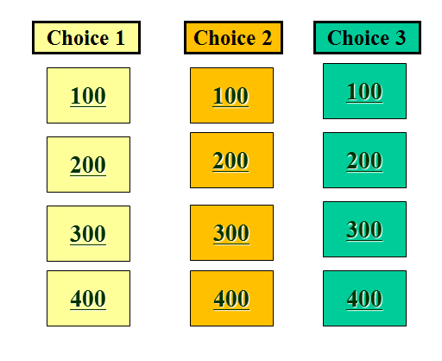
Question Cards
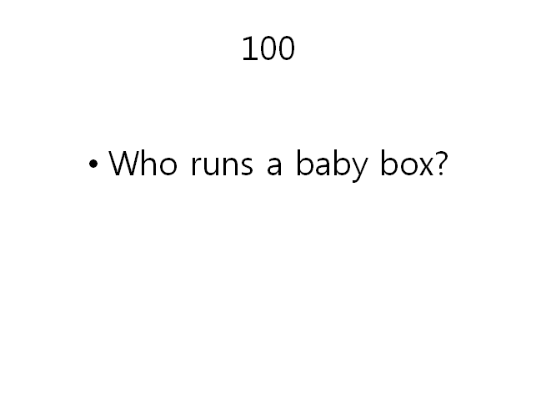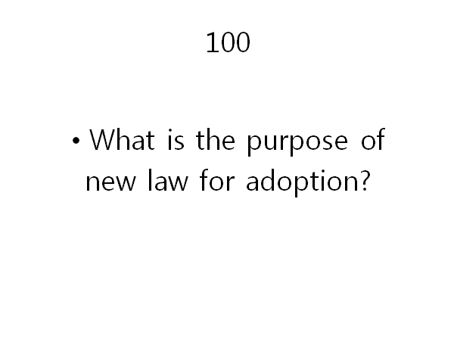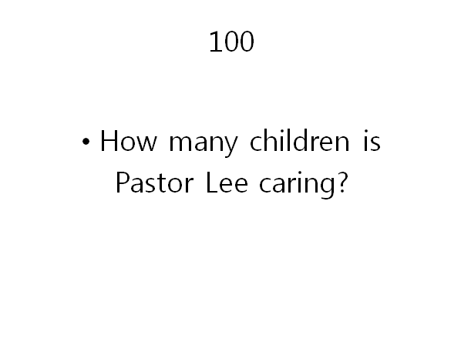
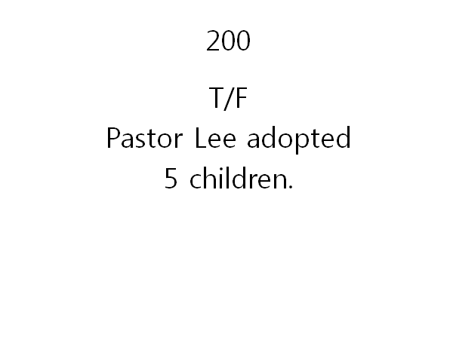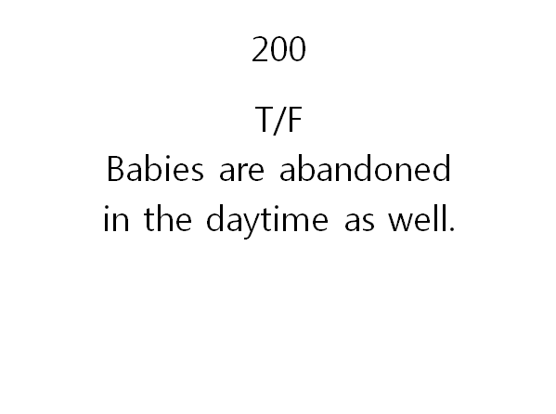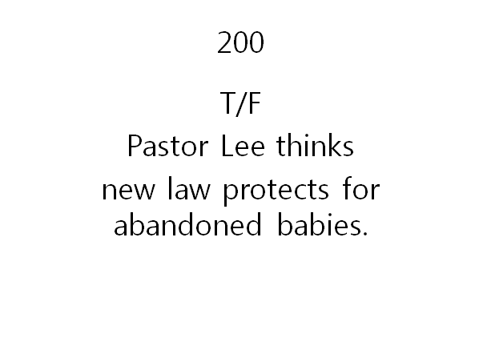
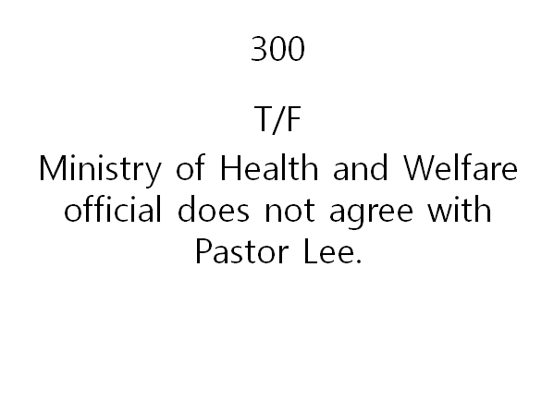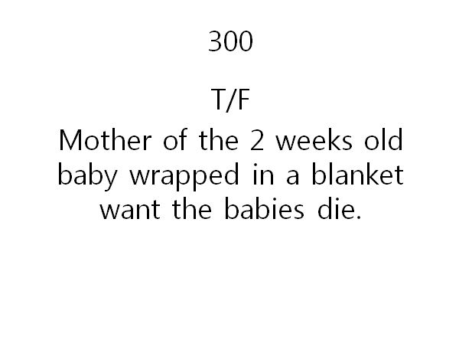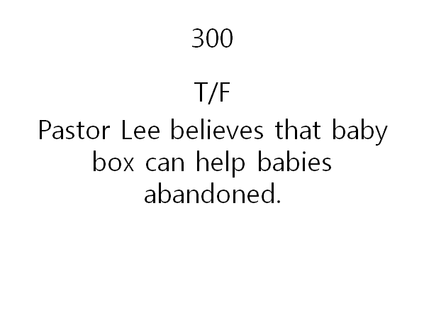
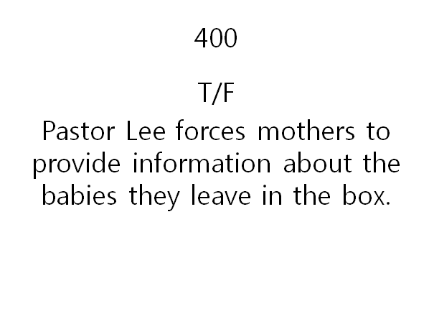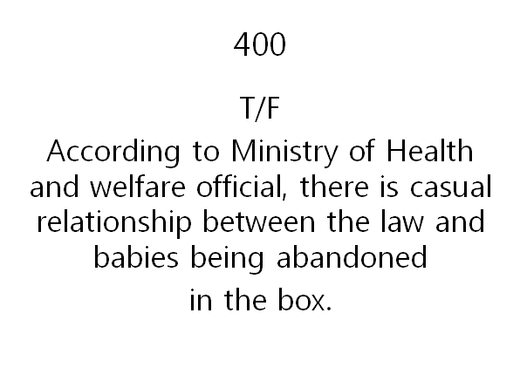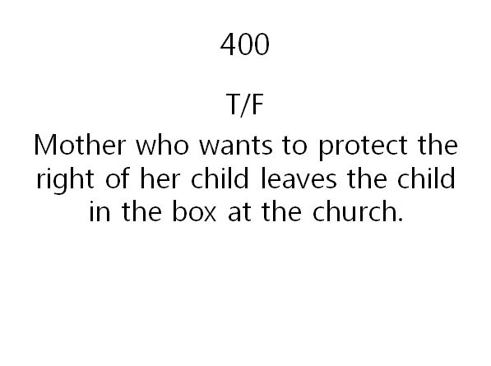

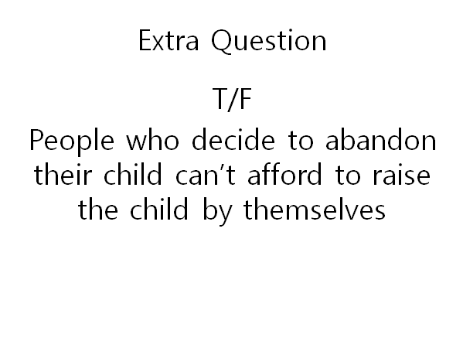

<Group activity>

