Listening Speaking Reading Grammar Writing

Topic: My Buddy, Adjectives

Instructor:  Stella | Level:  Upper Beginner | Students:  12 | Length:  50 Minutes

Materials:

-Board and markers
-Pencils
-Drilling Wall Chart on Board(Adjectives :How many, What sounds, Describing the nouns…etc)
-Pictures of restaurant and Street, One example of funny caption
-Worksheet of Adjectives(3copies each group)

Aims:

- Students identify adjectives by pre-activity and Main activity
- Students will learn how to use correct adjectives in sentences by completing the activities

Language Skills:
Listening Skills – Teacher’s instruction and explanation, Student’s discussion & presentation
Writing Skills - Writing captions(adjectives) on two photos
Reading Skills - Drilling Wall Chart instruction and read pictures.
Speaking Skills -Drilling The Wall Chart repeat after Teacher, responding to teacher CCQs & questions, Discussion to make captions

Language Systems:
Phonology – Drilling
Lexis –Meaning of Adjectives
Function – Describing
Discourse –Discussion

Assumptions:
All Students know many different kinds of adjectives.
All Students can learn grammar structure more effective by making captions.
All Students enjoy the game

Anticipated Errors and Solutions:
- Students may not have enough time to finish the lesson.
Solution: – cut-off plan (Pre-activity).
- Students may not understand clear in meaning.
Solution: - Provide more examples.
- Students may have a hard time to do a group activity
Solution : Show a direct examples of the group activity

References:
None

Lead-In
Materials:
- Board and Marker
- A Newspaper
- Drill Wall Chart(Adjectives : many, What sounds, Describing the nouns…etc)
- Tape
Time | Set Up | Student Activity | Teacher Talk
1min  5mins | Whole  whole | Student greeting teacher  Ss response | Greeting(Pretend to reading a newspaper)  -Throw the newspaper away and say “Why all the captions are are boring? I don’t want to read it anymore!” (Put the caption of article -This is a restaurant- and put it on the board)  -Finish the Teacher’s story (Example: why I can’t see interesting words in the newspaper?)  -Ask students: What kind of captions want to see from newspaper or books?  ☞Eliciting student’s stories for 3 minutes

Pre-Activity
Materials:
-Drilling Wall Chart on Board(Adjective is a word that describes a noun, Example : The smelly man went into the restaurant)
-Markers and Board, Tape
-Worksheet of Adjectives(3copies each group)
Time | Set Up | Student Activity | Teacher Talk
7mins  3mins  5mins  2mins | Whole  Individual  Whole  pair | Ss see and just listen  Ss response  Each S listen carefully and respond creative  Listen and respond in pairs  Finish pair work | Introduce Teacher’s job and tell about Adjective  Put a grammar chart on the board : Adjective is a word that describes a noun, Example : The smelly man went into the restaurant)  Read sentences and after ask them repeat. After individual repeat.  Handout the worksheet to students and let them find the adjectives as many as they can in pair for 3 minutes  CCQ: How many adjectives did you find?  Ask how many words they found and make them present ( Teacher will pick only 3 students)

Main Activity
Materials:
- Paper and Pencils
- Pictures of restaurant and Street, One example of funny caption
- Board, Marker, Tape
Time | Set Up | Student Activity | Teacher Talk
3mins  10mins  8mins | Whole  Group  Group | Ss listen to teacher and grouping  Students answer  Ss respond, discuss and do make captions  Students write down their captions on the board | Grouping (3 groups) : I want you to make 3 groups (4,4,3 people each group)  Handout pictures of article ( I won’t give them captions of article before students think about it)  CCQ: What is this place?  What do you think the people are doing? Why?  Make them create fun captions and make a fun story with adjectives for the pictures for 5 minutes to 10minutes in group.  Observe and check students if they have any problems with activity.  Teacher ask students to write down their captions on the board and give positive feedback  CCQ: Well done. Did you enjoy making captions and stories?

Post Activity
Materials:
- Board, Markers
Time | Set Up | Student Activity | Teacher Talk
1mins  3min  1min | Group  Whole  Whole | Ss respond  Students respond and add or change the word to make funnier captions.  Listen and take note. Write assignment on notebooks  Ss Respond | Give positive feedback. Check Ss understanding again.  Ask random students to change other group’s caption to make it funnier.  Give Ss follow-up assignment and write on the board “Describe Your Personality With Adjectives”  CCQ: What is your homework assignment?  Good-bye

Where Is My Buddy, Adjectives!(Pre activity)

One sunny morning Miss Nancy took a long walk.
She walked with her big and cute dog Coco. Coco is her lovely pet and good friend. Anyway, she puts warm sweater on coco and hold the expensive leash in one hand and a shiny, red apple in another hand. After One precious hour, Miss Nancy felt hungry. So she went in her beautiful, cozy house. She ate the apple and it sounded crunchy as crispy chips. Nancy also drank some delicious hot chocolate.
The tired, cranky toddler had a nap.
The little, black and white, spotted dog ran home.
The tall, smelly Stella went to school.
The crazy, loud Class 87 is so tired after micro teaching

Pictures for captions
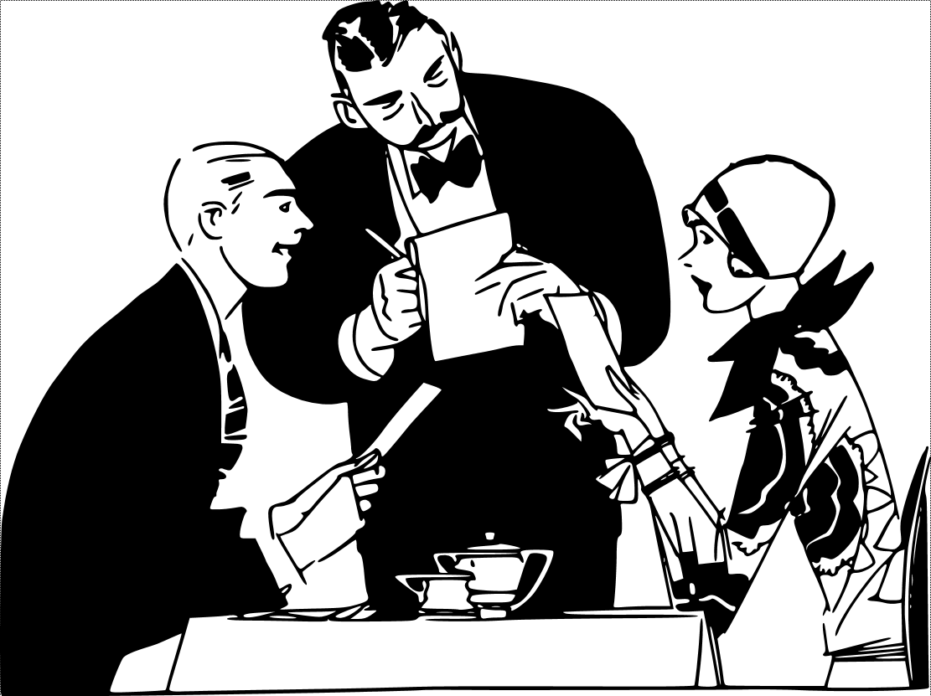

My Example of Funny Caption

= Everyday I’m shufflin’
= This story’s about a lonely old man who is dancing in front of many dangerous police.

