□Listening / Speaking □Reading ■Grammar □Writing
Topic: I USED TO BE A CABIN CREW.
Instructor:  Suzy |  |  | Level:  Pre-intermediate | Students:  12 |  | Length:  50 Minutes
Materials:
- White board, markers, board erasers and tapes,
- Hand writing papers for Lead-in,
- A cabin crew picture in uniform,
- Pictures for demonstration,
- Wall charts for grammar explanations,
- Worksheets for pre-activity (6copies)
- A balloon for productive activity.

Aims:
- Improve Ss grammar skills by having students use "Used to and Be used to" in sentences.
- Improve communication skills by having pair work and answering the partner.
- Students will use "Used to and Be used to" by having students working on completing sentences, writing and sharing their experiences using "Used to and Be used to"

Language Skills:
- Speaking: Sharing experiences by using "Used to and Be used to".
- Listening: Listening to other students. Teacher talk. .
- Reading: Reading wall charts and worksheets.
- Writing: Working on worksheets.
Language Systems:
- Phonology: Teacher talk, other Ss talks.
- Function: To enable Ss to use the correct tense.
- Lexis: Vocabulary.
- Grammar: How to clarify differences between Used to and Be used to.
- Discourse: Pair works, responding the teacher.

Assumptions:
- Some students might already know how to use "Used to and Be used to" in sentences.
Anticipated Errors and Solutions:
- Some students may find difficulties on completing sentences in pre-activity.
Solution: Work in pairs so that stronger students can help weaker students.
- Some students may find out difficulties to clarify how to use "Used to and Be used to".
Solution: Wall charts and giving examples will help students easier to understand..
- The post activity may take longer than anticipated.
Solution: Stop the activity when the time is up.

References: - www.naver.com
Lead-In (Presentation)
Materials: - - Hand writing papers for Lead-in, A picture of cabin crew, My picture in airline uniform.

Time | Set Up | Student Activity |  |  | Teacher Talk
3min  2min | Whole  Whole | Ss greet and listen to teacher.  Ss response. |  |  | Short greetings.  Tell T’s stories using "Used to and Be used to".  Elicit from Ss experiences,

Pre-Activity (Presentation)
Materials: - A picture of woman for demonstration, Wall charts for grammar explanations.
Time | Set Up | Student Activity | Teacher Talk
6min | Whole | Ss listen and answer. | Eliciting  “Can you guess who is in the picture?”  “What are differences between in the past and now?”  Paste the picture and write a sentence using "Used to” on the board.  Wall chart 1: ask student to read the wall chart  - Show the wall chart and explain the grammar  Used to (do)  1) We use “used to” when you talk about something happened regularly in the past but no longer happens.  2) We also use “used to” for something that was true but is not true anymore.  For example: I used to be thin but now I am fat.  Form  Subject + used to + Verb  In this sentence “to” is the infinitive so verb should be come after.  Ask Ss a question.  “Can you use “used to” to talk about the present?”  Transition:  Let’s compare it with “be used to”  Wall chart 2: ask students to read the wall chart  Be used to something (I am used to…)  It means something is not new or strange for me.  For example:  I am used to getting up early morning for the TESOL classes.  It means it is not new or difficult to get up early morning for the TESOL classes anymore.  Form  Subject + be used to + noun  In this sentence “to” is a preposition so a noun or gerund should be come after.

Main Activity (Practice)
Materials: - Worksheets for pair work (6copies)

Time | Set Up | Student Activity | Teacher Talk
3min  3min | Whole  Ss | Ss complete the sentence.  Ss answer. | Worksheet: complete sentences  “I want you to work with the person next to you”.  “Please complete the sentence with ‘used to’ or ‘be used to’.”  “I will give you 3 minutes.”  Check answers  - Ask students to answer in a variance order  Correct errors if necessary.

Post Activity (Production)
Materials: - A balloon. (Time bomb)

Time | Set Up | Student Activity | Teacher Talk
1min  3min  1min | Whole  Ss  Whole | Ss make a sentence using with ‘used to’ or ‘be used to’.  Ss do activity  Ss listen. | T gives instruction.  “Please make your own sentence using used to be or be used to.” “First, speak your sentence and then pass the balloon to the next person so that we can share the entire classmate what they used to be in the past.”  Close by giving Ss feedback about their accomplishment and improvement.  T dismisses Ss.  Thank you for your great work today!

<Work sheet 1>

Complete The Sentence with ‘Used to’ or ‘Be used to’ in 3min.

- Jay __________ washing her socks.
- Alex __________cleaning the house.
- Suzy __________ be a very kind person.
- Patrick __________ love Alex.
- Suzy __________cry every day because Patrick loves Alex.
- Jessica __________ work at a company which is famous for jeans.
- Cindy __________ driving a car so no more car accidents.
- Yong Woo __________ play the game ‘Cookie Run’ with Patrick.
- Sunny __________ live in Seoul but she lives in Je-Ju Island now.

- Elly __________ cook all the time but she loves to eat out now.

- Ah Young said, she __________ getting up early but we don’t think so.

- Bo Ra __________ play a piano after dinner.
- Stella __________ commuting from In-Cheon.

- Patrick__________ have lunch alone at the computer station.
- Stella __________ walking with her lovely puppies.
- Jay __________ working with Chinese.
- Ah Young __________ drinking alcohol alone.
- Patrick __________ staying in the prison.
- Frank __________ live in Argentina.

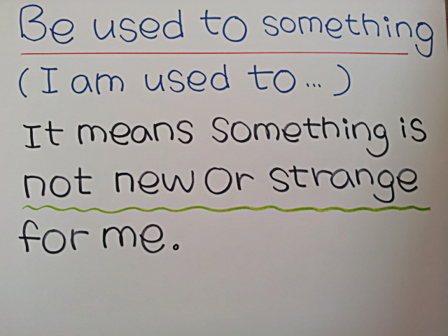
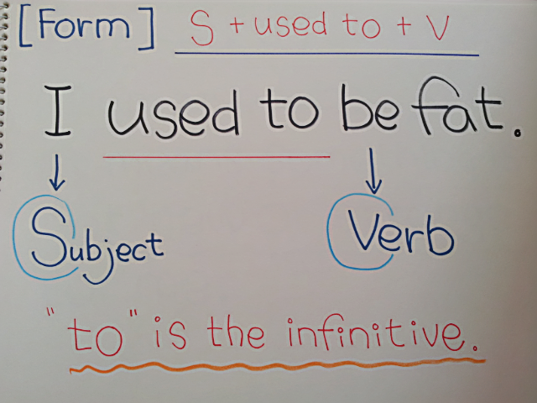
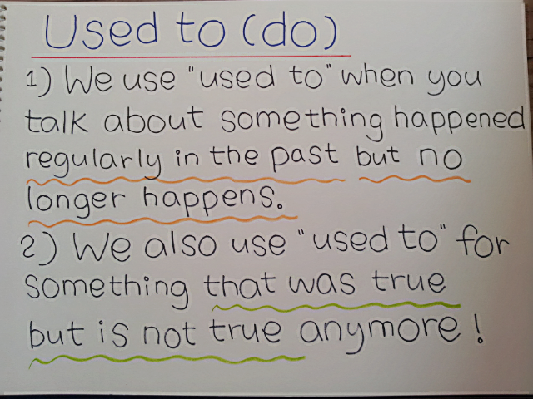
<Wall Chart 1-1> <Wall Chart1-2>
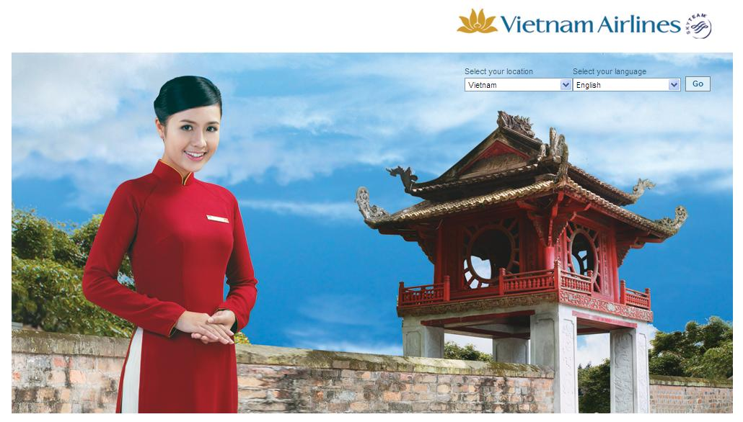
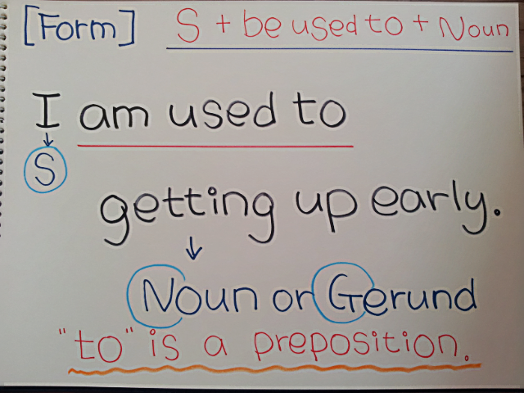
<Wall Chart 2-1> <Wall Chart 2-2>
<A picture of woman> <A picture of cabin crew>

