SB: 93
Grammar Lesson Plan

Modals (Must/Have to/Should)

Length:
50 minutes
es
Students:
5
Level:
Upper Intermediate
Instructor:
YOUNG

Materials:
-Pictures and worksheet of regret of modals
-Rules & recommendation worksheet
- Pictures of warning sign & symbol

Aims:
- Primary aim: to learn modal forms ‘Must’, ’should’ and ‘Have to’ by making rules & recommendation and by interviewing with partners.
- Secondary aim: to understand structure of modal forms in positive and negative forms. to become confident in writing and speaking modals.
- Personal aim: to be confident in teaching the lesson, to give clear instruction, to maximize student – student interaction in class, to be better at time management.

Language Skills:

- Speaking: students will share ideas and opinions to class on activities.
- Reading: students will read text from work sheet on activities.
- Listening: students will listen to teacher’s instruction, speakers and partners.
- Writing: students will write positive and negative sentences using modals.

Language Systems:

- Grammar: to learn structure of modals forms ‘Must’ and ‘Have to’
- Lexis: to make use of different vocabularies on post activity.
- Phonology: pronouncing new vocabulary
- Function: to make sentences using modals
- Discourse: discussion on activities and writing rules & recommendations

Assumptions:

- Students are able to understand different meaning between ‘must’ and ‘have to’
- Students are able to understand common rules apply to modal verbs and make use of modal forms in various situations.

Anticipated Problems and Solutions:

If I fail to time management.
If time is short, skip the presentation part of post activity
If time is left, give students sometime to work on the SOS activity.

References:
- Grammar Practice Activities Paperback with CD-ROM
- : A Practical Guide for TeachersPenny Ur | Cambridge University Press

Lead-In
Materials: N/A
Time  3min | Set Up  Whole Class | Procedure:  Greeting students  Ask 2guiding questions  -Have you ever heard of bucket lists?  -What do you think we must do in our 20’s or 30’s?

Pre-Activity
Materials: N/A, maker&board
Time  10 min | Set Up  Group | Procedure:  Make a list of 5 things ‘have to’ and ‘must do.  -Demonstration  I must take medication.  I must not drink alcohol.  I should prepare a lunch box.  I should not drink coffee.  -Explain different level of obligation between ‘must/must not’ and ‘should/should not’.  Instruction  -Make student work in a pair.  -Give students 5minutes to talk about daily routines and make a list of 5things that they have to do/must do everyday.  ICQ  -Are you working alone?  -What do you have to do?  -For how long?  Monitor discreetly.  Answer students if they ask questions.  Time monitoring.  -After 5minute, make all students present what their partners have to do/must do everyday to whole class.  CCQ  -What is difference between ‘have to’&‘must’?  -Which modal is more related to obligation?  -Which modal is more related to daily routine?
Main Activity
Materials: Rules & recommendation worksheet
Time  10 min | Set Up  Whole Class  Group  Whole Class | Procedure:  Rules & recommendation  Instruction  -Ask each student to think of any rules and recommendations which they think a new teacher should know and write down them on the board.  -Rules should be phrased with ‘must’ or ‘have to’/ ‘must not’, recommendations with should/shouldn’t.  -Give them examples  Ex) You must come to lessons on time.  You shouldn’t give very much homework.  Make each team to write down 5 rules and recommendations for occupation, place or situation  (the reading room of a library, a nature reserve, museum, a train or bus)  ICQ  -How long do you have?  -What are you going to do?  Hand out worksheet.  Monitor discreetly.  Answer students if they ask questions.  Give time warning: 30 seconds left.  Make each student presents ideas to class.  Feedback  -What rules do we must follow at library?  -What recommendations are there on subway?  -Drilling  Make student practice positive/negative and question sentences using modals based on substitution table.  I must/should/have to study everyday.  He/she must should/have to work out everyday.  I must/should not work out everyday.  I don’t have to work out everyday.  Should I study everyday?  Do I have to study everyday?  -CCQ  What should be followed after modals?  How can make question sentence using ‘must’?

Post-Activity
Materials:picture, worksheet
Time  10 min | Set Up  Whole Class | Procedure:  Modals of Regret  -Eliciting topic by picture  -What is he doing in this picture?  -Does he look happy?  -When you did something wrong or made mistake how you feel?  -Explain grammar using substitution table.  We can make sentence to express ‘regret’ using ‘should’.  I should have (present/simple past/past particple)  I should have (study/studied/studied).  I shouldn’t have (go/went/gone).  I should have (write/wrote/written).  -CCQ  Do you regret about something will happen in the future?  After ‘should have’, which tense is appropriate?  -Instruction  Now, we are going to talk about our mistakes and regrets.  This is an team work.  Each of you have 5minutes.  You have to find out 2 mistakes your partner did in life and  Make sentences to express feeling of regret with phrases with  -I should have p.p  -I shouldn’t havep.p  -I really should have p.p  After 5minutes, each of you will present about your partner’story to whole class.
Feedback
Materials: n/a
Time  3 min | Set Up  Whole Class | Procedure:  -What did we talk about today?  -Can you make positive/negative/question sentences using modals?
SOS
Materials:Pictures of warning sign & symbol
Time  5~10 min | Set Up  Whole Class  Group | Procedure:  Design modal symbols  Elicit topic  -Present pictures and make students guess what each photo means, using can, can’t, must, have to or must not.  Instruction  -Make students in a pair.  -You have 5minutes  -These are meaning of symbols.  -You have to design symbols for each interpretation.  (meaning of symbols)  -No body language allowed!  -No casual ware allowed!  -No PDA(public display of affection) allowed!!  -No flattering allowed!  ICQ  -How long do you have?  -What should you have to do?  Monitor discreetly.  Give time warning: 30 seconds left.  Each team presents their symbols to class.  CCQ  -(pick up one of each team’s symbol) What does this symbol mean?

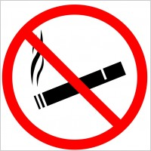

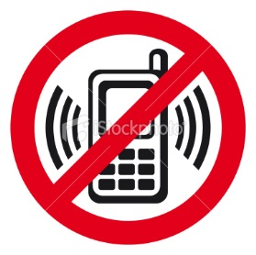

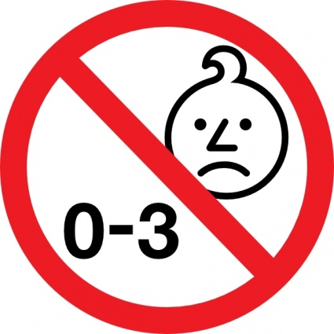

Rules (Must/must not)
-you must seat in your assigned seat.
-you must not record performance.
-you must turn off your cell phone.
Recommendation (Should/should not)
-you should not wear casual clothes.
-you should not drink beverage.
-you should not leave before end of performance.
Ex)At the theater

1) At the museum
Rules (Must/must not)
-
-
-
Recommendation (Should/should not)
-
-
-

2) At the airplane
Rules (Must/must not)
-
-
-
Recommendation (Should/should not)
-
-
-
Rules (Must/must not)
-you must seat in your assigned seat.
-you must not record performance.
-you must turn off your cell phone.
Recommendation (Should/should not)
-you should not wear casual clothes.
-you should not drink beverage.
-you should not leave before end of performance.
Ex)At the theater

3) At the gym
Rules (Must/must not)
-
-
-
Recommendation (Should/should not)
-
-
-

4) in the forest
Rules (Must/must not)
-
-
-
Recommendation (Should/should not)
-
-
-

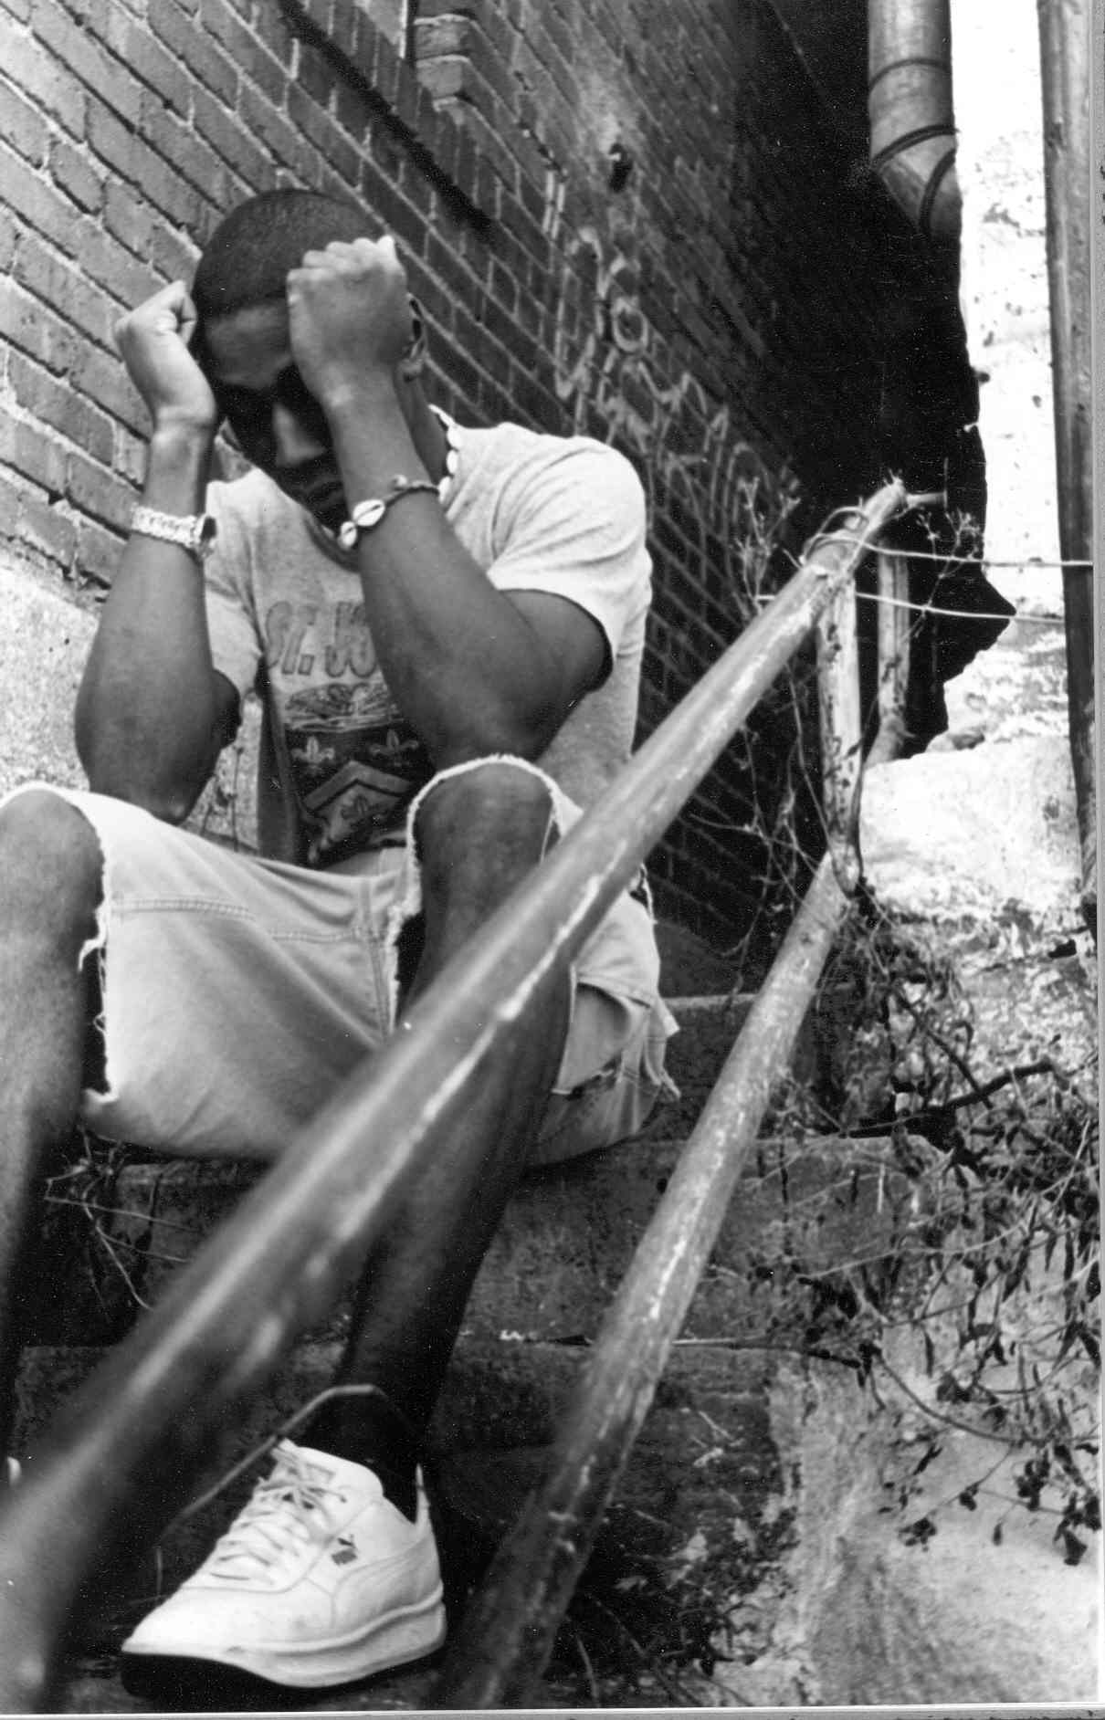

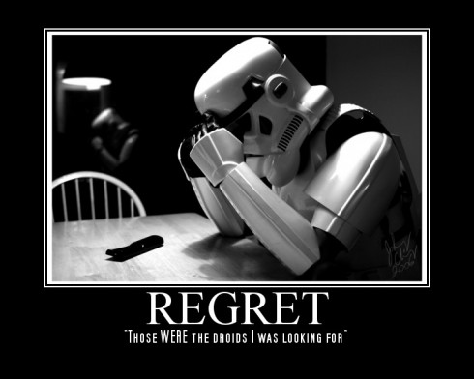 “ I should have done it differently………”

Who do you interview?
-

What are his/her mistakes in life?
-
-

How does he/she feel about it?

1)

-He/she should have _____________________________________________.

-He/she shouldn’t have___________________________________________.

-He/she really should have________________________________________.

2)

-He/she should have _____________________________________________.

-He/she shouldn’t have___________________________________________.

-He/she really should have_____________________________________________.

