Speaking Lesson Plan

A change for the better!

Level:
Upper
Intermediate
Length:
50 minutes
es
Students:
5
Instructor:
Cynthia

Materials:
- picture
- Hidden catch handout
- Word map worksheet
- Sample conversation handout.
- Ask and answer worksheets.
- White board, markers

Aims:
- Primary aim : To enable students to improve their speaking skills by practicing
Something happen changed.
- Second aim : Students will make the sentence by using the word map and
sample conversation handout
- Personal aim : Students will think their goals by speaking , listening and
writing.

Language Skills:
- Reading: Students will read handout.
- Listening: Teacher’s explanation, group activities.
- Speaking: Students have their presentation using their learned.
- Writing: Students will write that they have changed.

Language Systems:
- Lexis : new vocabulary
- Function:.Discussion
- Grammar : the present perfect (I’ve changed my hairstyle.)
- Discourse : listening and speaking.
- Phonology: None of discuss.

Assumptions:

Students already know:
- Students all understand past, present, future tense.
- Students know the comparative.(My hair is shorter now.)

Anticipated Errors and Solutions:

- Students need more time the worksheet.
If so, I will give more time.

- Students may finish their tasks earlier than anticipated.
If so, I will do the SOS activity.

References:
- Interchange book –cambridge public

Lead-In
Materials:
Time  5 min | Set Up  Whole Class | Procedure:  Greetings  Hello, everyone. How are you?  I really like to play the hidden catch.  Have you ever played the game?  Now, let’s play it together. There are five difference.  I’ll give you 1 minute.  If you find all of things within the time, you can say I’m done. Then I’ll give you points. If you get many points and you win.  ICQ  What are you going to do?  How much time do you have?  Are you ready? Go~~!!!

Pre-Activity
Materials: video
Time  3min.  7min  3min.  1min. | Set Up  Whole Class | Two guiding Question.  --“Do you notice that this class change something?”  - “What is one change the burgerKing next to?”(KFC)  Procedure:  1.Eliciting  Let’s look at the picture. How has she changed?  Make the story. You are going to work in group. I’ll give you 7 minutes and you have a presentation.  ICQ  -What are you going to do?  -Are you working alone?  -How much time do you have?  -After the time, what are you going to have?  Give time warning; 3minutes left, 2 minutes left, 1minute left, 30 seconds left.  Time’s up.  (Students have a presentation)  OK, Today, we are going to think and talk  ‘A change for the better!’  CCQ  -Is it more good?  -Does it mean worse?  -Can you think in the future?
Main Activity
Materials: Board, right and wrong grammar sentence card, worksheet
Time  5min.  3min.  5min.  3min. | Set Up  individually  whole class  Group  Whole class | Procedure:  - Changes  After take a handout, complete the word map with phrases form the list. Then add two more examples to each category. I’ll give you 5 minutes and then tell your class about a change in each category with sentence.  ICQ  -What are you going to do?  -How much time do you have?  -Are you working in group?.  Give time warning; 3minutes left, 2 minutes left, 1minute left, 30 seconds left.  Time’s up  You guys, come up to the front and give your presentation.  <Feedback>  -How has A changed?  -How about B?  (Check the changed together)  2.Conversation.  This time, you’ll make the conversation about your changed with your partner. Here is sample. You can refer to the sample conversation.  You have 5 minutes to make conversation.  ICQ  -How much time do you have?  -What are you going to do?  -Are you working alone?  Now, you come up to front, speak to the class about group conversation  ICQ  -What are you going to do?  -Are you working alone?  (Students conversation with each group front of the class.)

Post-Activity
Materials: n/a
Time  5min.  3min.  5min.  1min. | Set Up  Whole class  Whole class | Procedure:  I. planning your future  I’ll give you a handout.  What are your plans for the future? Go anywhere, and meet anybody and ask it. If you answer that question, and sit your seat.  I’ll give you 5 minutes.  ICQ  -What are you going to do?  -How much time do you have?  -Are you working alone?  <Feedback>  -A, Could you tell the class whose answered one of questions?  -B, Who wants to get a new job in a few years?  .  *S.O.S activity  Now, we’re going to speak your goals?  What are your personal goals? What steps will you take to achieve them? After 5 minutes, you have presentation front of the class. Tell the class about your goal..  ICQ  -What are you going to do?  -How much time do you have?  -Are you working in group?  Give time warning; 1minute left, 30 seconds left  (Ss give presentation)  (Feedback)  -What is A goal?  -Do you remember what B goal?  .  .  Everyone, Goo job!!  Today, What did we learn?  Did you enjoy the lesson?  See you tomorrow.  (Teacher gives students homework.)

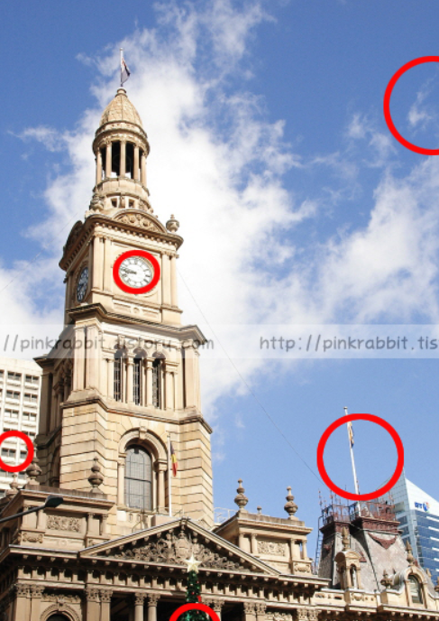
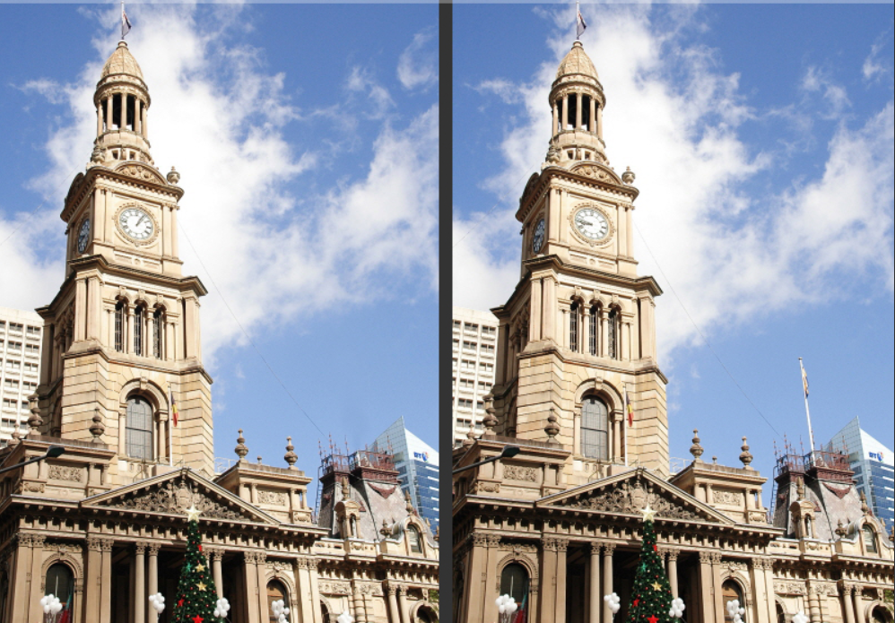
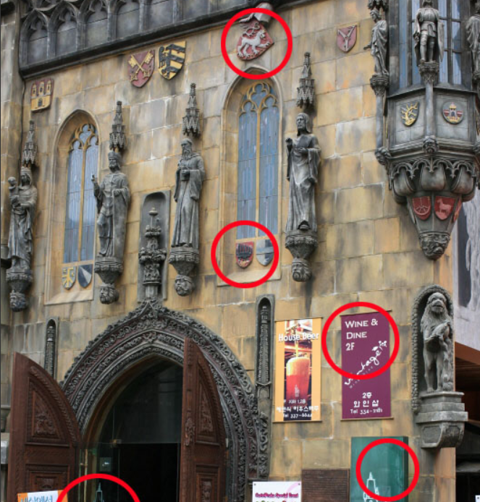
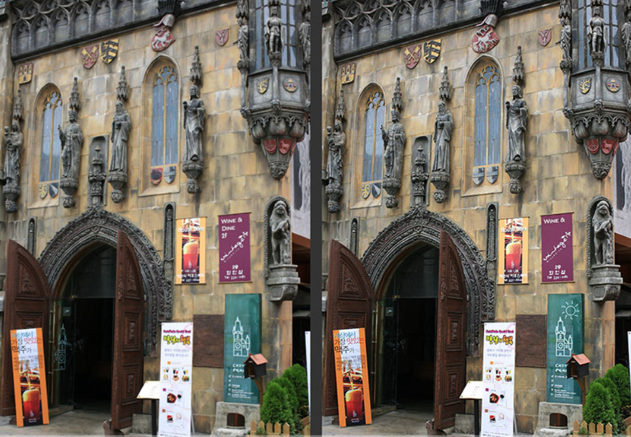
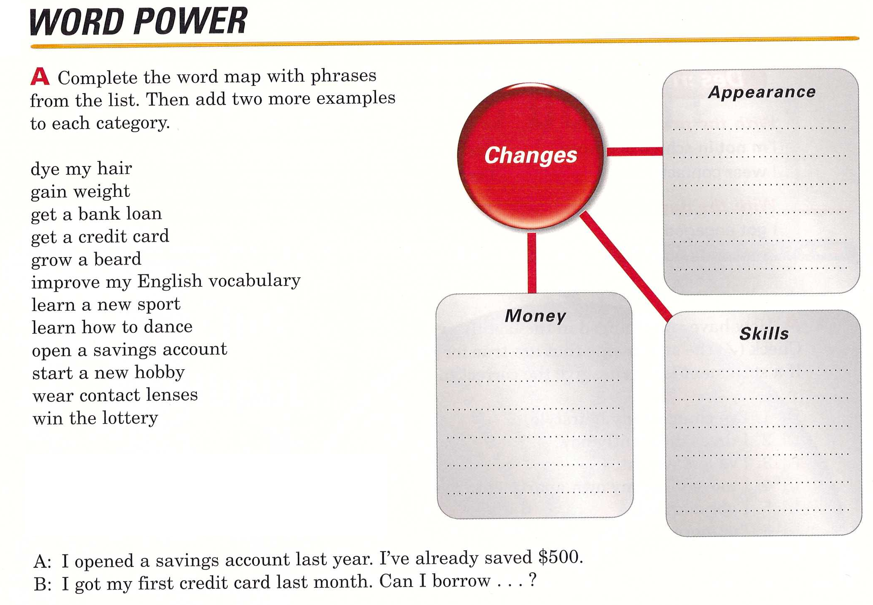

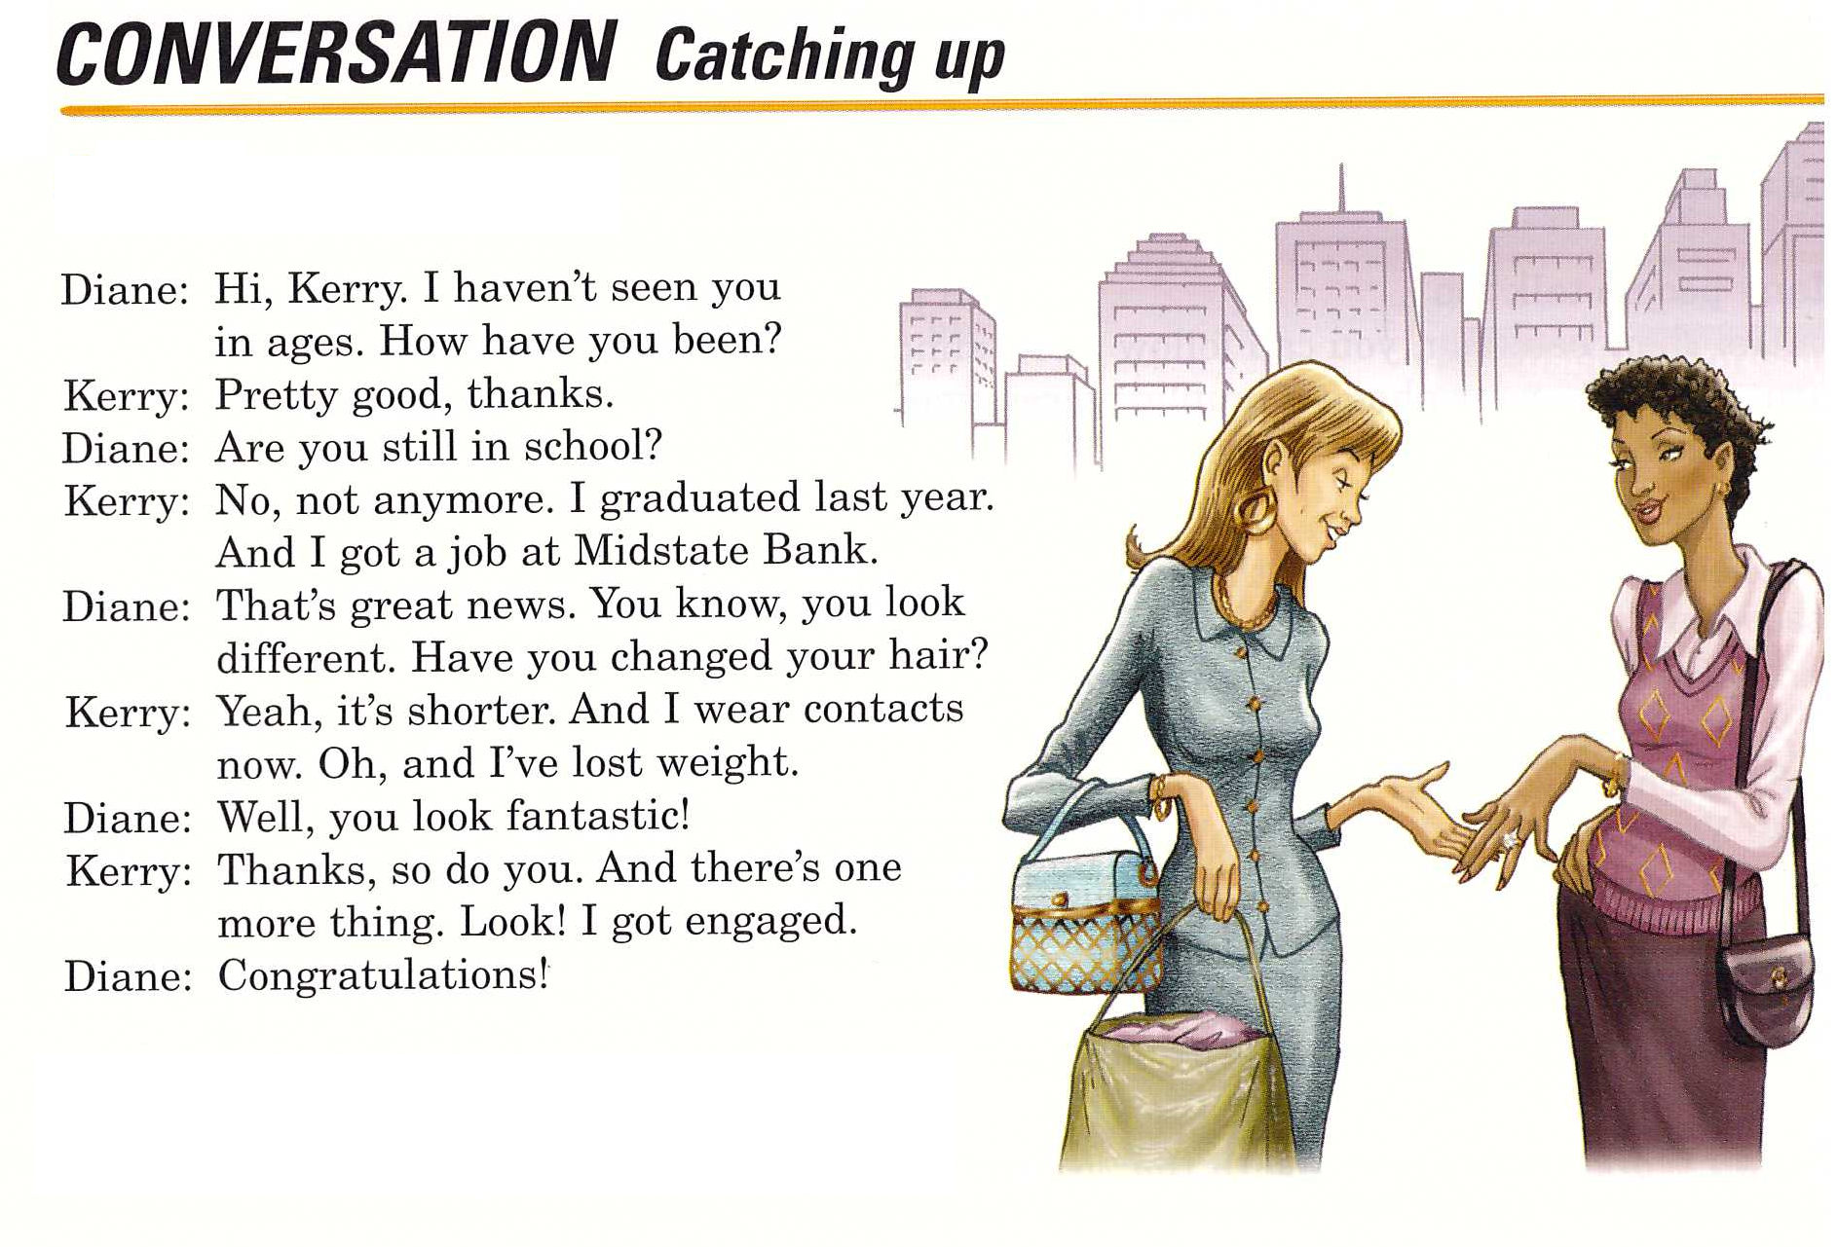

Mate the Conversation.

A :

B :

A :

B :

A :

B :

A :

B :

A :

Ask and answer worksheets
1. What are you going to do after this English course is over?
2. Do you plan to study here again next year?
3. What other languages would you like to learn?
4. What countries would you like to visit ? Why?
5.What kind of future do you hope to have?

S.O.S activity
What is your goal?

