Listening Speaking Reading Grammar Writing
Michelle & Soyoung _89th WD (10-07-2013)

Topic: Unexpected Fortune Stories

Instructor:  Michelle & Soyoung | Level:  Intermediate | Students:  14 | Length:  30 Minutes

Materials:
- Vocabulary Wall Chart
- Vocabulary Worksheet (7 copies)
- Answer Vocabulary Worksheet (7 copies)
- 3 Picture-sets (Story Ordering, 3 copies)
- 3 Answer Pictures (Story Ordering)
- 3 Pictures (Real Photos)
- Story Worksheet (14 copies)
- Speed Quiz File (PowerPoint), Bell, Gift
- White board, Board markers & Tape

Aims:
- Main Aim: Students can improve reading skills by reading stories and understanding contents.
- Secondary Aim: Students can learn vocabulary by matching idiom worksheet.
- Personal Aim: We want to improve our modeling and reduce commentary to a minimum.

Language Skills:
- Reading : Students will understand the contents and catch details by reading the stories.
- Listening : Students will listen to others ‘opinions.
- Speaking : Students will speak their opinions about the stories and answer questions.
- Writing : Students will write vocabulary in their worksheet.

Language Systems:
- Phonology : None to discuss
- Lexis : New vocabulary related to unexpected fortune: windfall, dump, skyscraper
- Function : Use of proper words related to fortune
- Grammar : None to discuss
- Discourse : Expressing opinions about the stories

Assumptions:
Students already know:
- All students are adults. ( over 20 years old )
- How the class is set up and run.
- The teacher’s style of teaching and the pace of the course.
- All students have background knowledge related to expected fortune.

Anticipated Problems and Solutions:
- Students may not be able to follow how to run the class.
→ Show the demonstration and explain accurately.

- Students may need more time to work on activities.
→ Give some hints about activities or give 1 more minute.

- Students may run out of time to finish their main activity.
→ Make post –activity shorter and do time management discreetly.

- If students finish their tasks earlier than anticipated,
→ Give students extra questions or make post-activity longer or do SOS-activity.

References:

- Scrivener, Jim. Learning Teaching. Macmillan, 2011.
- Heyer, Sandra. Easy True Stories. Longman, 1994.

Lead-In
Materials: None
Time | Set Up | Student Activity | Procedure
1 min | Whole class | Answer the teacher’s questions | Hello, everyone! How are you today?  - , have you ever bought a lottery ticket?  - Is there anyone who won the lottery? Did you expect to win the lottery?

Pre- Activity
- Total : 8 min / Learning New Vocabulary
Materials: Vocabulary Wall Chart
Vocabulary Worksheet (7 copies)
Answer Vocabulary Worksheet (7 copies)
White board, Board markers & Tape
Time |  | Set Up | Student Activity |  | Procedure
2 min  2 min  4 min |  | Whole Class  Whole Class  pairs  Whole Class | Answer the elicited questions  Answer the CCQ  Listen carefully  Students begin to match the answers  Students give the answers |  | Elicit the word, “Unexpected fortune”  (Teacher shows students a picture while walking around in the classroom.)  - Show the picture.  - A , What can you see in this  picture?  What is it falling on man’s head?  Does he expect this situation?  That’s right. Unexpected fortune.  (Write “Unexpected Fortune” on the board and stick picture.)  CCQ  - , if an old millionaire gave you a lot of money and asked you to get married, would you accept it?  - Why would you accept the proposal?  Instruction  We’ll learn vocabularies before reading unexpected fortune stories.  I’ll make pairs. You and you ~ .  This is the Vocabulary worksheet.  You fill in the blanks and match the words in the bottom. You have 2minutes and work in pairs.  (Distribute the Vocabulary worksheet.)  Demonstration  After a wave of people, the theater turns into a __dump _.  ICQ  - Are you working in pairs?  - How much time do you have?  “Now begin.”  Monitoring  Monitor carefully.  Answer students if they ask questions.  - Give time warning : 1 minute  (After 2 minutes)  “Time’s up”  check the answers  “Let’s check answers.  “What is #1? (Check #1~#7)  (Distribute the Answer Sheets)
Main Activity
- Total : 11 min / What is True or False? (Reading Stories)
Materials: 3 Picture-sets (Story Ordering, 3 copies),
3 Answer Pictures (Story Ordering , 3 copies)
3 Pictures (Real Photos), Story Worksheet (14 copies)
Time |  | Set Up | Student Activity |  | Procedure
2 min  5min  1min  3 min |  | Whole Class  Groups  Groups  Whole Class | Listen carefully  Students read and place pictures in order  Students check the answer and guess a false story |  | - What is True or False?  CCQ  - , have you watched TV program ’Surprise’?  - , can you guess which story is true or false?  Instructions  “Here are unbelievable three stories. We’re going to do ‘A True or False Game’. Here are 3stories about unexpected fortune. You have to guess what is false. First, read stories quickly. Second, place the pictures in order. Third, guess which story is false and discuss about the stories. I’ll make three teams and you have to finish working in 5minutes. I’ll hand out a reading sheet and pictures.”  (Distribute a reading sheet and pictures.)  Demonstration  - Skip  ICQ  - What are we doing?  - Are you working in groups?  - How much time do you have?  “Now begin.”  Monitoring  Monitor carefully.  Answer students if they ask questions.  Give time warning: 1 minutes  Be flexible with time. Give students 1 more minute if they need it.  “Time’s up”  Check the Answer and Discussion  “Let’s check the answer.”  “ Team A, please show ordered pictures of the first story.”  Teacher makes each team present ordered pictures of three stories.  (Stick to the answer sheet on the board.)  “Now, guess which story is false.”  Each team speaks their opinion about the stories and argues what is false.  After that, teacher speaks the right answer and shows real photos relate to stories.  “First, ‘Win the Lottery’ is true.  Here is the photo: He is looking for the lottery ticket.”  “Second, ‘The expensive apartment’ is also true. Here is East 60th Street in New York.  It’s unbelievable.”  “Lastly, ‘Marrying a millionaire’ is false!  The real story is the old man died. He left the large amount of money to the woman.”
Post Activity
Total : 10 min / Speed Quiz Game ( About Three Stories)
Materials: Quiz File (PowerPoint), Bell
Time | Set Up |  | Student Activity | Procedure
3 min  1 min  5 min  1 min | Whole Class  Groups  Groups  Whole Class |  | Listen carefully  Students scan the stories quickly  Students guess the answers actively.  Listen carefully | - Speed Quiz  Instruction  “We’re going to do a speed quiz about the three stories.  You stay in your team.”  “ First, read a question.  Second, come forward and ring a bell.  Third, answer quickly and choose the next question number.  Forth, go to the end of the line.  It’s a team play, take turns in your team.”  (Seating Arrangement)  “Move your desks and chairs to the wall.  Come forward and stay on this line.  Bring your story worksheet.”  Demonstration  “Now, Soyoung, John and Soyoun show Demo.”  Teacher show the question board on a screen.  First, they read a question. First, Soyoung rings a bell and speaks the wrong answer. She gets (-) points. Next, John speaks the right answer. He gets (+) points and chooses a number for the next quiz. Press the number, There is a Bomb(-)! How many points did John get?”  “Be careful, there are bombs at several places. Everything is clear?”  - Show a presentation on a computer screen for example.  - Explain how to play discreetly.  “First of all, scan the story worksheet in  1 minute. After that, we start the speed  quiz.”  ICQ  - Are you working in groups?  - How much time do you have for scanning?  “Now begin.”  “Now, start to scan the stories quickly in  1 minute.”  Monitoring  (After 1 minute)  “Time’s up”  “Please, put down the sheet.”  Speed Quiz Game  “Let’s start speed quiz. I will give a present to the winning team”  - Teacher runs the quiz game with a PowerPoint.  - Students guess the answers.  Monitoring  Monitor carefully.  a few minutes later,  “This is the last question. Cheer up!”  “Time’s up”  “Check scores of each team”  Teacher gives a gift to the winning team.  Error correction  millionare -> millionaire  millioniar -> millionaire  - Conclude lesson  “So, we’ve read unexpected fortune stories and understood the contents by guessing game. We had a great time. Good job today. See you tomorrow”
SOS Activity
Total : 4 min / If I were a millionaire…
Materials: Blank Sheet (14 copies), Pen
Time | Set Up |  | Student Activity | Procedure
1 min  2 min  1 min | Whole Class  Individually  Whole Class |  | Listen carefully  Students write their opinion.  Students present their wish. | - If I were a millionaire…  Instruction  If you have a chance that you would strike oil, what do you want to do?  I’ll distribute the worksheet. Please write you own opinion about it.  I’ll give 2 minutes individually.  Demonstration  - If I were a millionaire, I would buy new apartment for my mom. ~  ICQ  - Are you working individually or in groups?  - How much time do you have?  “Now begin.”  Monitoring  Monitor carefully.  - Give time warning :1 min  (After 2 minutes)  “Time’s up”  Presentation  Some students present their wish.  - Conclude lesson
Vocabulary Worksheet

Picture |  | Sentence
 |  | I wish I’d come into a big _____________.
 |  | They really ____________ with that investment.
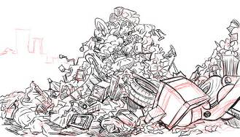 |  | After a wave of people, the theater turns into a ___________.
 |  | The ____________ stood against a background of blue sky.
 |  | The _____________ was caused by the virus.
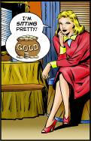 |  | This family is _______________.
 |  | Hey, did you know that there’s a ___________ at the end of a rainbow.
pot of gold windfall sitting pretty dump
skyscraper pneumonia strike oil
Answer Vocabulary Worksheet

Picture |  | Sentence
I wish I’d come into a big _____________.

a sum of money that you receive unexpectedly or by luck, for example if you won a lottery
They really ____________ with that
investment.

make a fortune, a large amount of money
After a wave of people, the theater turns into a ___________.

a storage place for goods or supplies / landfill
The ____________ stood against a background of blue sky.

a very tall building in a city
The _____________ was caused by the virus.

a serious disease which affects your lungs and makes it difficult for you to breathe

This family is _______________.

be rich, successful or in a pleasant situation
Hey, did you know that there’s a ___________ at the end of a rainbow.

the realization of all one’s hopes and dreams
pot of gold windfall sitting pretty dump
skyscraper pneumonia strike oil
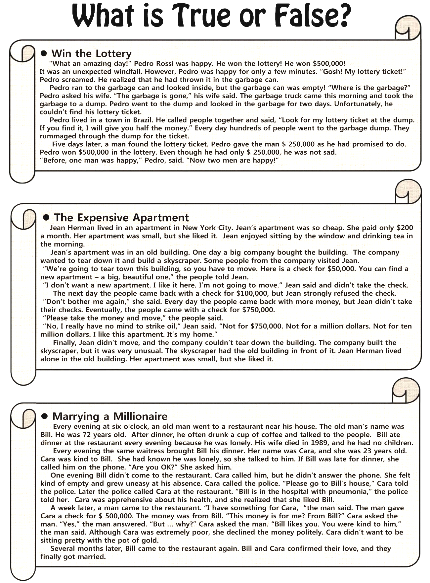
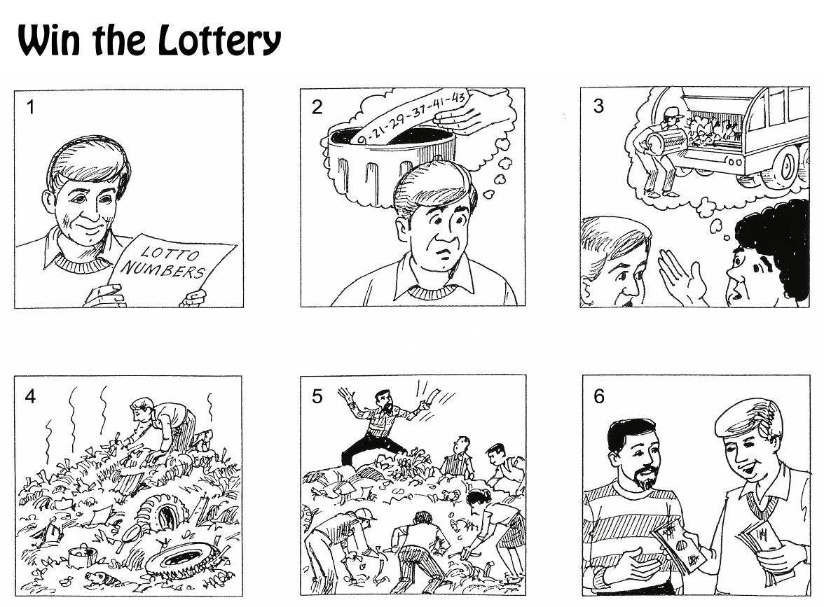

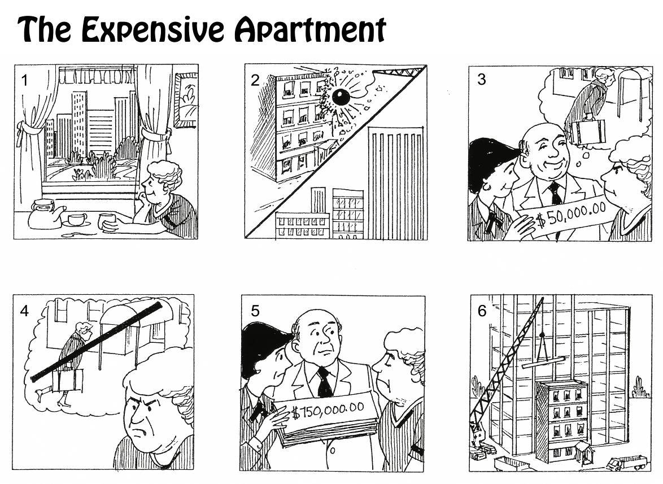
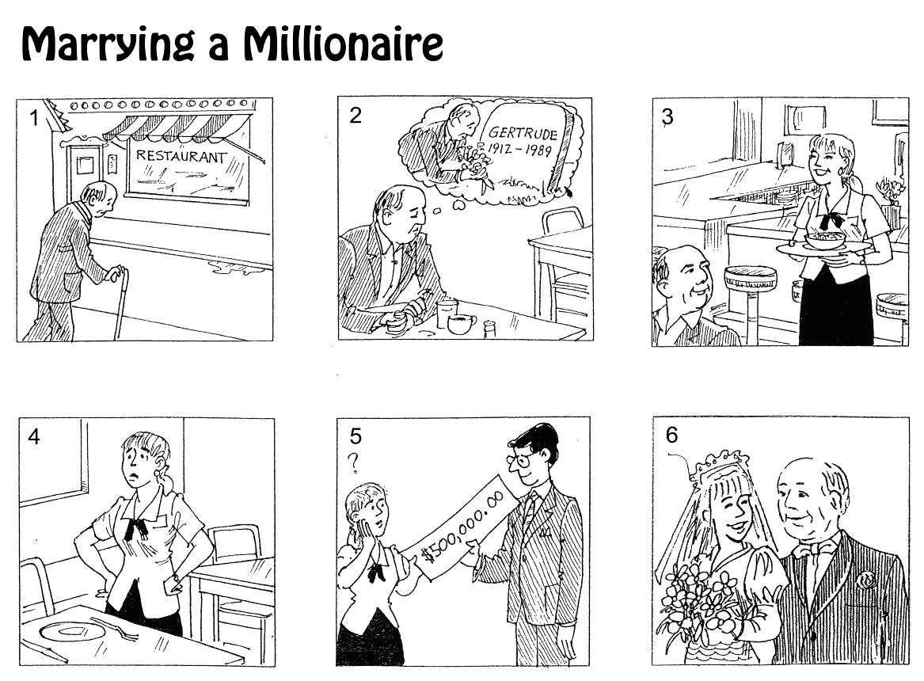

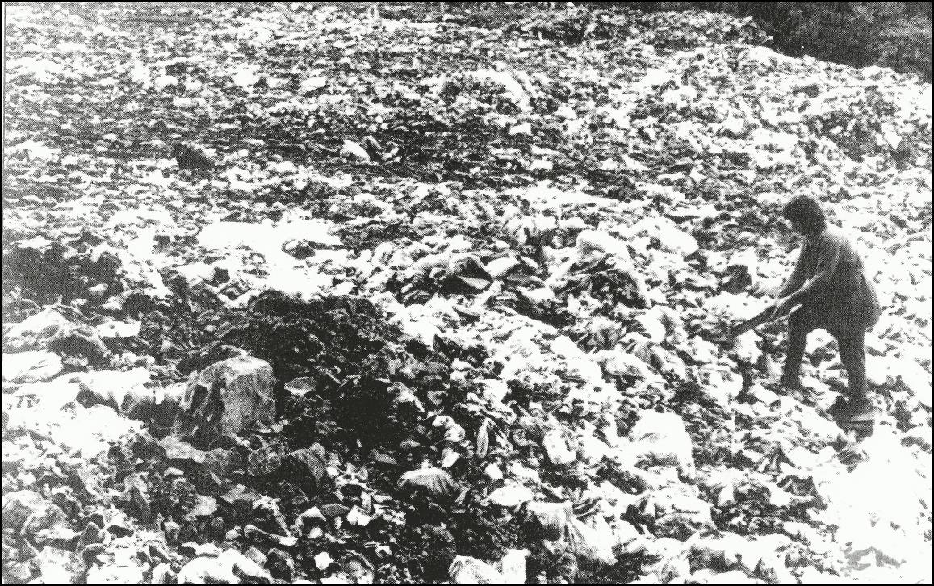
PICTURE 1

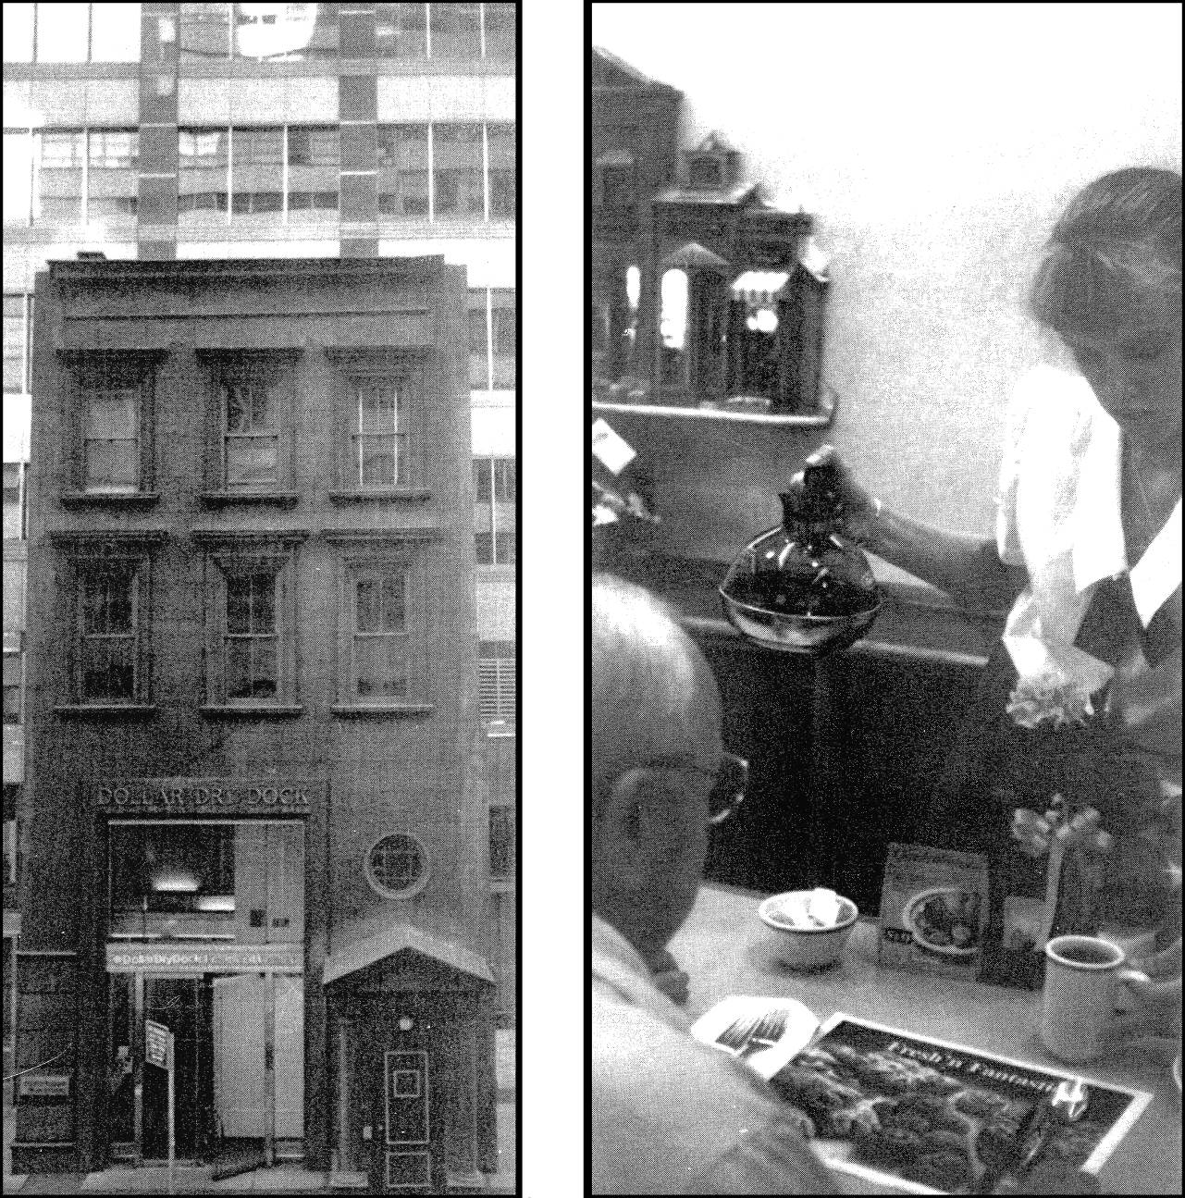
PICTURE 2
PICTURE 3

Speed Quiz Game _ PowerPoint



