X Listening/Speaking Reading Grammar Writing
Topic: Time Travel
Instructor:  WES LEE | Level:  Intermediate | Students:  4 | Length:  55 Minutes
Materials:
- White board and makers
- Movie Poster ‘Back to the Future’.
- ‘Time Travel’ Brainstorming Worksheet
- ‘What do you want to do?’ Worksheet

Aims:
- Improve speaking skills by discussing with partners, sharing ideas in group, having presentation, responding teacher’s question and answering CCQs.
- Practice listening skills by listening to teacher’s introduction, questions and CCQs, listening to other student’s opinions during group discussion, listening to other group’s presentation.
- Practice writing skills by brainstorming and completing the worksheet, and taking notes during communication.
- Improve communication skills by having discussion and sharing ideas with partners.

Language Skills:
- Speaking: small group discussion, presentation, responding to teacher’s question.
- Listening: listening to teacher’s instructions, listening to other students’ opinions during discussion.
- Reading: reading off the board and worksheets.
- Writing: writing sentences in worksheet and taking notes.
Language Systems:
- Phonology: discussion, presentation, teacher talk.
- Function: trip, travel, imagination.
- Lexis: vocabulary.
- Grammar: Tense, proverbs, etc.
- Discourse: group discussion, responding the teacher.
Assumptions:
- All students have opinion about the topic.
- All students probably are excited about imagining something.
- All students will enjoy discussion and sharing their opinions in group.
- All students are cooperative with one another during the group activity.
- All students know how to do brainstorming.
- All students know how to have presentation in front of the other students.

Anticipated Errors and Solutions:
- If students don’t understand instructions. ☞ Solution: teacher rewords or demonstrates.
- If students may not have many ideas. ☞ Solution: teacher approaches with examples.
- If some students are too shy to participate during the group discussion. ☞ Solution: teacher encourages students to participate and give positive feedback.
- If some students don’t give their opinion during the group discussion. ☞ Solution: teacher gives her opinion and leads them to participate in communication.
- If activity takes too long. ☞ Solution: teacher gives them time warning.
- If activity finishes too soon. ☞ Solution: teach makes suggestions and shares ideas.
References:
Finding drama poster from the website - http://www.naver.com and www.google.com

Lead-In
Materials:
- White board and markers.
- Movie poster

Time | Set Up | Student Activity | Teacher Talk
1min  4min  6min | Whole  Whole  Students | Ss greet the teacher.  Ss listen to teacher and look at the Movie poster that teacher has.  Ss talk their experiences and look at the board. | Greeting.  Tell T’s interesting experience of watching movie. Going back to past and altering the main event and changing the present time is somewhat out of reach story.  Elicit the stories from Ss and write the word ‘Time travel’ in the center of the board. What comes to your mind when you think of ‘Time travel’?

Pre-Activity
Materials:
- ‘Time Travel’ Brainstorming Worksheet
- White board and markers.

Time | Set Up | Student Activity | Teacher Talk
2min  1min  1min  7min  3min | Whole  Ss  Group  Group  Whole | Ss look at the worksheet and listen what T says.  Ss respond.  Ss move into group. Ss take the worksheet and look at it.  Ss do brainstorming creative and interesting ideas imagining ‘time travel’ and write them on the worksheet.  Ask questions to T if they have.  All groups tell their ideas. | Show the worksheet and explain how to complete it.  <CCQ>  What will you do?  What is the first thing would like to make change?  Divide Ss into four members. Hand out the worksheets.  Let Ss do brainstorming, discuss and write the ideas on the worksheet.  Monitor Ss how they are doing.  Write down what Ss have in mind on the board.  Everyone goes for time travel!

Main Activity
Materials:
- ‘What do you want to do?’ worksheet

Time | Set Up | Student Activity | Teacher Talk
2min  1min  9 min  2 min  3min  4min  3min | Whole  Ss  Group  Group  Whole  Group  Whole | Ss listen to T’s instruction.  Ss respond.  Ss share their ideas one another and complete the worksheet.  Ask questions to T if they have any.  Ss choose one idea in their group.  Each group has presentation in front of the other students.  Each group makes short story supposing the time travel realized.  Each group has presentation in front of the other students. | T gives instruction.  <CCQ> What will you do? How much time do you have for communication?  Let Ss imagine going time traveling and talk about what they want to do.  Monitor group activity and help Ss if someone has difficulty in communication. Give Ss positive feedback.  Let Ss discuss and choose the most interesting idea in their group.  Let all groups have presentation about the most extraordinary and interesting idea.  Let each group makes the short story following the idea they presented.  If they are realized, what will be changed?  Let all groups have presentation about their story.  Now, it’s time to come back to reality!

Post Activity
Materials:
- White board and markers.

Time | Set Up | Student Activity | Teacher Talk
5min  3min | Ss  Whole | Ss look at the board. Ss talk about what they want to do in the present.  Ss cheer for each other’s work. | Write the words ‘consequence’ and ‘now’ on the board.  Let Ss talk about what they want to do ‘consequence and now’ for a better life.  Close by giving Ss feedback about their activities both good and bad.

Drama Poster
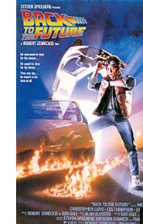

Brainstorming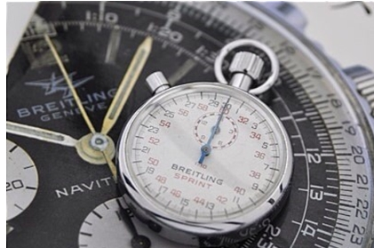
Time Travel

What do you want to do?  Name _____________________ | When | What | Why
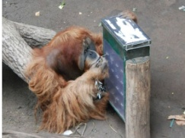
Short Story

