X Listening/Speaking Reading Grammar Writing
Topic: Special Pets
Instructor:  Dina | Level:  Pre-intermediate | Students:  4 | Length:  50 Minutes
Materials:
- White board and makers
- Pets picture.
- ‘Pets’ worksheet for each group
- Role cards - ‘What Do You Think of Pet’s Character?’

Aims:
- Improve speaking skills by discussion in group, sharing ideas in group, having presentation.
- Improve listening skills by listening to T’s introduction, listening to other Ss opinions during group discussion, listening to other group’s presentation.
- Improve writing skills by completing worksheet and taking notes during communication.
- Improve communication skills by having discussion and sharing ideas in group.

Language Skills:
- Speaking: small group discussion, presentation, responding to T’s.
- Listening: listening to T(T talk, instructions, etc.), listening to other Ss’ opinions during discussion.
- Reading: looking at the board and worksheets.
- Writing: writing sentences in worksheet and taking notes.
Language Systems:
- Phonology: role play, presentation, teacher talk.
- Function: introduction, respect.
- Lexis: vocabulary.
- Grammar: N/A
- Discourse: group discussion, role play, responding the teacher.
Assumptions:
- All Ss have opinion about the topic.
- All Ss will enjoy discussion and sharing their opinions in group.
- All Ss cooperative with one another during the role play.

Anticipated Errors and Solutions:
- If Ss don’t understand instructions. ☞ Solution: T shows demonstration.
- If Ss may not have many ideas. ☞ Solution: T gives them some examples.
- If some Ss are too shy to participate during the group discussion.
☞ Solution: T encourages Ss to participate and give positive feedback.
- If some Ss don’t give their opinion during the group discussion.
☞ Solution: T gives her opinion and leads them to participate in communication.
- If activity takes too long. ☞ Solution: T gives them time warning.
- If activity finishes too soon. ☞ Solution: T makes suggestions and shares ideas.

References: none

Lead-In
Materials:
- White board and markers.
- Pets picture.

Time | Set Up | Student Activity | Teacher Talk
1min  4min  5min | Whole  Whole  Ss | Ss greet the teacher.  Ss listen to teacher and look at the Pets picture that teacher has.  Ss talk their experiences and look at the board. | Greeting.  Tell T’s interesting experience of having pet.  Elicit the stories from Ss.

Pre-Activity
Materials:
- ‘Pets’ Worksheet.
- White board and markers.

Time | Set Up | Student Activity | Teacher Talk
2min  1min  6min  3min | Whole  Group  Group  Whole | Ss look at the worksheet and listen what T says.  Ss move into group.  Ss take the worksheet and look at it.  Ss do talk about ‘pet’ and write them on the worksheet.  Each Ss tell their partner’s ideas. | Show the worksheet and explain how to complete it.  Divide Ss into two groups of two members.  Hand out the worksheets.  Let Ss do ask, answer and write the ideas on the worksheet.  Monitor Ss how they are doing.

Main Activity
Materials:
- Role cards - ‘What Do You Think of Animal’s Character?’
Time | Set Up |  | Student Activity |  | Teacher Talk
2min  10min  5min | Whole  Group  Whole |  | Ss listen to T’s instruction.  Ss discuss and make a story with role play card. Complete the story.  Ask questions to T if they have.  Each group has presentation in front of the other students. |  | T gives instruction.  Let Ss imagine animal’s character and make a story.  Monitor group activity and help Ss if someone has difficulty in communication.  Give Ss positive feedback.  Let all groups have presentation about what they made a story.
Post Activity
Materials:
- White board and markers.
Time | Set Up | Student Activity |  | Teacher Talk
10min  1min | Ss  Whole | Ss look at the board.  Ss talk about special pets and their character.  Ss say good bye. |  | Write the words ‘merit’ and ‘demerit’ on the board.  Let Ss talk about what merit and demerit is.  Close by giving Ss feedback about their accomplishment and improvement.

- Pets Pictures
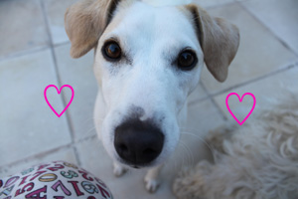

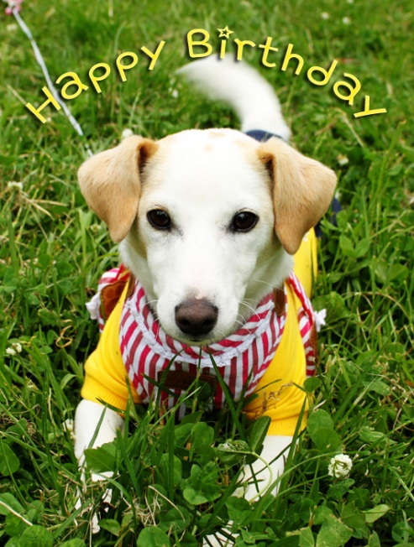

Situation Role Cards (‘What Do You Think of Animal’s Character?)
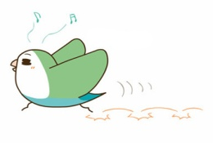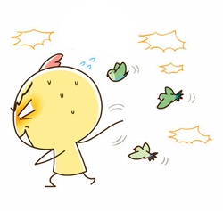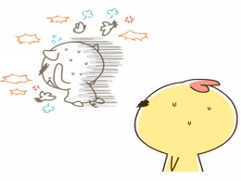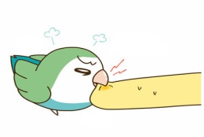
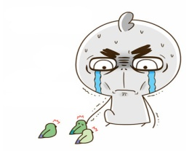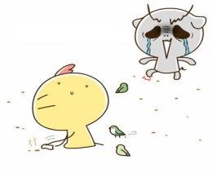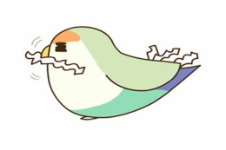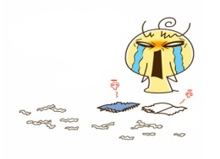
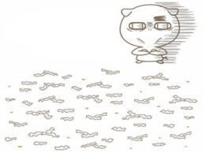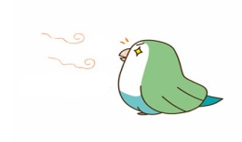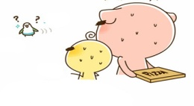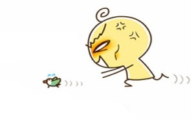
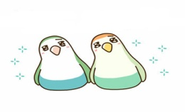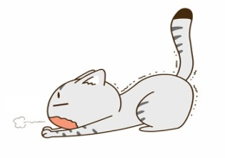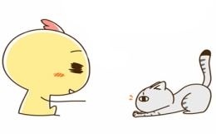
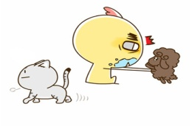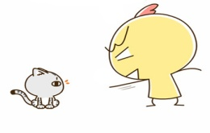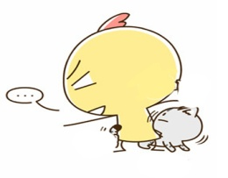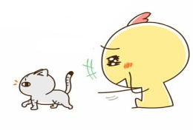
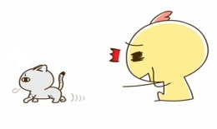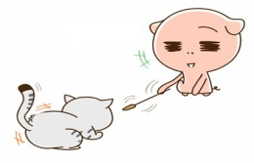
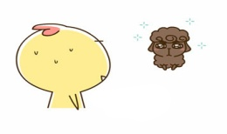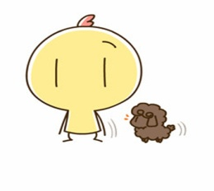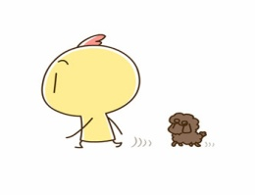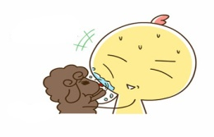
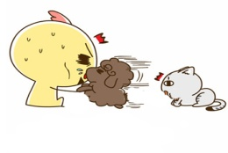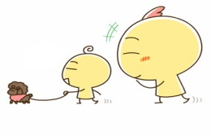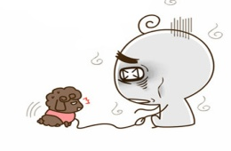
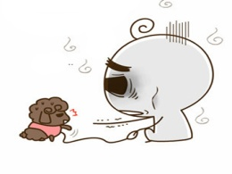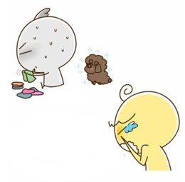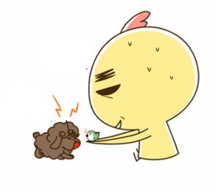

- ‘Pets’ Worksheet

*Ask your partner and write down the answer.

- Have you ever raised any pet?

- If yes, what kind of animal?

- What merits and demerits is there living with pets?

- Do you think is it possible to keep tiger as a pet? Why?

- What do you think of their tendency?

- a cat

- a dog

- a bird

- a snake

- a tiger

- a monkey

- What is the most important while we keep animal as a pet?

