SB: 93
Reading Lesson Plan

Unexpected Fortune

Length:
50 minutes
es
Students:
6
Level:
Upper intermediate

Instructor:
Christine

Materials:
- Vocabulary worksheet
- Answer Vocabulary Worksheet
- 3 pictures (story ordering)
- 3 pictures (real photos)
- Story worksheet
- White board, board markers

Aims:
- Primary aim : to enable students to improve reading skills by reading stories
- Secondary aim : students will learn about unexpected fortune by matching
idiom worksheet
- Personal aim : to make class better, to improve writing skills on board, to make
students participate in class, time management

Language Skills:
- Reading: students will read and understand idioms by reading stories
- Listening: students will listen to others opinions
- Speaking: students will speak their opinions bout the stories and answer
questions
- Writing: students will write vocabulary in their worksheet

Language Systems:
- Lexis : idioms related to unexpected fortune - windfall, dump, skyscraper
- Function: using proper words related to fortune
- Discourse: expressing opinions about stories
- Grammar, Phonology : none to discuss

Assumptions:

Students already know:
- how the class is set up and run (there will be 2 student groups at each table)
- the teacher’s style of teaching and the pace of the course
- most students have background knowledge related to unexpected fortune
- most students know how long the reading lesson takes

Anticipated Problems and Solutions:

- Students may not be able to follow how to run the class
Show the demonstration and explain accurately
- Students may need more time to work on activities
Give some hints about activities or give more minutes
- Students may run out of time to finish their main activity
Make post activity shorter and do time management discreetly
- If students finish their tasks earlier than anticipated,
Give students extra questions or make post activity longer or do SOS activity

References:
- Heyer, Sandra. Easy True Stories. Longman, 1994
- Website : www.google.com, www.onestopenglish.com

Lead-In
Materials: Board
Time  3 min | Set Up  Whole Class | Procedure:  Hello everyone, how are you today?  2 guiding questions  - Have you ever bought a lottery?  - Is there anyone who won the lottery?  Did you expect to win the lottery?  (Elicit the important qualities & write them on the board)  OK, today’s lesson is Unexpeted Fortune. We will read some stories and find out which one is true or false through group discussion. But first, we will guess some idioms and then learn new vocabulary the stories have.

Pre-Activity
Materials: Vocabulary Worksheet, Board, Pictures of unexpected fortune, Markers
Time  2 min  6 min  2 min | Set Up  Whole Class | Procedure:  I. Elicit, Unexpected Fortune  (Teacher shows students a picture while walking around in the classroom)  Show the pictures  What can you see in this picture?  What is it which is behind the man?  Does he expect this situation?  That’s right. Unexpected Fortune.  (Write down on the board and stick pictures)  II. Vocabulary  Instruction  Before we read unexpected stories, we will learn new vocabularies. There are 7 words I want you to guess the meaning.  I’ll make pairs. Work with your partner. Fill in the blanks and match the words in the bottom. You have 3 minutes.  (Distribute the worksheet)  ICQ  Are you working alone?  How much time do you have?  Encourage students share their idea. Answer students if they ask questions. Give time warning: 30 seconds left.  Be flexible with time. Give 1 more minute if they need it.  (Distribute the answer worksheet)  Check answers: let students write the correct vocabularies  - Go through the vocabularies one by one  - Elicit the meaning from students  - Explain the meaning if necessary  CCQ  (new vocabulary - pot of gold)  1. Should we try for the pot of gold if we have a goal?  2. Can you take some risks until one of them brings you the pot of gold?  3. Is pot of gold a magic?
Main Activity
Materials: 3 pictures, 3 real photos, Story Worksheet
Time  5 min  5 min  1 min | Set Up  Whole Class | Procedure:  Have you watched TV program ‘Surprise’ on Sundays?  Do you know ‘True or False’? There is a True or False in that program. Now we will read true or false stories.  Instructions  Here are unbelievable 3 stories. We are going to find out true or false. These 3 stories are about unexpected fortune. First, you have to read stories. Second, place the pictures in order. Third, guess which story is false and discuss about the stories.  I’ll make 2 teams and you have to finish working in 5minutes.  (Distribute a story worksheet and pictures)  ICQ  What are we doing?  Are you working alone?  How much time do you have?  Give time warning : 1 min  Be flexible with time. Give students 1 more minutes if they need it.  Check the answer and discussion  Team A, please show ordered pictures of the first story.  Teacher makes each team present ordered pictures of 3 stories.  (Stick to the answer sheet on the board)  Now, guess which story is false.  Each team speaks their opinion about the stories and say what is false.  (After that, teacher speaks right answer and shows real photos related to stories)  First, ‘Win the lottery’ is true.  Here is the photo. He is looking for the lottery ticket.  Second, ‘The expensive apartment’ is also true.  Here is East 60th street in New York.  Third, ‘Marrying a millionaire’ is false.  The old man finally died. He left the large amount of money to the woman.  Feedback  Team A, What did Pedro do to the man who found Pedro’s lottery?  Team B, What did Jean do when big company visited her house?

Post-Activity
Materials: Computer, Cell phone, Markers, Board, Paper
Time  15 min | Set Up  Whole Class | Procedure:  Instructions  Now I want you to present ‘True or False’. Each team presents 2 true stories and 1 false story. And the other team guesses which story is false.  You can use computer or cell phones if you like. I’ll give you 10 minutes.  ICQ  Are you working alone?  For how long?  Give time warning : 1 min  Be flexible with time. Give students 1 more minutes if they need it.  Each team has presentations.  Feedback  Team B, What did Team A say about true stories and false story?  Team A, What did Team B say about true stories and false story?  Conclude lesson  Feedback  What did we talk about today?  What words did you learn?  What were true stories? What was a false story?

SOS Activity – If I were a millionaire..
Material : Blank sheet, pen
Time  10 min | Set up  Whole class | Procedure  Instruction  If you have a chance that you would strike oil, what do you want to do?  I’ll distribute the worksheet. Please write your own opinion about it. I’ll give 2 minutes individually.  Demonstration  If I were a millionaire, I would buy new apartment for my family. ~  ICQ  - Are you working as a group?  - How much time do you have?  Give time warning: 3 minutes: 1 minutes: 30 seconds  Presentation  Students present their wish.

Vocabulary Worksheet

Picture |  | Sentence
 |  | I wish I’d come into a big _____________.
 |  | They really ____________ with that investment.
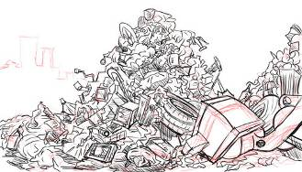 |  | After a wave of people, the theater turns into a ___________.
 |  | The ____________ stood against a background of blue sky.
 |  | The _____________ was caused by the virus.
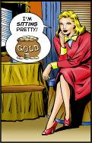 |  | This family is _______________.
 |  | Hey, did you know that there’s a ___________ at the end of a rainbow?
pot of gold windfall sitting pretty dump
skyscraper pneumonia strike oil
Answer Vocabulary Worksheet

Picture |  | Sentence
I wish I’d come into a big windfall.

-a sum of money that you receive unexpectedly or by luck, for example if you won a lottery
They really strike oil with that
investment.

-make a fortune, a large amount of money
After a wave of people, the theater turns into a
dump.

-a storage place for goods or supplies / landfill
The skyscraper stood against a background of blue sky.

-a very tall building in a city
The pneumonias was caused by the virus.

-a serious disease which affects your lungs and makes it difficult for you to breathe

This family is sitting pretty.

-be rich, successful or in a pleasant situation
Hey, did you know that there’s a pot of gold at the end of a rainbow?

-the realization of all one’s hopes and dreams
pot of gold windfall sitting pretty dump
skyscraper pneumonia strike oil
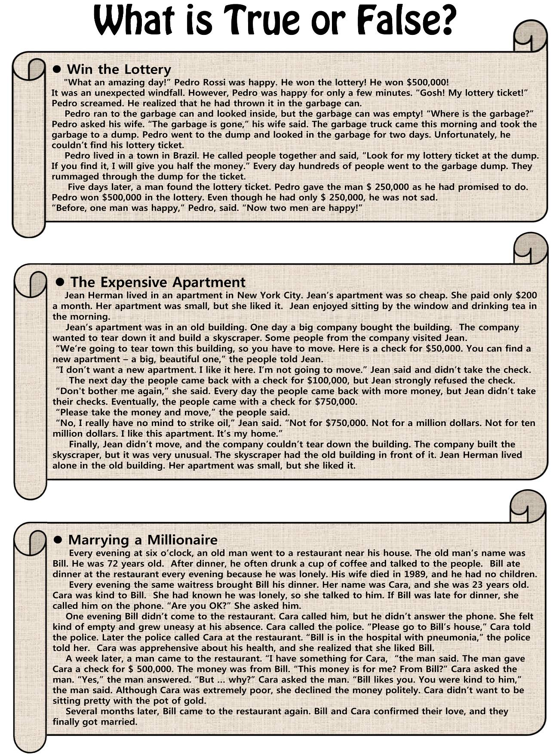
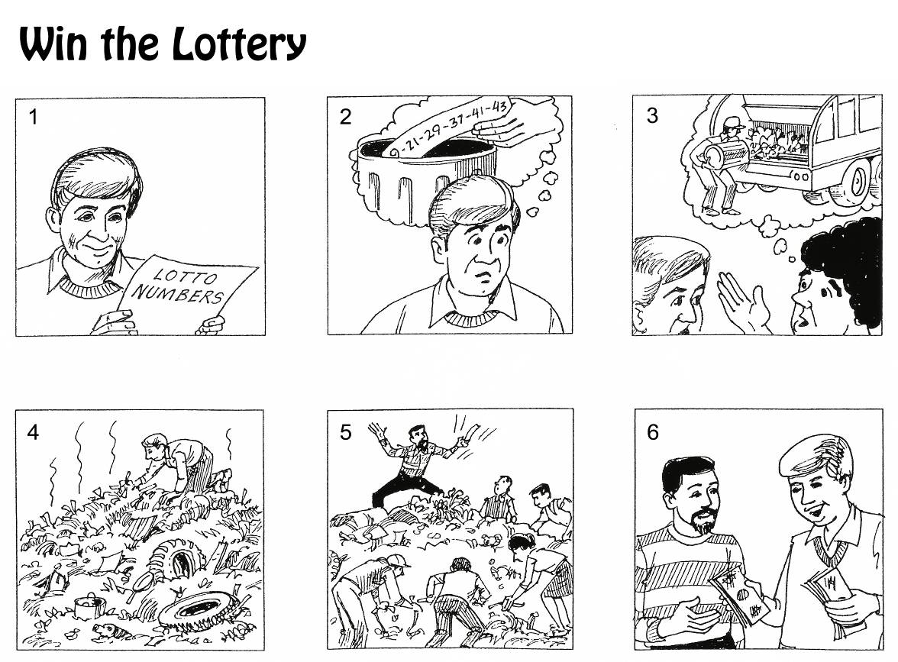

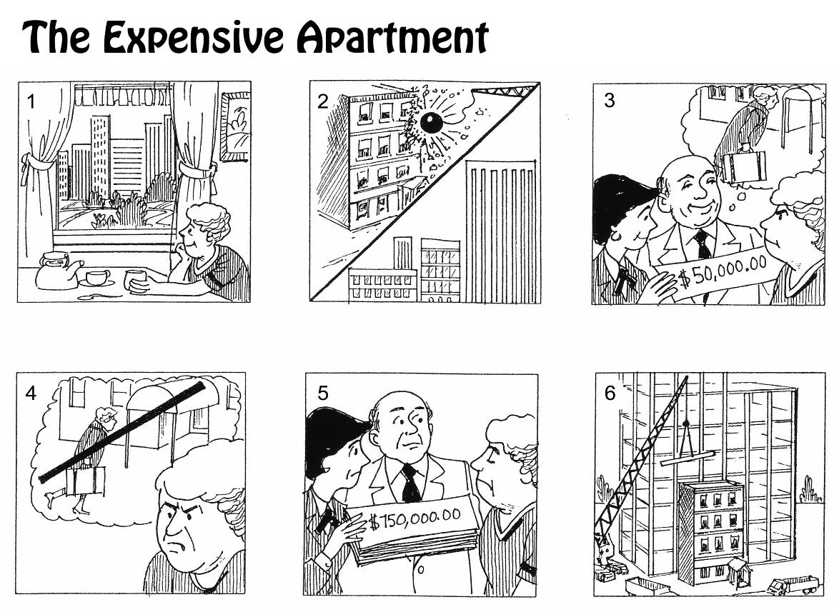
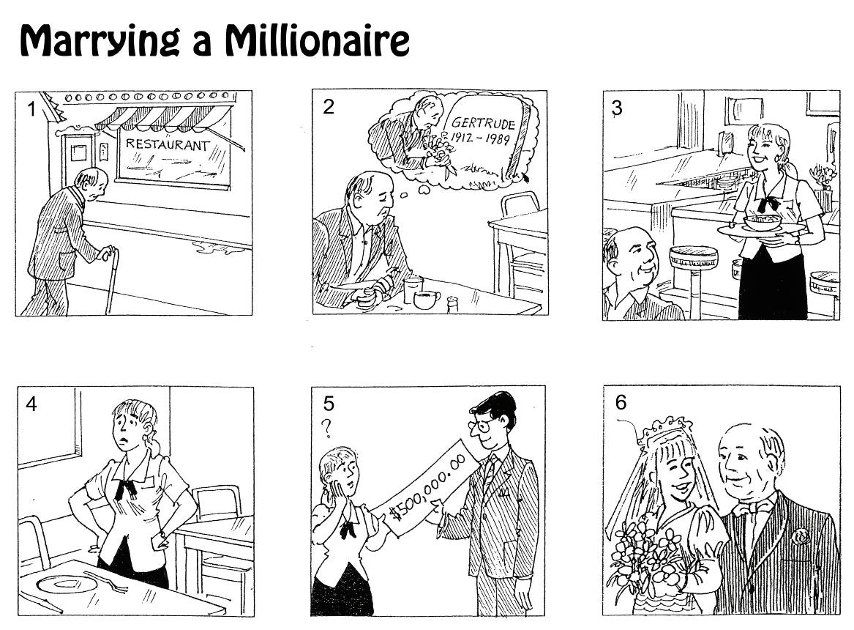

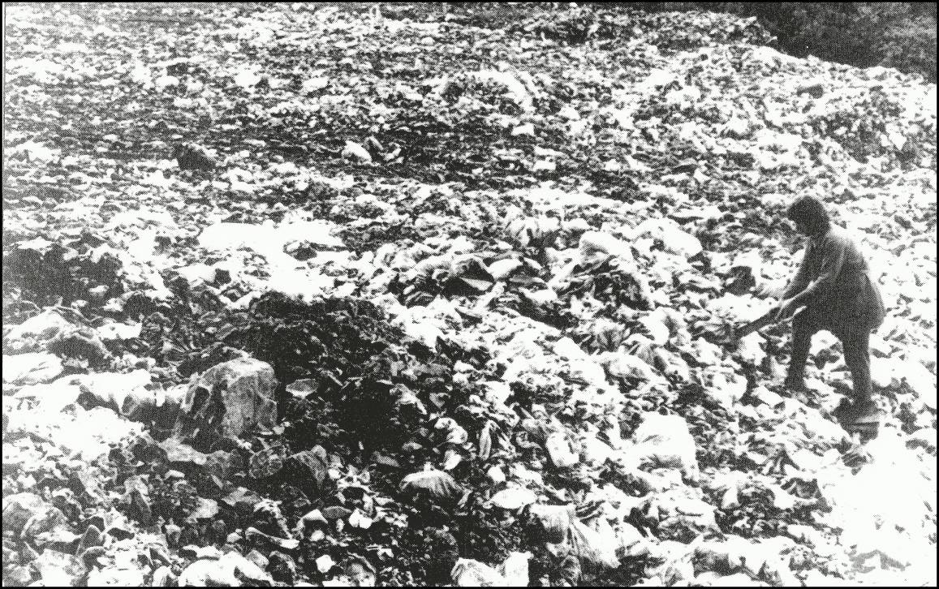
PICTURE 1

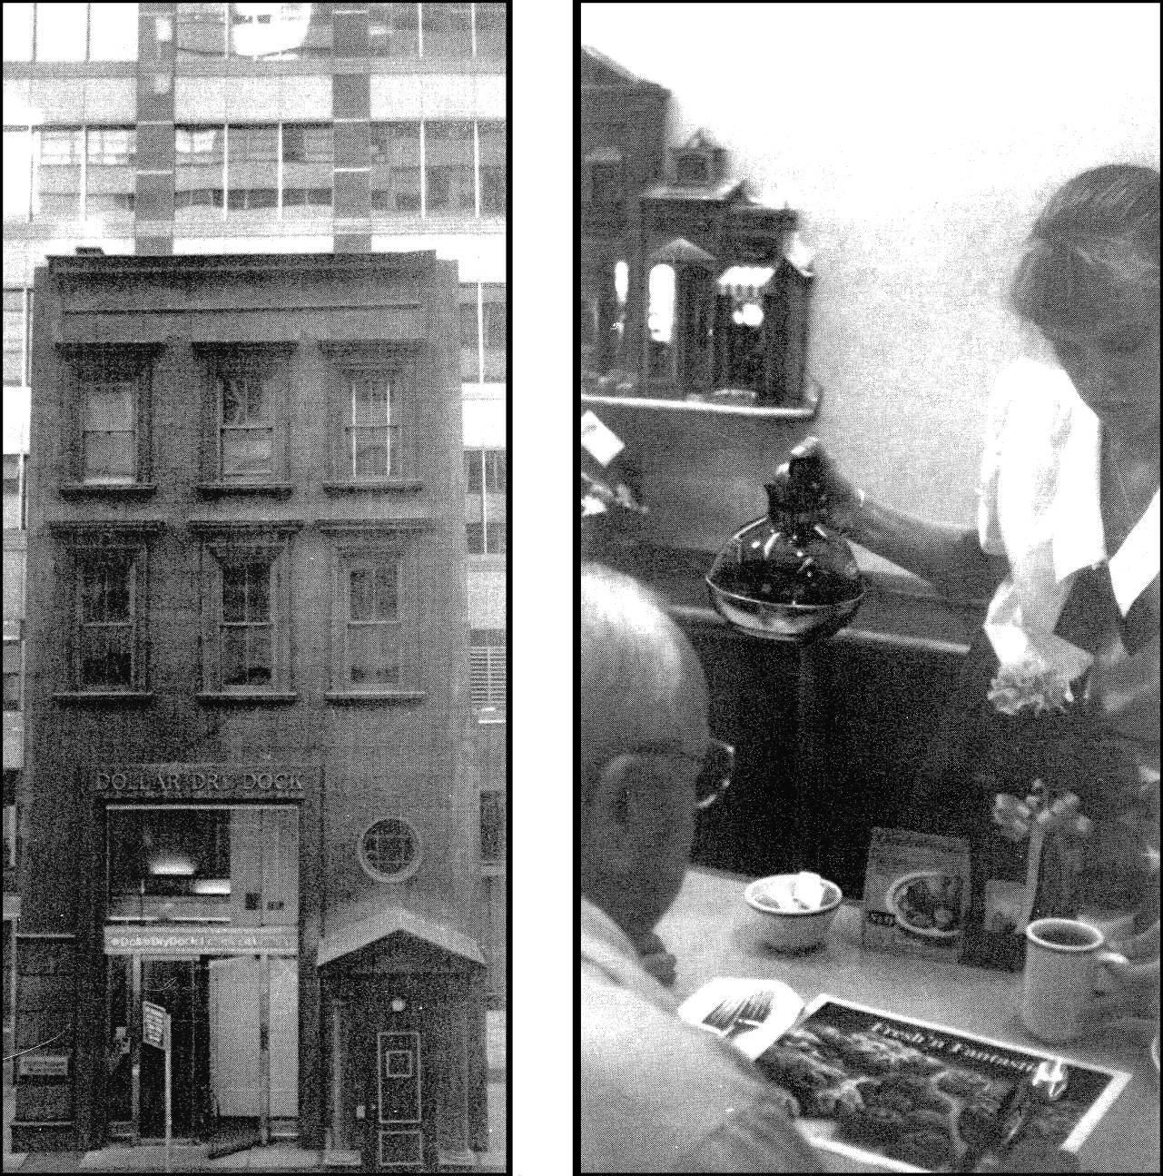
PICTURE 3
PICTURE 2

