Listening Speaking Reading Grammar Writing

Topic: Turning Point

Instructor: Tiffany  (Jang, Eunkyung) | Level: intermediate | Students: 9 | Length:  30 Minutes

Materials:
1 images to elicit the topic (Turning Point)
Cross words worksheets for pre-activity (10 copy)
Cross words answer sheets for pre-activity (10 copy)
Article for main-activity (10 copy)
Wall chart for tic tac toe in main-activity (how to overcome trouble) (10 copy)
Empty sheets for each student for the post activity (10 copy)

Aims:
- -Main aim: Students will improve their reading comprehension skills having Ss talk about on turning points
- - Secondary aim: Students will enlarge their vocabulary by filling the crosswords, answering the questions for tic tac toe and writing a letter inside the recommended book

- Personal aim: I want to improve my speaking accuracy

Language Skills

- Reading: Students will read article on the main activity
- Listening: Students will practicing listening skills by listening other students’ presentation of explain their life graph on the main activity
- Speaking: Students will explain their life graph and share experiences on the main activity
- Writing: Students will write their advice to turning point book

Language Systems:

- Phonology: answering the crossword, students can practice how to say the new vocabulary following the teacher’s pronunciation
- Lexis: Fill the blanks of crosswords related to the main article
- Function: Reading article and catch the main thought
- Grammar: None to discuss
- Discourse: None to discuss

Assumptions:
Students already know:
- How the class is set up and run (there will be 4 student groups at each table)
- All students are mature and college graduates (Age 21 and above)
- The teacher’s style of teaching and the pace of the course
- Most students can understand the article in 3 minutes

Anticipated Errors and Solutions
Problems | Solutions
Students may not understand some key vocabularies on the article  Some students need more time to fill the cross word  Students may not understand tic tac toe game  Whole class is odd number and difficult to make pairs for dialogue  If time is short  If students finish their tasks earlier than anticipated | Using cross word to let students understand new vocabularies before reading an article  Some students need more time to fill the cross word  Show the demonstration  Instead of pair work, make groups  For the post activity , only 1 student have a chance to read the switched solution card  Prepare SOS activity to draw life graph

References:

- http://newsfeed.time.com/2013/07/22/study-23-and-69-are-the-happiest-ages
- http://puzzlemaker.discoveryeducation.com/CrissCrossSetupForm.asp

Lead-In
Materials: not necessary
Time | Set Up | Student Activity | Teacher Talk
1 min | Whole Class | 2 students answer the questions in one after another | - Do you have any personal motto? Why did you choose it?  - Did you have any trouble recently?

Pre-Activity
Materials: visual- picture for eliciting life graph
worksheet 1- cross words activity
Time |  | Set Up |  |  |  | Student Activity |  | Teacher Talk
1min  1 min  4min  2min |  | Whole  Class  Group  Whole class  Group work  Individually |  |  |  | -Students guess from the picture and elicited the time period  concept check question  Answer to the teacher as yes/no  Grouping1  Pre-activity instruction  -Instruction Check Question  activity  Read the answers |  | Eliciting  Visual  Look at this picture. How can you describe this picture?  What is this?  Turning point  CCQ  I want to show you this life graph  In this life graph  - Is turning point means the sign when you drive a car?  -Is turning point the time period you overcome the trouble?  Grouping  123 together/ 456 together/789 together  Instructions  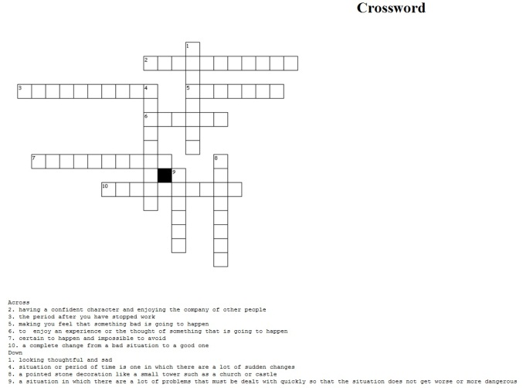  -Now, I will give you this cross words  and please fill the blanks using sample words  I will give you 4 minutes  and please work as a group  ICQ  -What are we going to do?  -How many minutes do we have?  -Are you working individually?  Explicit ICQ-1  -Please do not start until I say begin  -Are you going to start as soon as I give you the paper?  -Are you going to start when I say begin?  -Okay begin!  (2min, 1 min,30 sec! 10 sec! Time’s up!)  Please read across no.1.  What’s the answer?  (Give them answer sheets)
Main Activity
Article for main-activity (10 copy)
Tic tac toe visual
Wall chart for tic tac toe in main-activity (how to overcome trouble)
Empty card for tic tac toe question
Time |  |  | Set Up |  | Student Activity |  |  |  | Teacher Talk
1min  3min  1min  1mn  3min  1min  5min |  |  | Whole class  Individually  Whole class  group |  | Reading Activity  Activity  Read the  Grouping  Activity |  |  |  | Instructions  -Now, I will give you this copy of article about the happiest age  I will give you 3 minutes  and please read individually  ICQ  -What are we going to do?  -How many minutes do we have?  -Are you going to read individually?  Explicit ICQ-1  -Please do not start until I say begin.  -Are you going to start when I say begin?/ Begin!  (Timing: 1min, 30 sec, 10 sec  Time’s up!)  [Grouping]  1-4 one group/ 5-9 one group  [Instruction]  Now, I will give you 3 minutes.  With your group members, think about What kind of hard time can be happened in turn around period  And write down on this card  For example, you can write  “you are suddenly fired”  ICQ  -What are we going to do?  -How many minutes do we have?  -Are you working individually?  Explicit ICQ-1  -Please write different problems on each card  -Can you write same question with your member?  Explicit ICQ-2  Please do not start until I say begin  -Are you going to start as soon as I give you the paper?  Begin!  (Timing: 1min, 30 sec, 10 sec  Time’s up!)  [Visual]  What is this? Tic Tac Toe  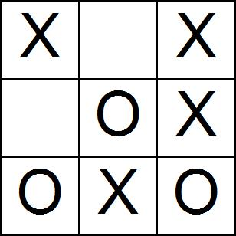  [Instruction]  Now, as a group we are going to play tic tac toe game by making solutions  For example  choose no.1 .  And here , you will see the difficult situations “You are suddenly fired”  And make a solution  “I will go to see a job counselor and then.do this this this.”  After making a solution make your group mark  Each of you have 30 seconds to express your solution  ICQ  -What are we going to do?  -How many seconds do we have?  -Are you working individually?  Begin! Timing  Jenny, Please come front  Choose the number  Which team is the winner?
Post Activity
Materials: English Verb Roulette
Time | Set Up |  |  | Student Activity |  |  |  |  |  | Teacher Talk
1min  2min  2min | Whole class  Whole Class |  |  | [visual]  Activity  Let students speak  Error Correction  Conclusion |  |  |  |  |  | [Demonstration]  I bought this book as a gift to my friend who is in her turning point  And I wrote a letter inside  [Instruction]  Now, I will give you this paper  And fold it  And write a title of a book what you want to recommend  And write a letter inside  I will give you 2 minutes and please work individually  ICQ  -What are we going to do?  -How many minutes do we have?  -Are you working individually?  Explicit ICQ  Please write a letter to your classmate  Can you write to your parents?  Are you going to write letter to your class mate?  Explicit ICQ-2  Please do not start until I say begin  -Are you going to start as soon as I give you the paper?  Now Begin!  (Timing: 1min, 30 sec, 10 sec  Time’s up!)  Which book did you choose?  I heard any errors today and please make a sentence with this unscrambled sentence  BE CHANGED FROM THIS MOMENT MY LIFE WILL  MY LIFE WILL BE CHANGED FROM THIS MOMENT  -You did a good job and if there’s no questions I conclude my microteaching and followed by the Ben
SOS Activities

Materials: Life graph worksheet
Time | Set Up |  |  |  |  |  | Student Activity |  |  | Teacher Talk
1 min  1min  1min | Whole class  Individually  Whole class |  |  |  |  |  | Activity |  |  | What is this?  Life graph  Instructions  -Now, I will give you the blank sheet and please draw your own personal life graph  I will give you an 1 minute  and please work individually  - ICQ  -What are we going to do?  -How many minutes do we have?  -Are you working individually?  Explicit ICQ-  Please do not start until I say begin.  -Are you going to start when I say begin  Okay, Begin!  Please come front and share your life graph

http://newsfeed.time.com/2013/07/22/study-23-and-69-are-the-happiest-ages/

Study: 23 and 69 Are the Happiest Ages

In case you hadn't noticed, life is one big roller coaster ride
A recent study indicates that the ages at which we’re most satisfied are in fact 23 and 69, giving us not one but two stages of life to relish.
The study that identified those two pinnacle satisfaction periods, conducted by the Center for Economic Performance at the London School of Economics, involved a massive number of participants: 23,161 people, ranging in age from 17 to 85, reports Daily Mail.
What goes up must come down: after our early twenties, happiness declines on the way to our mid-fifties; then, after cycling back up through our late sixties, it falls again once we reach 75. If you’re having a midlife crisis — brooding over life choices and unfulfilled ambitions — cheer up, better days are coming: the turnaround point is 55, according to the study, at which point happiness starts climbing once more (though that second harder turnaround after 75 sounds a little ominous).
Don’t take any of this as inevitable, however, because mental attitudes play an important role: Another recent study (via Scientific American) published in the Journal of Research in Personality that analyzed thousands of people across nearly four decades of life, age 16 forward, found that extroverted, emotionally stable young adults tended to be happier in retirement than young adults who’d been reticent or experienced an emotionally turbulent early adulthood.

CROSSWORD PUZZLE
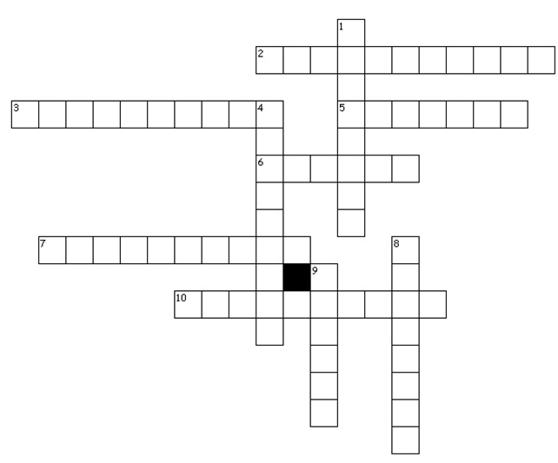Across (ANSWER)
2. Extroverted: having a confident character and enjoying the company of other people
3. Retirement: the period after you have stopped work
5. Ominous: making you feel that something bad is going to happen
6. Relish: to enjoy an experience or the thought of something that is going to happen
7. Inevitable: certain to happen and impossible to avoid
10. Turnaround: a complete change from a bad situation to a good one
Down (ANSWER)
1. Brooding: looking thoughtful and sad
4. Turbulent: situation or period of time is one in which there are a lot of sudden changes
8. Pinnacle: a high mountain top / a pointed stone decoration like a small tower such as a church or castle
9. Crisis: a situation in which there are a lot of problems that must be dealt with quickly so that the situation does not get worse or more dangerous

CROSSWORD PUZZLE
Sample: crisis, pinnacle, extroverted, turnaround, turbulent, retirement, relish, inevitable, brooding, ominous
Across
2. having a confident character and enjoying the company of other people
3. the period after you have stopped work
5. making you feel that something bad is going to happen
6. to enjoy an experience or the thought of something that is going to happen
7. certain to happen and impossible to avoid
10. a complete change from a bad situation to a good one
Down
1. looking thoughtful and sad
4. situation or period of time is one in which there are a lot of sudden changes
8. a high mountain top / a pointed stone decoration like a small tower such as a church or castle
9. a situation in which there are a lot of problems that must be dealt with quickly so that the situation does not get worse or more dangerous

