Grammar Lesson Plan

Uncountable Nouns (Non-count Nouns)

Length:
50 minutes
es
Students:
5
Level:
Upper intermediate

Instructor:
Christine

Materials:
- Pictures
- Uncountable Nouns Worksheet
- Uncountable Nouns Answer Worksheet
- Dialogue Sheet
- Shopping List Sheet
- Correct the Sentences Sheet
- Correct the Sentences Answer sheet

Aims:
- Primary aim : to enable students to improve grammar skills by learning
uncountable nouns and making a dialogue
- Secondary aim : to enable students to learn uncountable nouns and unit for
the uncountable nouns
- Personal aim : to make class better, to improve writing skills on board, to make
students participate in class, time management

Language Skills:
- Reading: students will read worksheet
- Listening: students will listen to others opinions
- Speaking: students will speak correctly by using unit for the uncountable nouns
- Writing: students will write a dialogue

Language Systems:
- Lexis : new vocabulary related to unit for the uncountable nouns
- Function: using proper words in counting
- Discourse: dialogue
- Grammar: uncountable nouns.
- Phonology : none to discuss

Assumptions:

Students already know:
- how the class is set up and run
- the teacher’s style of teaching and the pace of the course
- most students have experience in buying at the market and ordering at the
restaurant

Anticipated Problems and Solutions:

- Students may not be able to follow how to count uncountable nouns
Show the demonstration, wall charts and explain accurately
- Students may need more time to work on activities
Give some hints about activities or give more minutes
- Students may lack of writing a dialogue time
Make post activity shorter and do time management discreetly
- If students finish their tasks earlier than anticipated,
Give students extra questions or make post activity longer or do SOS activity

References:
- Website : www.google.com, www.onestopenglish.com
- Young & Son. Grammar Wonder 3. YBM,2012

Lead-In
Materials: Board
Time  2 min | Set Up  Whole Class | Procedure:  Hello everyone, how are you today?  2 guiding questions  - When you are thirsty, what can you do?  - How many glasses of water do you drink a day?

Pre-Activity
Materials: Picture, Uncountable Worksheet, Board, Markers
Time  5 min  3 min  3 min | Set Up  Whole Class | Procedure:  Elicit, Uncountable Nouns  (Teacher shows students a picture while walking around in the classroom)  Show the pictures  What can you see in this picture?  Can you count these?  Yes, what do we commonly call these words?  That’s right. Uncountable nouns or Non-count nouns.  (Write down on the board and stick pictures)  We’ll learn Uncountable Nouns.  (Point picture1) Why can’t you count these?  Because they are liauid.  (Stick the Wall Chart and Point the Wall Chart)  What do we call these three items?  (soap, hold, ice)? Find the word in the bottom.  What do we call these three items?  (air, wind, gas)?  What do we call these three items?  (bread, rice, pizza)?  What do we call these three items?  (football, baseball, tennis)?  Yes, we can’t count liquid, solid, gas, food and sport.  Learning Unit  CCQ  - I drink a milk, is it right?  - We order a water, is it right?  - What do we call these words?  (Stick Wall Chart on the board)  Instructions  When we need to count uncountable nouns, we use the unit like a piece of, bottle of, and so on.  Look at this chart.  Here is unit for the unit uncountable nouns.  You can guess the unit depending on different shapes.  I’ll make pairs. This is Uncountable Nouns Worksheet.  You fill in the blanks in pairs for 2 minutes.  (Distribute the Worksheet)  ICQ  Are you working alone?  How much time do you have?  Give time warning : 1 min  Check the answers  Let’s check the answers. From team 1, come forward and match the answer.  Usually we use these expressions with singular noun. But when we use a bunch of or pair of, we use always plural nouns. Like a pair of socks, a bunch of grapes.  (Distribute the Answer Worksheet)
Main Activity
Materials: Pictures, Dialogue Sheet
Time  5 min  5 min | Set Up  Whole Class | Procedure:  Role playing & Dialogue  CCQ  How do you count grapes?  How do you order pizza?  How do you count cake?  Instructions  We’re going to do a role-play about how to order or buy some food at the stores such as supermarket, restaurant and bakery. Please, make a dialogue including a seller and a customer. After making a dialogue, you will have a presentation.  I’ll hand out a picture of food menu and a dialogue sheet. I’ll make 2 teams. Work in groups for 3 minutes.  (Distribute the pictures and dialogue sheets)  ICQ  What are you doing?  Are you working in groups?  How much time do you have?  Give time warning : 1 min  Presentation  Let’s have a presentation.  Each team shows a dialogue for 1 minute.

Post-Activity
Materials: Shopping List Sheet
Time  10 min  5 min  1 min | Set Up  Whole Class | Procedure:  Instructions  We are going to make a shopping list. Imagine, you prepare your friend’s birthday party. Ten people are invited. So, you have to make a shopping list, and talk about why do you want to buy them. This is a shopping list. Fill in the blanks. I’ll give you 3 minutes. Work in pairs.  (Distribute shopping list)  ICQ  What are you doing?  Are you working in pairs?  How much time do you have?  Give time warning : 1 min  Presentation  Students talk about their shopping list and the reasons for buying.  Conclude lesson  We’ve learned about unit for the uncountable nouns.  Good job everyone.

SOS Activity – Correct sentences
Material : Correct the sentences sheet, Answer sheet
Time  2 min  3 min | Set up  Whole class | Procedure  Instruction  I’ll distribute the worksheet. There are 10 sentences. Correct the underlined part. I’ll give 2 minutes individually.  Demonstration  Sarah has a milk. - Sarah has a glass of milk.  ICQ  - Are you working individually or in groups?  - How much time do you have?  Give time warning: 1 min  Presentation  Ask students to answer.  Distribute the answer sheet.

Uncountable Nouns
Water Milk Tea
Soap Gold Ice
Air Wind Gas
Bread Rice Pizza
Football Baseball Tennis
Solid Gas Food
Liquid Sport

Unit for the Uncountable Nouns
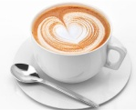 | a ___________ of | coffee / tea
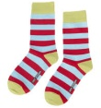 | a ___________ of | socks / shoes
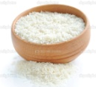 | a ___________ of | rice / ice cream
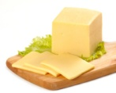 | a ___________ of | cheese / pizza
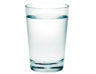 | a ___________ of | water / milk
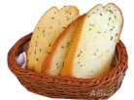 | a ___________ of | bread / cake
 | a ___________ of | wine / water
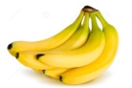 | a ___________ of | bananas / grapes
glass pair slice cup
bowl bottle bunch piece
Answer sheet (Uncountable Nouns)
Liquid | Water Milk Tea
Solid | Soap Gold Ice
Gas | Air Wind Gas
Food | Bread Rice Pizza
Sport | Football Baseball Tennis
Solid Gas Food
Liquid Sport

Unit for the Uncountable Nouns
 | a cup of | coffee / tea
 | a pair of | socks / shoes
 | a bowl of | rice / ice cream
 | a slice of | cheese / pizza
 | a glass of | water / milk
 | a piece of | bread / cake
 | a bottle of | wine / water
 | a bunch of | bananas / grapes
glass pair slice cup
bowl bottle bunch piece

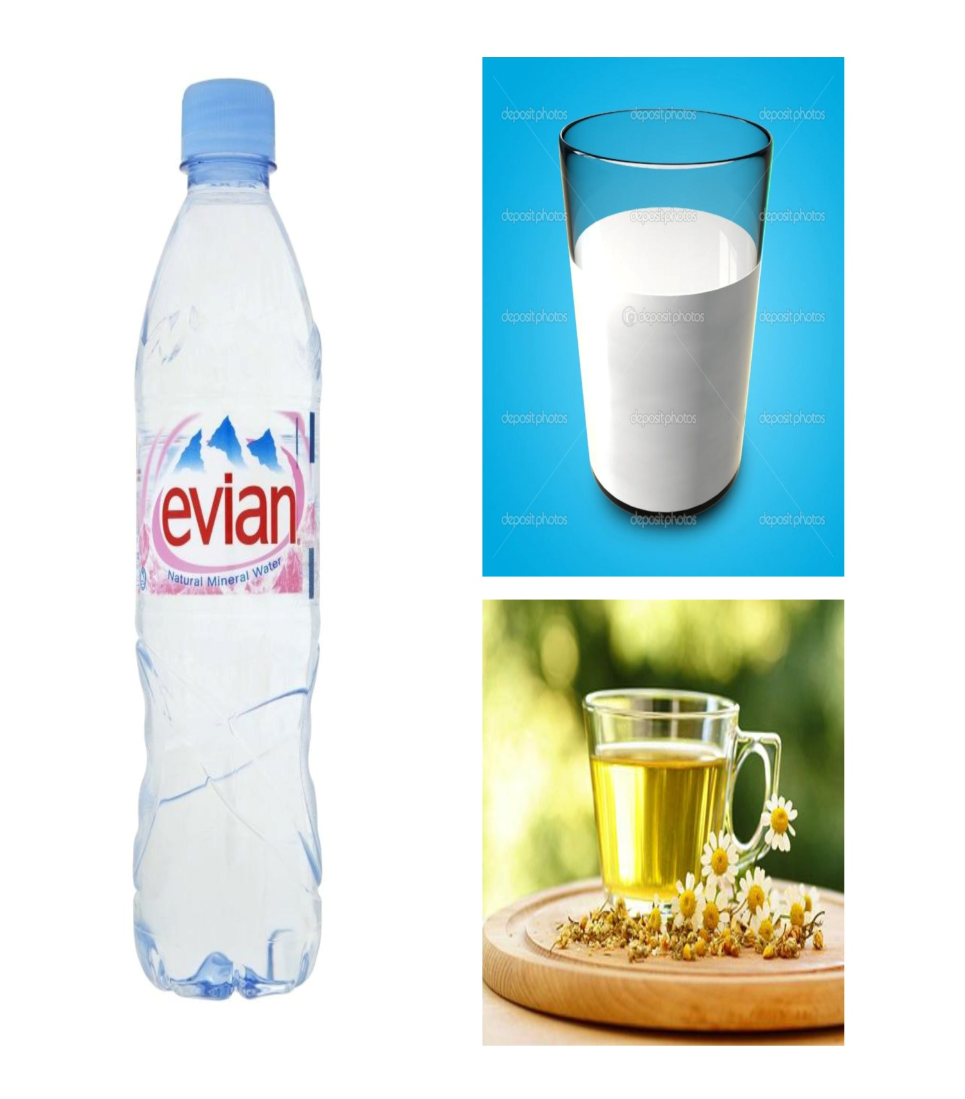

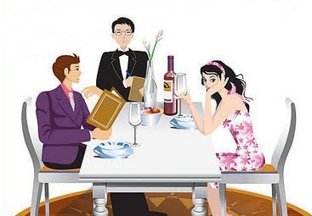
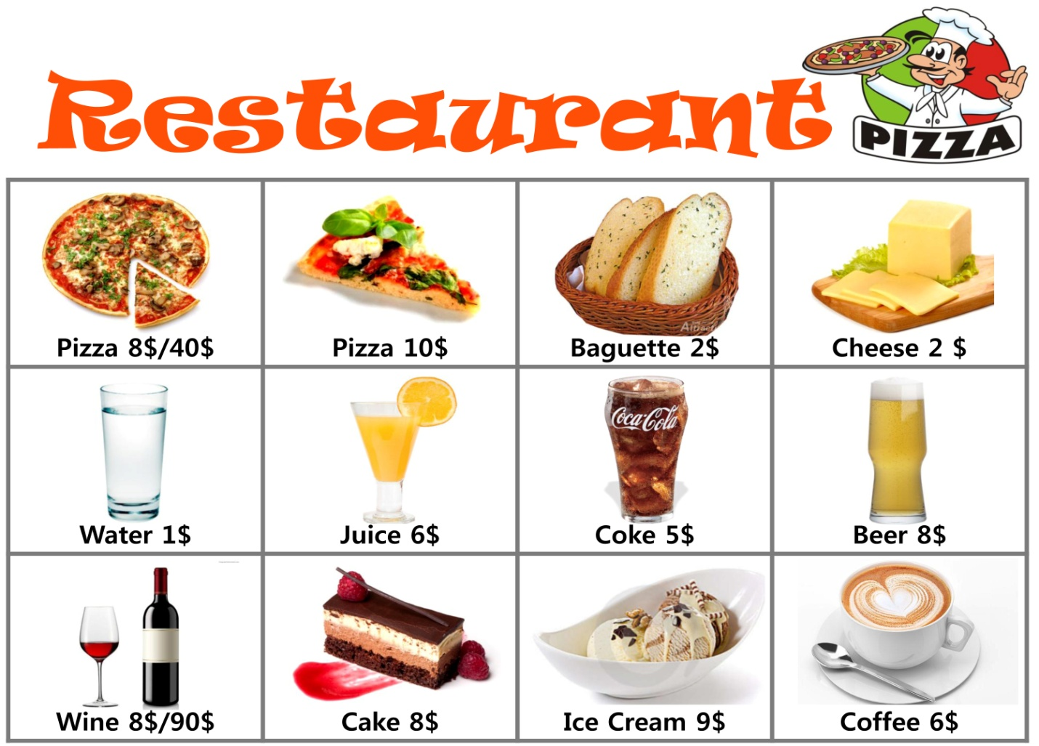
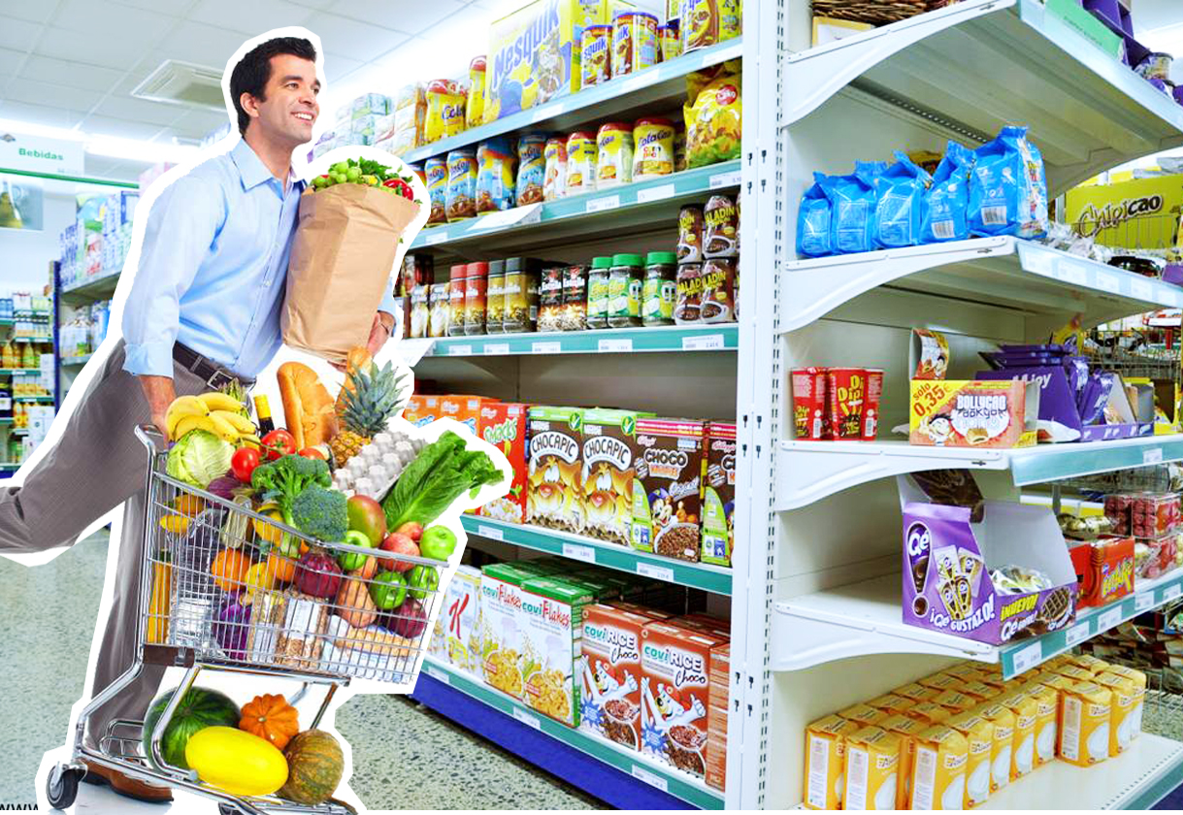

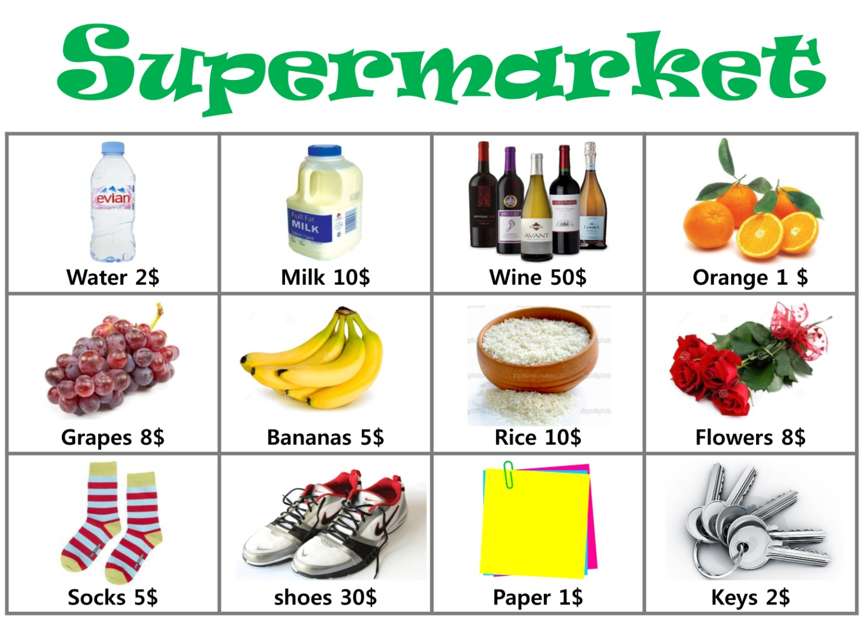
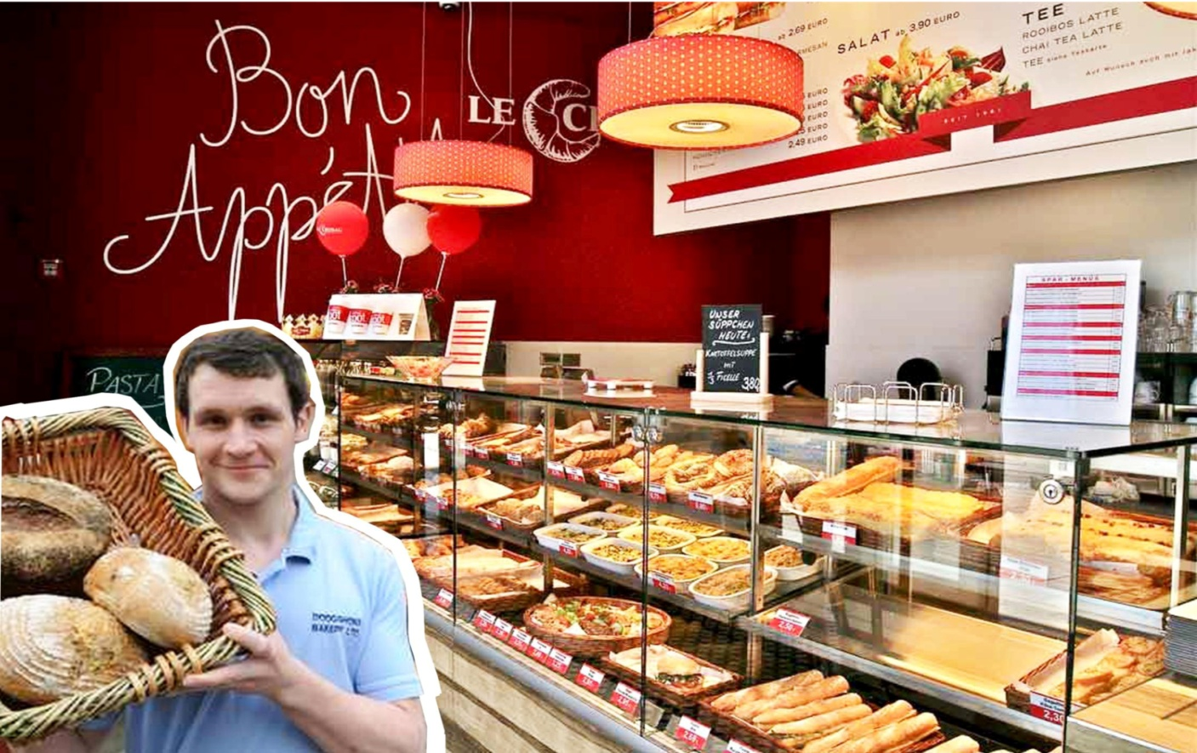
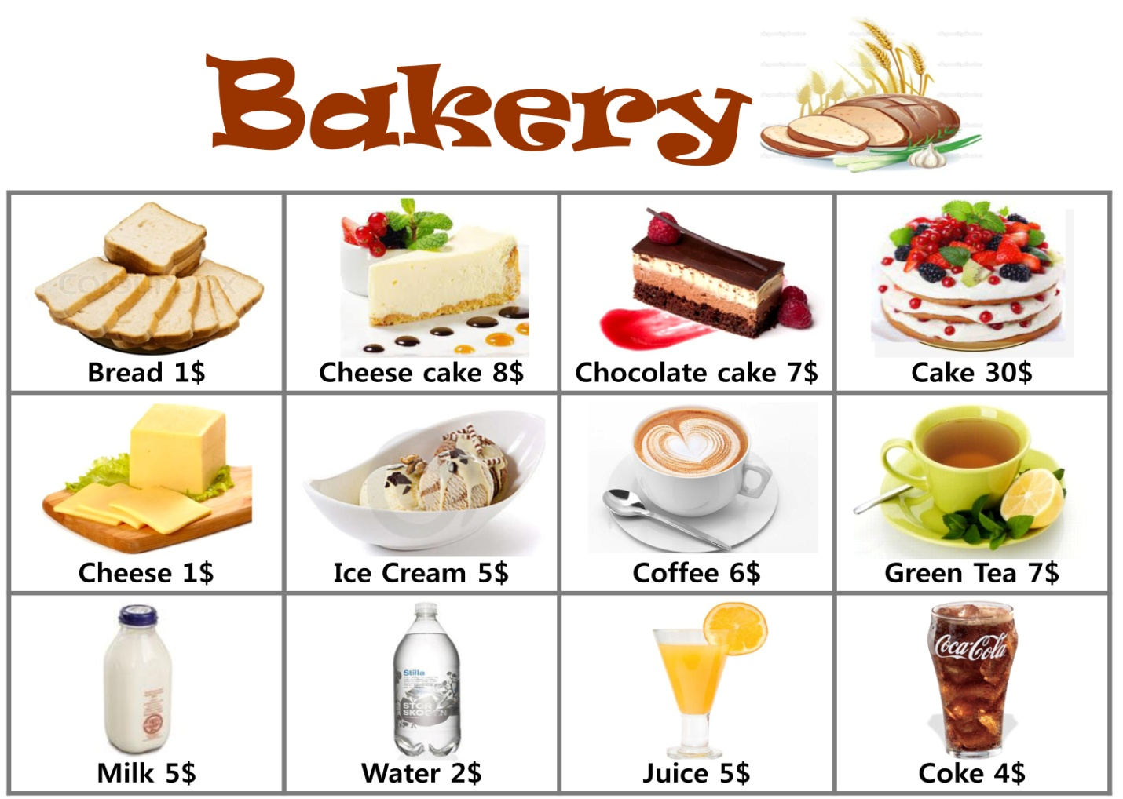

Dialogue Worksheet
----------------------------------------------------------------------------------------------------------------------
----------------------------------------------------------------------------------------------------------------------
----------------------------------------------------------------------------------------------------------------------
----------------------------------------------------------------------------------------------------------------------
----------------------------------------------------------------------------------------------------------------------
----------------------------------------------------------------------------------------------------------------------
----------------------------------------------------------------------------------------------------------------------
----------------------------------------------------------------------------------------------------------------------
----------------------------------------------------------------------------------------------------------------------
----------------------------------------------------------------------------------------------------------------------
---------------------------------------------------------------------------------------------------------------------
----------------------------------------------------------------------------------------------------------------------
----------------------------------------------------------------------------------------------------------------------
----------------------------------------------------------------------------------------------------------------------
----------------------------------------------------------------------------------------------------------------------
----------------------------------------------------------------------------------------------------------------------
----------------------------------------------------------------------------------------------------------------------

Shopping List Worksheet
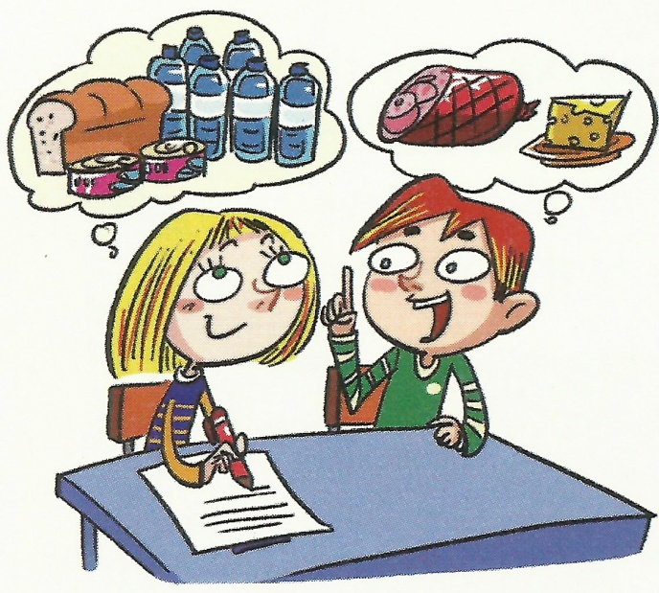
A: Let’s prepare a birthday party. Ten people are invited. This is our shopping list. First, we have to buy a bottle of water. We will also buy…. What else do we need?
B: Well… we need .
Shopping List

Correct the Sentences

No. | Correct the underlined part
1 | - Sarah has a milk.
2 | - I need two piece of bread.
3 | - Will you have cup of coffee?
4 | - There are five sheep in the field.
5 | - He bought ten cans tuna.
6 | - There are fresh milk in the refrigerator.
7 | - We have to buy a loave of bread.
8 | - I want two glass of juices.
9 | - We’ll buy three bottle of water.
10 | - We need ham and piece of cheese.

Answer sheet

No. | Correct the underlined part
1 | - Sarah has a milk. | a glass of milk.
2 | - I need two piece of bread. | two pieces of bread.
3 | - Will you have cup of coffee? | a cup of coffee?
4 | - There are five bunch of grape. | five bunch of grapes
5 | - He bought ten cans tuna. | ten cans of tuna.
6 | - There are fresh milk in the refrigerator. | There is fresh milk
7 | - We have to buy ten piece of papers. | ten pieces of paper.
8 | - I want two glass of juices. | two glasses of
9 | - We’ll buy three bottle of water. | three bottles of
10 | - We need ham and piece of cheese. | a ham and a piece of cheese.

