Speaking Lesson Plan

City vs Country

Length:
50 minutes
es
Students:
5
Level:
Upper intermediate

Instructor:
Christine

Materials:
- Pictures
- Wallcharts
- Vocabulary Worksheet
- Vocabulary Answer Sheet
- Discussion Worksheet
- Name cards
- Role playing name cards

Aims:
- Primary aim : to enable students to improve speaking skills by debating and
role playing
- Secondary aim : to enable students to learn new vocabulary about a city and
a country
- Personal aim : to make class better, to improve writing skills on board, to make
students participate in class, time management

Language Skills:
- Reading: students will read worksheets
- Listening: students will listen and dispute against the opposing team’s
arguments
- Speaking: students will speak by debating and participating in a role play
- Writing: students will write worksheets

Language Systems:
- Lexis : new vocabulary related to characteristics about a city and a country
- Function: use of proper words in debating
- Discourse: debating
- Grammar, Phonology : none to discuss

Assumptions:

Students already know:
- how the class is set up and run
- the teacher’s style of teaching and the pace of the course
- All students have experience in living in a city or a country

Anticipated Problems and Solutions:

- Students may not be able to follow how to debate
Show the demonstration and wall charts and explain accurately
- Students may need more time to work on activities
Give some hints about activities or give more minutes
- Students may lack of debating time
Make Make post –activity shorter and do time management discreetly
- If students finish their tasks earlier than anticipated,
Give students extra questions or make post activity longer or do SOS activity

References:
- Website : www.google.com, www.onestopenglish.com

Lead-In
Materials: Board
Time  2 min | Set Up  Whole Class | Procedure:  Hello everyone, how are you today?  2 guiding questions  - Where do you live?  - Where is your hometown?

Pre-Activity
Materials: Pictures, Wallcharts, Vocabulary Worksheet, Board, Markers
Time  3 min  5 min | Set Up  Whole Class | Procedure:  Elicit, City & Country  (Teacher shows students a picture while walking around in the classroom)  Show the picture ‘City’  What do you see in these picture?  Show the picture ‘Country’  What is it?  Yes, what do we call these pictures?  That’s right. City and Country.  (Write City & Country on the board and stick pictures)  CCQ  - Can you take a subway in the city?  - Can you breathe in fresh air in the country?  (Stick the Wall Chart and Point the Wall Chart)  Learning New Vocabulary  Instructions  Today, we’re going to discuss City and Country.  First, let’s see the vocabulary related to this.  Look at this wall charts.  One girl lives in a big city, and the other girl lives in a country. They have very different life styles.  I’ll hand out the vocabulary sheet.  Look at the picture carefully, the picture is the answer.  You may refer to information at the bottom.  Please, fill in the blanks. I’ll make pairs. Working in pairs in 3 minutes.  (Distribute the Vocabulary Worksheets)  ICQ  Are you working alone?  How much time do you have?  Give time warning : 1 min  Check the answers  Let’s check the answers.  What is number 1? ~ number 10?  (Distribute the Vocabulary Answer Sheets)  Pick two volunteers and let them read the full story.  Can you read the city life story?  Please read the country life story.
Main Activity
Materials: Wallcharts, Discussion Worksheet, Name cards
Time  5 min  10 min | Set Up  Whole Class | Procedure:  Discussion & Writing  Do you fight in words with friends, sometimes?  Have you ever seen a debating TV show?  Instructions  We’ll have a debate about City & Country.  Now I am going to divide 2 teams. Please, push desks back and bring your chair. Make a circle like this.  (Point out the wall chart)  Please, choose one. Open it.  Okay, This team is City, and the other team is Country.  Before debating, we will write down your opinion on discussion sheet for 3 minutes in groups.  (Show the debate sheet)  Discussion sheet is categorized 3 parts, hobby, health, facilities. Each person has to choose a different one. You write down your name and the reason.  Demonstration  [City]  -Hobby: [Someone] I want to live in the City. Because I like watching movies and musicals. The theater is close to my house.  -Health: [Someone] I want to live in the City. Because~  -Facilities: [Someone] I want to live in the City. Because~  ICQ  What are you doing?  Are you working in groups?  How much time do you have?  Give time warning : 1 min  Run a Debate  Instructions  Let’s start a debate.  Team City speaks good things of City life  Team Country speaks good things of Country life  Each team takes turns. Everyone speaks for 30 seconds. You must express your thought.  Demonstration  - Judge Please, speak Hobby part  - Team City I want to live in the City. Because I like to go to see movies and musicals. The theater is close to my house.  - Team Country I want to live in the Country. Because I can go hiking and fishing near my home.

Post-Activity
Materials: Pictures, Role playing name cards
Time  10 min | Set Up  Whole Class | Procedure:  Instructions  We’re going to do a role play. Imagine, you have a big family. Grandfather, Grandmother, Father, Mother, and three Kids. Your family is moving to another place.  You choose a role and act out in your family.  I will give you 3 minutes in groups.  - Situation A:  Team A is a big Canadian family.  They are moving from City to Country.  - Situation B:  Team B is a big Chinese family.  They are moving from Country to City.  Demonstration  Chinese family  Father: “I don’t want to live in the City, because City is too noisy.”  Mother: “I want to live in the City, because I want to go shopping at the department store.”  ICQ  What are you doing?  Are you working in pairs?  How much time do you have?  Give time warning : 1 min  Presentation  Let’s act out your role play in your family.  Conclude lesson  So, we’ve learned about city and country by debating and role playing activity. We had a great time.  Good job today. See you tomorrow”

SOS Activity
Material : none
Time  2 min  3 min | Set up  Whole class | Procedure  Instruction  If you are moving, where do you want to live?  We’ll talk about your dream place to live. I’ll give 2 minutes individually.  Demonstration  I want to live New York.  Because NY is a great city for shopping and eating new food.  ICQ  - Are you working individually or in groups?  - How much time do you have?  Give time warning: 1 min  Presentation  Ask students individually to present their opinion.  If time is not sufficient to answer, only ask 2~3 students to present their story.

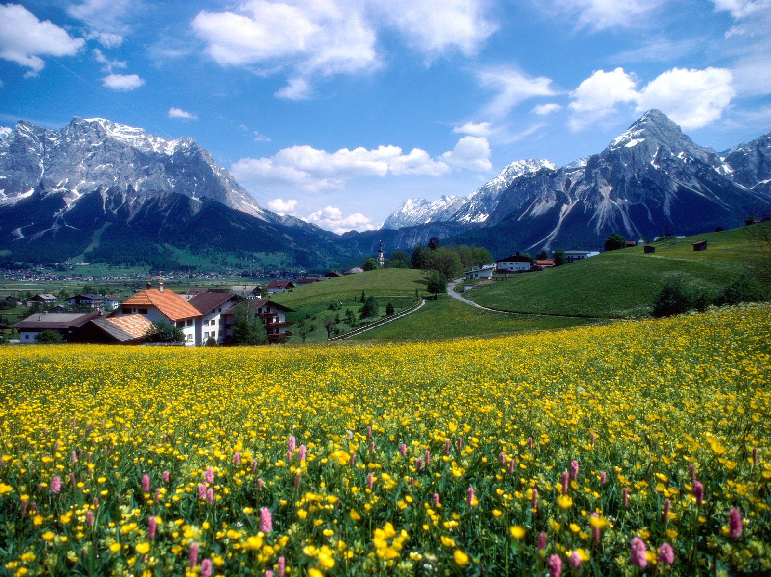

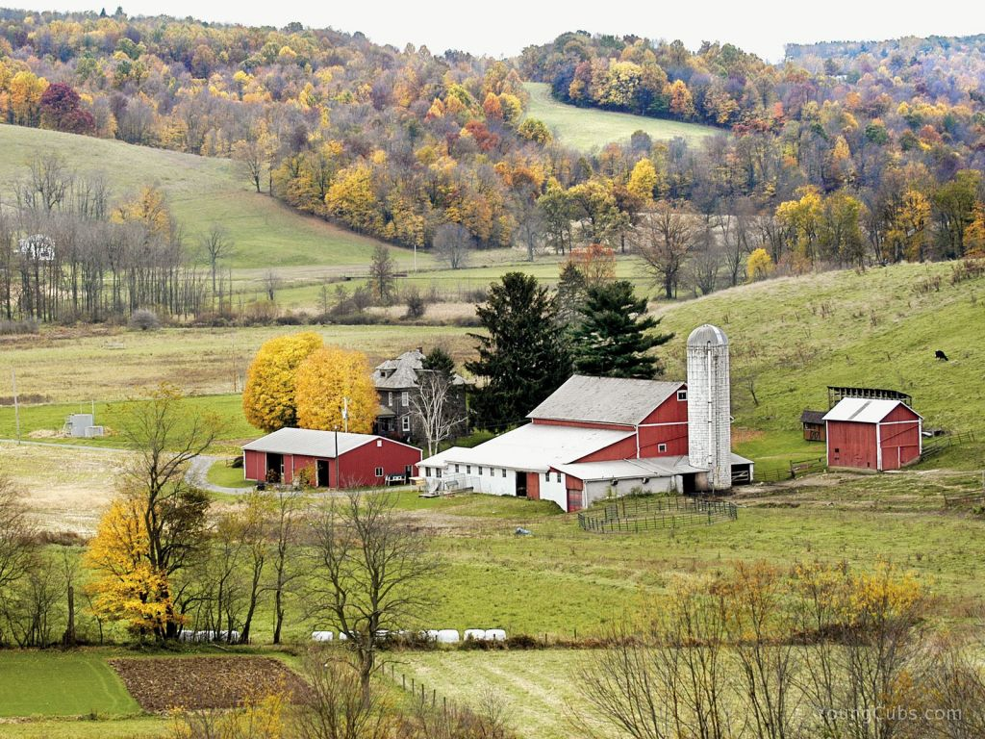
- WALL CHART 1. CITY LIFE

- CINDY’S LIFE STYLE
My name is Cindy. I like living in the city. My is located in New York. There are many near my house such as hospitals, stations and public offices. One of my favorite is subway. Every morning, I go to a gym
by subway because it’s always fast and so cheap! My hobby is shopping. Whenever the bargain sale is on, I seem to be a . Also, I really love watching movies. That’s why my friends call me .
- Vocabulary
================================================================================
vehicles: transport / shopaholic: someone who greatly enjoys shopping and buying things / condominium: a fancy apartment / a movie buff: someone who watches a lot of movies facilities: buildings or piece of equipment you can use for doing something
- WALL CHART 2. COUNTRY LIFE

- RACHEL’S LIFE STYLE
My name is Rachel. I like living in the country. My house is located in McBaine. The scenery here is so beautiful and peaceful. Moreover,
doing yoga in nature is beyond all description. Every morning, I pull out fresh eggs from my for breakfast. It is very nutritious. Also, I often have a with my friends in the . It’s really good for my health.
My house is an excellent place to relax and to enjoy the beautiful scenery.
================================================================================
- Vocabulary
cookout: barbecue with family or friends outside/ yard: the land around a house, usually covered with grass/ pastoral: country, rustic, rural/ a chicken coop: a cage of chicken brick: rectangular blocks of baked clay used for building walls
- VOCABULARY ANSWER SHEET

- CINDY’S LIFE STYLE
My name is Cindy. I like living in the city. My condominium is located in New York. There are many facilities near my house such as hospitals, stations and public offices. One of my favorite vehicles is subway. Every morning, I go to a gym by subway because it’s always fast and so cheap! My hobby is shopping. Whenever the bargain sale is on, I seem to be a shopaholic. Also, I really love watching movies. That’s why my friends call me a movie buff.
- RACHEL’S LIFE STYLE
My name is Rachel. I like living in the country. My brick house is located in McBaine. The pastoral scenery here is so beautiful and peaceful. Doing yoga in nature is beyond all description. Every morning, I pull out fresh eggs from my chicken coop for breakfast. It is very nutritious. Also, I often have a cookout with my friends in the yard. It’s really good for my health. My house is an excellent place to relax and enjoy the beautiful scenery.

*CITY LIFE
- condominium : a fancy apartment
- facilities : buildings or piece of equipment you can use for doing something
- vehicles : transportation
- shopaholic : someone who greatly enjoys shopping and buying things
- a movie buff : someone who watches a lot of movies
*COUNTRY LIFE
- brick: rectangular blocks of baked clay used for building walls
- pastoral : country, rustic, rural
- a chicken coop : a cage of chicken
- cookout : barbecue with family or friends outside
- yard : the land around a house, usually covered with grass
- SEATING ARRANGEMENT

Discussion worksheet

Categories | TEAM ‘CITY’
Hobby | [Speaker’s Name: ]  I want to live in the city . Because ….
[Speaker’s Name: ]
I want to live in the city . Because ….

Health | [Speaker’s Name: ]  I want to live in the city . Because ….
[Speaker’s Name: ]
I want to live in the city . Because ….

Facilities | [Speaker’s Name: ]  I want to live in the city . Because ….
[Speaker’s Name: ]
I want to live in the city . Because ….

Discussion worksheet

Categories | TEAM ‘COUNTRY’
Hobby | [Speaker’s Name: ]  I want to live in the country . Because ….
[Speaker’s Name: ]
I want to live in the country . Because ….

Health | [Speaker’s Name: ]  I want to live in the country . Because ….
[Speaker’s Name: ]
I want to live in the country . Because ….

Facilities | [Speaker’s Name: ]  I want to live in the country . Because ….
[Speaker’s Name: ]
I want to live in the country . Because ….

Judge worksheet

Categories | Judgment | Winner
Hobby | Debating 1. | City / Country
 | Debating 2. | City / Country
Health | Debating 1. | City / Country
 | Debating 2. | City / Country
Facilities | Debating 1. | City / Country
 | Debating 2. | City / Country

- Conclusion

