v
Listening Speaking Reading Grammar Writing
Topic: My Happy Imagination.

Instructor:  Chuwon | Level:  Pre-Intermediate | Students:  8 | Length:  57 Minutes
Materials:
Photos –Moon, Dinosaur, Obama.
Drawing sheets – blank paper
Color pencils
Drilling wall Chart I – If + subject + simple past, subject + would + base verb.
Drilling wall Chart II - If + subject + simple past, subject + could + base verb.

Aims:
- Improve Ss listening skills by listening to T’s story.
- Improve Ss speaking skills by answering T, Ss presentations.
- Improve Ss grammar skills about second conditional by drilling, writing and game.

Language Skills:
- Listening: teacher talk
- Speaking: sharing Ss stories about their happy imagination,.
- Reading: drilling wall chart.
- Writing: writing 5 sentences about happy imagination in activites.

Language Systems:
- Phonology: drilling.
- Function: writing and description.
- Lexis: second conditional.
- Grammar syntax: If + subject + past simple, subject + would/ could + base verb.
- Discourse: game.

Assumptions:
- All Ss know about first conditional.
- All Ss can talk about happy imagination through drawing and writing.
- All Ss know how to use would, could when they talk..

Anticipated Errors and Solutions:
- If Ss cannot have happy imagination : tell Ss when they watch a drama, and want to be a main character, it can be happy imagination.
- If Ss take a long time to make sentences with drawing : never push students, give more time and encourage them.

References:
None

Lead-In (13 min)
Materials:
Board
Markers

Time | Set Up | Student Activity | Teacher Talk
1 min  5 min  7min | Whole  Whole  Ss | Greet T.  Listen to T.  Share Ss’s story. | Greet Ss.  Talk about ‘My Happy Imagination’ with showing drawing by using second conditional.  Ask Ss to share their story about their happy imaginations.

Pre-Activity (15 min)
Materials:
Drawing sheets – blank paper
Color pencils
Drilling wall chart I ,II – If + subject + simple past, subject + would/ could + base verb

Time | Set Up | Student Activity | Teacher Talk
2min  8min  5 min | whole  whole/  Ss  Whole/  Ss | Listen to T and receive the drawing sheet, color pencil.  Start drawing and Ss  Follow the drilling. | Ask Ss to draw their happy imagination and to write 3sentences based on their stories.  Hand out the drawing sheet, color pencils  Tell Ss to start drawing and write 3 sentences and present drawing and story.  Put drilling wall chats on the white board  Do drilling with student  If + subject + simple past, subject + would / could + base verb.

Main Activity (18 min)
Materials:
Papers, Pencils

Time | Set Up | Student Activity | Teacher Talk
5 min  8min  5min | Whole  /Ss  Group  Whole | Listen T and make 2 sentences using picture  Present to partner  Game | Make 2 sentences based on picture, and teach others  Help students to present their sentence to their partners.  Explain a game : “If I went to a market, I could buy…(Memorial Market Game)

Post Activity (11 min)
Materials:
Board

Time | Set Up | Student Activity | Teacher Talk
3min  7min  1min | Whole  /Ss  Group  Whole | Listen T  Present  Listen to T | Give time to present  Present their partner  Close by giving feedback about their work done.

Teacher’s story picture

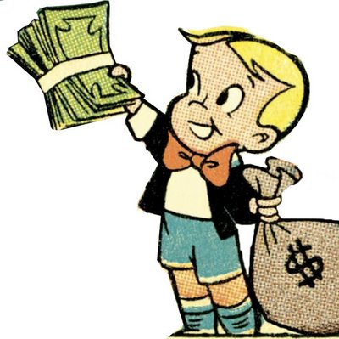

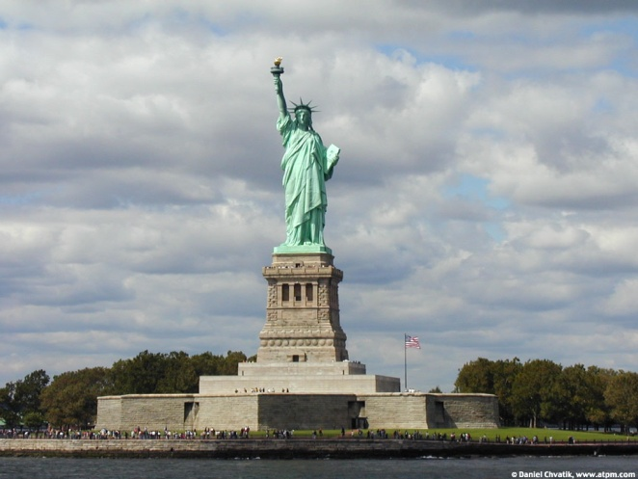

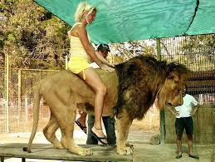

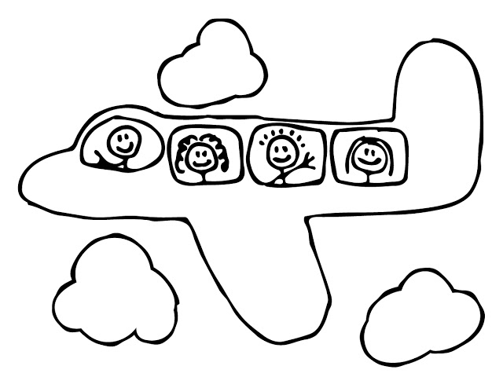

Activity picture – Moon, Dinosaur, Obama

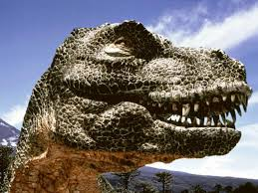

Drilling wall chart I - If + subject + simple past, subject + would + base verb .

If I were rich, I would go to Africa.

If I went to Africa, I would ride on a lion.

Drilling wall chart II - If + subject + simple past, subject + could + base verb .

If I were rich, I could buy New York City.

If I were rich, I could buy air planes.

