v
Listening Speaking Reading Grammar Writing
Topic: The Place Where You Want To Travel.

Instructor:  Dina | Level:  intermediate | Students:  4 | Length:  50Minutes
Materials:
T’ Picture- Paris France
Brain Storming Work Sheet.
Paris in France Text Sheet and Audio File.
Text Question Work Sheet.
CD player and CD.
The Place Where I Want to Travel Writing Work Sheet.
Aims:
- Improve Ss listening skills by listening to T’s introductions and Ss presentations.
- Improve Ss speaking skills by answering T and Ss presentations.
- Improve Ss reading skills by reading the text and their work sheet.

Language Skills:
- Listening: T talk, Ss presentations and audio files.
- Speaking: Ss presentations.
- Reading: Read the text and work sheet.
- Writing: Work Sheet.
Language Systems:
- Phonology: Presentation.
- Function: Expressing their idea.
- Lexis: Vocabulary.
- Discourse: Exchange information.

Assumptions:
- All Ss have where they want to go.
- All Ss will enjoy discussion and sharing their idea.
- All Ss will enjoy the work sheets.

Anticipated Errors and Solutions:
- If Ss take too long time in reading: T helps to read.
- If Ss afraid of presentation: T encourage Ss. Give Ss some example ideas.
- If Ss don’t know some words: T explains the word meaning.

References:
None

Lead-In (10 min)
Materials:
T’ Picture.
Time | Set Up | Student Activity | Teacher Talk
1 min  4 min  5min | Whole  Whole  Whole | Greet T.  Listen to T.  Share Ss’s story. | Greet Ss.  Tell where T wants to travel.  Ask Ss to where they want to go.

Pre-Activity (8min)
Materials:
Brain storming work Sheet.
Time | Set Up | Student Activity | Teacher Talk
2min  6 min | Whole  Ss | Listen to T how complete the work sheet.  Ss do brainstorming and then share their idea. | T gives the work sheet to Ss and shows how complete it.  Let Ss complete the work sheet and ask their own idea. Ss share ideas on work sheet.

Main Activity (21min)
Materials:
Text sheet.
Work sheet.
CD player and CD.
Time | Set Up | Student Activity | Teacher Talk
1 min  10min  5 min  5 min | Whole  Ss  Ss  Whole | Listen to T.  Read the work sheet and complete the work sheet.  Read the work sheet together and Ss answer the questions.  Listen to audio files. | T gives text sheet and work sheet to Ss and let them read. T tell them how complete the work sheet.  Monitor Ss and help Ss if someone has difficulty in reading text sheet. Let Ss do it and complete work sheet correctly.  Let Ss read the text sheet and confirm the questions.  Play the audio files.

Post Activity (11min)
Materials:
Writing work sheet.
Time | Set Up | Student Activity | Teacher Talk
2 min  3 min  5 min  1 min | Whole  Ss  Ss  Whole | Listen to T.  Write their idea.  Read the other S’s work sheet each other and talk about their idea.  Ss say good bye. | Give writing work sheet to Ss and explain how complete and read.  Monitor Ss activity and help Ss if someone does not have any idea.  Let all of Ss read and talk.  Close by giving Ss feedback.

Paris France

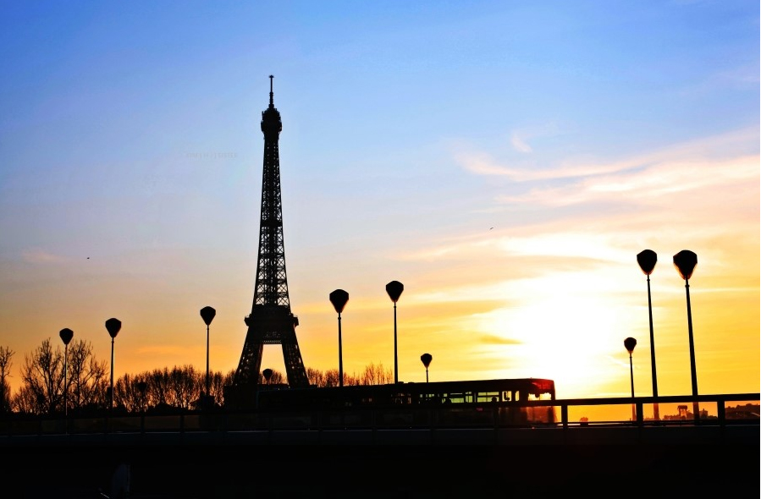

Writing Work Sheet

The Place Where I Want To Travel.

Reading text and Audio file
Paris in France

- Though there is more than one Paris in the world, there’s really only one Paris in the world. It is, of course, the capital of France. First thing’s first: breakfast. Paris is the home of croissant and café au lait. Sitting on a terrace, watching the world go by while dunking your pastry is one of life’s treats, and it’s very important to treat yourself, at least once a day. One of the finest spots to do this is at the Café Marly, which, by some miracle, is located right in the Palais du Louvre. It’s worth putting up with expensive, cold coffee, surly service, and grubby cutlery, for the sake of one of the finest views of any café anywhere. Read the paper. Decide if you think the pyramid is a stroke of genius or monstrous carbuncle, and decide what to do in Paris.

- Paris is divided in two by the River Seine. Traditionally the left bank has been hip, bohemian, arty, and intellectual, while the right bank is smarter, richer, more commercial. Most of the big hotels are on the right bank near the Louvre, but if you want something more interesting, try Saint Germain, the Bastille, or Montmartre. L’Ardoise is definitely something special. It’s tucked away in a street in the fashion district, and you’re unlikely to be strolling past. Even if you did stroll past, you’d be unlikely to stop. The restaurant looks very ordinary, the décor plain, but it should always be a clue when you find a restaurant filled with locals. Each dish is surprising and delightful, the wine’s impeccable.

- This is a capital city and there’s truly something for everyone. One of the most enduring and popular nights out in Paris is at the legendary Moulin Rouge. The Moulin Rouge first opened in 1889 when Paris got its first taste of the Quadrille Realiste. The English later immortalized the dance as the cancan, and it has been part of every show since.Over the years, many stars have performed here: Frank Sinatra, Ella Fitzerald, Edith Piaf, Maurice Chevalier, Elton John, Bing Crosby, Ginger Rogers, and even the Village People. Not everyone did the cancan though. It is renowned as one of the most demanding dances around.

Text Questions Work sheet
- The text has three paragraphs, A-C. Choose the correct heading for each paragraph from the list of heading below.

1.Paragraph A

2 .Paragraph B

3. Paragraph C
List of Headings

- Breakfast in Paris
- At the Legendary Moulin Rouge
- The River Seine

- Do the following statements agree with the information given in the text?
Write if the statement agrees with the information ‘True’
if the statement contradicts the information ‘False’
if there is no information on this ‘Not Given’

a) The capital city of France is Paris.
b) The Café Marly is located next to the Palais du Louvre.
c) The Café Marly serves cold coffee.
d) There is a restaurant inside of the Louvre.
e) L’Ardoise serves delightful dishes and wine.
f) Elton John did cancan at the Moulin Rouge.
g) The cancan is one of hardest dance in the world.
h) Croissant is for breakfast.

Brain Storming Work Sheet
Where do you want to travel?
Where?

What is the most popular in there?

Why do you want to go there?
What do you know about the place?
What do you want to do?

