Listening Speaking Reading Grammar Writing

Topic: Gerunds

Instructor:  Debbie | Level:  Pre-Intermediate (Adult) | Students:  7 | Length:  45~50 Minutes

Materials:
- Visual aids (youtube video) (computer, Internet)
- 35 Cards for Icebreakers.
- Worksheets
- White board, board markers
- Paper & pen

Aims:
- Main Aim: To help and give students to use gerunds and involve in the class.
- Secondary Aim: STT.
- Personal Aim: I want to improve my teaching skills in grammar and time management.

Language Skills:
- Reading: Ss will read worksheets.
- Listening: Students will watch video clip and teacher’s instruction and other students ’speaking.
- Speaking: Students will have time to speak during activities..
- Writing: Students will complete worksheets..

Language Systems:
- Phonology: sound from video, vocabulary.
- Lexis: from worksheets.
- Function: answering and discussing.
- Grammar: gerunds.
- Discourse: Group discussing, Presenting.

Assumptions:
- Ss have good communication skills; therefore they would be able to interact with each other for pair work.
- Ss have an adequate ability to understand T’s instructions in English and to perform the productive skill activities.

Anticipated Problems and Solutions:
- Ss may not understand the teacher’s instructions clearly.
→ Give instructions as simple as possible. Check their understanding by asking specific concept questions.
- Ss may run into problems completing their pair work because of their proficiency in English.
→ During the pair work, monitor the students progress and give them a helpful feedback (word, sentence, structure).
- When time is not enough,
→ Shorten activity with volunteer group only.
- When there is still time to run,
→ Review & Do another activities (SOS)
- Ss may not understand the teacher’s instructions clearly.
→ Give instructions as simple as possible. Check their understanding by asking specific concept questions.

References:
Pre-task : Singing in the rain : http://www.youtube.com/watch?v=-wI4jJq98tU
Worksheets: YSG Grammar wonder (books from times tesol)
SOS : http://www.puzzles.ca/wordsearch.html

Pre-task
Materials:
For Ice breakers: Card 35eas
Computer, internet for visual aid (youtube)
Time | Set Up | Student Activity | Teacher Talk
10min | Whole class | Do activity  Watch and answer teacher’s  Questions  (If no volunteer, ask specific Ss to answer) | Greeting  [Ice breakers]  “Me too” game  Everyone in the group gets 5 poker chips/pennies/paper clips etc. Start the game by saying something that you have done. For example: I have gone skating. Everyone who has gone skating throws one poker chip in the middle of the table. Go around the circle until everyone has had a chance to say something. Continue the game until someone runs out of poker chips.  -Show video clip from youtube (singing in the rain) to student and ask questions.(Eliciting)

Task Preparation
Materials: Worksheet 1~2
Board and Board markers
Time | Set Up | Student Activity | Teacher Talk
15min | Whole  group  As a group  (2-2-3) | Do worksheet individually  Answer.  Discuss as a group  Explain grammar point to the class as a group | [Distribute worksheet]  Give them 5 mins to complete worksheet 1~2..  Write below in board  “Point A, Gerunds as S______ or Complements.  Point B, Gerunds after V______.  Point C, Gerunds after P________.  Check the answer randomly.  Instructions  In worksheet 1, there are 3 points of gerunds type. (A,B,C)  Make a 3 group and have them discuss about grammar point on the worksheets. Each group will choose each point and explain about what they learned to the class.  Monitoring  Monitor discreetly.

Task-Realization
Materials: Worksheet3 / Paper & pen
Time | Set Up | Student Activity | Teacher Talk
15min | Whole class  (2-2-3) | Do individually  Work as a group | Worksheet3  Let them complete worksheet3.  [Activity]  After finishing, they will make their own chart by referencing worksheet 3 as a group.  Give them paper and chart.

Post Task
Materials: Board and a board marker
Time | Set Up | Student Activity | Teacher Talk
5 min | Whole class | Listen to teacher  And answer. | Feedback & Error corrections.  What did you learn?  Elicit below from students.  [Grammar point]  We form a gerund by adding –ing to the base verb.  Gerunds can be used as nouns.  Gerunds can be used as subjects or complements and as objects of some verbs or prepositions.
SOS Activities
Materials: Word search Worksheet
Time | Set Up | Student Activity | Teacher Talk
7min | Whole class  Individually | Listen to teacher  Do worksheets | Distribute SOS worksheet

Worksheets 1

Point A. Gerunds as S_______ or Complements.
=> Choose the correct words.
1. My plan is (prepare / preparing) a Halloween party for students.
2. (Take / Taking) a walk is a good exercise.
3. Stanley's job is ( make / making) cookies and cakes.
4. (Eat / Eating) junk food is bad for your health.
5. The problem is (get / getting) there on time.
6. (Go / Going) hiking is my favorite hobby.
7. Debbie's dream is (travel / travelling ) around the world.

Point B. Gerunds after V_____
=> Fill in the blanks using the given words.
1.(fight) Brian and I stopped ____________with each other.
2.(read) June enjoys _________ science fiction.
3.(play) He suggested __________soccer after school.
4.(write) You have to finish ___________the book review.
5.(open) I don't mind __________ the window.

Point C. Gerunds after P__________
=> Correct the underlined parts and rewrite the sentences.
1.How about take a walk? __________________________________
2.I'm interested in write stories. __________________________________
3.Bob is good at play the violin. __________________________________
4.Thank you for cheer me up. __________________________________
5.We are sorry for be late. __________________________________

Worksheet2)
A. Choose the correct words.
1. (Eat/ Eating) breakfast is a good habit.
2. My goal is (travel/travelling) all around the world.
3. Let's go (swim/swimming/ to swim) in the sea.
4. I'm tired of (take/taking/to take) piano lessons.
5. The old lady thanked me for (help/ helping/ to help) her.

B. Complete the sentences with the words in the box. Change the forms if necessary.
eat tell go gain clean
1. Don't worry about ____________ weight.
2. Lora loves ____________vegetables.
3. I was sorry for ____________ a lie for her.
4. We finished _________________the house.
5. I'm thinking of _______________ to Canada next year.

C. Complete the sentences using the correct forms of the given words.
1. A: Is your dream__________________ a singer? (be)
B: Yes. I love _____________ in front of people. (sing)
2. A: How about _________________basketball after school? (play)
B: Sorry. I just enjoy ______________basketball on TV. (watch)
3. A: Mary finished ____________________cookies (bake)
B: Oh, I'm looking forward to _______________________her cookies. (try)
4. A: I'm interested in ______________________foreign languages. (learn)
B: Really? I'm poor at __________________foreign languages. (speak)

worksheet3

Writing practice
1. Find the errors. Then rewrite the dialog.

A: Let's go shopped in Insadong.
I enjoy to look around in the shops.
B: How about visit the palaces of Korea?
A: Good idea. I'm interested in see Korean traditional buildings.

--------------------------------------------------------------------------------------------------------------------------------------------------------------------------------------------------------------------------------------------------------------------------------

2. Look at the chart and complete the sentences. Then read the passage aloud.
 | ☆ love | ★ hate | ○ good | ● bad | ♡ interested | ♥ not interested
 | Write stories | Ride a bike | Draw pictures | sing songs | Play the guitar | Play computer games
Mark | ★ | ♡ | ♥ | ○ | ● | ☆
Sue | ☆ | ★ | ♡ | ♥ | ○ | ●
Jason | ♥ | ○ | ★ | ☆ | ● | ♡

Mark loves (1) _________________________, but he hates (2)________________________.
Sue is interested in (3)__________________ , but she isn't interested in singing songs.
Jason is good at (4)___________________, but he is bad at (5)_______________________.

SOS Activity. – Word search puzzles.
Free Printable Word Search Puzzles
Weather
Find and circle all of the words that are hidden in the grid.
The remaining letters spell an additional weather word.
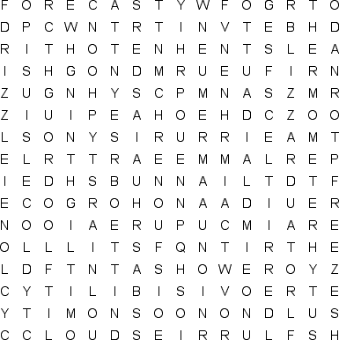
BAROMETER  BLIZZARD  CELSIUS  CLOUDS  COLD  CYCLONE  DOWNPOUR  DRIZZLE  DROUGHT  FAHRENHEIT |  | FLOOD  FLURRIES  FOG  FORECAST  FREEZE  FROST  HAIL  HOT  HUMIDITY  HURRICANE |  | ICE  LIGHTNING  MIST  MONSOON  OVERCAST  RAIN  SHOWER  SLEET  SNOW  SQUALL |  | STORM  SUNNY  TEMPERATURE  THERMOMETER  THUNDER  TORNADO  TSUNAMI  TYPHOON  VISIBILITY  WINDY

Free Printable Word Search Puzzles
Weather
This is the solution to the puzzle located here.
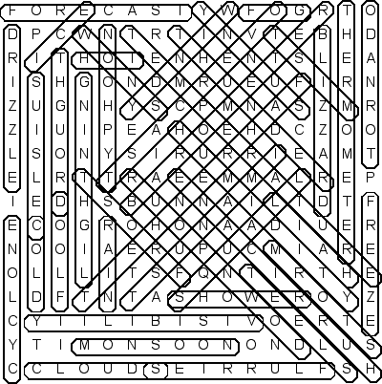
http://www.puzzles.ca/wordsearch.html

