|  |
| --- |
| **Speaking Lesson Plan** |
| **Topic : Create your own recipe** |

|  |  |  |  |
| --- | --- | --- | --- |
| **Instructor:**  Yujin Hong | **Level:**  Intermediate  For Adults | **Students**:  16 | **Length:**  45 Minutes |

|  |
| --- |
| **Materials:**  -Board and markers  -Bingo card (4 copies)  -Worksheet 1 (Frequently used cooking verbs)-5 copies, Worksheet 2 (Apple pie recipe photos)-17 copies, Worksheet 3 (Fill in the blanks) -17 copies  -Blank sheets (4) |

|  |
| --- |
| **Aims:**  Main aim  -At the end of this lesson, students should be able to speak fluently and express and share their ideas by presentation and discussion..  **Secondary aim**  -At the end of this lesson, students should,  -be able to speak fluently to their classmates about how to prepare certain meals with the target vocabulary words.  - be able to work cooperatively in a group by sharing information that is unique to each student.  -have practiced their listening skills by listening to other student’s talking through discussion and presentation.  **Personal aim**  -I would like to improve my CCQ’S and time management in class. |

|  |
| --- |
| **Language Skills:**  **-**Speaking Skills – Group discussion, Presentation..  -Listening Skills – Teacher ‘s instruction and explanation, discussion.  -Writing Skills – Writing a recipe.  -Reading – Reading worksheets and recipe. |

|  |
| --- |
| **Language Systems**  -Phonology – Learning pronunciation of new words.  -Lexis – Vocabularies about cooking.  -Function – Discussing cooking, presenting their recipes.  -Discourse – Sharing opinion about cooking individually and in group discussion..  -Grammar – General observation |

|  |
| --- |
| **Assumptions**  Students already know  -how the class usually runs and teacher’s style of teaching and the pace of the course  -all students are women and have ideas about cooking or have experienced cooking before. |

|  |
| --- |
| **Anticipated Errors and Solutions**  Students may not easily understand the meanings of new vocabularies.  -Teacher will explain with simple and easy words and give examples if necessary.  Students might have troubles in activities.  -Monitor students and give some demonstrations.  If some of the students are too shy to participate during the group discussion.  -Encourage students to participate and give positive feedback.  If running out of time.  -Cut it and move on. You can give them an answer directly and go to the next activity.  If activity finishes too soon  - Go to S.O.S activity. |

|  |
| --- |
| **References**  <http://drewseslfluencylessons.com>  <http://americanfood.about.com/od/keytipstechniques/ss/Carm_Apple_Pie.htm> |

|  |
| --- |
| **Ice Breaker** |
| **Materials**: Board and marker. Bingo card (4 copies) |

|  |  |  |
| --- | --- | --- |
| **Time** | **Set Up** | **Procedure** |
| 5 min | Whole  class | -Divide students into 4 groups of 4 and ask one student from each group to come out and write down on the board, 5 different words for each category. (Fruit, Vegetable, Meat, Seasoning )  -Hand out 4 x 4 empty Bingo card to each group and tell them to write down 16 items from the board.  -One student in each group takes a turn to call out one word in their grids and other groups mark the matching word.  -The goal is to get a straight vertical, horizontal or straight diagonal line from corner to corner.  -The winning team gets a prize. |

|  |
| --- |
| **Lead-In** |
| **Materials**: Board and marker. |

|  |  |  |
| --- | --- | --- |
| **Time** | **Set Up** | **Procedure** |
| 5 min | Whole  class | -Greeting.  -Ask students about famous Korean TV program about cooking.  -Ask students about their cooking experience.  -Elicit the world ‘recipe’.  (Ask students to spell the word ‘recipe’ and write down the word on the board)  -Tell students that today’s topic is ‘recipe’. |

|  |
| --- |
| **Pre-activity** |
| **Materials**: Board and marker, Worksheet 1 (Frequently used cooking verbs)-4 copies, all cut it in squares. |

|  |  |  |
| --- | --- | --- |
| **Time** | **Set up** | Procedure |
| 5 min | Groups | **Instruction**  -Tell students that they are going to do word matching activity.  -Tell them to discuss in their groups and match words with correct definitions.  -Inform them that they have 2 minutes to do it  (Hand out two bundles, one for words and the other for definitions to each group)  **Error corrections.**  -Go through Worksheet 1(Frequently used verbs in cooking) with students and check the answers. |

|  |
| --- |
| **Main-activity** |
| **Materials** Board and marker, Worksheet 2 (Apple pie recipe photos), Worksheet 3 (Fill in the blanks) |

|  |  |  |
| --- | --- | --- |
| **Time** | **Set up** | **Procedure** |
| 2 min  5 min  5 min | Groups  Whole | Instruction  -Hand out Worksheet 2 (Apple pie recipe photos) to students.  -Ask students to guess what ingredients might be included.  -Put students in groups and let them have a small chat about the photos of the recipe for 2 minute.  -Hand out Worksheet 3 (Fill in the blanks)  -Tell students to discuss and find out the answers in their groups.  -They have 5 minutes to do it.  Monitoring  -Monitor discreetly and answer if students ask questions.  -Give time warning. Be flexible with time. Give students 1 more minute if they need it.  Error correction  -Go through Worksheet 3 (Fill in the blanks) with students and check the answers.  -CCQ some vocabularies. |

|  |
| --- |
| **Post-activity** |
| **Materials**: Board and marker, Blank Sheet |

|  |  |  |
| --- | --- | --- |
| **Time** | **Set up** | **Procedure** |
| 3 min  10 min  10 min | Whole  Group  Whole | Instruction  -Elicit some ideas about how to write a recipe, such as ‘Imperative structure, Shorter instructions than ordinary text ‘and so on.  -Tell students that they are going to create a recipe of their own in their groups and present it.  -Ask students to be creative and use vocabularies that we have learned in the class.  -They have 10 minutes to do it.  Monitoring  -Monitor students and help them whenever needed.  Presentation  -Ask each group to present their recipe and share their ideas in the class.  Closing  -Wrap up by summarizing what we have learned today. |

|  |
| --- |
| **S.O.S Activity** |
| **Materials**: Blank sheet. |

|  |  |  |
| --- | --- | --- |
| **Time** | **Set up** | **Procedure** |
| 10 min | Individual  Whole | Instruction  -Hand out a blank sheet of paper to students.  -Tell students that they will interview their partner.  -Ask them to write 5 questions related to foods.  (for example, What kinds of foods do you like, dislike? What foods do you never eat? Do you often eat out? etc )  -When everybody has finished, let some students come out and present what they have interviewed. |

**Worksheet 1** (Frequently used cooking verbs)

|  |  |
| --- | --- |
| 1. Bake | To cook in an oven |
| 1. Grill | To cook by heating the food directly, for example, on a barbeque |
| 1. Boil | To cook in hot water |
| 1. Fry | To cook in hot oil |
| 1. Measure | To determine exact amount |
| 1. Chop | To cut into small pieces |
| 1. Slice | To cut with a knife |
| 1. Roll out | To press, spread with a roller |
| 1. Peel | To remove the outer skin, for example, of a potato or apple |
| 1. Microwave | To cook or heat in a microwave oven |
| 1. Stir | To cause a movement with a spoon |
| 1. Pour | To transfer from a container |

**Worksheet 2** (Apple pie recipe photos)

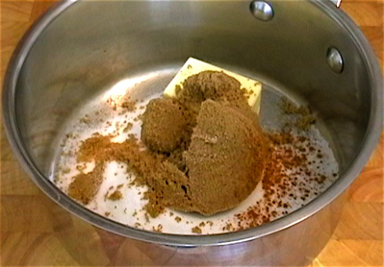****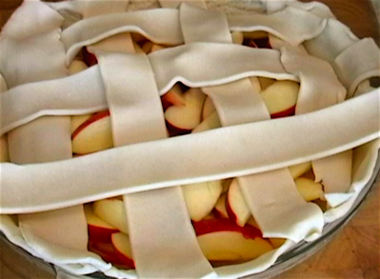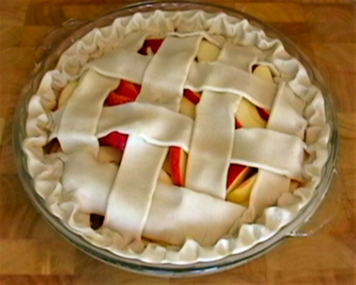

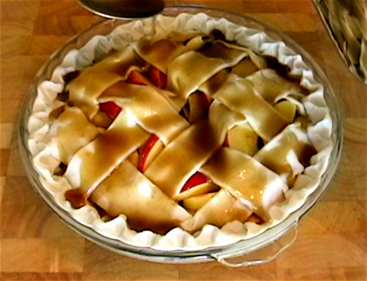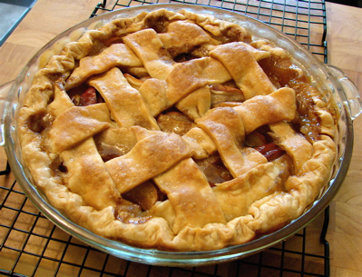

**Worksheet 3** (Apple pie recipe-Fill in the blanks)

**Preheat Roll out Stir Pour Measure Place Bake**

**Fold Boil Slice Seal Peel Fry**

1. _________ the sugar, brown sugar, butter, salt, cinnamon, and water into a

saucepan.

2. ________ the caramel sauce over medium heat. When the sauce is boiling, turn

off the heat.

3. ________ the bottom crust into a 9‐inch pie dish, and press into shape.

4. ________ each apple into approximately 12 wedges. ______ the apples into

the bottom crust.

5. __________ the top crust and cut into 8 strips. Place 4 strips one way, turn and

place 4 strips across the others.

6. Once the web top is in place, go around the pie and _______ together the top

and bottom crusts. Using your fingertips, go around and _____ the edge of the

crust.

7. Using a large spoon, _______ the caramel sauce over the top of the apple pie.

Try not to get any of the syrup on the outside edge of the piecrust if possible.

8. ________ the oven to 425 degrees F. _______ the pie in the hot oven for 15

minutes, then reduce the heat to 350 degrees F., and bake for 30‐40 minutes,

until the pie is browned. Remove and let cool completely.

**Ingredients:**  
6 large red apples, sliced   
1/2 cup sugar   
1/2 cup brown sugar   
6 tbsp unsalted butter   
pinch of salt   
1/4 tsp cinnamon   
1/4 cup water   
1 package (15-oz) Pillsbury Pie Crust, or pie dough for a double-crust 9" pie

|  |  |  |  |
| --- | --- | --- | --- |
|  |  |  |  |
|  |  |  |  |
|  |  |  |  |
|  |  |  |  |

Bingo card