Listening Lesson Plan

Topic : COOKING

Instructor | Level | Students | Length
Yujin Hong | Upper intermediate | 16 | 50 minutes

Materials
-3 pictures of cuisine
-Listening CD and CD player
-Student work sheet 1 (17 copies)-Comprehension questions
-Student work sheet 2 (4 copies)-Vocabularies matching task
-Student work sheet 3 (4 copies)-Cooking vocabularies
-Transcription of listening materials
-Transcription text to fill in the blanks
-White board and board markers
-S.O.S Activity worksheet
Aims
Main Aims
-At the end of this lesson, students should have improved their listening skills by listening to CD and practiced speaking by discussing with group members and during pair works .
Second Aims
Students should have
- practiced listening to real-life speech of people with various accent and learn vocabulary and expressions related to cooking and recipe
- been able to pick up details from the short news by answering detailed questions on a Worksheet.
- practiced writing a recipe of the cuisine.
Personal Aims
- I want to improve time management skill.

Language Skills:
- Reading: Student Worksheets 1, 2, 3.
- Listening: the speakers’ short speech about a cooking lesson and about recipe of some cuisines, teacher’s instruction and classmate’s opinion in a discussion.
- Speaking: prediction, discussion and comparing answers with group members. Also answering teacher’s individual questions.
- Writing: Writing a recipe with group members.

Language Systems:
- Lexis: vocabulary related to cooking and recipes and various situations.
- Grammar: None to discuss.
- Phonology: British and various accents of English language.
- Discourse: Group discussions and expressing their thoughts and opinions.
- Function: Sharing their ideas of cooking and interact with each other

Assumptions:
- Students already know how the class usually runs.
- Students are in upper intermediate level and are able to express their ideas and discuss freely in English..
- Some of them enjoy cooking and the others don’t.

Anticipated Errors and Solutions:
- Student may not be able to understand the details from the listening : Chunk the listening (pause-play-pause-play).
- Some students might not be active in group discussion : Encourage these students to participate
If activity takes too long : Shorten remaining activity or give time warning
If activity finishes too soon : Ask additional questions or go to S.O.S activity.

References
http://www.teachingenglish.org.uk/sites/teacheng/files/cooking-britain-lesson-plan.pdf
http://www.bbclearningenglish.com/recipe

Lead in
Materials: Board and board marker
Time | Set up | Procedure
3  min. | Whole class | Greetings  Ask students how their weekend was.  Ask them if they had a nice weekend dinner and whether they cooked it or went out to a restaurant.  Also ask them if they have a cooking lesson experience.  Get students answer and respond to them.  Elicit the good and bad points and write them on the board.

Pre-Activity
Materials: Listening CD & CD Player (Tracks 2-4), board and board marker

Time | Set up | Procedure
4 min. | Whole  class | Instructions for prediction  Show 3 pictures of cuisines to students one by one but do not identity them in order of tracks.  Tell students that these 3 pictures are the 3 recipes of the cuisine that they are going to listen to.  Ask students to guess about taste, flavor and ingredients of these cuisines.  Eliciting  Elicit vocabulary used to describe the taste, the flavor of the cuisine.  Write down on board what student talk about the taste of the cuisine.

Main Activity
Materials: Listening CD & CD Player, Student Worksheet 1, 2, 3, transcription text to fill in the blanks, board, board marker and transcription of listening materials

Time | Set up | Procedure
3 min. | 4 groups of 4 | 1. Listening for the main idea (general understanding)  Instructions for 1st listening  Tell students that they are going to listen to a news about the cooking lesson in England.  Tell them not to take notes and try to listen for the general feeling of the news and inform them you will only play once.  CCQ  What are you supposed to listen?  Can you take notes?
5  min. | 4 groups of 4 | 2. Listening for the details  Instructions for 2nd listening  Tell students that you will play the recording again and this time they can take notes.  Ask students to summarize the idea about the news in groups.  CCQ  What are you supposed to do?  Are you working together?
12  min. | 4 groups of 4 | 3. Listening for complete understanding  Instructions for 3rd listening  Tell students that this is the last time to listen to the recording.  Inform them that they will do the comprehension questions with worksheet 1.  CCQ  Could you repeat what I ask you to do?  Ask students of each group to give a summarized idea of the news and imagine the best title of this news and compare the answer with students.  Check the answers of comprehension questions.
8  min. | 4 groups of 4 | 4. Work with worksheets and transcription text.  Ask students to answer to the questions of worksheets 2 and 3, and after that, ask them to fill in the blanks of the transcription text.  Elicit the vocabulary of cooking and other new vocabularies.

Post-Activity
Materials : Board and marker

Time | Set up | Procedure
10 min. | 4 groups of 4 | Instructions for creating a recipe  In the groups, ask students to choose their favorite dish and write down the recipe of the cuisine to share in the class.  You have to create your own recipe in your group.  CCQ  Are you working with whom?  Eliciting some information.  Monitor actively and participate with in each group.
5 min. | 4 groups of 4 | Ask students of each group to present their recipe together.  Elicit today’s new vocabularies.  Wrap up by summarizing what we have learned today.

S.O.S ACTIVITY
Materials : Board and marker, S.O.S Activity worksheet

Time | Set up | Procedure
10  min | 4 groups of 4 | Tell students that we will do an exercise about ‘describing food’.  Give each examples of food (ice cream, popcorn, egg, apple) to each groups and ask them to think of an adjectives to describe the food.  Write examples up on the board from students. Clarify any new vocabulary that comes out of this exercise.  Give out the worksheet to students and let them compare it to their work.
5  min | 4 groups of 4 | Ask each groups to write a clue of their own food, for the rest of the class to guess.  After everybody has finished, let each group come out and present their writing and make the rest of the students to guess.

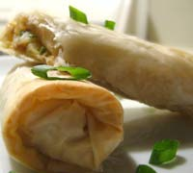

What’s the name of this dish ?

How can we make it?

Guess the recipe of this dish.

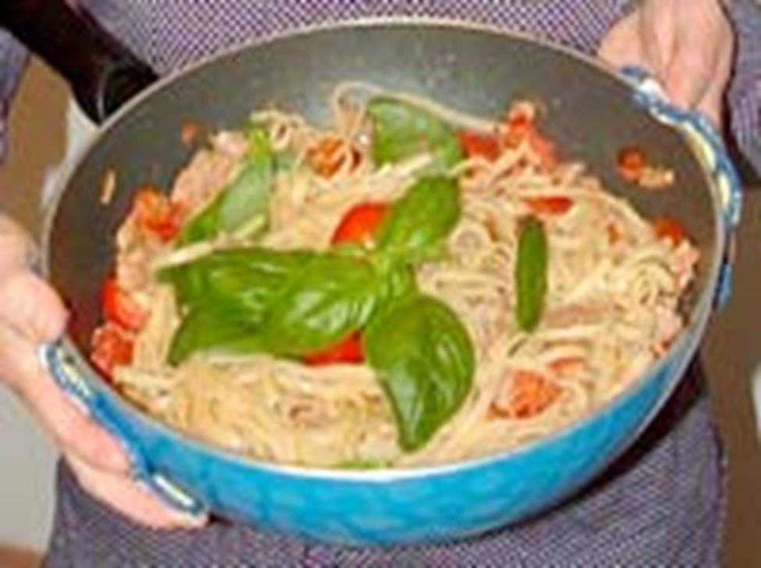

What’s the name of this dish ?

How can we make it?

Guess the recipe of this dish.

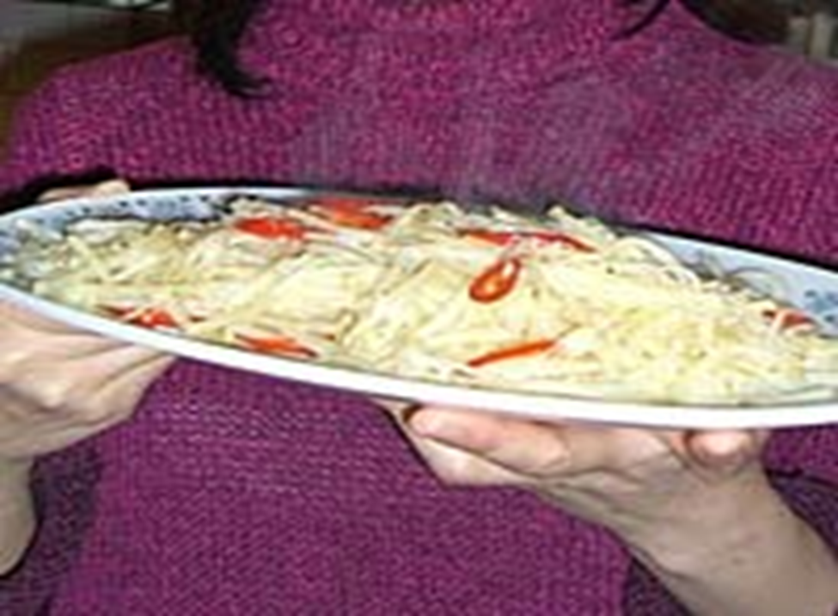

What’s the name of this dish ?

How can we make it?

Guess the recipe of this dish.

- Spaghetti with tuna fish

Ingredients
- 300g tuna fish ( if possible , buy it at the local market) in olive oil
- 300g spaghetti
- 250g fresh tomatoes
- 10 basil leaves
- 2 spoonfuls of oregano

Instructions
Cut the tomatoes and put them in the large pan with olive oil, salt and a lot of oregano
- Cook them for about 15 minutes.
- Add the tuna fish, cut in small pieces and let it cook for 2 minutes.
- Put spaghetti in a pan of boiling water and cook until ready (al dente).
- Drain the pasta and add to the tuna and tomato mix, stirring constantly, and serve immediately with a lot of basil.

2. Lemon potatoes

Ingredients
- 1 large potato (or 2 medium)
- 1 lemon
- 3 cloves of garlic (or spring onions if you prefer)
- ½ a red chilli
- oil
- salt
- sugar

Instructions
- Peel, wash, slice the potato Then shred the slices as finely and delicately as possible.
- Put the potato in to a colander (or sieve) and rinse in cold water to wash away the starch.
- Cut the lemon in half and squeeze out the juice into a bowl.
- Mix the lemon juice with some salt and sugar, to your taste.
- Chop the red chilli into small slices.
- Chop the garlic (or spring onions) into fine pieces.
- Heat the frying pan and put in some cooking oil to heat for 1 minute till it gets very hot.
- Add the chili and garlic in to stir for 10 seconds.
- Add the potato in and stir for 2 minutes.
10. add the lemon juice already mixed with salt and sugar and stir for 5 seconds.
11. The dish is ready.

3. Spring rolls

Ingredients
- 8 spring roll skins
- 2 oz thinly sliced pork, cut into thin strips (if you prefer vegetarian, you do not need to include the meat!)
Sauce mixture:
- 1 teaspoon Chinese rice wine or sherry
- 1 teaspoon soy sauce and cornstarch
- A few grains of pepper
- 2 large dried Chinese mushrooms, soaked in water, drained and cut into strips
- 2.5 oz boiled bamboo shoots, cut into strips
- 2 cabbage leaves, cut into strips
- Half a teaspoon salt
- Flour-and-water paste (mix a little flour and water to make a paste: this will be used to "glue" the spring roll together
- Oil for deep frying plus 4 tablespoons more of oil

Instructions
- Combine the pork with the sauce mixture. Let sit for 15 minutes.
- Heat 3 tablespoons of the oil in a wok, and stir-fry the pork briefly. Remove.
- Heat the remaining 1 tbsp oil and add the salt. Stir fry the vegetables, then mix in the pork. Turn off the heat and let the filling cool thoroughly.
- Place some of the filling a little above the centre of each spring roll skin. Fold the upper edge over the filling, turn in the 2 sides, and roll it down to the bottom. Brush the bottom edge with the flour-and-water paste to seal it thoroughly.
- Heat the deep-frying oil over moderate heat. Deep-fry the spring rolls until golden. Turn them frequently.
- Serve immediately with table seasonings.

TESOL LISTENING LESSON PLAN
STUDENT WORKSHEET 1

COMPREHENSION QUESTIONS
Are the following sentences true or false?

1 | In the past, learning to cook was a key part of  learning in the English education system. | T/F
2 | In the last 20 or 30 years cooking has become even more important English schools. | T/F
3 | The schools minister wants all pupils to be able to  cook like professional TV chefs. | T/F
4 | At the moment there aren't enough teachers who  know how to teach practical cooking because recentlyteachers have been teaching about food rather than  about how to cook. | T/F
5 | Pru Leith thinks cooking is fun for children and that learning how to do it will help them a lot when theyleave school when they are older. | T/F
6 | If people don't change the way they eat, in less than 30 years time 50% of all British people will be very  fat. | T/F

TESOL LISTENING LESSON PLAN
STUDENT WORKSHEET 2

VOCABULARY
Match these words and phrases to their definitions.
1. | Integral | A. | not enough teachers
2. | Peripheral | B. | knowledge that you can use all your  life, that will help you outside of school
3. | on the premises | C. | in the schools
4. | Obesity | D. | practical, making or doing something  with your hands
5. | to adapt | E. | essential, very important
6. | a shortage of  teachers | F. | the way that most people (here, British people) are behaving continues
7. | compulsory | G. | extreme fatness
8. | hands on | H. | to change so that they are suitable
9. | a life skill | I. | something you are obliged or have to  do
10. | current trends  are not halted | J. | minor, not as important as other things (here, school subjects)

TESOL LISTENING LESSON PLAN
STUDENT WORKSHEET 3

COOKING VOCABULARY
Match these cooking verbs to their definitions.
1. | peel | A. | cook by heating the food directly, for example, under a very hot surface in a cooker or on a barbeque
2. | chop | B. | heat food
3. | mix | C. | cook, for example fish, in gently boiling water or other liquid
4. | bake | D. | cook food in hot oil
5. | boil | E. | cut food into small pieces or  slices
6. | cook | F. | cut food into small pieces or  slices
7. | fry | G. | take the outer skin off, for example, a potato or apple
8. | grill  (or barbeque) | H. | use an electric microwave oven to hear orcook food
9. | microwave | I. | cook food in an oven
10. | poach | J. | combine ingredients together so that the  result cannot be separated into its original  parts

TESOL LISTENING LESSON PLAN
Fill in the blank

Cooking was once regarded as an ________ part of education in England - even if it was mainly aimed at girls. In recent decades cooking has progressively become a __________ activity in schools. In many cases the schools themselves have given up cooking meals in kitchens __ ___ ________. But the rising level of _______, has led to a rethink about the food that children are given and the skills they should be taught. Ed Balls is the minister in charge of schools.

"What I want is for young people to be taught how to do basic, simple recipes like a tomato sauce, a bolognaise, a simple curry, a stir-fry - which they can use then at home and in their later life, experiment with, discover the joy of food, having got the basics under control."

The new lessons are due to start in September but some schools without kitchens will be given longer __ _____. There is also likely to be _ ________ __ ________ with the right skills, since the trend has been to teach food technology rather than practical cooking. Also the __________ lessons for _____ __ cooking will only be one hour a week for one term. But the well known cookery writer, Pru Leith, believes it will be worth it.

"If we'd done this thirty years ago we might not have the crisis we've got now about obesity and lack of knowledge about food and so on. Every child should know how to cook, not just so that they'll be healthy, but because it's _ ____ _____ which is a real pleasure and we deny children that pleasure."

The renewed interest in cooking is primarily a response to the level of obesity in Britain which is amongst the highest in Europe, and according to government figures half of all Britons will be obese in 25 years if _______ ______ ___ ___ ______ .

TESOL LISTENING LESSON PLAN
Transcription of audio material

Cooking was once regarded as an integral part of education in England - even if it was mainly aimed at girls. In recent decades cooking has progressively become a peripheral activity in schools. In many cases the schools themselves have given up cooking meals in kitchens on the premises. But the rising level of obesity, has led to a rethink about the food that children are given and the skills they should be taught. Ed Balls is the minister in charge of schools.

"What I want is for young people to be taught how to do basic, simple recipes like a tomato sauce, a bolognaise, a simple curry, a stir-fry - which they can use then at home and in their later life, experiment with, discover the joy of food, having got the basics under control."

The new lessons are due to start in September but some schools without kitchens will be given longer to adapt. There is also likely to be a shortage of teachers with the right skills, since the trend has been to teach food technology rather than practical cooking. Also the compulsory lessons for hands on cooking will only be one hour a week for one term. But the well known cookery writer , Pru Leith, believes it will be worth it.

"If we'd done this thirty years ago we might not have the crisis we've got now about obesity and lack of knowledge about food and so on. Every child should know how to cook, not just so that they'll be healthy, but because it's a life skill which is a real pleasure and we deny children that pleasure."

The renewed interest in cooking is primarily a response to the level of obesity in Britain which is amongst the highest in Europe, and according to government figures half of all Britons will be obese in 25 years if current trends are not halted.

Tesol Listening Lesson Plan
S.O.S Activity

This food is soft and it tastes sweet. It is made from cream, sugar and fruit or
chocolate. It is eaten very cold, usually in summer. (ice cream)
This food is crunchy and it can be salty or sweet. It is often eaten in the cinema.
(popcorn)
This food is hard on the outside, but usually soft in the middle. It is very versatile
and is used to make lots of sweet and savoury dishes. In the UK people also eat it
on its own for breakfast or in a sandwich.(egg)
This food is usually hard and crunchy, and it is red or green in colour. People
often use it to make desserts, eg pies. (apple)
•

