Task-Based Lesson Plan Template

X Listening X Speaking Reading Grammar Writing
Topic: What Color Is It?

Instructor:  Tiffany  (Eunkyung Jang) | Students Age – Competency Level  6-7 years old, Beginner | Number of Students:  10 | Lesson Length:  52 min
Materials:
Yellow Puppet ‘Pipi’*
Board and Makers
Blank papers
Colorful Crayons
Pipi’s Tree Wall Chart
Flash cards *
10 copy of colorful apple pictures
Some Duc tapes
Smart phone for Mp3
Mp3-Color Song

Aims: (What students will be able to achieve by participating in the activities of the lesson.)

Ss get comfortable and interested in lesson by T presentation and attitude.
Ss will improve listening, writing, and speaking skills by searching color cards, repeating a memory game, sharing what color they have and sing a ‘color song’ in class.
Ss will learn name of colors by following T direction and demonstration, practicing, and singing.
Ss will learn how to move by following T direction

Language Skills: (Lists what language skills students will be using by participating in the activities of the lesson.)

- Reading : flash cards, search the hidden apple cards
- Listening: teacher, students presentations and the song
- Speaking: Sharing the what color they have, playing memory game and singing the song
- Writing: Dictate the spell with colorful drawing of Puppet

Assumptions: (What students must already be able to do and what concepts must already be mastered before the lesson in order to achieve the aims of the lesson.)

Ss will enjoy and also have fun
Ss will like Pipi and willing to help Pipi to search lost colorful apples
Ss will love Pipi and will easily share their apple cards with friends who don’t have any cards when Pipi is asking
Ss will easily learn how to pronounce colors by practicing sound and playing games
Ss have already heard the song with same melody ‘Head and shoulder’ before
Ss can easily follow directions to stand up, turn around, sit down and stretch up

Anticipated Errors and Solutions: (What things might go wrong in the lesson and what the solution will be)

Mp3 doesn’t work, teacher will sing the song by self and help Ss follow the direction
Activity takes too long; the other activity may be shortened.
Ss have difficulty to draw Pipi; simplifier the drawing
Ss might be shy, teacher give encouragement.
References:

Pre Task (Warm-Up Part to activate and create interest in the lesson)
Materials: Yellow Puppet ‘Pipi’
Board and Markers
Blank papers
Colorful Crayons

Time | Set Up | Student Activity and Goals | Teacher Talk – Instructions an Procedures
1 min  3 min  2 min  3 min  3 min | W  S | Greet teacher  Ss listen – become interested  Ss learn how to draw Pipi  SS choose one crayon and draw Pipi  Sharing their colorful pics  Listen to T  Write down the spelling | Greet students  T shows colorful puppet “Pipi”*  Draw Pipi on the board  Hands out papers  T asks Ss to choose 1 crayon and draw Pipi  T asks Ss to share. Say and spell the color  (It’s red/ R.E.D Red!)

Task Familiarization Part (Input Stage, the main purpose is to introduce the key language needed for the Main Activity)

Materials:
Materials: Puppet ‘Pipi’
Pipi’s Tree Wall Chart
Flash cards *
10 copy of colorful apple pictures

Time | Set Up | Student Activity and Goals | Teacher Talk – Instructions an Procedures
1min  6min  1min  1min  4min  2min  1min | Whole  G  W | Ss see the tree and guess  Ss listen to the PiPi  Learn names of colors  Bring chairs and make a circle  Make 2 groups  Ss walk around  Find and read cards  Back to the circle seats  Count total apples in group  Feel achievement | Put wall chart with a big tree pic on the board  Play a sad Pipi role. Pipi lost her apples.  Explain 8 colors of apples using wall chart  Let Ss make a circle with chairs/  Grouping -2 groups  Let Ss to search hidden 10 apple pics* in the classroom (hide pics where Ss can easily find)  Let Ss back to the circle and sit down  Ask each team total of their apples  Pipi thanks to Ss

Task Realization (Task Production Using the Key Language to participate in a productive way or activity)

Materials:
Puppet ‘Pipi’
10 copy of colorful apple pictures
Some Duc tapes

Time | Set Up | Student Activity and Goals | Teacher Talk – Instructions an Procedures
2min  3min  1min  2min  5min | S  W | Share apple pics  Every Ss have own card  Share their colors  Recheck the name of colors  Become interested.  Stick pics on their chest  Listen T and learn how to play the game  Repeat colors by playing the game | Pipi helps Ss to share pics with friends with no apples  Ask each S what color they have  Give Ss duc tapes  Ask Ss to stick their apples on the chest  (colored side up)  Using colors Ss have,  show Ex. of “Memory game” with Pipi  (I am Red/ I am Red & Blue/ I am Red blue &….)  Let Ss play the game

Post Task (Activity show that students have personalized the language presented and wraps up the lesson on a high note)

Materials: Smart phone for Mp3
Mp3-Color Song

Time | Set Up | Student Activity and Goals | Teacher Talk – Instructions an Procedures
1min  1min  2min  4min  3min | W  S  S  W  W | Follow T directions  Become interested  Ss answer/ remind their color  Follow T directions  On acting start to sing  Ss sing a song and follow instructions  Ss Good bye | Let Ss do 4 actions  1.stand up/ 2.turn around / 3 stretch up / 4.sit down  Ask Ss who is what color  Let Ss do 4 actions only who are called  (Red stand up/ Yellow sit down)  Play actions with instructions same as “color song”  -step 1, act and sing without melody  -step 2, act and sing a song with melody  Play the mp3 “Color Song”  Let Ss sing and act together  Congratulate and thank Ss for active participation

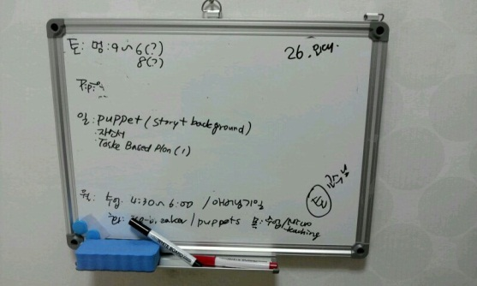
Materials
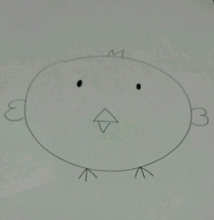
*(1) Yellow puppet ‘Pipi’ (2)
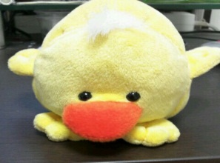

*(3) (4)
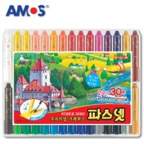
10 copy

*(5)

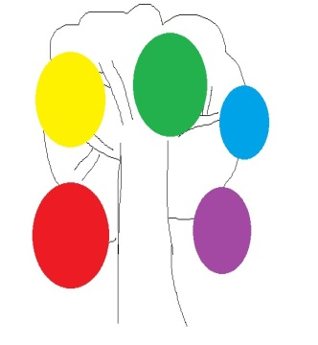

RED
YELLOW
BLUE
GREEN
PINK
PURPLE
BROWN
TAN
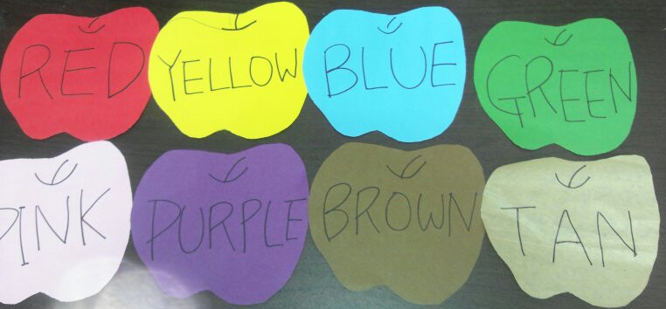
*(6)

RED
YELLOW
BLUE
GREEN
PINK
2 PURPLE
2 BROWN
TAN
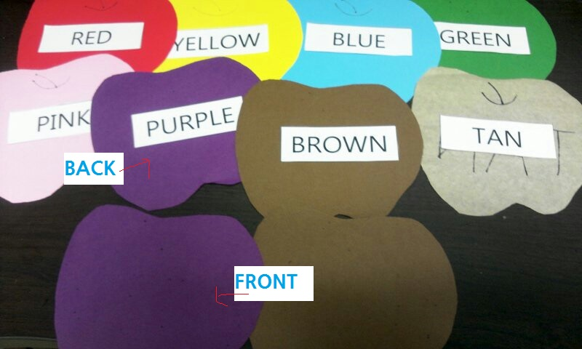
(7)

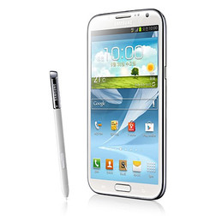
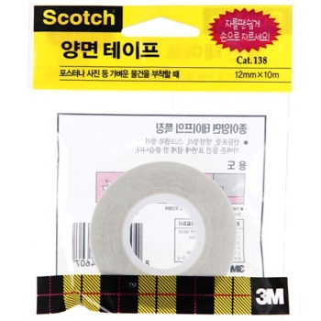
*(8) *(9)

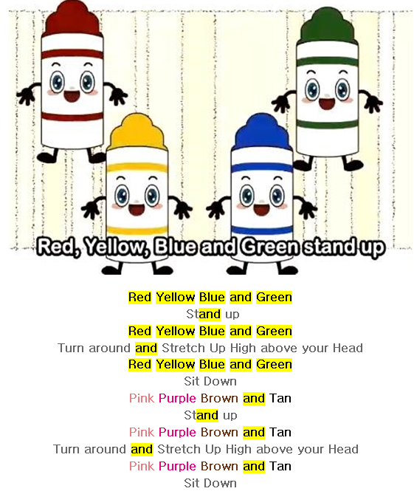
*(10)

