Speaking

Topic: House hunting

Instructor:Fiona | Level:Intermediate | Students:16 | Length:  45 Minutes

Materials: A eliciting picture
Dialogue sheet with questions
Form for house hunting
Long term hotel information
Worksheet for comparison between house and apartment

Aims: To brainstorm vocabulary related to the house hunting, renting, amenities
To integrate speaking and listening skills into the activity
Role-playing for hotel manager and client
Speaking about merit and demerit living in an apartment or a house

Language Skills:
Reading : Dialogue sheet, hotel information leaflet
Listening : Partner’s speaking while roleplaying and discussing
Speaking: Practicing in roleplaying , discussing about merit and demerit
Writing : Making client form, describing about merit and demerit

Language Systems:
Lexis : vocabulary used in dialogue, related to topic
Function : discussing, answering, inquiring, explaining, suggesting
Grammar : I would like + to infinite form, present, future tenses
Discourse : General use of inquiring about hotel information

Assumptions:
Students are familiar with some of the vocabulary related to house renting and buyung
Students are familiar with present, future tenses
They may think about good environment through comparison between apartment and house
Roleplaying for Hotel inquiry will be helpful for reserving hotel room in real life

Anticipated Errors and Solutions:
- Students may be got stuck on some words
: provide further explanation
- Students may not be familiar with amenities provided by Hotel
: pre-teaching is required

References:
On tesol/TEFL program

Ice Breaker
: Whispering to deliver message by groups

Lead-In
Materials: An eliciting picture
White board and tape

Time | Set Up | Procedure
3min | Whole class | Show the picture to elicit the word ‘house hunting’ one by one  Asking some questions.  Stick a picture on the board

Pre-Activity
Materials : Dialogue sheet with questions

Time | Set Up | Procedure
10min | Whole class | Hand out dialogue sheet  Have students read and write the answer of questions  Teacher define some housing vocabulary (amenities, utilities etc.)

Main Activity
Materials: Client form

Time | Set Up | Procedure
22min | Indivi  dually  in group | Hand out Client form and have students write on them  Give them 3min.  Hand out hotel information sheet and have students fully understand for roleplaying  Give them 7min.  Roleplaying for 12 min.  Students practice into pairs using client form and hotel information  One is client, the other is hotel sales manager and exchange roles in a group  CCQ.  How many time do you exchange roles?  Feed back

Post Activity
Materials: Comparison sheet between house and apartment

Time | Set Up | Procedure
10min | Individually  In a group | Hand out comparison sheet  Have students describe merit and demerit individually and have them discuss in a group  Give them 8min.  CCQ  What can you do to improve the demerit?  Feed back  Review what they have learned about ‘house hunting’

SOS Activity
Materials: Worksheet for house advertisement

Time | Set Up | Procedure
10min | Individually  In a group | Hand out worksheet for making classified advertisement ‘For rent’  Ask students to write an advertisement for the house on the picture to rent out  Give them 3 min.  Have students read out their ad and compare in a group  : Share their ideas if the rental charge is reasonable or not  and amenities provided.

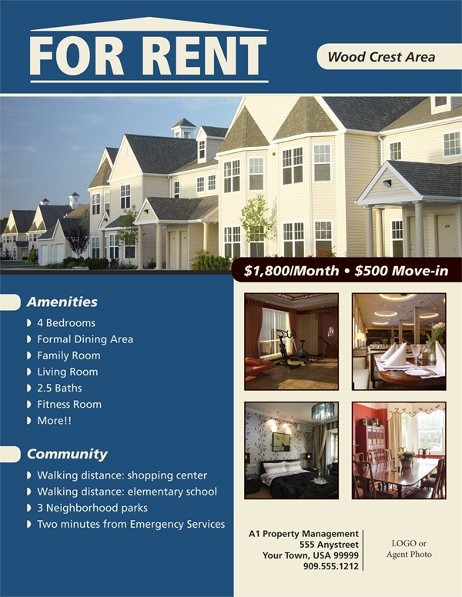

Agent : Hi Welcome to Rental Property Management. How may I help you?
John : Hi, yes. I’m looking for renting a two-bed room apartment.
Agent: Okay If you have a seat, one of our staff will be with you in a moment.
John : Thank you
Jerry : Hi, my name is Jerry Mcquire.
John : Hi, I’m John Hamington.
Jerry : Hi, Mr. Hamington. So that we will be able to match your needs better, I would like to ask you a few questions before I show you what we have available. First, what price range are you interested in?
John :Somewhere between $400-450 a month.
Jerry :Okay, Did you have any specific location in mind?
John : Well, I would like to live somewhere near the foreign school.
Jerry : When would you like to move in?
John : On the first of the month.
Jerry : Okay, Are there any other amenities which you would like to have? For example, a dishwasher, a balcony, a swimming pool or central air conditioning?
John : I would definitely like to have a dishwasher, and with summer like these, central air! A balcony is not that important. Oh, yes, and two bathrooms would be nice.
Jerry : Okay. Here are photos of the apartments we have available which fit your preference.
John : Thank you. This one in UN Village looks nice. I would like to see that one. And the one on Main street.
Jerry : Sure. Let’s go to take a look at them. If you choose to rent one of them, we will need a damage deposit of $250. You will be responsible for all the utilities. You can sign a lease today, If you like
John : Great! Thank you
Questions.
- Does John want to rent or to buy an apartment?
- Where does john want to live?
- When does John want to move in?
- How much can John pay each month for rent?
- What does John want to have as amenities?
- How much does John deposit for any damage?

Client Form for House Hunting
Specific location/condition :  House type:  Budget per month:  No. of Room  Amenities :  Move in Date: | Specific location/condition :  House type:  Budget per month:  No. of Room  Amenities :  Move in Date
Specific location/condition  House type:  Budget per month:  No. of Room  Amenities :  Move in Date | Specific location/condition  House type:  Budget per month:  No. of Room  Amenities :  Move in Date
Specific location/condition:  House type:  Budget per month:  No. of Room  Amenities :  Move in Date | Specific location/condition  House type:  Budget per month:  No. of Room  Amenities :  Move in Date
Specific location/condition  House type:  Budget per month:  No. of Room  Amenities :  Move in Date | Specific location/condition  House type:  Budget per month:  No. of Room  Amenities :  Move in Date

Describe about your opinion about living in apartment or house and discuss about it in a group
- House with yard
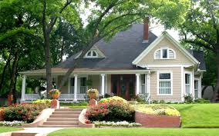 | Merit  1. | Demerit  1.

- Apartment
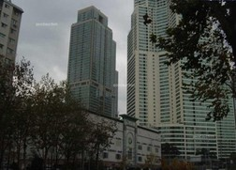 | Merit  1. | Demerit  1.

- Write an advertisement of the following house to rent out
- Include size, price, location and other amenities offered etc.
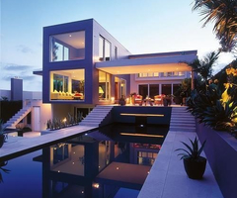 | 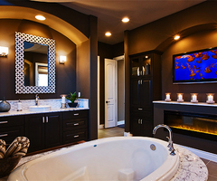 | 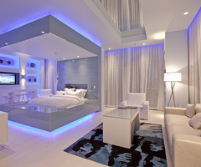

T H E G R A N D S U I T E
Type | : | Serviced Residence Apartment [Hotel]
No of Units | : | 105 apartment units in three buildings of 12 stories
Location | : | - Located 7 km or 15 minutes from Seoul City Hall, and 56 km or 40 minutes from Incheon International Airport [ICN].  - Located to Grand Hilton Seoul, surrounding Mt. Baekryun offers fresh air and scenic view in Seoul.
Benefits | : | - Residence Staff are fluent in numerous languages and offer five-star hotel service to ensure guests feel perfectly at home.  - The Grand Suite is fully furnished with separate living, dining, kitchen and bedroom areas. Units ranges from two to five bedrooms.  - 24-hour reception, security, and CCTV.  - Use of 25-meter indoor swimming pool, aerobic space, and fitness center with various fitness equipments.  - Complimentary shuttle bus service to downtown Seoul and Itaewon (shopping district)  - Indoor Children's playroom and play facilities.  - Located 5 minutes from Seoul Foreign School and Seoul Foreign British School [School bus stop at door]  - Special discounts for 7 restaurants and sauna at Grand Hilton Seoul.  - Gas, Water, and Electricity bills are included in room charge.  - Free rental for kitchenware, cookware, cutlery, etc.  (Seperate charges will be added for the usage of wine glasses if ordered)  - Washing & dry machines, dishwasher, vacuum cleaner, microwave, gas range, TV, audio components, DVD/CD, (CNN, BBC, Movie Channel, Children's Channel, etc) are provided  *Furnished items may be different according to room types  - VDSL high speed internet and voicemail access  *VDSL service is available when requested at least one day before usage.  (additional charge KRW 70,000, Service charge and tax are not included.)  - *These benefits are available only to long-term guests.  (Short-term or package guest are not privileged for above benefits.)
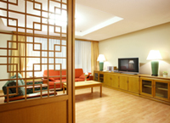  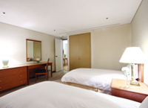  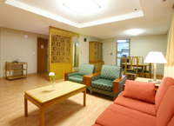  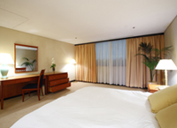 |  |  | RESIDENCE TYPE  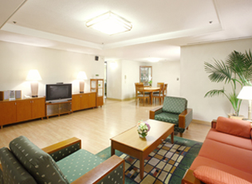
  Type | 2 Bedroom | 3 Bedroom | 4 Bedroom | 5 Bedroom
  Unit | 38 | 37 | 28 | 2
  Size | 96 m² | 140 m² | 182 m² | 216 m²
  View | Hotel/  Mountain | Hotel/  Mountain | Hotel | Hotel
  Livingroom | 1 | 1 | 1 | 1
  Kitchen | 1 | 1 | 1 | 1
  Bathroom | 1 | 2 | 2 | 3
  RACK RATE INFORMATION (KRW)
  Quoted price is negotiable based on term and condition.
  Daily | 208,000 | 256,000 | 304,000 | 336,000
  Monthly | 6,240,000 | 7,680,000 | 9,120,000 | 10,080,000
  FLOOR PLAN
  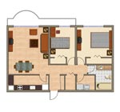 | 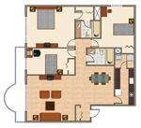 | 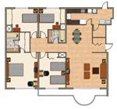
  2 Bedroom | 3 Bedroom | 4 Bedroom

