Listening Speaking Reading Grammar Writing
Topic: Meet The Shapes
Instructor:  Sookyung Lee | Students Age – Competency Level:  5-6 years old, Upper Beginner | Number of Students:  6 | Lesson Length:  50min
Materials: Box
Picture of Things with Five Shapes (Circle, Square, Triangle, Rectangle, Star)
Shapes Worksheet – Color & Draw
Shapes Worksheet – Color
Crackers and Cookies
Play Dough
Toothpicks
MP3 Player and MP3 Song– “Hokey Pokey”
Aims:
- The students will be able to accurately identify shapes by having completing lesson on the characteristics of each shape
- The students will be able to draw each shape by having students do Task Familiarization (‘Drawing and Coloring Shapes Worksheet’)
- The students will be able to name defining characteristic of each shape by having students do Task Realization (‘Making and Creating Shapes Activity’)
- The students will be able to recognize and name each shape by having students do Post Task (‘Playing with Shapes’)
Language Skills:
- Reading: Worksheet
- Listening: Teacher Talk, Ss short presentations and song “Hokey Pokey”
- Speaking: Answer Teacher questions, Ss short presentations and singing song “Hokey Pokey”
- Writing: The students will draw 5 shapes and name them
Assumptions:
- The student knows the basic structures and types of the shapes
- The student is expected to name the basic five shapes
- The student is expected to be able to sing “Hokey Pokey” without lyrics
Anticipated Errors and Solutions:
- If the time is short, cut post-activity short
- If students finish their tasks earlier than anticipated, ask as many students as possible to make sentences with shapes by identifying the shapes or telling the characteristics of the shapes
- Students may not be able to follow the direction easily then repeat and explain over and over again until he/she understands it or make it easier.
- Students might have difficulties doing activities then show hints, examples, or suggestions.
- Students may not know the song then listen and sing more times together (chunk listening; pause-play-pause-play)
References: Pictures, Google Images
“Hokey Pokey”, Youtube

Pre Task (10mins)
Materials: Box (***)
Pictures of Circle (basketball)
Pictures of Square (gift box)
Pictures of Triangle (triangle)
Pictures of Rectangle (smart phone)
Pictures of Star (star)
Crayons
Shapes worksheet
Time | Set Up | Student Activity and Goals | Teacher Talk – Instructions and Procedure
1min  2min  3min  3min  2min | Whole Class  S | Greet Teacher  Ss listen – become interested and respond to T  Ss participate and respond  Draw and color the worksheet  Sharing ideas | Greet Students  T shows what’s in the box. Ask Ss if they know what shape the picture is.  Then Ss to pick a picture in the box and say what it is and what shape it is  Allow Ss to draw and color the Shapes worksheet.  Ask Ss to share what they draw for each shape.

Task Familiarization (15mins)
Materials: Crayons
Shaped Worksheet
1 Box of Round(Circle-shaped) Ritz Crackers
1 Box of Square Saltine Crackers
1 Bag of Triangle Tortilla Chips
1 Box of Rectangle-shaped Wafer Cookies
1 Bag of Star-shaped Chips
Ritz Cracker Pictures
Saltine Cracker Pictures
Tortilla Chip Pictures
Wafer Cookie Pictures
Star-shaped Chip Pictures
Time | Set Up | Student Activity and Goals | Teacher Talk – Instructions and Procedure
3min  5min  7min | Whole Class  S | Ss listen and learn the shapes  Ss listen and color the shapes  Look for the shapes that they’ve been assigned then tell/share the name of the shape to the class. | T introduces characteristics (shapes/corners) of 5 shapes with pictures such as “Rectangle has 2 long and 2 short sides and 4 corners”  Handout Shapes worksheet and give directions such as “Color the Circles Red” or “Color Yellow the shape that has 4 sides”  Assign each different shape to each Ss. Such as “S, find the shape that has 3 sides and 3corners”. Have Ss look for the shapes they’ve been assigned, pick it up, and name it to the class.

Task Realization (15mins)
Materials: Play Dough
Toothpicks
5 Shapes (Circle, Square, Triangle, Rectangle, Star) made with play dough and toothpicks
Time | Set Up | Student Activity and Goals | Teacher Talk – Instructions and Procedure
1min  7min  7min | Whole Class  S | Ss listen and respond to T  See T’s direction then make 5 shapes with play dough and toothpicks  Create new shapes using five shapes that they made then share their new figures | T shows 5 play dough/toothpicks shapes (circle, square, triangle, rectangle, star). Ask Ss to name the shapes.  T presents how to make shapes with play dough and toothpicks. Hand out play dough and toothpicks. Then allow Ss to make 5 shapes with it.  Ask Ss to create shapes with 5 shapes that they made (Ss can make more). T shows Ss making house with Square and Triangle. Then ask Ss to share their new figure.

Post Task (10mins)
Materials: MP3 Player
MP3 – Song “Hokey Pokey”
5 Shapes that Ss colored previously
Time | Set Up | Student Activity and Goals | Teacher Talk – Instructions and Procedure
3min  7min | Whole Class | Ss come out to the classroom with the shapes then listen and join in with T  Spread out the shapes  Sing and dance the “Hokey Pokey” with the shapes | Have Ss stand with shapes that they colored previously. Play song of “Hokey Pokey”. T sings and dance along with the Hokey Pokey Shape Song.  Spread out the shapes near his/her feet.  Ask Ss to sing and dance the “Hokey Pokey” with the shapes. Call the shape out before each verse, so Ss can pick up the shape and then dance with it.

Pre Task
 |  | 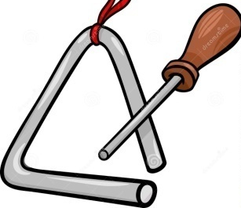
CIRCLE | SQUARE | TRIANGLE | RECTANGLE | STAR
Task Familiarization
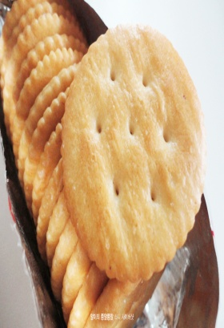 | 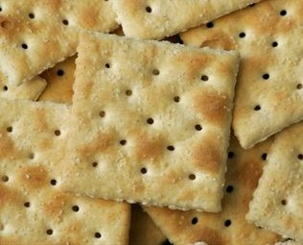 |  | 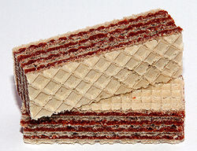
Task Realization
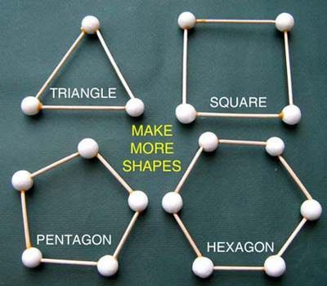
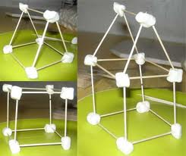
Post Task
<Sing and dance along with the Hokey Pokey Shape Song>

T : “Circle!”
Ss pick up circle
T & Ss: “You put your circle in, you put your circle out.
You put your circle in and you shake it all about.
You do the Hokey Pokey, and you turn yourself around.
That’s what it’s all about!”
T : “Square!”
Ss pick up square
T & Ss: “You put your square in, you put your square out.
You put your square in and you shake it all about.
You do the Hokey Pokey, and you turn yourself around.
That’s what it’s all about!”
T : “Triangle!”
Ss pick up triangle
T & Ss: “You put your triangle in, you put your triangle out.
You put your triangle in and you shake it all about.
You do the Hokey Pokey, and you turn yourself around.
That’s what it’s all about!”

T may also allow the Ss to take turns calling the shapes.

