Grammar Lesson Plan
Topic: Used to

Instructor: Sophie  (Soyoun Jung) | Level:  intermediate | Students:  16 | Length:  45 Minutes

Materials:
- Pictures 1: famous stars.
- Worksheet 1: ‘used to’ song (16copies)
- Worksheet 2: Lyrics (16 copies)
- Picture 2: Time concept.
- Picture 3: Substitution table.
- Worksheet 3: Role cards and data worksheet (4 copies)
- Worksheet 4: Practice worksheet (16 copies)
- Worksheet 5 : SOS activity
- Whiteboard, markers

Aims:
At the end of this lesson,
- Students should have been able to practice the form “used to”
- Students should have been able to change the statement form into negative and question form.
Personal aims:
- I want to deliver explicit instructions by speaking slowly and clearly.

Language Skills:
- Speaking: answer the question about the pictures, Role play
- Reading: Lyrics worksheet, Role cards
- Writing: Lyrics worksheet, Data worksheet, Practice worksheet
- Listening: the song, teacher’s instruction, other students opinions

Language Systems:
- Grammar: ‘used to’ form
- Lexis: vocabulary and idioms related to habit, state, character…etc.
- Function: Questioning about people, Explaining about you in past and present.
- Discourse: general use of questioning about people.
- Phonology: pronounce of ‘used to’

Assumptions:
-The students are interested in role playing.
-The students will enjoy the Song ‘used to’

Anticipated Errors and Solutions:
- Students might have some troubles to do worksheet 1.
→ If necessary, play one more time.
- The post activity might take over time.
→ Homework.

Reference:
http://www.youtube.com/watch?v=Rm_tiWDwA7A (Song: ‘Used to’ by Daughtry)
http://www.youtube.com/watch?v=tCdMH8j3yyA (Lyrics)
http://movie.naver.com/movie/bi/mi/photoView.nhn?code=18852&imageNid=5020886 (Picture 1)
http://blog.naver.com/seunsub2?Redirect=Log&logNo=100165771223 (Picture 1)
http://busyteacher.org/8976-used-to-worksheet.html (worksheet 1,4,5)
Grammar in use essential – chapter25. ‘USED TO’ (picture 2)

Lead-In
Materials:
- Whiteboard, markers
Time | Set Up | Procedure
3min | Whole  students | - Greeting  - Eliciting  Tell students your past habit and let them know you don’t do it now.  Ask students how you can express it into a single sentence.  Elicit the form ‘used to’  - Motivation  Introduce today’s topic: Used to

Pre-Activity
Materials:
- Pictures 1: famous stars.
- Worksheet 1: ‘used to’ song (16copies)
- Whiteboard, markers.
Time | Set Up | Procedure
5min  5min  3min | Whole  students  Individually  Pair work | - Warmer: Quiz about celebrities.  Show students the picture 1(pictures of famous stars) and give a quiz about their previous job.  Tell students some episodes of the celebrities’ former job. And tell students that the stars don’t do it anymore.  Let students use the form ‘used to’ to explain the star’s state.  - Song ‘Used to’  1-1. A correct paragraph sequence in lyrics.  - Give instructions.  Explain the background of this song.  Distribute worksheet 1 to students.  Students should listen the song and set up the paragraphs in right order.  Let students do the question 1 with their group members.  - Ask I.C.Q. and run the activity.  ‘Will you read the lyrics?’ ‘No’  - Run the activity and check the answers  1-2. Filling in the blanks  - Give instructions.  Let students listen carefully and fill in the blanks in the question 2 in pairs.  - Run activity and check the answers.  - Ask C.C.Q and transition  ‘When do you use the form ‘used to’?’  ‘Does it mean you still be in former state?’ ‘No’  After C.C.Q, let students jump in to the main activity to study more detail about ‘used to’.

Main-Activity
Materials:
- Worksheet 2: Lyrics (16 copies)
- Picture 2: Time concept.
- Picture 3: Substitution table.
- Worksheet 3: Role cards and data worksheet (4 copies)
- Whiteboard, markers
Time | Set Up | Procedure
5min  5min  7min | Whole  students  Whole  students  Group  work | 1. Making a rule.  - Give instructions  Distribute worksheet2 to students.  Let students look through the lyrics.  Ask students the common thing of ‘used to’ sentences in the worksheet.  Elicit ‘used to + infinite’  Write down the rule on board.  Show Picture 2 and remind students of the meaning of ‘used to’.  2. Drilling  - Give instructions  Show students the Picture 3 of substitution table.  Let students drill it.  3. Role Play  - Give instructions.  Hand out worksheet3(the role cards and data worksheet).  Let students choose their roles and do role play with their group members.  - Ask I.C.Q and run the activity  Monitor and control the time of activity.

Post-Activity
Materials:
- Worksheet 4: Practice worksheet (16 copies)
- Whiteboard, markers
Time | Set Up | Procedure
7min  5min | Group  work  Group  work | 1. Practice worksheet  - Give instructions  Distribute worksheet 4.  Let students know this is an individual work.  Students should fill in the blanks in 5min.  - Ask I.C.Q and run the activity.  - Check the answers.  2. Error correction and feedback.  - Let students correct errors by themselves.  If necessary, explain the rule one more time and correct the mistakes.  - Feedback  Tell the strength of each student during the class. Also suggest them some advice to improve.

SOS-Activity
Materials:
- Worksheet 5 (4 copies)
- Whiteboard, markers
Time | Set Up | Procedure
10min  (can be flexible) | Group  work  Group  work | 1. Practice with a picture.  - Give instructions  Distribute worksheet 5.  This is group work.  Students should discuss and create 5 sentences about the picture by using ‘used to’ form.  - Ask I.C.Q  Check who they are working with.  Check what they work  Check how much time they have.  2. Presentation  Let one student of each group make a presentation about their group’s work.

Sophie 2013-10-30 Worksheet 1
Used to
-by Daughtry-
1. Listen to the song and put the paragraphs in the right order.
Use the sentences in BOLD as hints.)

( )--( )--( )--( )--( )--( )--( )

2. Listen one more time and fill in the blanks

A) I look around me,
And I want ____ ___ ____ there
'Cause I miss the things that we shared.
Look around you.
____ ______, and you're sad
'Cause you miss the love that we had.
B) We used to have this figured out;
We used to breathe without a doubt.
When nights were clear, you were the first star that I'd see.
We used to have this ______ _______.
We never thought. We used to know.
At least there's you, and at least there's me.
Can we get this back?
Can we get this back to how it _____ ____ ____?
C) You used to talk to me like
I was the only one around.
You used to lean on me like
the only other choice was falling down.
You used to walk with me like
We had _______ we needed to go,
Nice and slow, to no place in particular.
D) We used to have this figured out;
We used to breathe without a doubt.
When nights were clear, you were the first star that I'd see.
We used to have this under control.
We never thought. We used to know.
___ ______ there's you, and at least there's me.
Can we get this back?
Can we get this back to how it used to be?
E) You used to talk to me like
I was the only one around,
The only one around.
F) We used to have this figured out;
We used to breathe without a doubt.
When nights were clear, you were the first star that I'd see.
We used to have this under control.
We never thought.
We used to know.
At least there's you, and at least there's me.
Can we get this back?
Can we get this back to how it used to be? Yeah.
To how it used to be.
To how it used to be, yeah.
To how it used to be.
To how it used to be.

G) I used to reach for you when
I got lost along the way.
I used to listen.
You always had just ____ ______ _____ to say.
I used to follow you.
Never really cared where we would go,
Fast or slow, to anywhere at all.

Sophie 2013-10-30 Picture 1

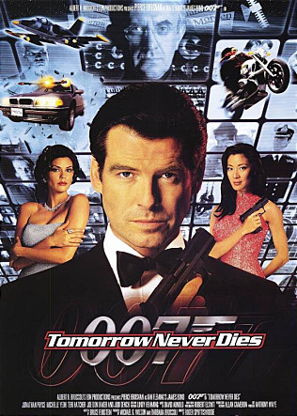

He was before.
But he is famous actor now.

Sophie 2013-10-30 Picture 1

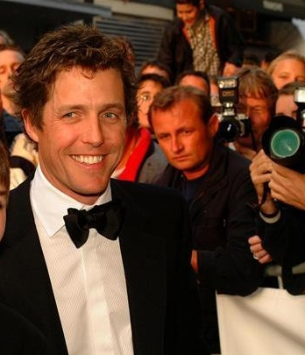

He was before.
But now, he is a renowned actor.
Sophie 2013-10-30 Picture 1

She was before.
But she is a big star now.

Sophie 2013-10-30 Picture 1

He was before.
But he is a popular Korean actor now.

Sophie 2013-10-30 Worksheet 2
Used to -by Daughtry-

You used to talk to me like I was the only one around
You used to lean on me the only other choice was falling down
You used to walk with me like we had nowhere we needed to go
Nice and slow, to no place in particular
We used to have this figured out
We used to breathe without a doubt
When nights were clear you were the first star I'd see
We used to have this under control
We never thought. We used to know
At least there's you and at least there's me
Can we get this back, can we get this back...
To how it used to be
I used to reach for you when I got lost along the way
I used to listen, you always had just the right thing to say
I used to follow you, never really cared where we would go
Fast or slow to anywhere at all
We used to have this figured out
We used to breathe without a doubt
When nights were clear you were the first star I'd see
We used to have this under control
We never thought. We used to know
At least there's you and at least there's me
Can we get this back, can we get this back...
To how it used to be
I look around me and I want you to be there
Cause I miss the things that we shared
Look around you-it's empty and you're sad
Cause you miss the love that we had
You used to talk to me like I was the only one around...
We used to have this figured out
We used to breathe without a doubt
When nights were clear you were the first star I'd see
We used to have this under control
We never thought. We used to know
At least there's you and at least there's me
Can we get this back, can we get this back...
To how it used to be

Sophie 2013-10-30 Picture 2

Time line

- We use used to when we describe a habit in the past
- We often use used to to contrast a past habit with what we do now
- The past simple is also possible but used to is more common

Sophie 2013-10-30 Picture 3
Substitution Table

- Statement
I , You  They  He/She  David | used to | Work  go  play | there | at that time

- Negative form
I , You  They  He/She  David | didn’t | used to | Work  go  play | there | at that time
 | never

- Question form
Did | I , You  They  He/She  David | used to | Work  go  play | there | at that time

Sophie 2013-10-30 Worksheet 3
Role cards

Alex
He is a teacher now. He is 45 years old.
He is married and has 3 children.
When he was young he went to school every day. He liked school very much.
He did not watch TV. He read a lot of books.
Today, he does not like school. He does not go to school every day too.
He likes watching TV.
He does not read.

Bob
He is a sportsman. He is 27 years old
He is not married.
When he was young he did not like sport.
He watched TV and met with his friends a lot.
He was lazy. Today, he loves sport. He does not watch TV and meets his friends sometimes.
He likes working.

Julia
She is a doctor. She is 43 years old.
She is married and has 2 children.
When she was young she did not like hospital.
She liked playing piano.
She liked dancing and listening to music.
Today, she loves hospital.
She does not play the piano.
She does not dance or listen to music.

Kathy
She is an actress. She is 38 years old.
She is not married.
She did not learn languages when she was young.
She did not cook. She did not sing or dance.
Today, Kathy is a good cook. She dances and sings beautifully.
She speaks 2 foreign languages.

Sophie 2013-10-30 Worksheet 3

Data worksheet

PAST  - I did it in the past.  - I don’t do it nowadays. | PRESENT  - I do it nowadays.
My person: | My person:
My partner’s person: | My partner’s person:

Sophie 2013-10-30 Worksheet 4

Practice worksheet

Statements: I used to play tennis when I was a teenager
Negatives: I didn’t use to play basketball when i studied at school
Question: Did you use to play football when you were little?

A. Rewrite each sentence with used to

- I was in the school swimming team ________________________________________________________________
- Sophie had long hair when she was 7 ________________________________________________________________
- Mary didn’t listen when her teachers were speaking ________________________________________________________________
- Ricardo got up at 6:00 when he was training for the Olympics ________________________________________________________________
- What did you usually do on Saturday evening? ________________________________________________________________
- My brother wore glasses when he was small ________________________________________________________________
- Becky was afraid of dogs when she was a little girl ________________________________________________________________
- We always gave our teacher presents at the end of the term ________________________________________________________________
- Paul has spoken Italian well but he has forgotten it ________________________________________________________________
- Did you live next door to Mrs Harrison? ________________________________________________________________

- Complete the personal details

- I used to drink but now I don’t
- I used to live in but now I don’t
- I used to go to but now I don’t
- I used to play with but now I don’t
- I used to read but now I don’t
- I used to watch but now I don’t
- I used to listen but now I don’t
- I used to get up at but now I don’t
- I used to go to bed at but now I don’t
- I used to sit next to but now I don’t
- I used to love but now I don’t
- I used to hate but now I don’t

Sophie 2013-10-30 Worksheet 5 (SOS activity)

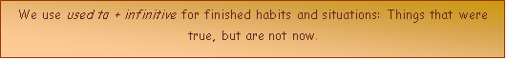
1. Look at the picture and write sentences about people hundreds of years ago. Begin (Most) people used to … or (Most) people didn't use to….
Or a lot of people used to…
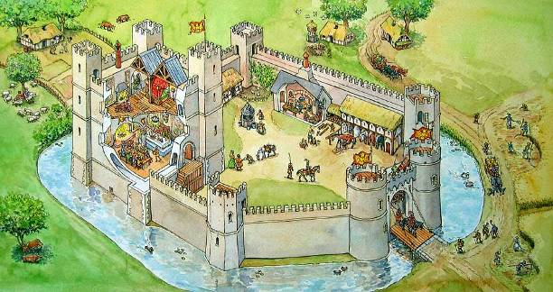
Example: Be farmers – Most people used to be farmers.

- Have cars. ____________________________________________
- Travel on foot or on horses ________________________________
- Go to school. ___________________________________________
- Learn to read __________________________________________
- Live in castles. _________________________________________
- Live very long. __________________________________________
- Watch TV. ____________________________________________
- Work very long hours ____________________________________

