Grammar Lesson Plan

As … as

Length:
45 minutes
Students:
16
Level:
Upper-Intermediate
Instructor:
Youngshin Woo

Materials:
- Mp3 file of Everything At Once by Lenka
- Video clip of Quick as a Cricket
- Computer and projector
- Idiom definition worksheets and idiom worksheets (18 sheets respectively)
- 4 sets of Quick as a Cricket Strips
- Tape and Board

Aims:
- Main aim: to enable students’ to use ‘as…as’ forms naturally as they listen to Everything At Once, watch Quick as a Cricket, and make up riddles
- Secondary aim: to improve students’ ability to understand idioms that have ‘as…as’ form by learning such idioms and using them the given context
- Personal aim: I would like to improve my time management

Language Skills:
- Speaking: students will talk about their ideas throughout the whole lesson by discussing and exchanging their ideas; they will also answer the CCQs, and practice substitution drilling.
- Reading: students will read idiom strips and worksheets as well as other groups’ riddles.
- Listening: students will listen not only to the teacher’s instructions and others’ ideas, but they will also listen to Everything At Once, and watch Quick as a Cricket.
- Writing: students will write in answers on the idiom worksheets and make up a riddle of their own on paper.

Language Systems:
- Grammar: various Idioms, lyrics, riddles and story that have ‘as…as’ forms
- Lexis : idioms including new lexical items that appear in the idioms
- Phonology: pick up the intonation as listening to/watching the class materials
- Function: compare and describe two things that have something in common
- Discourse: asking one another for ideas and opinions to complete the tasks

Assumptions:
- Students are able to communicate and exchange their ideas in English
- Students have learned comparatives and superlatives through previous lessons
- Students knows what idioms are
- Most students are willing to make the lesson as active as possible

References:
- Everything At Once by Lenka http://www.youtube.com/watch?v=7zMbB3TzuPc
- You Tube. http://www.youtube.com/watch?v=NYWcyRHGFPo
- Fun with Grammar, Suzanne W. Woodward, Prentice Hall Regents.
- Learn English Today. http://www.learn-english-today.com/idioms/idiom-categories/comparisons/comparisons-sim2-free-qui.html
Anticipated Problems and Solutions:
- Some students may not concentrate when watching Quick as a Cricket
Have students pantomime what each picture shows
- Some students might find idiom matching quite difficult
Help students if they ask questions
- Students may get bored during the substitution drill
Try various approaches; lead students to wrong answers and see if any of them notice it
- Class can become quite noisy during the riddle activity
Have students copy the riddles and discuss in groups at the desks
Lead-In
Materials: Computer, Projector
Time  3 min | Set Up  Whole Class | Procedure:  Greetings. Play Everything At Once by Lenka and elicit ‘as…as’ from students.  Introduce the topic and the following activity.  (Quick as a Cricket).

Presentation
Materials: Computer, Projector, Quick as a Cricket Strips, Board
Time  10 min | Set Up  In Groups | Procedure:  I. Recall  Students watch the video clip Quick as a Cricket. Have students pantomime what each picture shows. Tell them to pick up the intonation.  Then students match the strips in groups.  When checking answers, each group reads two expressions aloud with the right intonation.  2. Reflect  Elicit 1) what the purpose of this book is and 2) When to use this ‘as…as.’  3. Conclude  Tell students that they have just learned a type of similes, which describes similarities between two unlike things.  Ask CCQs. “I’m as busy as a bee.” (PPT)  1) Does it imply bees are lazy?  2) Does it mean I am busy?  3) What is the relationship between ‘I’ and this ‘bee’?  Elicit the form of ‘as…as.’
Practice
Materials: Idiom Definition Worksheet, Idioms Worksheet, Computer, Projector
Time  7 min  7 min  3 min | Set Up  In Groups  In Groups  Whole Class | Procedure:  1. Match Idioms  Have students match idioms with correct definitions. Give 5 minutes. Check answers by reading the answers together. Explain some vocabulary if necessary.  2. Completing the Idioms  Students put the idioms into the right context on the worksheet.  Check answers all together.  3. Drilling (PPT)  Show the substitution drill table and have students practice putting the right words together. Point some word and let student say the correct following word. Make false pairs and elicit answers from students.

Production
Materials: Computer, Projector, Tape
Time  15 min | Set Up  In Pairs  In Groups | Procedure:  I. Riddle (PPT)  Introduce the following riddle:  It is bigger than a baseball.  It is as round as the moon.  It is as orange as a carrot.  It is as hard as a melon.  It is not as sweet as fruit.  Answer: A pumpkin.  Using the structure above, students work in pairs to make their own riddles. Monitor and answer the questions. Make sure their riddles are not too a ambiguous.  In their groups, students exchange their riddles and choose one riddle and right it on paper.  Tape the riddles to the board. Students come out and write answers to the three riddles in groups.  Ask students to go back to their seats. Each group reads their riddles aloud and gives the answers. See which group got the most answers.

S.O.S activity
Materials: N/A
Time  10 min | Set Up  Individually  Whole class | Describe  Students choose someone and describe her. Use as many ‘as…as’ forms as possible. Students can describe the looks, personalities, clothes, wishes, etc. Give 5 minutes.  A volunteer reads her description aloud, and the rest guess who she is. Do the same as long as the time allows.

1. as quick as | a. a basset
2. as small as | b. an ox
3. as sad as | c. a cricket
4. as happy as | d. as a shark
5. as mean as | e. a lark
6. as weak as | f. a clam
7. as strong as | g. an ant
8. as quiet as | h. a kitten
9. as gentle as | i. a shrimp
10. as shy as | j. a lamb
Quick as a Cricket Strips

Idiom Definition Matching

1. as blind a bat ____ | a. in an excellent state of health or physical condition
2. as cool as a cucumber ____ | b. very close friends who are very loyal to each other
3. as fit as a fiddle ____ | c. morally upright and extremely honest
4. as thick as thieves ____ | d. unwilling to change one’s mind; very obstinate
5. as sharp as a tack ____ | e. very difficult to catch; can easily avoid answering questions
6. as stubborn as a mule ____ | f. looks very pale and frightened
7. as slippery as an eel ____ | g. able to think very quickly and learn very fast
8. as straight as an arrow ____ | h. when doing something surprisingly fast
9. as quick as a dog can lick a dish ____ | i. unable to see anything
10. as white as a ghost ____ | j. not anxious, but relaxed, calm and non-emotional

Completing Idioms

Complete the following sentences with the idioms which were on the strips.
1. My grandfather is nearly ninety but he's _________________________.
2. You can leave the money with Andy. He's ___________________________.
3. She went ___________________________ when she saw the gun.
4. The man was ________________________. He was arrested for theft several times but was never convicted.
5. Without his glasses, the old man is ___________________________.
6. Because he overslept, he packed his bag ____________________________.
7. The bride's mother stayed __________________________ all through the ceremony.
8. You won't have to explain it to him twice. He’s ________________________.
9. Chris always takes Danny's side. They're _________________________.
10. His friends advised him to accept the offer, but you know Larry - he's ______________________________!

Completing Idioms (Answers)

Complete the following sentences with the idioms which were on the strips.
1. My grandfather is nearly ninety but he's as fit as a fiddle.
2. You can leave the money with Andy. He's as straight as an arrow.
3. She went as white as a ghost when she saw the gun.
4. The man was as slippery as an eel. He was arrested for theft several times but was never convicted.
5. Without his glasses, the old man is as blind as a bat.
6. Because he overslept, he packed his bag as quick as a dog can lick a dish.
7. The bride's mother stayed as cool as a cucumber all through the ceremony.
8. You won't have to explain it to him twice. He’s as sharp as a tack.
9. Chris always takes Danny's side. They're as thick as thieves.
10. His friends advised him to accept the offer, but you know Larry - he's as stubborn as a mule!

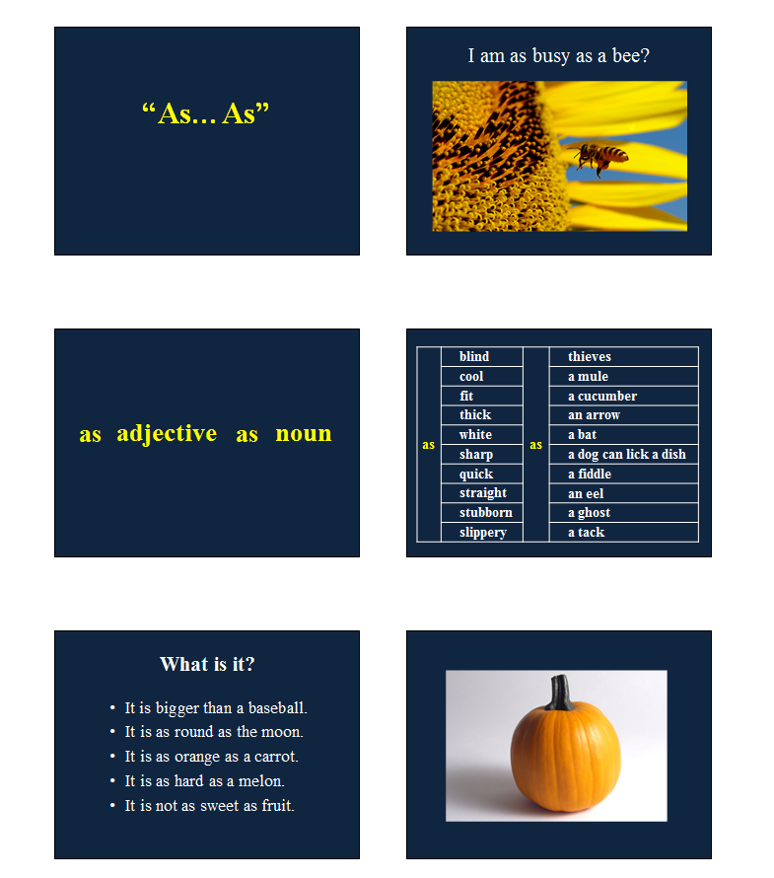
PowerPoint Presentation

