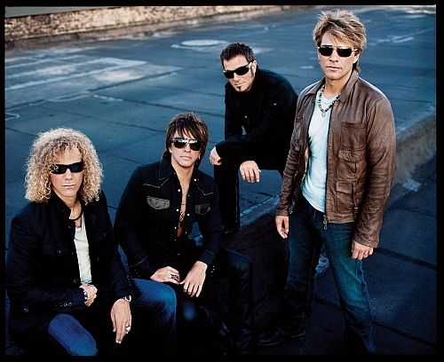

Brief Information of the band
Band Name: Bon Jovi
Country: UK
Debut: 1984
Member:
- Jon Bon Jovi: (Vocals, Guitar), Tico Torres (Drum), Richie Sambora (Guitar), David Bryan (Keyboards)
Genre: Hard rock, heavy metal
Best songs
- Livin’ on a prayer
- It’s my life
- Always
- You give love a bad name
- Wanted dead or alive….

Main activity questions

- Who else might have control over your life? (wife, husband, parents, boyfriend, girlfriend, unpleasant neighbors, etc)
- How much control does your work have over your home life? Do you take work home? Do you have to prepare anything in your free time for work? (lessons, reports, etc.)
- Is it possible to live life exactly as you would like?

Worksheet_‘It’s my life’ sung by Bon Jovi

This ain't .............. song for .............. broken-hearted
No .............. silent prayer for .............. faith-departed
I ain't gonna be just .............. face in .............. crowd
You're gonna hear my voice. When I shout .............. it out loud
----------------------------------------------Chorus----------------------------------------------
It's my .............. life. It's now or .............. never
I ain't gonna live forever. I just want to live while I'm alive (It's my .............. life)
----------------------------------------------
My heart is like .............. open highway. Like .............. Frankie said
I did it my way. I just wanna live while I'm alive. It's my .............. life
----------------------------------------------
This is for .............. ones who stood their ground
For..............Tommy and .............. Gina who never backed down
Tomorrow's getting .............. harder make no mistake
.............. Luck ain't even lucky. Got to make your own breaks
----------------------------------------------Chorus----------------------------------------------
It's my .............. life. It's now or .............. never. I ain't gonna live forever
I just want to live while I'm alive. (It's my .............. life)
----------------------------------------------
My heart is like .............. open highway. Like ..............Frankie said
I did it my way. I just wanna live while I'm alive. 'Cause it's my .............. life
----------------------------------------------[Solo]----------------------------------------------
Better stand tall. When they're calling you out
Don't bend, don't break, Baby, don't back down
----------------------------------------------Chorus----------------------------------------------
It's my .............. life. It's now or .............. never. I ain't gonna live forever
I just want to live while I'm alive. (It's my .............. life)
----------------------------------------------
My heart is like .............. open highway. Like .............. Frankie said
I did it my way. I just wanna live while I'm alive. It's my .............. life
----------------------------------------------Chorus----------------------------------------------
It's my .............. life. It's now or .............. never. I ain't gonna live forever
I just want to live while I'm alive. (It's my .............. life)
----------------------------------------------
My heart is like .............. open highway. Like Frankie said
I did it my way. I just wanna live while I'm alive. 'Cause it's my .............. life!
----------------------------------------------

The Full Lyrics_’It’s my life’ sung by Bon Jovi

This ain't a song for the broken-hearted. No silent prayer for the faith-departed
I ain't gonna be just a face in the crowd. You're gonna hear my voice
When I shout it out loud
----------------------------------------------Chorus----------------------------------------------
It's my life. It's now or never. I ain't gonna live forever
I just want to live while I'm alive. (It's my life)
----------------------------------------------
My heart is like an open highway. Like Frankie said. I did it my way
I just wanna live while I'm alive. It's my life
----------------------------------------------
This is for the ones who stood their ground
For Tommy and Gina who never backed down
Tomorrow's getting harder make no mistake
Luck ain't even lucky. Got to make your own breaks
----------------------------------------------Chorus----------------------------------------------
It's my life. It's now or never. I ain't gonna live forever
I just want to live while I'm alive. (It's my life)
----------------------------------------------
My heart is like an open highway. Like Frankie said. I did it my way
I just want to live while I'm alive. 'Cause it's my life
----------------------------------------------Solo----------------------------------------------
Better stand tall. When they're calling you out.
Don't bend, don't break, Baby, don't back down
----------------------------------------------Chorus----------------------------------------------
It's my life. It's now or never. I ain't gonna live forever
I just want to live while I'm alive. (It's my life)
----------------------------------------------
My heart is like an open highway. Like Frankie said. I did it my way
I just wanna live while I'm alive. It's my life
----------------------------------------------Chorus----------------------------------------------
It's my life. It's now or never. I ain't gonna live forever
I just want to live while I'm alive. (It's my life)
----------------------------------------------
My heart is like an open highway. Like Frankie said. I did it my way
I just wanna live while I'm alive. 'Cause it's my life!

Worksheet_Starting a New Life

Advantages | Disadvantages

Worksheet_About Music

- Is music important: to you? Why (not)?

- How often do you listen to music?

- Do you play music while you study, or work?

- Have you ever been to see your favorite musicians live? Were they as good as on the CD?

- What is your favorite music? Did you like it the first time you heard it?

- Is there any music you can’t stand? What is it, and why don’t you like it?

- Do you think music can heal sick people?

