X Listening X Speaking Reading Grammar Writing

Topic: Our Friends, Animals

Instructor:  Rebekah | Students Age –Competency Level  8-9 years old, Upper Beginner | Number of students:  12 | Lesson Length:  53 min
Materials: Pictures of Animals
Lion
Tiger
Pig
Giraffe
Elephant
Dog
Cat
Fish
Duck
Computer MP3 player, Computer
MP3 - “We’re Going To The Zoo”
White board, markers
Farm and Zoo Animal Worksheet
Scissors, Glue
Early Readers’ Book Prints
Scissors, Stapler

Aims: (What students will be able to achieve by participating in the activities of the lesson.)
Ss get comfortable and interested in lesson by T presentation and attitude.
Ss will learn about many kinds of animals’ name and difference between farm and zoo animals by doing farm and zoo animal worksheet.
Ss will learn about some adjectives from the song ‘We’re Going To The Zoo’ by listening to the song, singing the song, and practicing the song.
Ss will improve listening and speaking skills by doing song activity, responding to teacher and sharing their answers about farm and zoo animals.
Ss will improve writing skills by doing Finding Zoo Animals Correct Name Worksheet.
Ss will learn sentence drill “I see” by following T direction and demonstration, practicing, and reading.
Ss will learn by listening to teacher’s explanation and examples.

Language Skills: (Lists what language skills students will be using by participating in the activities of the lesson.)
- Reading : the worksheet, song lyrics, sentences on the books
- Listening: Listening to the song, to the teacher, and to the presentation of other students
- Speaking: Sharing the answering, singing the song, experience to visit to the zoo and reading
- Writing: Finding correct the name of zoo animals.

Assumptions: (What students must already be able to do and what concepts must already be mastered before the lesson in order to achieve the aims of the lesson.)
Ss will enjoy and also have fun
Ss already know some animals’ name.
Ss have been at the zoo and roughly know which animals are at the zoo.
Ss can use scissors and glue with T assistance as needed

Anticipated Errors and Solutions: (What things might go wrong in the lesson and what the solution will be)
The computer doesn’t work, teacher will sing the song by self and help Ss learn the melody or use cell phone.
Activity takes too long; the other activity may be shortened.
Ss have difficulty on reading sentences, teacher read first and they repeat.
Ss might be shy, teacher give encouragement.

References:
www.ready-set-Zoo book adventure
www.youtube.com
www.kids-pages.com

Lead-In In (Warm-Up Part to activate and create interest in the lesson) (12)

Materials: Pictures of Animals
Lion
Tiger
Pig
Giraffe
Elephant
Dog
Cat
Fish
Duck

Time: | Classroom Set Up: | Student Activity and Goals: | Teacher Procedure Instructions:
1 min  5 min  3 min  3 min | Whole class  S  S | Greet teacher  Ss listen – become interested  S respond  SS listen and guess.  Sharing ideas | Greet students  T shares story about fun at the Zoo  T shows pictures of animals  Ask Ss about names of animals’  T makes some sounds’ of animals. (Use animal sounds worksheet but that not for Ss doing)  T asks Ss to guess. Which animal make this sound?

Pre-Activity (Presentation Part Presenting the language structure to be covered in the lesson) (14)

Materials: Computer MP3 player, Computer
MP3 - “We’re Going To The Zoo”
White board, markers

Time: | Classroom Set Up: | Student Activity and Goals: | Teacher Procedure Instructions:
3 min  4min  7 min | Whole class  S  S | Ss listen and watch  Ss act the meaning.  Ss sing a song | Play the Song “We’re Going To The Zoo”.  Ask Listen to the song first.  T introduces new adjectives scratch, swing, stretch, splash, huff. T demonstrates the meaning first and asks Ss to show.  Ss sing together. They don’t have to sing all the lyrics exactly. Some repeat part and adjective they could sing. Repeat the song 2 times. First time, sing all together second time teacher could call Ss name for each adjective.

Main Activity (Practice to Production Part Teacher lead practice of the language presented) (16)
Materials: Farm and Zoo Animal Worksheets
Scissors, Glue
White board and markers
Zoo Animal Worksheet

Time: | Classroom Set Up: | Student Activity and Goals: | Teacher Procedure Instructions:
3 min  5 min  3 min  5min | Whole class  S  S  S | Ss listen and answer about farm and zoo animals.  Ss cut and sort farm and zoo animals  Ss check the answer.  Ss do the worksheet | Hand out the worksheet. Ask Ss what kinds of animals they see on the paper. T introduces farm and zoo animals are different. Ask Ss first the meaning and add explanation.  T gives scissors and glue to each student. Monitor Ss.  Ask Ss how they did. Check the answers together.  Handout the worksheets. Let Ss do first and check together later.

Post Activity (Wrap-Up Part Close the Lesson on a high note to consolidate language learned) (11)
Materials: Early Readers’ Book Prints
Scissors, Stapler
White board and markers

Time: | Classroom Set Up: | Student Activity and Goals: | Teacher Procedure Instructions:
3 min  5 min  3min | Whole class  S  S  Whole | Ss listen and share  Ss repeat the sentences.  Ss cut the page and make books.  Ss read the books  Ss say goodbye | Ask Ss when they went to the zoo and what they see. T introduces “I see.” “I see ______ at the zoo.”  Distribute the materials for making book. Monitor Ss.  Ask Ss to read out the books one by one. Later, whole class read the books together at the same time.  Congratulate and thank Ss for active participation

Materials to be included in the Lesson Plan
-Pictures of Animals (Lion, Tiger, Pig, Giraffe, Elephant, Dog, Cat, Fish, Duck)
-Animal Sounds Page:
http://www.kids-pages.com/folders/worksheets/Animals/Animal%20sounds.pdf
-Song “We’re Going To The Zoo.”: http://www.youtube.com/watch?v=jRXjiKsJAQo
-Farm or zoo Animals worksheet
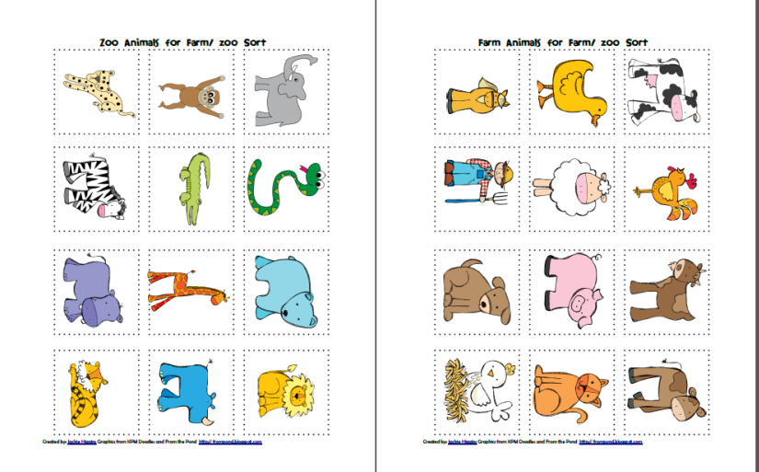
-Zoo animals’ worksheet -Early readers’ books
