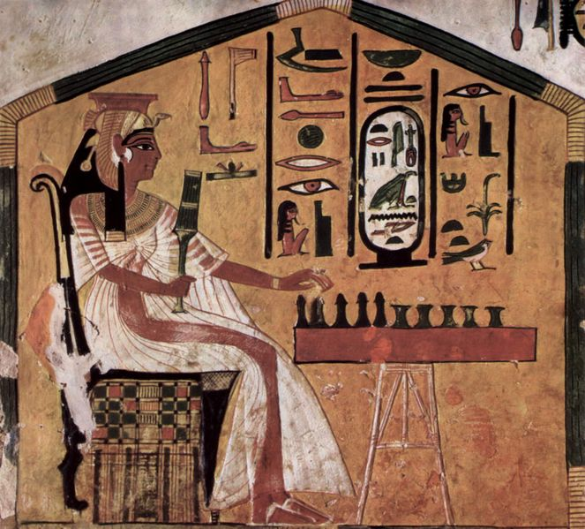
People around the world enjoy playing games. Games are a way for people to compete using both skill and luck. One of the most common types of game is the board game, which is any game played on a board and uses dice and counters.

Possibly the oldest example of a board game is Senet. This game comes from ancient Egypt and its name is believed to mean “passage”. It was played from as early 3,500 B.C. and was popular with kings and nobles. Although the actual rules of Senet are still a mystery, it is thought that it was a kind of race using lucky dice rolls to move pieces across the board.

Modern board games are similar to Senet in some ways, but have different purpose. In Monopoly, players move around the board to buy properties using play money. Its name means exclusive control of an item or service.

Monopoly is very popular with families all over the world. Many say that it is similar to the actual buying, selling and rental of properties. Just like in real life, there is a bit of luck involved. Players need to roll a dice to move around the board, and if they land on another player’s property, they need to pay rent. If they land on a property without on owner, they can but it.
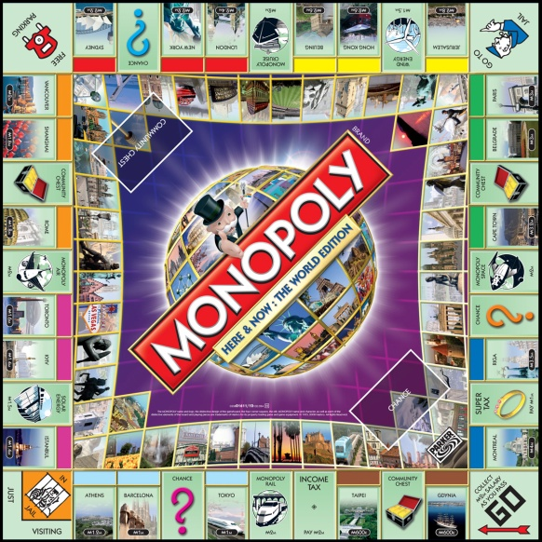
Over the years, different versions of Monopoly have appeared. There is a special version for younger players. There are also versions in different themes, such as the Disney Monopoly and Star Wars Monopoly.

