Listening Lesson Plan

Ⅰ.

Title: Listening to “The Little Mermaid”
INSTRUCTOR | LEVEL | STUDENTS | LENGTH
Jenna NaHyun Jeon | High Intermediate | Junior High school 1st grade Ss 12 | 50 mins

Materials:
- A notebook and a projector
- Listening mp3 file
- Video clip, Audio clip
- Vocabulary worksheet (12copies each)
- Idiom & Expression worksheet (〃)
- Listening “Dictation” worksheet (〃)
- Feelings worksheet
- Listening Script
- Visual Aid
- White board & board markers

Aims:
- To improve listening skills by listening to music
- To practice listening to details (expressions, abbreviation, spoken language, onomatopoeia)
- To practice listening with various accents
- To learn vocabularies and idiomatic expressions
: to be able to pick up the word from music by answering details questions on a worksheet and
dictate expressions on a worksheet
- To learn expressions for emotion(feeling)

Language Skills:
Listening: listening to music, teacher’s instruction and explanation, pair work
Speaking: comparing answers within groups
Reading: vocabulary & expression worksheet, “dictation” worksheet
Writing: dictating for details

Language Systems:
Phonology: practicing new vocabulary
Lexis: vocabulary from the listening text, spoken language, usage of the verb ‘get’
Grammar: usage of interrogative pronouns and auxiliary verb and preposition, abbreviation of verb,
the present perfect tense
Functions: expressing one’s own opinion and thought about the proverb and emotion
Discourse: dialogue with partner, discussion about meaning of the proverb “The seaweed is always
greener in somebody else’s lake”

Assumptions:

Students already know:
- how the class is set up and run(there will be 4 student groups at each table)
- the teacher’s style of teaching and the pace of the course
- all students are junior high school 1st grade students
- they are intermediate level of English proficiency
- they actively speak out when needed

Anticipated Errors and Solutions:
- Students may not be able to understand the story of song
→ Chunk the music
- Students may not be able to understand exactly after chunking the music
→ Before listening the music again, learn the new vocabularies and idioms
- Students may need more time to work on the worksheet
→ If it takes longer than 5 minutes, cut answer-checking short by verbally sharing the answers
- If time is short
→ Cut post-activity short and only ask 2~3 students to share their song
- If students finish their all tasks earlier than anticipated
→ Do the Plan B only to those who finished
- Some students may not actively participate the group discussion
→ Encourage them to present their opinion by asking questions

References:
Music form the movie “The Little Mermaid”
Visual aids: www.naver.com

Notes:

If we have time left over, Plan B is Feelings worksheet*

Ⅱ.
1.

Pre-Task or Warmer
Title:  The  Little Mermaid |  | Aims:  To elicit about title  To learn vocabulary and idiom | Materials:  Notebook, projector, whiteboard, marker,  poster jpg. file , visual-aid file, worksheet
Time | Set Up | Students | Teacher
4min  5min | Whole  Class | Answering teacher’s questions  Listening about new vocabularies and idioms to teacher | 1. Greeting  Good morning, everyone!  How was your weekend?  How are you today?  *Elicit the feelings &write them on the board  2. Eliciting  Show the poster on the screen.  Guiding questions  Did you ever seen the animation “the Little Mermaid?”  Do you remember what became the mermaid later?  Did you ever heard of the original sound track from this animation?  What was the song title was famous for?  Tell me about title of song or hum a song .  Lyrics of songs contain the story.  Let’s check about two songs.  3. Learning the vocabulary and idiom  Before we listen to a song,  I’ll explain the meaning of vocabularies and idioms on worksheet first.  And elicit the meaning from students.

2.

Task Preparation or Presentation
Title:  Listening to broadly |  | Aims:  To learn vocabulary and idiom  To improve listening skills | Materials:  Worksheet, audio clip,mp3 file, notebook
Time | Set Up | Students | Teacher
7min  7min | Individually  Pairs  Whole  Class | Doing worksheet related to the listening  Listening to teacher’s talk  Listening to music  “Under the Sea”  “Part of Your World” | 1.Checking the vocabulary  Instruction  I’ll hand out worksheets for vocabularies . Please read the #1 on vocabulary worksheet. After read definitions , find the right vocabulary in the below box and write down it in blank.  Do it on your own.  Demonstration  Let’s look at No.1… It is a definition of ‘wail’. So, you write it in the first blank.  ICQ  What do you fill in the blank?  Do you work in group?  How much time do you have?  Monitoring  Monitoring discreetly. If students ask a question, answer it.  Give time warning: 1minute left.  Check answers  Let’s check the answers together.  Let students read the definition and tell the answer by themselves.  Show the visual-aid on the screen.  Have you ever seen the sea creatures?  Do you know about the names of these?  Let’s make pairs!  Please keeping read #2 on vocabulary  worksheet and circle the right word  In below box together.  Ok, then, before listening to music, look over the left word (sea creatures)  CCQ  Are you working alone?  What are you supposed to do after checking the vocabularies?  How much time do you have?  2. Listening to music “Under the Sea”  (general understanding)  Play the music without stopping  Instructions  Put your pens down. Close your eyes.  Listen to music.  CCQ  Can you take notes?  What are you supposed to do?  Do you want to listen again?  - Yes → Have them listen one more  time.  - No → Have them share their  thoughts about contents  Listening to music “Part of Your World”  (general understanding)  Do you want to listen again?  - Yes → Have them listen one more  time.  - No → Have them share their  thoughts about contents

3.

Task Realization or Practice
Title:  Listening for details |  | Aims:  To learn vocabulary and idiom  To improve listening skills  To practice listening to details  To practice listening with various accents | Materials:  Worksheet, audio clip, mp3 file, notebook
Time | Set Up | Students | Teacher
11min  11min | Whole  Class  Pairs  Groups  Individually  Whole  Class  Groups | Listening to music  “Under the Sea”  Doing worksheet related to the listening | 1. Listening for Details “Under the Sea”  Now Listen to the music carefully.  Instructions  Please check the #3 on vocabulary sheet. Answer the questions on the worksheet as you listen. Work in pairs  CCQ  What are you supposed to do?  Are you working alone?  Play the music.  Let students write answers as they listen.  Do you need to listen again?  - Yes → Play again.  - No → Give them time to write answer.  Compare the answers with your group members.  Instructions  Please read the “dictation” worksheet. After listen to music carefully one more time, fill in the blanks. Work individually  2. Listening for details “Part of Your World”  Listen to the music carefully.  Instructions  Please check on idioms &expression sheet. Let students explain about meaning. Work with each group  Discussion about the proverb.  And let students listen to the “Part of Your World” one more time. Fill in the blanks on “dictation” worksheet.  Check the answers as a whole class.  Listen to the tracks one last time.  If there is anything missing: pause the right there and let students say it out loud.

4.

Post Task or Production
Title:  Reviewing |  | Aims:  To review everything learned | Materials:  Video clip, white board & marker
Time | Set Up | Students | Teacher
5min | Whole  Class | Watching video clip with lyrics and check out.  Listening to teacher’s talk | Error correction & Feedback  Check the wrong answers on worksheet  Write questions that students make on the board.  Talk together about students’ answers.  Encouragement  Did you enjoy? I hope it was a good time for you to speak more in English.  You did a good job.
Notes
SOS Activity:

Elicit today’s feeling shared when class started from students.
Checking various feelings and Doing a feeling worksheet.

Ⅲ.
Vocabulary Worksheet

1. Find and write the right vocabulary for each definition from below

● make long, loud, high-pitched cries which express sorrow or pain.

-------------------------------------
● the air moves

___________________
● to emphasize that something you like exists in very large quantities

___________________
● walk there in a slow, relaxed way

___________________
● just below the surface, and are being supported by it

___________________
● tidy and smart, and has everything in the correct place

___________________
● travel around the place to find out what it is like

___________________
● they are a very good or rich source of that thing

___________________
● turn a device on or off by pressing the switch quickly

___________________
● they are spoken to angrily or seriously for doing something wrong, usually by a person in authority

___________________

stroll reprimand blow flip float

wail neat trove galore explore

2. Draw circle the words except sea creatures

smelt sprat plaice sturgeon carp brass bass ray

chub trout fluke tub slug muck clam rug newt

3. The following lyric is part of “Under The Sea”
Find the right pictures in the blank

Even the (① ) and the (② )
They get the urge and start to play
We've got the spirit. You've got to hear it
Under the sea
The (③ ) play the flute
The (④ ) play the harp
The (⑤ ) play the bass
And they soundin′ sharp
The bass play the brass
The chub play the tub
The fluke is the duke of soul
The(② ) he can play the lings on the strings
The trout rockin′ out
The (⑥ ) she sings
The smelt and the sprat they know where it′s at
And oh that (⑦ ) blow under the sea
When the sardine begin the beguine, it′s music to me
What do they got? A lot of sand
We got a hot (⑧ ) band
Each little (⑨ ) here, know how to jam here
Under the sea
Each little (⑩ ) here cuttin′ a rug here
- 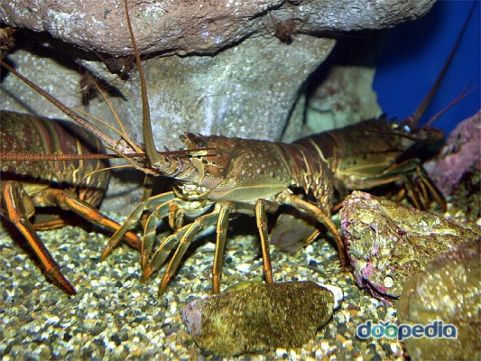 b. 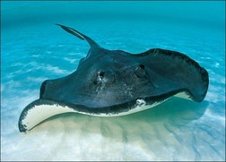

- 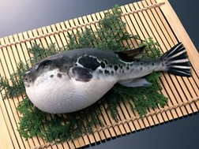 d. 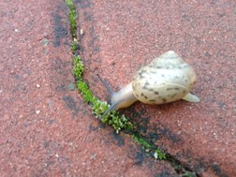

- 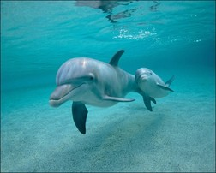 f. 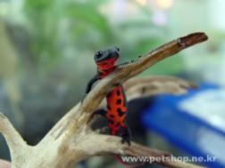

- 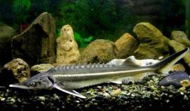 h. 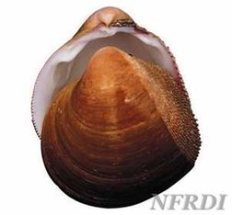

i. 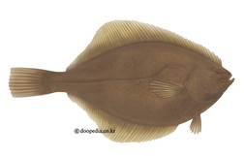 j. 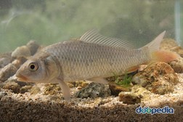

<Visual aid>

Idiom & Expression Worksheet

Let’s study new expressions and idioms presented in Listening file.

1. thingamabobs

2. no big deal

3. rock out

4. take from

5. slave away

6. off the hook

7. cut a rug

8. up above

9. The seaweed is always greener in somebody else′s lake (proverb)

Listening “Dictation” Worksheet

Fill out the blanks on the sentences as you listen
-Part of Your World-

Maybe he’s right. Maybe there is something wrong with me. I just don't see how a world that.
That makes such wonderful things... could be bad? ______ ___ this stuff. Isn't it neat?
_______ ___think my collection's complete? ______ ___ think I'm the girl? The girl who has everything?
Look at this trove, ______ _____ . How many wonders can one cavern hold?
Looking around here, you'd think (Sure) she's got everything.
I've got gadgets and gizmos a-plenty. I've got who's-its and ________ ________.
(You want thing-a-ma-bobs? I've got twenty.)
But who cares? No big deal. I want more. I wanna be where the people are.I wanna see, wanna see 'em dancing.
Walkin' around on those.(_______ ____ ____?) Oh, feet!
Flippin' your fins, you don't get too far. Legs are required for jumpin', dancin. _______ _____ ______ a,
(What's that word again?) Street!
Up where they walk, up where they run. Up where they stay all day in the sun.
Wanderin' free, wish I could be part of that world. What would I give if I could live out of these waters?
What would I pay to spend a day Warm on the sand?
_________ on land they understand. Bet they don't reprimand their daughters.
Bright young women, sick of swimming. Ready to stand. And ready to know what the people know.
Ask'em my questions and get some answers. What's a fire-and why does it. (What's the word?) Burn!
_______ ___ ___ ______? Would not I love, love to explore that shore___ ______.
Out of the sea. Wish I could be part of that world.

-Under The Sea-

The seaweed is always greener in somebody else’s lake. You dream about going up there but that is a big mistake. Just look at the world around you
Right here on the ocean floor such wonderful things surround you
What more is you lookin′ for? Under the sea Under the sea
Darling it′s ______, down where it′s _______. _____it ______me
Up on the shore they work all day. Out in the sun they slave ______.
While we devotin’ full time to floatin′ Under the sea. Down here all the fish is happy.
__ __ _______ the waves they roll. The fish on the land ain′t happy. They sad ′cause they in their bowl
But fish in the bowl is lucky. They in for a worser fate. One day when the boss get hungry
Guess who′s gon′ be on the plate Under the sea Under the sea
Nobody beat us, fry us and eat us in fricassee. We what the land folks loves to cook
Under the sea we ____ ____ ______ We got no troubles. Life is the bubbles under the sea
Since life is sweet here, we got the beat here. Naturally _____ the sturgeon and the ray
They ___ ___ _____ and start to play. We ___ the spirit. You ___ to hear it Under the sea

Listening Script

1. Part of Your World

Maybe he’s right
Maybe there is something wrong with me.
I just don't see how a world that.
That makes such wonderful things... could be bad?
Look at this stuff. Isn't it neat?
Wouldn't you think my collection's complete?
Wouldn't you think I'm the girl?
The girl who has everything?
Look at this trove, treasures untold.
How many wonders can one cavern hold?
Looking around here, you'd think
(Sure) she's got everything.
I've got gadgets and gizmos a-plenty
I've got who's-its and what's-its galore.
(You want thing-a-ma-bobs? I've got twenty.)
But who cares?
No big deal.
I want more.
I wanna be where the people are.
I wanna see, wanna see 'em dancing.
Walkin' around on those.
(Whad'ya call 'em?) Oh, feet!
Flippin' your fins, you don't get too far.
Legs are required for jumpin', dancin.
Strollin' along down a,
(What's that word again?) Street!
Up where they walk, up where they run.
Up where they stay all day in the sun.
Wanderin' free, wish I could be
Part of that world.
What would I give if I could live
Out of these waters?
What would I pay to spend a day
Warm on the sand?
Betcha on land they understand.
Bet they don't reprimand their daughters.
Bright young women, sick of swimming
Ready to stand.
And ready to know what the people know.
Ask'em my questions
and get some answers.
What's a fire-and why does it.
(What's the word?) Burn!
When's it my turn?
Would not I love, love to explore
That shore up above.
Out of the sea.
Wish I could be
Part of that world.

2. Under The Sea

The seaweed is always greener in somebody else’s lake.
You dream about going up there but that is a big mistake
Just look at the world around you
Right here on the ocean floor such wonderful things surround you
What more is you lookin′ for?
Under the sea
Under the sea
Darling it′s better, down where it′s wetter
Take it from me
Up on the shore they work all day
Out in the sun they slave away
While we devotin′ full time to floatin′
Under the sea
Down here all the fish is happy
As off through the waves they roll
The fish on the land ain′t happy
They sad ′cause they in their bowl
But fish in the bowl is lucky
They in for a worser fate
One day when the boss get hungry
Guess who′s gon′ be on the plate
Under the sea
Under the sea
Nobody beat us, fry us and eat us in fricassee
We what the land folks loves to cook
Under the sea we off the hook
We got no troubles
Life is the bubbles under the sea
Under the sea
Since life is sweet here, we got the beat here
Naturally
Even the sturgeon an′ the ray
They get the urge ′n′ start to play
We got the spirit
You got to hear it
Under the sea
The newt play the flute
The carp play the harp
The plaice play the bass
And they soundin′ sharp
The bass play the brass
The chub play the tub
The fluke is the duke of soul
(Yeah)
The ray he can play the lings on the strings
The trout rockin′ out
The blackfish she sings
The smelt and the sprat they know where it′s at
And oh that blowfish blow
Under the sea
Under the sea
When the sardine begin the beguine, it′s music to me
What do they got? A lot of sand
We got a hot crustacean band
Each little clam here, know how to jam here
Under the sea
Each little slug here cuttin′ a rug here
Under the sea
Each little snail here, know how to wail here
That′s why it′s hotter under the water
Yeah, we in luck here down in the muck here
Under the sea

Feelings Worksheet (SOS Activity)

Match the first part of each faces with the second part of feelings

1. |  |  | a. | surprise
2. |  |  | b. | neutral
3. |  |  | c. | disgust
4. |  |  | d. | sadness
5. |  |  | e. | fear
6. |  |  | f. | anger
7. |  |  | g. | joy
8. |  |  | h. | pleasure

