Listening Lesson Plan

Title: Kim jang
INSTRUCTOR | LEVEL | STUDENTS | LENGTH
Stephanie(JI-yeon Han) | intermidiate | 10 students | 50 mins

Materials:

1.Pictures to introduce the new vocabulary.
2.vocabulary worksheet (10+ 1extra)

3.Dictaion sheets (10+ 1extra)
4.MP3(track #1)-1min / MP3 player
5.(in case of emergency ) my own speaker.
6. board and maker

Aims:
At the end of the lesson, students will learn vocabulary and expressions in newspaper article through dictation and questions.
Students will improve their listening skill by practicing listening.
Students will speak and write about the Korean food or items through the class activity.(through introducing other Korean items)

Language Skills:
Listening: students can listen to this article and other student’s speech.
Speaking: students can answer the question and speak details about the other Korean items in group / share these with other groups.
Reading: students can read the sheets given to them.
Writing : students can write the details(4-5sentences) about the Korean items in group discussion./ dictation

Language Systems:
Phonology: to learn vocabulary , we will pronoun these words.
Lexis: formal vocabulary in newspaper article , UNESCO (acronym).. etc.
Grammar: is likely to+V , according to +N etc.
Discourse: discuss in group
Functions: newspaper article(information)

Assumptions:
All students know about Kimjang and Kim chi.
All students know why Kimchi is popular all over the world.
All students know about other Korean items to be deserved as the intangible cultural heritage.

Anticipated Errors and Solutions:
*Students can’t follow the passage easily.
-- let them listen to the article many times until they catch the gist of the article.
*students can’t pick up the details from listening.
--students can do chunk listening.
*If the discussion takes longer than 5 min,
--teacher will give 3min more.
**SOS plan
If time is short,
--teacher will give more time to the group discussion and ask for adding more sentences .
--if there is more than 15min left , teacher can do the bingo game based on the information given from the other groups.
they have to fill in the blank with information which they listen to. They will do this activity in group.

References: www.koreaherald.com

???

Notes: plan B (in case of the malfunction)
If there is technical problem such as malfunction in audio system, teacher have to prepare the script and speak it manually to them.
Script:
“Kimjang,” the process of making kimchi, is likely to be included on UNESCO’s list of Intangible Cultural Heritage, the government announced recently. According to the Cultural Heritage Administration, the body tasked with deliberating new additions recommended Korea’s “Kimjang; Making and Sharing Kimchi” for inscription, meaning it would be adopted by the UNESCO committee as intangible cultural heritage of humanity. Though the final decision will not be made until December, when UNESCO’s intergovernmental committee meets in Azerbaijan, if Kimjang is approved, it would be Korea’s 16th item on the UNESCO list.

Pre Task or Warmer
Title:  Introducing today’s topic |  | Aims:  Before the lesson, student can have the curiosity and interest about the topic . | Materials:  Pictures1, , board
Time | Set Up | Students | Teacher
3min | Whole class | Students can answer about the weather and have various answer like Christmas , winter sports etc.  After seeing the picture ,they can answer . | *Ask about the weather .  (As the weather gets colder, what idea do the students have?)  *teacher can elicit the kim jang season.(empathizing the season ahead of winter)  If they don’t come up with an idea, then teacher can show them the picture(1)

Notes:
???

Task Preparation or Presentation
Title:  vocabulary |  | Aims:  Before the lesson, students can learn the new vocabulary through eliciting from the pictures to understand better. | Materials:  Vocabulary sheet(material 2)  Pictures2,3
Time | Set Up | Students | Teacher
10min | whole class | Students can answer the question. | *Distribute the vocabulary sheet.  *Instruction  Students have to participate to give the answer .  *Eliciting  Go through the vocabulary one by one.  Teacher can elicit the meaning of the vocabulary from the students using the pictures , body language, and contexts .  Explain the meaning if necessary.  *CCQ  Does the word “deliberate” have various meaning?  What are these?  What is the UNESCO short for?

Notes: plan B

If my material is gone, I will draw the picture on the board to elicit .

Task Realization or Practice
Title: dictation |  | Aims: students can improve their listening skill through listening to the article and dictating. | Materials:  Dictation sheet
Time | Set Up | Students | Teacher
8min  3min  5min  5min  5min | individually  In group  Whole class  In group  Whole  class | Students can listening to the article many time and fill in the blank.  Students will discuss and share the answer .  Each of the group will write the answers in the board.  Share the ideas with teacher.  Students will discuss about the questions.  They will share the idea with other groups. | *Distribute the dictation sheet .  *Instruction  After listening to this article , students should fill in the blank .  If students want to listen more, let teacher know.  *play the mp3(#1)  If students want to listen more , play again.  *Instruction  -Give 3min to share their answer with group member.(designate the group member explicitly )  -After 3 min, each of their group can write an answer in the board.  *ICQ  How many min did I give?  Do you work alone?  *talk about and explain the answer  *Instruction  Teacher will give the 2 comprehension question .  Let them discuss about it.  *Teacher will write on the board.(comprehension question)  -what is the title of this article?  -when can we get the final decision to designate Kimjang as the intangible cultural heritage?  *Share the idea with other groups.

Notes: plan B
If the audio system doesn’t work well, teacher will pronounce the article.(article include)

Post Task or Production
Title: anything to be deserved as intangible cultural heritage. |  | Aims:  Students can write a short article using the vocabulary we learned. | Materials:  Paper (students can prepare any paper)
Time | Set Up | Students | Teacher
5min  5min  1min | In group  Whole class | Student will make an article in group.  Share the idea with other group.  Students can elicit the vocabulary. | *Instruction  Students will make an article like this using 4-5 sentences .  Students have better use the vocabulary we learned.  Give 5min and after that we will share the ideas.  *ICQ  Will you make an article using more than 20sentenses?  How long?  Conclude lesson  Elicit today’s vocabulary from students.

Notes:

Worksheets, handouts and lesson materials
Material 1-Picture1
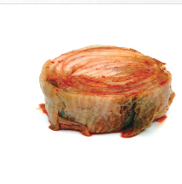

Material 1
Picture 2-unesco, intangible cultural heritage
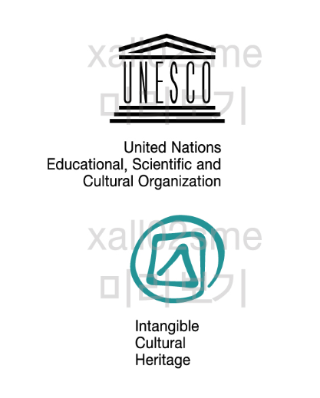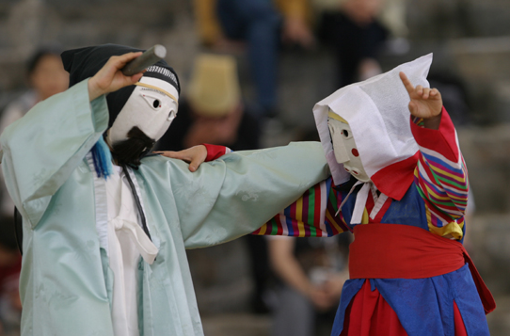

Material 1-Picture 3-to elicit the meaning of inscription
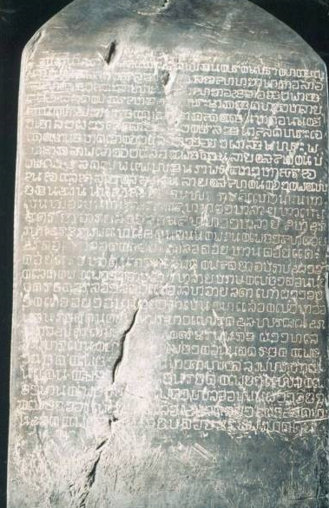

Material 2-Vocabulary worksheet

UNESCO( acronym):

Intangible cultural heritage:

Deliberate: a._____________________

Ex) deliberate mischief, deliberate judgement , with deliberate steps
v.____________________

ex)He deliberated a problem, He is deliberating what to do next.

Inscription:

Material 3-Dictation sheet
“Kimjang,” the process of making kimchi, __ ____ ___be included on UNESCO’s list of Intangible Cultural Heritage, the government announced recently. ________ __the Cultural Heritage Administration, the body tasked with __________new additions recommended Korea’s “Kimjang; Making and Sharing Kimchi” for __________, meaning it would be adopted by the UNESCO committee as intangible cultural heritage of humanity. ________ the final decision will not be made until December, when UNESCO’s intergovernmental committee meets in Azerbaijan, if Kimjang is __________, it would be Korea’s 16th item on the UNESCO list.

