|  |  |  |  |
| --- | --- | --- | --- |
| Speaking Lesson Plan | | | |
| Title The Best Home Doctor | | | |
| INSTRUCTOR | LEVEL | STUDENTS | LENGTH |
| MIN(minsook kim) | Pre-intermediate | 12 | 50 mins |
| Materials: White board, Markers, Erasers  Three categories of Word cards(12 copies)  Reward(chocolate bars)  Handout of Home Doctor’s Remedies chart(12 copies)  Pictures of ten common sicknesses and injuries (3copy)  Pictures for explaining new words(1 copy) | | | |
| Aims: * Main Aim  By the end of the lesson Ss will build up their speaking skills about giving medical advice.  * Subsidiary Aims  Ss will increase their speaking skills from learning vocabularies and expressions.  Ss will have a chance to work with new classmates  Ss will be better able to talk how to express their opinions through group discussion. | | | |
| Language Skills: Speaking: Group discussion. Sharing ideas in pairs  Listening: listen to the T’s instructions and Ss’ ideas  Reading: handouts of activity  Writing: Write their own opinions on the handout | | | |
| Language Systems: Phonology: pronounce the new Vocabularies, General observation from T and Ss  Lexis: Vocabulary  Grammar: General observation from T,Ss, handouts  Discourse: Group discussion, General conversation  Functions: Conversation in Best Home Doctor activity, | | | |
| Assumptions: Ss have some background knowledge of Home Doctor’s Remedies they will encounter in the class  Ss are enough to understand T’s instruction in English and to complete the productive skill activities | | | |
| Anticipated Errors and Solutions: - Some Ss may not know the teacher’s instructions accurately  : provide instructions as simple as possible, use some pictures to explain  -Students may not understand meaning of some vocabularies.  : If necessary, Let Ss use a dictionary.  - If time is short  : Skip Task Realization activity  - Activity could be finished earlier than timing of lesson plan.  : use SOS activity. | | | |
| References: <http://www.busyteacher.org>  <http://blog.naver.com/>  <http://www.sungwoobook.com> | | | |
| Notes:SOS Activities: Playing Hangman Plan B: Talk about your eating habits | | | |

|  |  |  |  |
| --- | --- | --- | --- |
| Pre Task | | | |
| Title: We found our group! | | Aims:To make new groups of Ss Ss will have a chance to work with new classmates | Materials: White board, Markers, Erasers, Three categories of Word cards(12 copies), Reward(chocolate bars) |
| Time | Set Up | Students | Teacher |
| 5 mins | Whole class | - Greeting  -listening  -listening and playing | - Greeting  **(Ice Breaker Activities)**  Demonstration  Show one of the word cards to explain  Instructions  -Explain “We are going to play a game to make new three different groups of four Ss. I am going to give each of you a card that has an English word and a picture. Look at your card and put it in their pocket.”  -giving cards to student  -Let Ss stand up and ask their classmates what kind of card he/she has. When they find Ss with a card in similar category, they will be a same group of member.  -Three categories are subject (English, math…), Animal (lion, tiger...), Food (cake…). Giving Ss some example  - When Ss find all four numbers, say “We found our group!” The first group who say this will be winner of the game and get chocolate bars  -play the game  -The activity will be run maximum for 2 mins  <CCQ>  -Why it is good for you to have new group members?  <ICQ>  -Do you understand the rule of game?  -Do your group members have the similar category card? |
| Notes: | | | |

|  |  |  |  |
| --- | --- | --- | --- |
| Task Preparation | | | |
| Title:What are Home Doctor’s Remedies? | | Aims:Ss will learn new vocabularies about some common sicknesses and injuries and Home Doctor’s Remedies | Materials: White board, Markers, Erasers, handout of Home Doctor’s Remedies chart(12 copies), Pictures of ten common sicknesses and injuries (3copy), pictures for explaining new words(1 copy) |
| Time | Set Up | Students | Teacher |
| 3 mins  10mins | Whole class | Listening and responding  Listening and responding  Reading  Listening and responding | -Eliciting example of common sicknesses and injuries from Ss and how to cure them at home  -Write Ss’ answers on the board  **(Activities)**  Demonstration  Showing the pictures to explain the new vocabularies  Instructions  -Giving each Ss the handout of Home Doctor’s Remedies  -Eliciting meaning of the new words in handout by showing pictures from Ss and explain them  -Give the sickness cards to each groups  <CCQ>  - What are common sicknesses and injuries?  -Does your family have a special remedy?  <ICQ>  -Do you understand the meaning of (word)?  (Keeping monitors Ss. If they looks do not understand the meaning of word, ask the ICQ to explain again) |
| Notes: | | | |

|  |  |  |  |
| --- | --- | --- | --- |
| Task Realization | | | |
| Title: Doctors I have ……. | | Aims:Ss will improve conversation skills Ss will improve their teamwork skills | **Materials**:  Handout of Home Doctor’s Remedies chart (12 copies) and Pictures of ten common sicknesses and injuries (3copy) will be used continually in this activity. |
| Time | Set Up | Students | Teacher |
| 22 mins  (2mins)  (5mins)  (5mins)  (10mins) | Group work | Listening and playing | **(Activities)**  Demonstration  Write the target language for question & answer on the board.  <Doctor, I have ~, You should ~, Why don’t you~, You’d better~>  Instructions  -Explain “Let play a game with your group. One of you should be the patient and the rest of you should be doctor.”  -The patient will show a sickness card saying, “Doctor, I have ______.”  -The doctor who gives the proper remedy first gets the sickness card.  -when the doctors say the remedy, they use expressions like “You should ______.”Or “Why don’t you ­­­­­­_______.”  -At the end of the game, the doctor who collects the most sickness cards will be the best home doctor.  - Let each group discuss who will be the patient  -Give Ss five mins for the doctors to study Home Doctor’s Remedies chart  -Give the sickness cards to The patients  -play game  <ICQ>  -Do you understand the rule of game?  -Who will be the patient in your group?  -Who is the best home doctor in your group? |
| Notes: | | | |

|  |  |  |  |
| --- | --- | --- | --- |
| Post Task | | | |
| Title: How can you prevent sickness and injuries? | | Aims:Ss will improve conversation skills Ss will be better able to talk how to express their opinions through group discussion. | Materials: White board, Markers, Erasers |
| Time | Set Up | Students | Teacher |
| 10mins  (2mins)  (3mins)  (3mins)  (2min) | In pairs  Whole class | Listening  Playing and discussing | **(Activities)**  Demonstration  Write the question on the whiteboard  < How can you prevent sickness and injuries? >  Instructions  -give information of the question shortly  -Let Ss discuss this topic in pairs  -Talk Ss’ ideas with the whole class  Conclude lesson |
| Notes: if time is short, skip in pair activity. Do class discussion | | | |

# Worksheets, handouts and lesson materials

##### Pictures of task Preparation 1 – temple

##### C:\Documents and Settings\kim\Desktop\speaking lesson plan\picture of remedies\temple.jpg

##### Pictures of task Preparation 2 – keep your ankle elevated

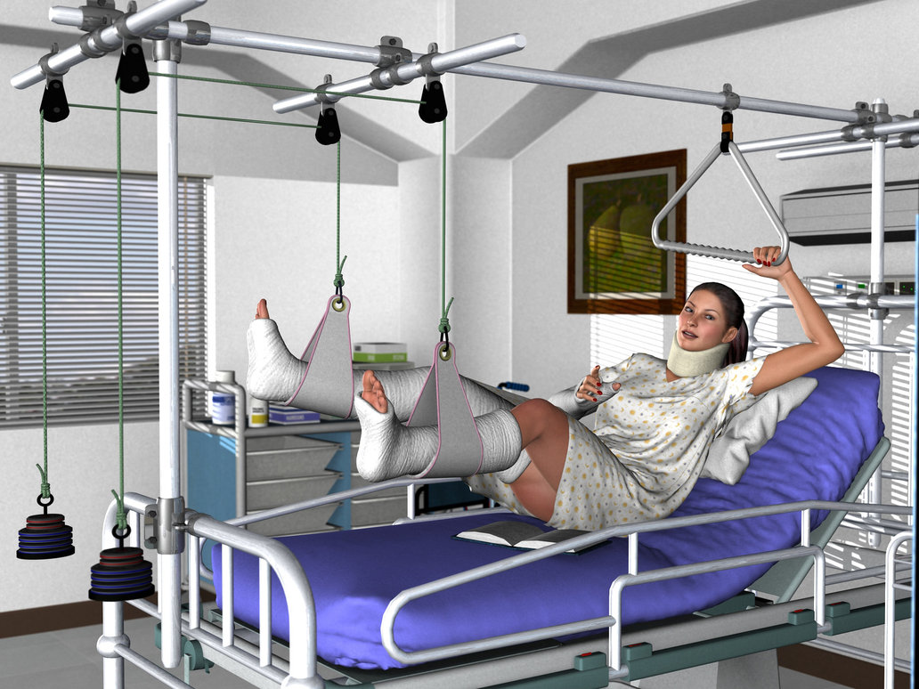

##### Pictures of task Preparation 3 – Gargle with warm salt water

##### C:\Documents and Settings\kim\Desktop\speaking lesson plan\picture of remedies\gargle.png

##### Pictures of task Preparation 4 – Do not tilt your head back. Lean forward

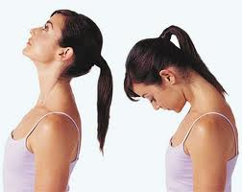

**Handout for Pre task activity 1**

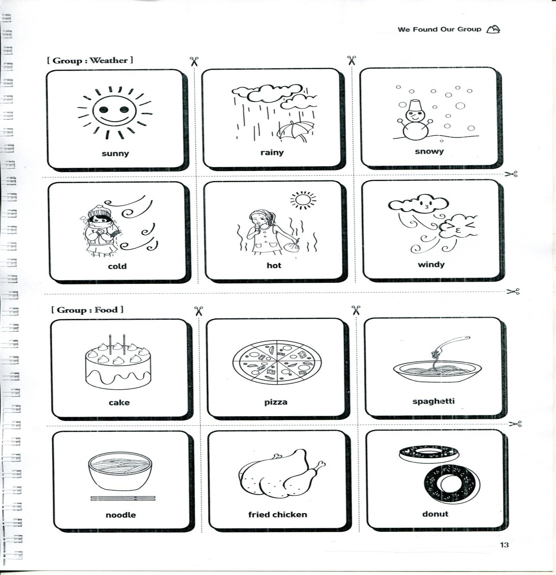

**Handout for Pre task activity 2**

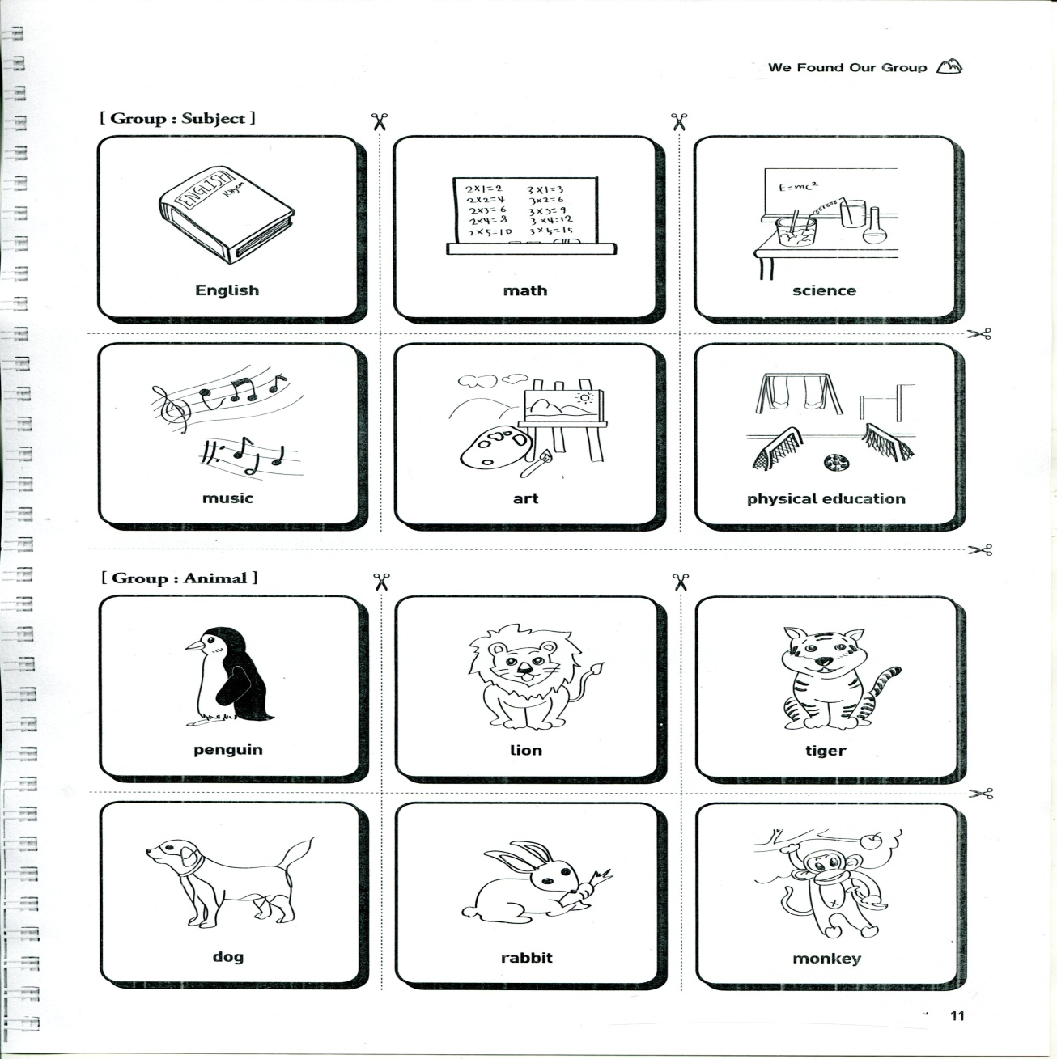

**Handout for Task preparation and Task Realization activity 1**

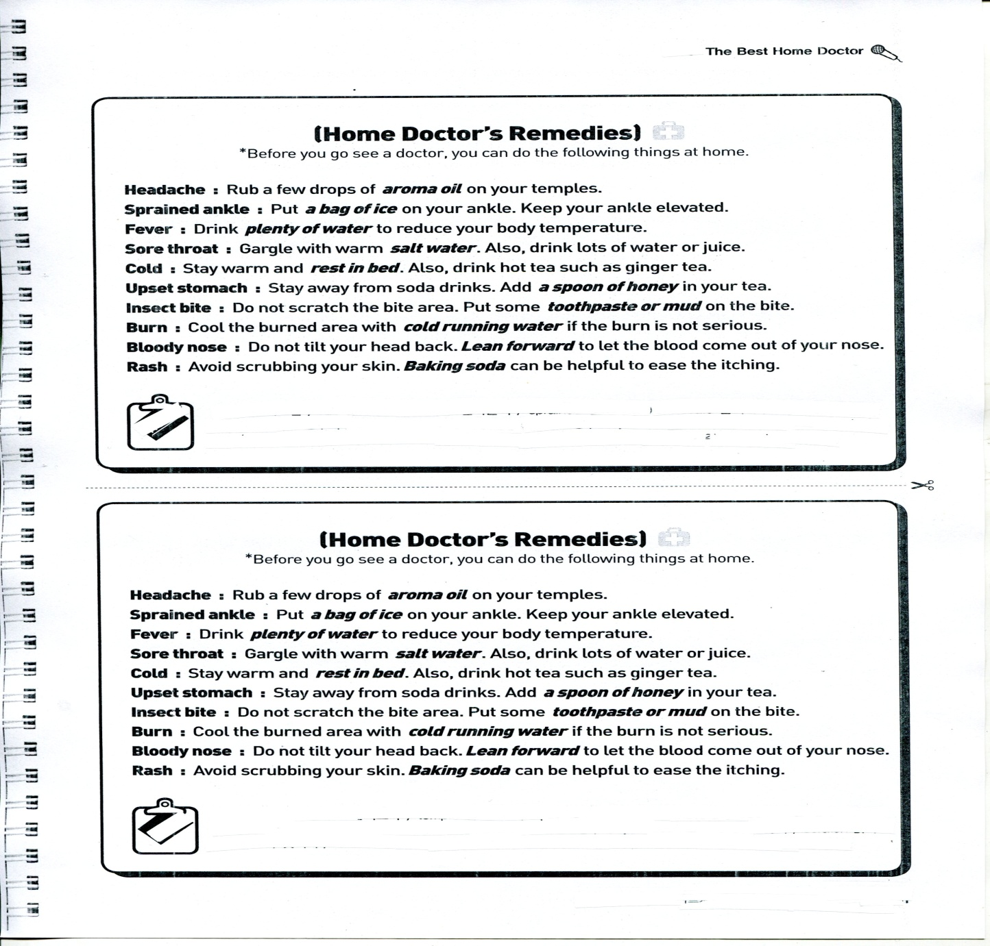

**Handout for Task preparation and Task Realization activity 2**

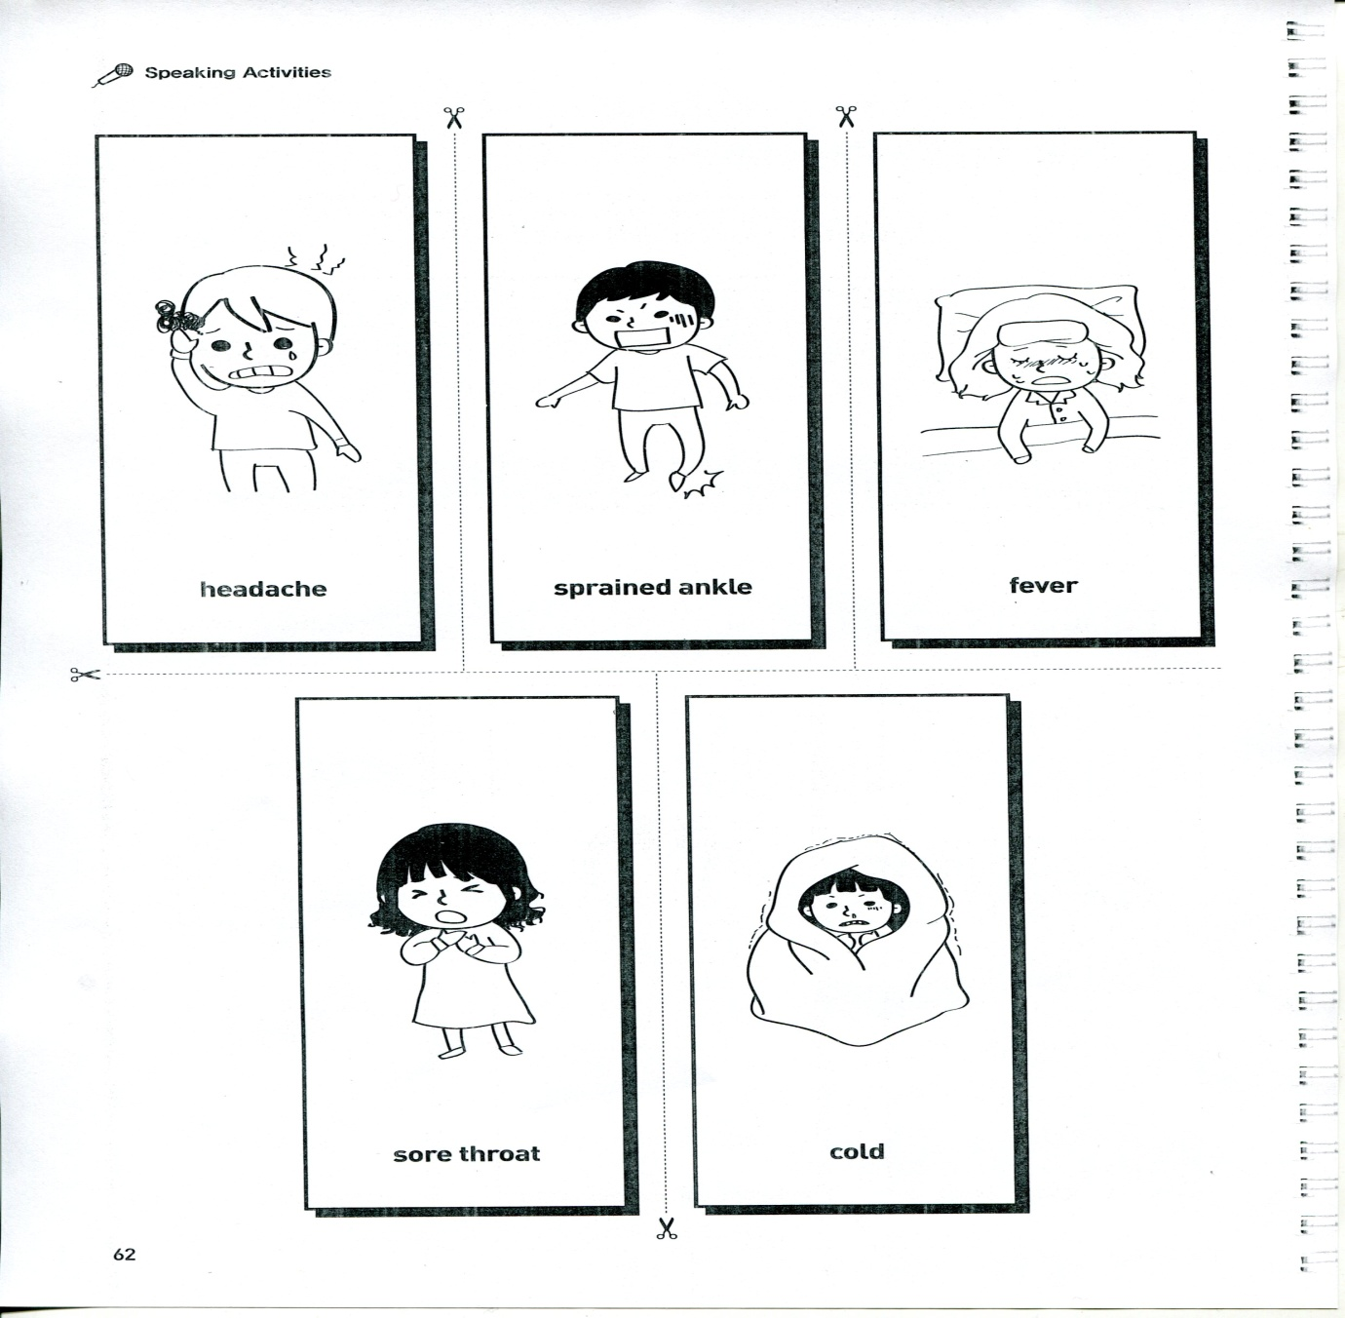

**Handout for Task preparation and Task Realization activity 3**

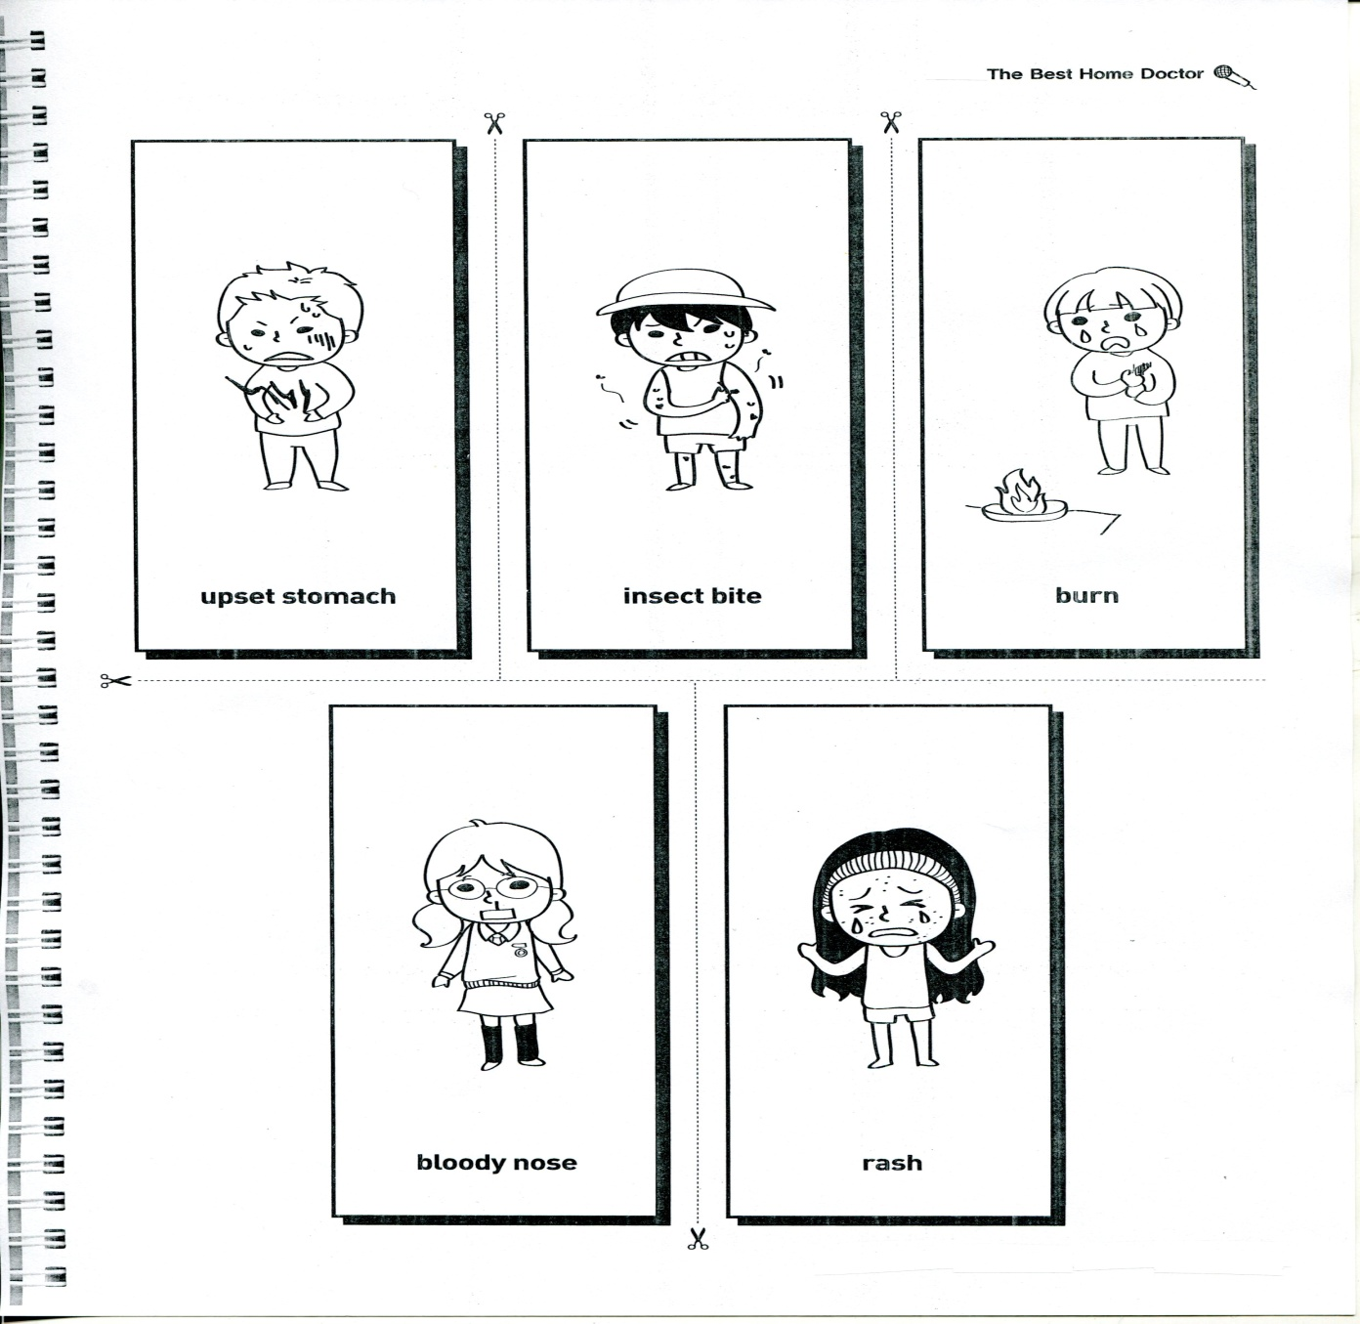

**Handout for post task (only for teacher)**

**Preventing any illness, including the common cold,**

- Wash Your Hands. You need to do it properly. With soap or a hand sanitizer

You should wash your hands before eating, preparing food, and dealing with sick people

-Take Your Vitamins

-Never touch your mouth, nose, or eyes without washing your hands.( prevent transmission of the virus)

-Teach your kids not to share food and other things that go in the mouth, as in guzzling milk from the carton or double dipping chips.

-Encourage family members to cover their mouths with a tissue when they cough or sneeze and to dispose of the tissue themselves. No time to grab a tissue? Cough or sneeze into the inside of your elbow instead of your hands.

-Avoid sharing personal items like toiletries, towels, and pillows.

-Get proper rest, getting enough sleep,

-Good nutrition to improve resistance and bolster immunity, eating well

-Exercise, and fresh air;

-Reduce your stress levels

-Avoid smoking or quit if you already smoke

**How to Prevent Injuries during Exercise**

-Wear protective gear, such as helmets, protective pads, and other gear.

-Warm up and cool down.

-Know the rules of the game.

-Watch out for others.

-Don't play when you're injured.

C:\Users\Sandrine\AppData\Local\Microsoft\Windows\Temporary Internet Files\Content.IE5\S0SRZWBR\MCj02515910000[1].wmfC:\Users\Sandrine\AppData\Local\Microsoft\Windows\Temporary Internet Files\Content.IE5\T3BVSEJU\MCj02514890000[1].wmfC:\Users\Sandrine\AppData\Local\Microsoft\Windows\Temporary Internet Files\Content.IE5\S0SRZWBR\MCj02902340000[1].wmfPlan B **TALKING ABOUT YOUR EATING HABITS**

C:\Users\Sandrine\AppData\Local\Microsoft\Windows\Temporary Internet Files\Content.IE5\S0SRZWBR\MCj04405240000[1].wmfC:\Users\Sandrine\AppData\Local\Microsoft\Windows\Temporary Internet Files\Content.IE5\T3BVSEJU\MCj04377630000[1].wmf

C:\Users\Sandrine\AppData\Local\Microsoft\Windows\Temporary Internet Files\Content.IE5\T3BVSEJU\MCj04134480000[1].wmfWhat are you used to eating for breakfast?

What do you usually have for lunch?

What about dinner?

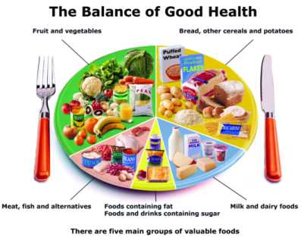  
  
  
Do you think you have a well-balanced diet? What should you do to make it healthier?