Speaking Lesson Plan

Title: how do you feel?
INSTRUCTOR | LEVEL | STUDENTS | LENGTH
Stephanie | Intermediate low | 12 / teenage boys and girls | 50 mins

Materials:
- vocabulary sheets (12+1)
- wall chart -pictures for introducing the vocabulary
- picture cards (12)
- papers for drawing straws
- tape for attaching the wallchart

Aims:
At the end of the lesson , students will learn the vocabulary related to the feeling.
At the end of the lesson, students will speak about their feeling and condition.
At the end of the lesson, students will improve the speaking skill by discussion in group and presentation.

Language Skills:
Speaking: students can make the story in group and do the presentation in front of other students.
Listening: students can listen to other students’ speech and teacher’s speech.
Reading: students can read the worksheet presented from the teacher, and wall chart.
Writing: students can write sentences to make a story and write down in worksheet,

Language Systems:
Phonology: pronounce the vocabulary .(enthusiastic, anxious, dizzy..etc)
Lexis: the vocabulary related to the emotion.
Grammar: adjective, present progressive tense.
Discourse: discuss in group, make a presentation in front of other people
Functions: dialogue , story

Assumptions:
Students are familiar with the pictures(from kakaotalk) (teachers can elicit the interest from the students)
Students can make story creatively based on the pictures given.
Students know basic words to express feeling.

Anticipated Errors and Solutions:
Students may need more time to make a story
teacher can give about 3 mins more to make a story.
Students may have the difficulty making sentences.
->teacher will monitor how their works do well.
Students may finish their work earlier than expected.
->teacher will encourage to make more sentences .
**SOS plan
If time is short,
--teacher will give more time to the group discussion and ask for adding more sentences .
--if there is more than 15min left , teacher can do the bingo game based on the information given from the other groups.
they have to fill in the blank with information which they listen to. They will do this activity in group.

References:
http://blog.naver.com/syhacla12?Redirect=Log&logNo=198656117

Notes: plan B

If wall chart is not available, teacher will draw the picture on the board .

Pre Task or Warmer
Title:  Introducing the topic-  how do you feel? |  | Aims:  Students can have the curiosity about the topic | Materials:  Board and marker
Time | Set Up | Students | Teacher
5  mins | Whole class | Students may answer like good, bad , tired.  Students may not give the various answer.(just routine words like good , bad, tired, angry..)  They will answer the question. | *Ask about the today’s feeling to all the students .(if it is possible , teacher will ask a question one by one)  *elicit specific words .  *Write the words given from the students on the board.  CCQ  We got the words like this.  -what do you think?  *Let them know they need to learn more vocabulary .

Notes:
???

Task Preparation or Presentation
Title:  vocabulary |  | Aims:  Students can learn the vocabulary by using the pictures which they are familiar with. | Materials: wall chart, work sheet,tape
Time | Set Up | Students | Teacher
7  mins | Whole class | Students can get the sheet.  Give the answers to the teacher. | *Teacher will distribute the worksheet and attach the wall chart on the board.  *Teacher will elicit the vocabulary from the students.  *And if necessary, teacher will add some explanation with examples.  CCQ  (Teacher pretends to be dizzy)  -How do I feel?  -can you pretend to be nervous?

Notes:
???

Task Realization or Practice
Title:  Make a story |  | Aims:  Base on the pictures, they can make a story by using the vocabulary we learned. | Materials:  Picture cards, papers for drawing straw.
Time | Set Up | Students | Teacher
3mins  7mins  15mins | Whole students  In pair  In group | Students will get a different picture.  Students will draw something in the picture teacher gave.  Students will discuss in pair.  Student will discuss in group. | *Let the students pick up the picture.  INSTRUCTION  *Give one min to draw some addition in there picture.  -show how to do it.(if it is needed)  ***Pair work  *Make sure the pair  INSTRUCTION  *Give them 10mins to make a story creatively.  *Let them make a story based on the picture by using 5-6 sentences.  ***group work  *after 10mins, teacher makes sure their group(4 persons) group 1, 2, 3  ICQ (for fun)  -what is your group number?  CCQ  -Why do you work in group?  INSTRUCTION  *Let them make a story based on 4 pictures.  *Teacher will give them 15mins to make a story by using 8-10sentences.  *after 15mins, they will present what they made in front of other students.  All group member should participate in a presentation.

Notes:
???

Post Task or Production
Title:  presentation |  | Aims:  students will have more chance to speak in front of other people. | Materials:  board
Time | Set Up | Students | Teacher
13  mins | Whole class  Group presentation | Students will do the presentation.  Students will answer the questions.  Students will come up with vocabulary they learned. | *Using the paper, decide which group will be the first .  *Let them present their ideas in front of other people.  *After finishing it , praise them .  CCQ  -How do you feel after the activity?  -Do you feel something?  Conclude lesson  * Based on this question, you will summarize the words we learned.

Notes:

Worksheets, handouts and lesson materials
Picture cards

Vocabulary worksheet
-------------------------------- ---------------------------- ------------------------------------ ---------------------------------
----------------------------------- ---------------------------- ------------------------------ ------------------------

----------------------------- --------------------- ---------------------------- ------------------------
Wall chart
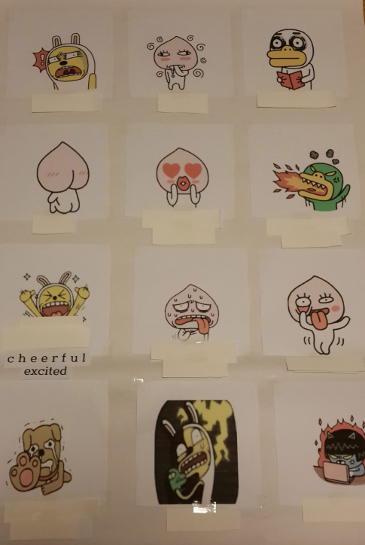
Papers to decide who will be the first(drawing straws)
