Reading Lesson Plan

Title: Hotel Reviews
INSTRUCTOR | LEVEL | STUDENTS | LENGTH
Jin Joo, Chu | Intermediate | 12 students | 50 mins

Materials:
-‘Hotel Review’ worksheet
-Board, board maker

Aims:
1.To integrate listening into writing and speaking skills and provide practice in summarizing
2. Practice skimming and scanning skills in reading.
3. To practice pronunciation, intonation, spelling, and listening

Language Skills:
Reading: Reading real hotel reviews on a hotel booking website.
Speaking: Tell stories from personal experiences of staying in hotels.
Listening: Listening to peer’s experience.
Writing: Writing a hotel review based on personal experience.

Language Systems:
Lexis: dump, cramped, stains, hell-hole, downside, top-notch.
Phonology: Correct pronunciation of new vocabularies.
Discourse: Discussing and talking about own experiences.
Grammar: Past tenses, conditionals
Functions: Telling and asking experiences.

Assumptions:
Students have experience with reading skimming and scanning techniques.
Students are familiar with most of the vocabulary in the review.
Students are familiar with classroom discussions and summarizing from it.

Anticipated Errors and Solutions:
- Students may have difficulty following and understanding the recording. I will play it as many times as is required for them to complete the listening comprehension tasks.
- Students may struggle with quite a bit of the vocabulary in the article. The more difficult vocabulary will be presented and practiced before the reading task.
- Students might struggle to imagine the situations presented in the first speaking activity and to convey their resultant feelings. I will show them various pictures of beautiful, tranquil scenes of nature and pictures of the mentioned animals to elicit responses.

References:
-‘Hotel Review’ worksheet
(http://busyteacher.org/14422-hotel-review-reading-and-discussion.html)

Notes:
SOS activity: 5X5 Bingo game with the following vocabularies. Explain them before the game.
Roll-away bed, king-size bed, queen-size bed, twin bed, single bed, suit, single room, double room, triple room, business center, gift shop, airport shuttle, make up the room, fitness center, wake-up service, pool, turn down the beds, take away the dishes, smoking, non-smoking, iron, check-in, check-out, FREE BINGO SPACE.

Pre Task or Warmer
Title:  Introduction to Hotel Reservations |  | Aims:  Speaking skill: Create interest in the topic with guiding questions. | Materials:  Board, board marker
Time | Set Up | Students | Teacher
3mins | Whole class | Answer guide questions according to their experience with the class. | Write topic on the board.  Guide questions  Do you remember about last class’s topic? (tourism and holidays)  What do we do normally when we prepare for holidays? (Elicit ‘book for a hotel’)  How do we make reservations for a hotel?

Notes:

Task Preparation or Presentation
Title: |  | Aims:  Pre-teach and practice unfamiliar vocabulary from the worksheet. | Materials:  ‘Hotel Review’ worksheet, board, board marker
Time | Set Up | Students | Teacher
9mins | Whole Class | Look at the bold vocabularies on the worksheet.  Guess what they mean with the context if needed. | Distribute worksheet  Instruction  There are two reviews about a hotel. Before starting let’s learn the vocabularies in bold. The one who gets the most answers will get a price. You may use the context as a hint!  *Elicit the meanings of vocabularies.

Notes:
Dump: Trash Lumpy: not smooth, having bumps
Dingy: dark, dirty, and in bad condition Downside: a negative aspect of something
Cramped: constricted in size, scrunched, small Top-notch: highest quality
Stains: smudges, discolored Go out of their way: (idiom) to make an effort to do something
Filthy: disgustingly dirty Can’t beat: nothing can be better

Task Realization or Practice
Title: |  | Aims:  Reading and understanding hotel reviews. Practice telling stories from personal experiences. | Materials:  ‘Hotel Review’ worksheet
Time | Set Up | Students | Teacher
29mins | In pairs  Group&Pair | 1. Reading  Listen to the T and follow along with the picture in the worksheet.  Read a review out loud and listen to the pair reading the other. Imagine how the hotel’s conditions and talk about it.  2. Discussion  Understand the meaning of ‘grain of salt’.  Discuss questions 1-3 in group and 4-6 with partner. | 1. Reading  Talk about the picture (hotel name, location, check in/out).  Pair up the Ss in twos.  Instruction  Read one review each out loud in pairs. Guess and talk about what kind of hotel it would be to each other. 9 mins.  Discuss in whole class what kind of hotel this is.  2. Discussion  Explain ‘grain of salt’  Instruction  Talk about questions 1-3 in your group (4 people), then after your group discussion share your experiences based on questions 4-6 in pairs. 16mins.

Notes:

Post Task or Production
Title:  Writing a Hotel Review |  | Aims:  Practice writing stories from personal experiences. (Summarizing from discussion) | Materials:  ‘Hotel Review’ worksheet, board, board marker
Time | Set Up | Students | Teacher
9mins | Individual work | Write a review based on the answers from discussion #6 (one review either best or worst).  Turn in the paper before leaving the class. | 3. Writing  Instruction  Write a review based on the answers from discussion #6 (one review either best or worst). 9 mins.  After they finish collect the reviews. Make feedbacks and return to them on the next class.

Notes:
HOTEL REVIEW
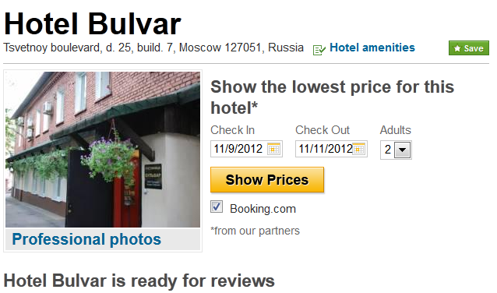
“This hotel will give you nightmares”
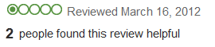
We stayed 3 nights at this overpriced dump. We arrived late at night and the dingy lobby was the first sign of the impending disaster. The room was small and cramped, with a carpet covered with stains (some that looked like blood...possibly from a previous murder?). The shower was filthy, and the toilet nasty, with something floating in it (we didn’t look too closely). The bed was a lumpy mess, and I woke up with red marks all over my body. I don’t know if this was from the bedbugs, or the mosquitoes that came in through the window. Oh yeah, I forgot to mention that there was no AC so we had to open the window because the room was so stuffy. Unfortunately, the hotel was right on the main street, and the traffic kept us up half the night. The hotel is only a 5 minute walk to Red Square, which is a plus, but it was a very dark and dangerous area of the city. The staff was unfriendly and unhelpful. Avoid this hell-hole!

“Delightful”
I recently stayed at this superb hotel in the center of Moscow. The hotel exceeded our expectations and certainly lived up to its excellent ratings on Tripadvisor. If you're looking for somewhere clean, comfortable, safe, and very close to Red Square....this is it. The room was very spacious, with lots of light and a big comfortable bed. In terms of cleanliness, it was impeccable. The only downside was the window (kind of small). The location is great and within walking distance of everything we wanted to see. Continental breakfast was included, but not very good. The staff was top-notch and very accommodating. They go out of their way to make dinner reservations, recommend local attractions, and make you feel welcome. We would definitely stay there again. Really, in terms of location, you can't beat this hotel.

HOTELS: Discussion

- How would you handle the following situations?
  - your hotel pillow has a dark stain on it
  - the children in the room next door are screaming non-stop after midnight.
  - you find a $50 bill under your bed.

- Which would you prefer, and why?
a) a large but dingy hotel room b) a cramped room but with new furniture

- What are you main criteria when selecting a hotel?
  - Price b) Location c) Good review d) Swimming pool e) other...

- What aspects of staying in hotels do you like/dislike?

- Do you trust the reviews you read? Or must you take them with a grain of salt?

- What's the worst hotel you've ever stayed at? The best?

Writing
Write a review based on the answers from discussion #6 (one review either best or worst).

