Listening Lesson Plan

Title: What color do you like?
INSTRUCTOR | LEVEL | STUDENTS | LENGTH
Stephanie | Intermediate | 12 (high school students) | 50 mins

Materials:
1.Worksheet (color personality test) - distribute each color section students choose
2.Comprehension worksheet(fill in the blank) -12sheets
3.PPT file(check USB)
4.Color paper -6
5.Color pen sets- 6
6.SOS plan sheet(color idioms)
7.chocholate bar

Aims:
Students will have learned the vocabulary in worksheet.
Students will improve their reading skill by reading the color personality test.
Students will improve their speaking skill by working in pairs.

Language Skills:
Reading: students can read the worksheets related to color.
Listening: students can listen to the students’ speech and teacher’s speech.
Speaking: students can speak when they work in pairs.
Writing: students can fill in the blank in worksheet .

Language Systems:
Phonology: pronounce the vocabulary in worksheet.
Lexis: vocabulary(related to the personality) in worksheet
Grammar: adjective, can(modal verb)
Discourse: work in pairs.
Functions: dialogue, information

Assumptions:

Students are familiar with and are interested in color personality test.
Students can draw the picture based on the worksheet given.
Students know the basic words related to the personality to understand the worksheet.

Anticipated Errors and Solutions:
Students may need more time to read and draw the picture.
teacher can give about 2-3 mins more to read and draw.
Students may have the difficulty filling the blank or they may need more time to fill in the blank.
->teacher will give a tip during discussion or give more time.
Students may finish their work earlier than expected.
->teacher will ask about their favourite color and also ask whether personality test matches your real personality or not.
**SOS plan
--if there is more than 15min left, teacher will give the color idiom sheet and let them discuss it.(included at the end of the file)

References:
http://www.goodreads.com/topic/show/1092168-what-your-favourite-color-says-about-your-personality
http://busyteacher.org/12848-poster-color-idioms.html

Notes:plan B
If ppt system doesn’t work , teacher will give the topic using by the hangman and blank.
Teacher will teach the vocabulary by using board and maker.

Pre Task or Warmer
Title: today’s topic |  | Aims: students will learn today’s topic by literacy quiz. | Materials: ppt , chocolate bar
Time | Set Up | Students | Teacher
2mins | Whole class | Students will give the answer to the teacher. | Teacher will elicit the topic from the students.  (among the unorganized letters, let them arrange the letters and figure out the topic)  To winner, teacher will give the chocolate bar.

Notes:
If ppt system doesn’t work , teacher will give the topic using by the hangman and blank.

Task Preparation or Presentation
Title: vocabulary |  | Aims:  Students can learn the meaning of vocabulary in the worksheet (color personality test) . | Materials: ppt
Time | Set Up | Students | Teacher
13mins | Whole class  (group) | Students will give ideas about the questions given by the teacher. | Teacher will elicit the meaning of vocabulary from the students by using the examples and showing the pictures. (teacher let them discuss in groups to elicit the meaning)  CCQ  -Can you tell me the meanings of the “cross”?  -what is meaning of “the down to earth ”?

Notes:
If ppt system doesn’t work , teacher will teach the vocabulary by using board and maker.

Task Realization or Practice
Title:  Personality test |  | Aims:  Students will improve their reading skill by reading personality test. | Materials:  Worksheet (color personality test) ,  Comprehension worksheet(fill in the blank),  Color paper and pen set,  ppt
Time | Set Up | Students | Teacher
2mins  10mins  15mins | Whole class  In pairs  In pairs | Students will answer the question.(blue , green..)  Student will work in pairs.  They will choose one color and write down the name on the board.  They will read the text and draw the picture.  Students will present their pictures.  Students will work with pairs.  Write the ideas(color) on the board. | Teacher will ask students what their favourite color is.  CCQ  -What is the color personality test?  Let them know we can expect the personality based on the color they like.  INSTRUCTION  -Teacher will make sure the pairs.  -Teacher will let them choose the one among 6 color. And let them write down the name next to the color on the board.(by order of arrival)  *After then, teacher will give the color paper, pen and the text sheet related to the color they choose .  INSTRUCTION  -teacher will let each group read the text and, students will draw the point of the personality from the text on the color paper.  (teacher can show them how to make it using ppt)  -Teacher will give 10mins.  After 10mins, if they finish, teacher will attach the pictures on the board.  CCQ  -Why did you draw the picture?  Teacher will distribute the comprehension worksheets to each person.  INSTRUCTION  -students will work with pairs.  -Teacher will let them guess and fill in the blank referring to the pictures students draw on the board.  -Teacher will give 15mins .  After 15mins, let each write the ideas on the board.

Notes:
If ppt system doesn’t work , teacher will draw the picture by using board and maker for demonstration.

Post Task or Production
Title: summarize |  | Aims:  Students will summarize what they have learned. | Materials:  ppt
Time | Set Up | Students | Teacher
7 mins | Whole class | Student will answer the questions. | Teacher will compare them and give the answer.  CCQ  -How do you feel after the activity?  Teacher will summarize today’s vocabulary.

Notes: color idioms is include at the end of the page in ppt file. (for SOS plan)

Worksheets, handouts and lesson materials
Worksheet no.1
RED: You are extroverted and optimistic. You are action oriented and physically active. You like to be the center of attention. You are ambitious and competitive. You have a passion and enthusiasm for life and are not afraid to pursue your dreams and goals. You are impulsive. Patience is not one of your strong points. You can be aggressive and easy to anger, often exhibiting a violent temper. you do not hold a grudge. You can be somewhat of a know-it-all, not wanting to appear unintelligent or ignorant. You can be quite determined when you want something, but tend to have a short attention span.
-----------------------------------------------------------------------------------------------------------------------------------------
WHITE: You are neat and immaculate in your appearance. You are well-balanced, sensible, discreet and wise. You are cautious, practical. You tend to have a great deal of self control. You are confident, poised and self-assured when at your most positive, but can also be very choosy when the mood strikes. You can be very critical of yourself and others. You are self-sufficient and a loner. You may appear to be shy, but you do have strong beliefs about most things and love the opportunity to air those beliefs.
-----------------------------------------------------------------------------------------------------------------------------------------
YELLOW: You've a happy disposition and are cheerful and fun to be with. You are creative, often being the one who comes up with new ideas. You tend to have your head in the clouds much of the time. You analyze everything, all the time, and are methodical in your thinking. You are impulsive and make quick decisions, but often, out of anxiety, jump in too quickly and rush things. You have a strong independent streak in you, and are selective with your choice of friends. You tend to hide your emotions, putting on a brave face in times of adversity. You have a modern outlook. New technology doesn't faze you. You communicate well on a mental level with like-minded people, but can become bitter and sharp-tongued if crossed. You are good at networking and getting information out of others. You can be stubborn but dislike pettiness and spitefulness of all kinds. You are good at anything that involves the mind, rather than physical pursuits.
-----------------------------------------------------------------------------------------------------------------------------------
GREEN: You are practical, down-to-earth person. You are stable and well balanced You are kind, generous and compassionate. You have a great need to love and to be loved and you tend to wear your heart on your sleeve- you are an open book. You have a need to belong. You are at home in any social situation. You have high moral standards and doing the right thing is important to you. You like to be accepted, appreciated and admired for the good you do in the community as well as in your family life. You are a loyal friend and a faithful partner, gentle but not passionate. You are strong-willed and do not like to be told what to do by others. You do like to win arguments and do not concede defeat easily. You are not a risk-taker and not action orientated, rather more of an observer. Detail bores you. You process information quickly and prefer to develop an idea, organize a plan and then delegate the rest to someone else. The ability to put yourself in the shoes of others is one of your true talents.
--------------------------------------------------------------------------------------------------------------------------------------------------

BLUE: You are conservative, reliable and trustworthy. You are not impulsive- you always think before you speak and act and do everything at your own pace in your own time. You take time to process and share your feelings. You are genuine and sincere, and you take your responsibilities seriously. You have a deep need for peace and harmony in your everyday life. You appear to be confident and self-controlled, but may be hiding your vulnerable side. You are generally fairly even-tempered, unless your emotions take over - then you can become either moody and over-emotional, or cool and indifferent. You are sensitive to the needs of others. While you are friendly and sociable, you prefer the company of your own close group of friends. You are a rescuer and love to be needed. You can be rigid - you like to stick to what is familiar to you- you stubbornly do things your way even if there is a better way. Untidiness and unpredictability overwhelm you. You don't like to draw attention to yourself. You make a loyal and faithful marriage partner and you are an honest, trustworthy and sincere friend.

--------------------------------------------------------------------------------------------------------------------------------------
PINK: You are loving, kind, generous and sensitive to the needs of others. You are friendly and approachable with a warmth and softness others are drawn to. You have a maternal instinct, with a need to protect and take care of others. You are very much in touch with your femininity - this includes men who are in touch with their feminine side. You are romantic and sensual and sensitive. With your optimistic and positive outlook on life, you see the good in everyone. You are methodical and organized, although you can sometimes be rather flippant when the immature girly side of pink appears. You are refined, reserved, calm and non-violent which may give the impression of shyness. You have a naivety, sweetness and beauty about you which can become girlish and immature in some.

Fill in the blank (worksheet no.2)
_______: You are extroverted and optimistic. You are action oriented and physically active. You like to be the center of attention. You are ambitious and competitive. You have a passion and enthusiasm for life and are not afraid to pursue your dreams and goals. You are impulsive. Patience is not one of your strong points. You can be aggressive and easy to anger, often exhibiting a violent temper. you do not hold a grudge. You can be somewhat of a know-it-all, not wanting to appear unintelligent or ignorant. You can be quite determined when you want something, but tend to have a short attention span.
_______: You are neat and immaculate in your appearance. You are well-balanced, sensible, discreet and wise. You are cautious, practical. You tend to have a great deal of self control. You are confident, poised and self-assured when at your most positive, but can also be very choosy when the mood strikes. You can be very critical of yourself and others. You are self-sufficient and a loner. You may appear to be shy, but you do have strong beliefs about most things and love the opportunity to air those beliefs.
_______: You've a happy disposition and are cheerful and fun to be with. You are creative, often being the one who comes up with new ideas. You tend to have your head in the clouds much of the time. You analyze everything, all the time, and are methodical in your thinking. You are impulsive and make quick decisions, but often, out of anxiety, jump in too quickly and rush things. You have a strong independent streak in you, and are selective with your choice of friends. You tend to hide your emotions, putting on a brave face in times of adversity. You have a modern outlook. New technology doesn't faze you. You communicate well on a mental level with like-minded people, but can become bitter and sharp-tongued if crossed. You are good at networking and getting information out of others. You can be stubborn but dislike pettiness and spitefulness of all kinds. You are good at anything that involves the mind, rather than physical pursuits.
_______: You are practical, down-to-earth person. You are stable and well balanced You are kind, generous and compassionate. You have a great need to love and to be loved and you tend to wear your heart on your sleeve- you are an open book. You have a need to belong. You are at home in any social situation. You have high moral standards and doing the right thing is important to you. You like to be accepted, appreciated and admired for the good you do in the community as well as in your family life. You are a loyal friend and a faithful partner, gentle but not passionate. You are strong-willed and do not like to be told what to do by others. You do like to win arguments and do not concede defeat easily. You are not a risk-taker and not action orientated, rather more of an observer. Detail bores you. You process information quickly and prefer to develop an idea, organize a plan and then delegate the rest to someone else. The ability to put yourself in the shoes of others is one of your true talents.
_______: You are conservative, reliable and trustworthy. You are not impulsive- you always think before you speak and act and do everything at your own pace in your own time. You take time to process and share your feelings. You are genuine and sincere, and you take your responsibilities seriously. You have a deep need for peace and harmony in your everyday life. You appear to be confident and self-controlled, but may be hiding your vulnerable side. You are generally fairly even-tempered, unless your emotions take over - then you can become either moody and over-emotional, or cool and indifferent. You are sensitive to the needs of others. While you are friendly and sociable, you prefer the company of your own close group of friends. You are a rescuer and love to be needed. You can be rigid - you like to stick to what is familiar to you- you stubbornly do things your way even if there is a better way. Untidiness and unpredictability overwhelm you. You don't like to draw attention to yourself. You make a loyal and faithful marriage partner and you are an honest, trustworthy and sincere friend.
_______: You are loving, kind, generous and sensitive to the needs of others. You are friendly and approachable with a warmth and softness others are drawn to. You have a maternal instinct, with a need to protect and take care of others. You are very much in touch with your femininity - this includes men who are in touch with their feminine side. You are romantic and sensual and sensitive. With your optimistic and positive outlook on life, you see the good in everyone. You are methodical and organized, although you can sometimes be rather flippant when the immature girly side of pink appears. You are refined, reserved, calm and non-violent which may give the impression of shyness. You have a naivety, sweetness and beauty about you which can become girlish and immature in some.

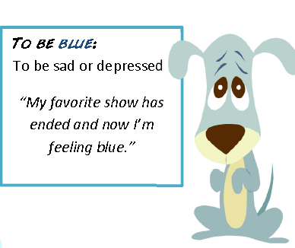
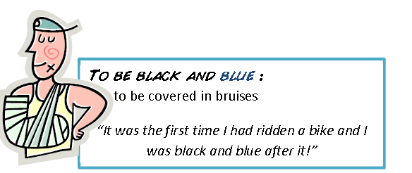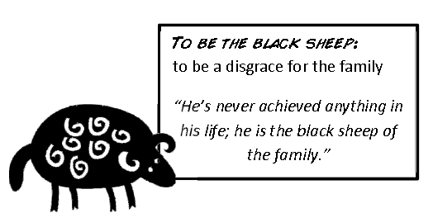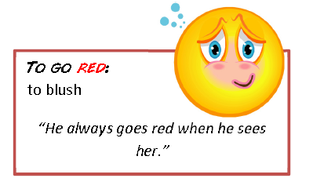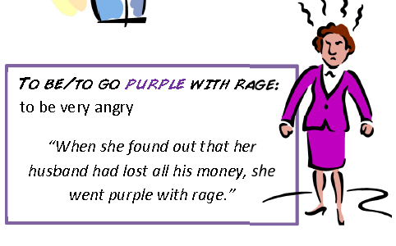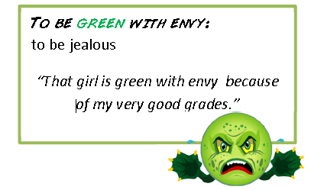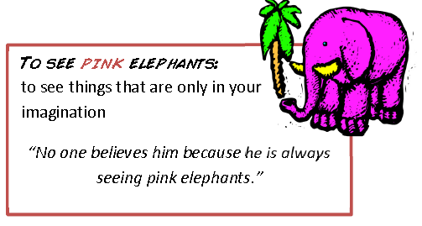
ppt file--------------------------------------------
