Activity Based Lesson Plan

Title – Count and Write the Number
INSTRUCTOR | AGE | STUDENTS | LENGTH
Brian Hong | 5-6 (Pre-intermediate) | 7 | 40 min

Materials: Worksheet #1~#5, Crayon, Visual Aid A~J, SOS Worksheet, 10 Pictures of “Teddy,” Scotch Tape, White Board & Board Marker, Overhead Projector & Screen, iPad, Music clip, MP3 Player, 2 - Youtube Video Clips.

Aims:
- Students will learn how to read 1~10 by observing the model and participating in the activities.
- Students will learn how to write 1~10 by following the model during the activity. (Repeated exposure)
- Students will learn the spelling for the numbers 1~10 by being exposed to it throughout the lesson.

Language Skills:
Writing: to write the numbers 1~10 numerically on the worksheet.
Reading: to read the numbers and words shown on the visual aids and the worksheets.
Speaking: to give their response, communicate during the activities, and to mimic the modelling.
Listening: to listen to “What number is this/that, and what is this/that?”question model. Following directions.

Language Systems:
Lexis: Students learn the spelling for the numbers and words covered in the lesson.
Functions: Students learn how to use the numbers learned when doing the worksheet activity. (Writing)
Discourse: Their understanding can be evaluated during the lesson by observing the different activities.
Phonology: Students mimic the pronunciation for the numbers and words learned.
Grammar: Students inductively learn how to substitute words for basic grammar. (“What number is this/that?” and “What is this/that?”)

Assumptions:
Students already know/have an understanding of:
- How to count from one to ten, but they do not know how to read/write it and how it is spelled.
- A-Z letters of the English alphabet.
- How to respond to “What ______ is this/that?” type of questioning from the previous lesson. (Repeating what they learned before.)
- Students have learned the different colors from the previous lessons. (Repeating what they learned before.)

Anticipated Errors/Problems and Solutions:
- Will make a few errors when participating in the number writing activity. (Use repetitive modelling)
- Will have difficulty paying attention during the lesson. (Use visual aids and activities to keep them interested)

References:
- Pancake Manor. “Count to 10 song - Numbers for Kids.” Online video clip.
You tube. n.d. 26 May, 2013. <http://www.youtube.com/watch?v=diMJIlv-4N0>
- n.p. “The Numeral Song.” Online video clip.
You tube. n.d. 3 Oct, 2009. <http://www.youtube.com/watch?v=qpA-YUC29E8>
- n.p.“Number recognition and number tracing worksheets.” Fun2write.com. n.d.
<http://www.fun2write.com/numbers.shtml?gclid=CMmkvK-CpbsCFSgB4godnGYALA>
- n.p. “number 33049.” My favorite coloring. n.d. 2013.
<http://www.my-favorite-coloring.net/Coloring/Print/Numbers-and-shapes/Number-four/33049>

Notes: Their understanding of how to write the numbers can be evaluated during the worksheet activity.

Pre Task or Warmer (7 min)
Title:  Counting Numbers |  | Aims:  Start the lesson by activating the student’s interest through the video and visual aids. | Materials:  “Count to 10 song” & “The Numeral Song” Video Clips, Visual Aids A~J, Overhead Projector, Projection Screen, Whiteboard, Scotch Tape, iPad.
Time | Set Up | Students | Teacher
2 min  4 min  1 min | Whole class  Whole class  Whole class  Whole class | Say hi to the teacher.  Watch the video  Give a response  Give a response | Set up the two videos on two different IE pages, iPad as a backup, and the student desks in a U shape.  Greet the children.  Step 1  Show the Count to 10 song video.(Running time 1:45)  Step 2  Show the 10 different visual aids while eliciting.  What number is this?  One. O-N-E.  What animal is this? Dragon. One dragon. O-N-E  Be sure to count the number of animals/objects in the visual aid with the number shown in the visual aid.  Repeat step 2 for all the numbers (1~10).  Step 3  Place some of the visual aids far away and go back and forth using the “What number is this/that?” questioning sequence.  - What number is this/that?  - Good. It’s the number ______..

Notes: Make sure that the students are paying attention to the spelling of the numbers and what each number looks like, both numerically and alphabetically, covered in the warmer through repetitive exposure.

Task Preparation or Presentation (10 min)
Title:  Number Activity |  | Aims:  To teach the children how to count, and to reinforce what they have learned through a fun activity. | Materials:  White Board, Scotch Tape, 10 Pictures of Teddy, MP3 Player, Music Clip.
Time | Set Up | Students | Teacher
4 min  1 min  5 min | Whole class  Whole class  Whole class  Circle  Whole class | Give a response  Observe the activity modelling.  Give a response  Listen to the instructions.  Get in a circle in the front of the class.  Participate in the activity. | What is this? Good. This is “Teddy.” One Teddy.  - Model how to count the “Teddys” first.  - One, two, three. “Three Teddys.”  - Use different sequences to post pictures of Teddy on the whiteboard.  How many Teddys are there? Good. ___ “Teddys.”  We are going do a fun activity.  Do you know the Jak-Jik-Gi Game?  - I will play a song.  - I will say a number when the music stops.  - If I say three, 3 students will get together in a group.  - A student without a group will be out.  Come to the front and make a circle.  Model the activity for the students. Let’s begin.  - Let all the students stay in the activity for a few rounds. (Positive reinforcement)

Notes: Make sure to demonstrate how to count by using the Teddy bear pictures. (Stick in on the whiteboard)

Guide the students throughout the activity by modelling it first, and be sure to use positive reinforcement.

Task Realization or Practice (20 min)
Title:  Writing Numbers |  | Aims:  To evaluate the children's understanding of what they learned through monitoring. | Materials:  Worksheet #1~#5, Visual Aid A~J, Crayons, White Board & Markers, Projector & Screen, Video clip.
Time | Set Up | Students | Teacher
2 min  5 min  13 min | Whole class  Whole class  Individually | Watch the video.  Do the modelling. (Taking turns doing the modelling.)  Do the activity. | Step 1  Show The Numeral Song video.(Running time 2:20)  Step 2  Use the whiteboard to demonstrate how to write 1~10 numerically.  - Use Visual Aids A~J to associate it with counting.  What number is this? One.O-N-E  Who wants to write it on the board?  - Elicit the response from the students.  - Repeat the process for numbers 1~10.  Step 3  Good. Now let’s do it individually.  Hand out Worksheet #1~#5 with the crayon.  Active monitoring throughout the activity.

Notes: Demonstrate how to do the activity for Worksheet #1~#5. This activity can be used as an observation point to evaluate how much information the students have learned. Let them do some coloring if there is time left over.

Post Task or Production (3 min)
Title:  Repeated Exposure |  | Aims:  Review what the children learned throughout the lesson by modelling through repeated exposure. | Materials:  Visual Aids A~J, White Board, White Board Marker.
Time | Set Up | Students | Teacher
3 min | Whole class  Individual  Whole class | Give a response.  Write number 1 on the board. (Numerically)  Listen to the teacher.  Finish the lesson. | Repeat what was done during the second part of the warmer. (Using Visual Aids A~J.)  Step 1  - What number is this? (Mix up the numbers)  One. O-N-E.  - What animal is this? Dragon. One dragon. O-N-E  - Who wants to write it on the board?  Be sure to count the number of animals/objects in the visual aid with the number shown in the visual aid.  Repeat step 1 for all the numbers (1~10).  Good job. You are very smart. (Clap your hands)  End the lesson.

Notes: Go over what the students have learned throughout the lesson by repeating parts of the lesson. (Reading & Writing) Use positive reinforcement to encourage participation.

SOS Activity-Coloring (15 min)
Title:  Color in the Number |  | Aims:  Back up activity for the children in case they finish the lesson earlier than expected. | Materials:  SOS Worksheet, Crayon.
Time | Set Up | Students | Teacher
3 min  12 min | Whole class  Individually | Give a response.  Do the activity.  Finish the lesson | Pass out the SOS Activity Worksheets along with the crayon.  Elicit the answers from the students.  - Can you see the number one?  - What color do we use?  - Good. Color in the area marked 1.  Demonstrate for all the numbers. (Modelling)  Ok. Let’s begin.  Start the activity and use active monitoring.  Guide them through the activity if needed.  End the lesson.

Notes: This activity will be useful as the students are exposed to what they have already learned.

Make sure to use active monitoring while using positive reinforcement. Give them additional Guidance if needed.

Appendix A: Numbers (Visual Aid A~E) ** Color in the visual aids after printing.**

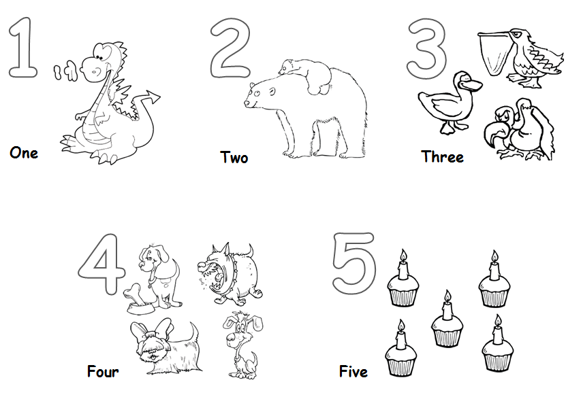

Appendix B: Numbers (Visual Aid F~J) ** Color in the visual aids after printing.**

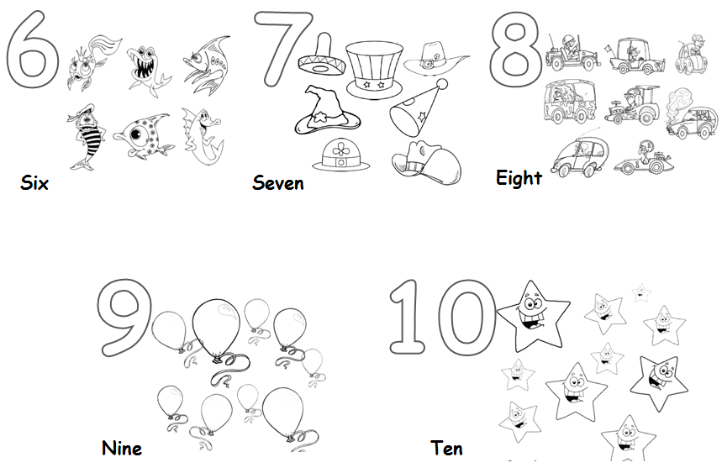

Appendix C: Picture of “Teddy.”

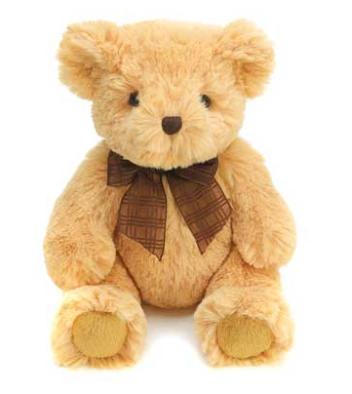

Appendix D: Worksheet #1 ~ #5: Writing Numbers

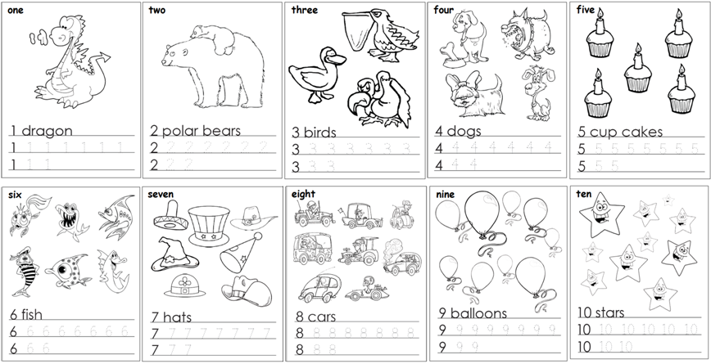

Appendix E: SOS Activity Worksheet

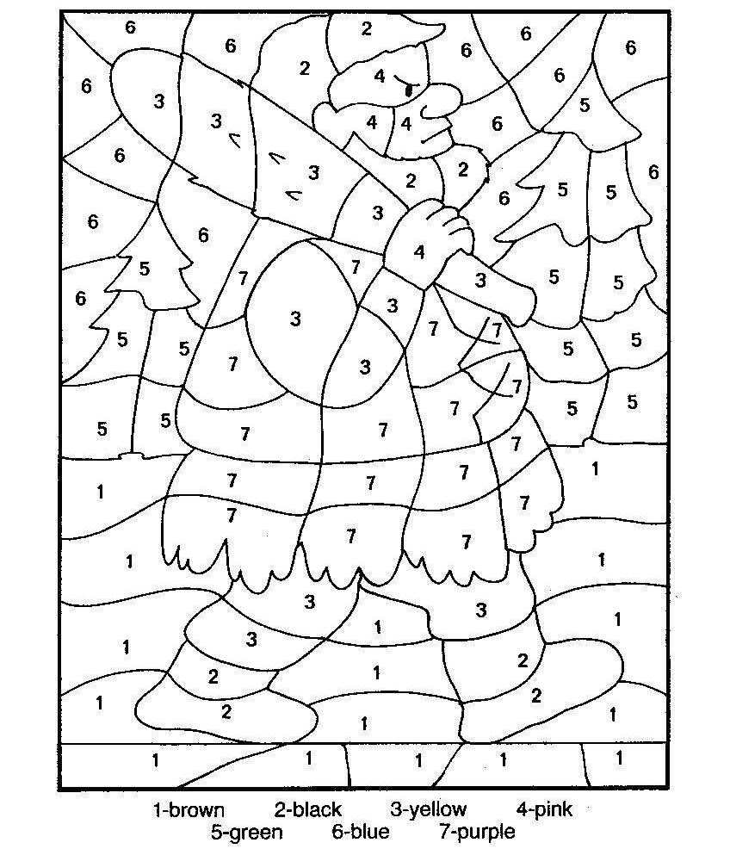

Worksheet #1: Writing Numbers

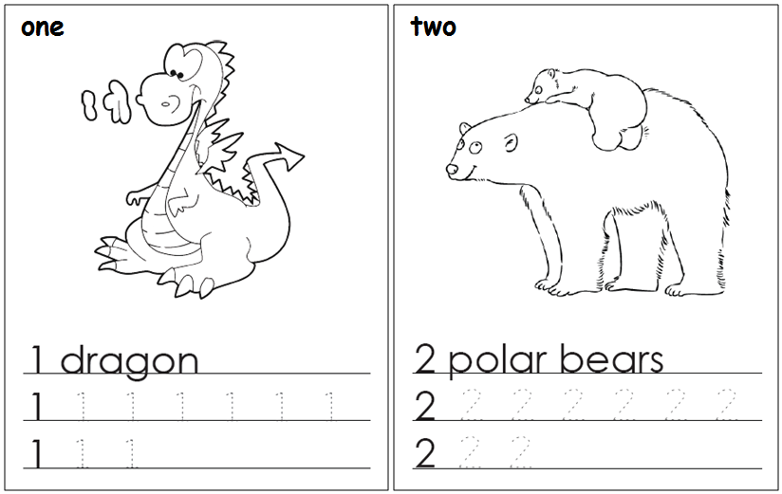

Worksheet #2: Writing Numbers

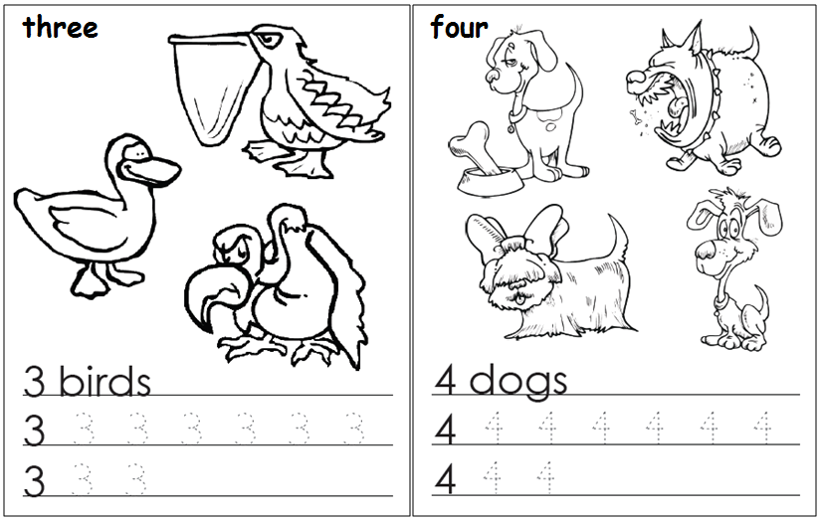

Worksheet #3: Writing Numbers

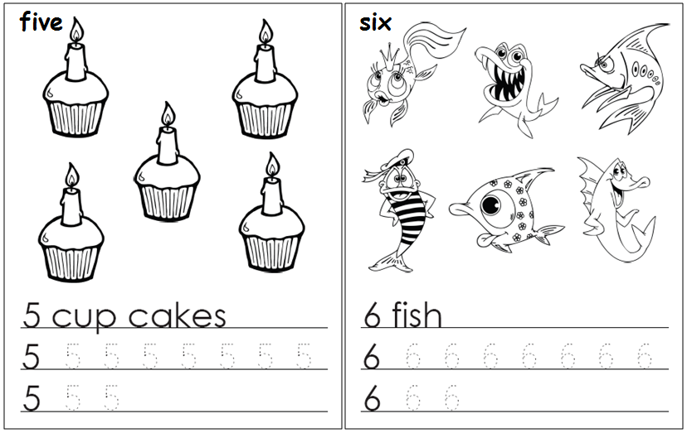

Worksheet #4: Writing Numbers

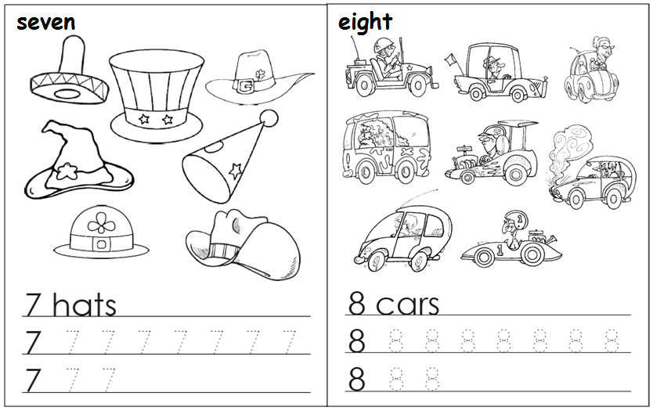

Worksheet #5: Writing Numbers
