Reading Lesson Plan

Learning about dog-related idioms – Lets guess the answers!
INSTRUCTOR | LEVEL | STUDENTS | LENGTH
Angie Kim | Upper Intermediate - Adults | 12 | 50 mins

Materials:
Whiteboard, tape and markers
Bizarre Animals picture sheets x5
Dog Idioms worksheet x 12
Sick as a Dog worksheet x12
Crossing the River riddle worksheet x12

Aims:
By the end of this lesson students will -
- Have learned several new idioms and know how to use them in conversations.
- Increased their vocabulary and become more comfortable using them in sentences.
- Develop their fluency in English by participating in the group activities.

Language Skills:
Reading: Dog idioms worksheet, Sick as a Dog worksheet, Crossing the river worksheet, reading the whiteboard.
Speaking: Class and group discussions and activities, responding to the teacher’s questions.
Listening: Teacher’s CCQ and ICQ, listening to group member’s opinions about the activities.
Writing: Meaning of the idioms on the word, writing their own sentences using the idioms the students have learned.

Language Systems:
Phonology: Practicing new vocabulary and their pronunciations
Lexis: Understanding the way new words are used in sentences and how to apply them freely in their own conversations.
Grammar: Allowing the students to form their own sentences based on the new idioms related to the topic.
Discourse: Group and class discussions about the idioms and figuring out the meanings.
Functions: Getting the students to discuss and question each other in groups, questioning the students about the idioms and their meanings.

Assumptions:
- Students may have heard the idioms used in passing conversations or in media, but do not know the exact definitions.

Anticipated Errors and Solutions:
- Students might have some difficulty understanding the words used in the main activity worksheet.
  - Make sure that the students are familiar with the vocabulary by pre-teaching the words that are used in the passage.
- If time is running short
  - Cut down the time of the post activity
- If students finish their activities earlier than anticipated
  - Assign the SOS Activity to the students – Look at the POST TASK section

References:
http://www.buzzfeed.com/summeranne/the-15-craziest-animals-on-the-planet
http://www.theequinest.com/unusual-dogs/
http://www.5minuteenglish.com/april14.htm

Notes:

Pre Task or Warmer
Name the animal! |  | Aims:  To lead the students into the main topic and get them interested. | Materials:  Bizarre Animals picture sheets x5
Time | Set Up | Students | Teacher
6 mins | Groups – 3 students per group | Students discuss with their group members about the pictures and also make up their own name for each animal. | Stick the 5 pictures onto the whiteboard.  Get the students to discuss with their group members about the animal pictures and come up with a new name for each animal.  After a few minutes, ask each group about the answers they came up with.  CCQ:  Can you guess what today’s topic is?

Notes:

Task Preparation or Presentation
Title |  | Aims:  To pre-teach new vocabulary and idioms related to the main topic. | Materials:  Whiteboard and markers  Dog Idioms worksheet
Time | Set Up | Students | Teacher
3 mins  7 mins | Individually  Groups | Students individually complete Activity 1.  Students can discuss with other classmates what they think about each of the word meanings, as well as actively engaging in a class discussion  One group member goes and writes what they think the meaning of each idiom is up on the board. | Hand out the Dog Idioms worksheet to students and ask them to do Activity 1 individually.  After 2-3 minutes go over with the students what they think the answers are.  Ask them to do Activity 2 in groups and guess the meanings of each idiom.  After several minutes, get a member from each group to write down their meanings on the whiteboard  CCQ:  Do you agree with what each group has written on the board?

Notes:

Task Realization or Practice
Title |  | Aims:  To let the students practice their reading comprehension skills by identifying the idioms. | Materials:  Sick as a Dog worksheet
Time | Set Up | Students | Teacher
12 mins  10 mins | Individually  Pairs | Students should be answering the teacher’s elicitations.  Students go over the worksheet and underline each idiom they find.  Students make up their own sentences using the idioms that were in the worksheet passage.  Students read out loud to their partners the sentences they have made.  Students can also share their sentences with the whole class if the teacher requests. | BEFORE handing out the worksheet, check that the students know the following vocabulary:  1. Flu virus  2. Immune System  3. Glory  4. Keep one’s eye on  If the students are unsure, ELICIT the meanings.  Hand out the Sick as a Dog worksheet to each student and ask them to read the passage.  Ask the students to highlight/underline each idiom they can identify.  ICQ:  What are you meant to highlight?  Check that the students identified all the idioms by going through the passage as a whole class  Ask the students to make up sentences using the idioms and also let them share their sentences with a partner.  CCQ:  Ask a pair (or two) to share their sentences with the class.

Notes:

Post Task or Production
Solve this riddle! |  | Aims:  To let the students improve their reading comprehension skills and practice their fluency in using English by conversing with other students. | Materials:  Crossing the River riddle worksheet
Time | Set Up | Students | Teacher
12 mins | Groups – 3 students per group | Groups read the riddle worksheet together and discuss with their group members about what they think the solution could be.  Provide answers to the teacher, when they are asked upon. | Hand out the Crossing the River riddle worksheet to all the students  Ask the groups to read the riddle and then discuss with their group members what they think the solution is.  When it seems like the groups have formed an answer, ask each group what they thought.  Elicit: If the students have not come up with the correct solution, provide enough information that will eventually allow them to figure it out.

SOS:

If there is time remaining after this activity, you can ask the groups to search for other riddles or brain teasers on the Internet.
- After they have found a couple of riddles or brainteasers, the groups can then question the riddles to each other.

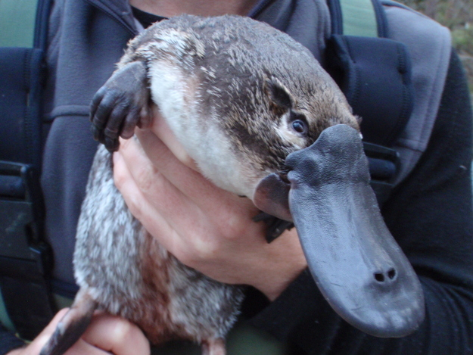
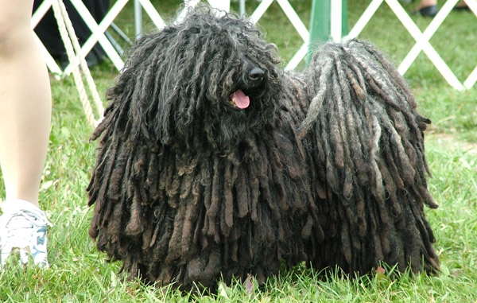

DOG IDIOMS

Activity 1 - Circle what you think the following underlined phrases mean:

Wow! It's raining cats and dogs today! I wish I'd brought my umbrella to school!
a. I forgot my umbrella today.
b. It's raining heavily.
c. Cats and dogs are falling from the sky.

I never learned how to use a computer, so I lost my job to a new employee. It's a dog-eat-dog world.
a. Only the strong or the best survive.
b. Dogs are eating dogs at the office.
c. Dogs like to eat dogs for lunch.

Activity 2 – Discuss what you think the meanings of these idioms might be:

- His bark is worse than his bite
- Gone to the dogs
- Let sleeping dogs line

SICK AS A DOG

Susan: Oh Shannon, you look as sick as a dog. What's the matter?

Shannon: I feel terrible. I think I might have caught that flu virus that has been going around. I've been working like a dog and had a lot of stress lately. Maybe that's lowered my immune system.

Susan: I know you told me about that argument you had with your coworker. You shouldn't worry so much about being top dog. Let him have some glory, too.

Shannon: I know. I don't know why I get so upset about everything. And there's another thing. If I get into any more fights with anyone in the office, I'm going to be in the doghouse. My boss is already keeping his eye on me.

Make up your own sentences and also include the idioms that were used in the conversation above:

1.
2.
3.
CROSSING THE RIVER RIDDLE

There was a farmer who wanted to go across a river. The farmer had a dog, a sheep and some cabbage. The farmer's boat was very small so the farmer could only take one thing across the river at a time.

The problem was that if the sheep were left alone with the cabbage, then the sheep would eat the cabbage. If the dog were left alone with the sheep, then the dog would eat the sheep.

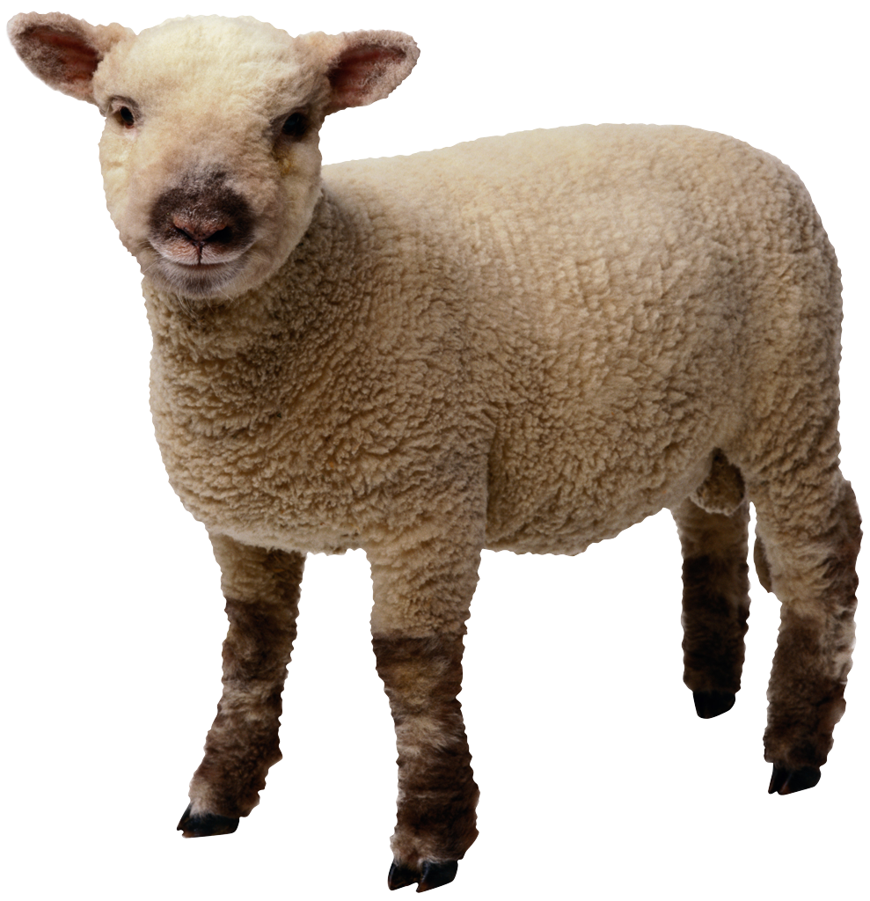

- How can the farmer get everything across the river?

- After reading the passage, discuss what the solution might be with your group members.

