Reading Lesson Plan

Group Reading: Order the story of Rapunzel
INSTRUCTOR | LEVEL | STUDENTS | LENGTH
ALICE | Higher-Intermediate | 13 (teenagers) | 50 mins

Materials:
- White board & markers
- Animation pictures (PPT), USB File (Folder name HR/LP/RLP/RLP_PPT)
- Text sheet (6 copies), 6 extracts prepared in advance, Number papers (1-6)
- Vocabulary worksheet ( 6 copies-pair work), Comprehension worksheet (13 copies)
- SOS activity worksheet (13 copies)

Aims:
- Main aim: To help Ss to be able to analogize the whole out of a part by ordering the story
- Secondary aim: To enhance skimming & scanning reading
- Third aim: To let Ss be interested to learn reading with familiar text and let them be storyteller

Language Skills:
Reading: Students will read a text per each pairs and also read loudly.
Listening: Listen to texts from the other pairs
Speaking: Answer to questions, pair discussion
Writing: Comprehension worksheet

Language Systems:
Phonology: Pronunciation “/-ed/”
Lexis: Vocabulary associated to the story
Grammar: Past tense & Past participle
Discourse: Pair discussion
Functions: Analogize & Order the text by reading

Assumptions:
- Ss are teenagers, so they may be are familiar with the text.
- Ss are a higher-intermediate level, so they may be able to do speed reading.

Anticipated Errors and Solutions:
- Ss may not know some vocabularies on the text.
- Teacher will allow Ss use dictionary only for one word with teacher’s authorization.
- Ss may finish their task earlier than expected.
- Teacher will do SOS activity.

References:
- www.naver.com/disney/images
- www.busyteacher.org/worksheet/reading/groupreading
- www.busyteacher.org/worksheet/reading/kidsandbedtimestories

Notes:
SOS activity: Article reading about Kids and bedtime stories
This is a reading activity on a newspaper article, about parents who do not tell bedtime stories to their children anymore. To make students read and discuss the vocabulary and talk. There are also some questions about this issue for discussion.

Pre Task
Title:  Engaging in the lesson |  | Aims:  To elicit Ss the ideas for today’s topic | Materials:  - Animation pictures (PPT), USB File (Folder name HR/LP/RLP/RLP_PPT)
Time | Set Up | Students | Teacher
7  mins | Whole class | Answering question | Show Ss the pictures  Give Ss guiding questions  - What do you think are they looking at?  - Why do you think are still these characters attractive?  - What is the difference between the old and the modern?  - Do you enjoy watching animations and then what’s your favourite film?

Notes:

Task Preparation
Title:  Focus on reading |  | Aims:  To read texts with skimming & scanning method | Materials:  - 6 extracts prepared in advance, Number papers
Time | Set Up | Students | Teacher
8  mins | Pairs | Reading texts and analogizing them | Divide Ss into pairs (6 team)  Let them choose a paper.  Hand out the extract to each pair according to the number.  Give instructions  - Work pairs. You have 5 mins.  - Read it carefully.  - If you don’t know some vocabularies, allow to use dictionary for only one word. (Raise your hand)  [ICQ]  - How many words are allowed?  - Please highlight the vocabularies you don’t know while you’re reading.  - Ready? GO!

Notes:

Task Realization
Title:  Reading activity & Learning vocabulary |  | Aims:  To analogize the whole out of a part by reading loudly, and learn vocabularies with pronunciation, grammar | Materials:  - Text sheet (6 copies), Vocabulary worksheet ( 6 copies-pair work), White board & markers
Time | Set Up | Students | Teacher
10  mins  2  mins  7  mins | Pairs  Whole class  Pairs | Reading the extracts loudly and listening accordingly  Answering questions  Doing worksheets | Give instructions  - Once you're finished, one of you has to realise that you have the beginning of the story.  - Then you read it and the rest listens carefully, if you think you have the following part- you read it (with Ts authorization).  - When you complete the reading you will know the story of Rapunzel. (Don’t mention the title)  - OK, go first!  - When the game is completed, distribute original copies to the pairs.  [CCQ]  - How did you infer the order of the story?  - What’s the key to recognize it?  - What’s the difference between plain reading and dynamic reading?  Check out vocabularies  - Work same pairs. You have 3 mins.  - Give Ss vocabulary worksheet.  - Check answers verbally and write down as needed.  Pronunciation “/-ed/” Grammar “past participle”

Notes:
If the game is finished earlier than expected, teacher will do SOS activity.
However, let Ss talk about freely a tendency toward recent animation if time is a bit short.

Post Task
Title:  Reading comprehension |  | Aims:  To check reading comprehension  To get Ss practice intensive reading by making questionnaires. | Materials:  White board & markers, comprehension worksheet(13 copies)
Time | Set Up | Students | Teacher
6  mins  10  mins | Individually  Whole class  Pairs  Whole class | Doing worksheets  Answering questions & Listening  Making questionnaire  Speaking questionnaire and listening | Give instructions.  - Work individually. Give Ss worksheets.  - You have 3 mins.  - Check out the answers as a whole.  Free production  - Work pairs.  - Please make 2 your own interpretive questionnaires with your partner.  - You have 5 mins.  - Speak one questionnaire per each pair.  Review overall  Well done. Have a good day!

Notes:

SOS Activity
Title:  Reading activity |  | Aims:  To practice general reading activity | Materials:  SOS activity worksheet(13 copies)
Time | SetUp | Students | Teacher
10  mins | Individually | Carrying out the task | Distribute the SOS worksheet  Instruction  - Work individually.  - You have 10 mins.

Notes: Give Ss homework if they do not finish it yet. Check the answer briefly in the next lesson.

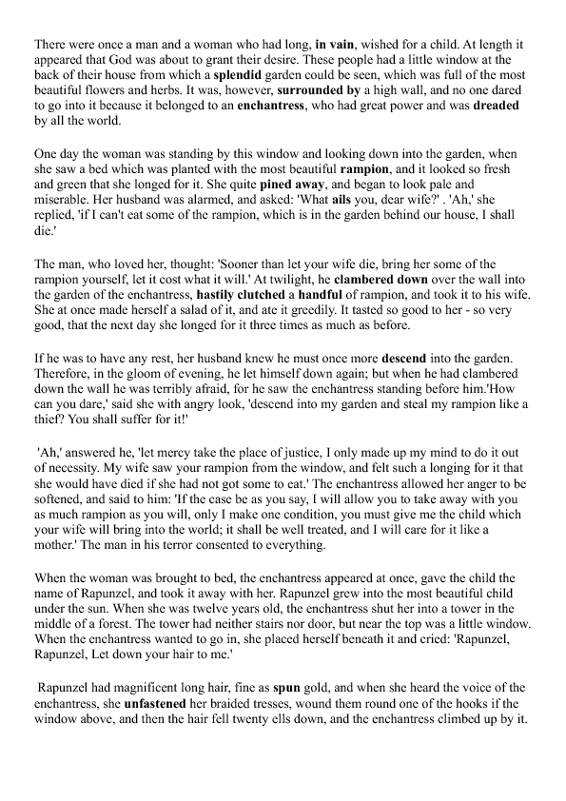
Text Worksheet

Vocabulary Worksheet
Please match!!
- hold it tightly
- it is very good
- to become very sad, and sometimes sick or weak
- extremely good, beautiful, or impressive
- it turns quickly around a central point
- move downwards from a higher to lower level
- remove the thing holding it
- without success
- a small number of
- the quality of doing something quickly
- a problem or source of trouble
- a woman who uses magic in fairy stories and legends
- terrible and greatly feared
- in vain
- splendid
- enchantress
- pine away
- ail
- clamber down
- hastily
- clutch
- a handful of
- descend
- magnificent
- spin
- unfasten
- dreaded

splendid

Comprehension worksheet

- What problem did a man and a woman have?

- Why did a woman pine away gradually?

- Was she satisfied with a handful of rampion?

- Why did a man and a woman can’t help giving their baby to the enchantress?

- Please give your opinion freely. Was there any possibility to prevent from losing their baby?

SOS activity Worksheet
