Grammar Lesson Plan

Second Conditional
INSTRUCTOR | LEVEL | STUDENTS | LENGTH
ALICE | Intermediate | 12 (adults) | 50 mins

Materials:
- White board & markers
- PPT file (USB - HR/LP/GLP/GLP_PPT)
- Second conditional worksheet (6 copies)
- Flash cards-1,2 worksheet (3 copies each)
- SOS activity worksheet (12 copies)

Aims:
- Main aim: To get Ss to understand the 2nd conditional by practicing making sentences for it.
- Secondary aim: To get Ss to be apply it to various situations.
- Third aim: To let Ss think creatively.

Language Skills:
Listening: TTT, Listening to other groups opinions during the lesson
Speaking: Responding to the teacher’s question, Class discussion about the topic
Reading: Reading vocabularies and sentences on worksheets, and through presentation
Writing: Writing answers on worksheets and on the board

Language Systems:
Phonology: New vocabulary with pronunciation
Lexis: Vocabularies through all materials
Grammar: Making sentences related to second conditional.
Discourse: Group discussion, Pair-speaking
Functions: Talking about a lot of situations using the grammar.

Assumptions:
- Sometimes, Ss would like to imagining or thinking of unreal things, so they may be interested in this subject.
- Ss may love to talk about topics on flash cards worksheet.

Anticipated Errors and Solutions:
- Ss may not know some vocabularies on the worksheet.
- Let Ss know by checking them quickly before the task.
- Ss may finish their task earlier than anticipated.
- Teacher will do SOS activity.

References:
- www.busyteacher.org/worksheet/grammar/conditionals/secondconditional/secondconditionalworksheets
- www.busyteacher.org/worksheet/grammar/conditionals/secondconditional(food)
- www.busyteacher.org/worksheet/grammar/conditionals/secondconditional/(movieworksheet)wackyinventions

Notes:
SOS activity: Movie worksheet; wacky inventions(the Flintstones)
This worksheet can be used either like vocabulary expansion + comparing life in the past with present after watching a cartoon or to practice conditionals.
Reference: www.youtube.com/wackyinventions

Pre Task
Title:  What’s the 2nd conditional? |  | Aims:  To elicit Ss the ideas of today’s grammar | Materials:  - PPT file (USB - HR/LP/GLP/GLP_PPT)
Time | Set Up | Students | Teacher
6  mins | Whole class | Answering question | Show Ss the presentation  Ask Ss to respond to CCQ’s  - If I won the lottery, I would travel Europe once a month.  - Do I expect to win the lottery?  - Did I win the lottery?  - Do I really want to travel Europe?  Explain what the 2nd conditional is through PPT.

Notes:

Task Preparation
Title:  Exercising making the 2nd conditional sentences. |  | Aims:  To let Ss practice changing verbs to correct form and rewriting the sentences. | Materials:  - Second conditional worksheet (6 copies-pair work), PPT file
Time | Set Up | Students | Teacher
8  mins | Pairs | Working out the worksheet in pairs  Checking their answers | Divide Ss into pairs (6 pairs)  - Work pairs. Give Ss 5 mins.  - Check out the answers through PPT.

Notes:

Task Realization
Title:  Applying the 2nd conditional to several situations. |  | Aims:  To ask Ss to apply the 2nd conditional to some situations, so let them understand the usage of it deeply | Materials:  - Flash cards-1,2 worksheets(3 copies each), PPT file, White board & markers
Time | Set Up | Students | Teacher
10  mins  4  mins  5  mins  6  mins | Groups  Individually  Whole class | Speaking in groups for the topic using the 2nd conditional  Talking in groups and writing down sentences related with the pictures on the board.  Forming sentences according to the instructions | Hand out flash cards-1 worksheet each group.  Give instructions  - Ask Ss to talk about the topics using the 2nd conditional in groups.  - Give Ss 10 mins.  - Let Ss look at PPT, and ask each group to write down sentences on the board after group talking.  - Give Ss 4 mins.  [ICQ]  - How much time do you have?  Hand out flash cards-2 worksheet each group.  Give instructions  - Work individually.  - Choose 3 among the images.  - Ask Ss to form sentences using the verbs given in the appropriate tense.  - Give Ss 5mins.  Point out 1-2 students each group.  Ask them to read loudly to the rest.

Notes:

If time is running short, cut down the flash cards-2 activity.
If Ss finish the activities earlier than anticipated, teacher will do SOS activity. (Refer to SOS activity below)

Post Task
Title:  Review the 2nd conditional |  | Aims:  To make sure if Ss are well-informed of the 2nd conditional by reviewing the lesson | Materials:  PPT file, White board & markers
Time | Set Up | Students | Teacher
11  mins | Whole class | Listening to the teacher’s talking and responding to the teacher’s questions | Review  - What’s the 2nd conditional?  - How do we use it?  - Did you get it fully?  - Do you have any ideas why “past verbs” are used in the 2nd conditional?  Give Ss homework.  - Compare 0, the 1st conditionals and the 2nd conditional by making 5 sentences each  - Ask Ss to preview the 3rd conditional for next lesson.  You all did well. Thank you!!

Notes:

SOS Activity
Title:  wacky inventions(the Flintstones) |  | Aims:  To expand vocabulary, and compare life in the past with present after watching a cartoon or to practice conditionals | Materials:  SOS activity worksheet (12 copies)
Time | SetUp | Students | Teacher
14  mins | Groups | Free talking about the wacky inventions | Hand out the SOS worksheet each group  Instruction  - Work in groups.  - You have 8 mins.  - Watch a cartoon video clip (running time about 5mins)  - Compare Ss’ opinions and a video clip

Notes:

Second Conditional
A. Write the correct form of the verbs in brackets.
- If I were you, I _________________ (not wear) those old jeans.
- Terence _________________ (win) the championship if he trained harder.
- If he _________________ (be) taller, he could be a basketball player.
- If everybody _________________ (protest), they would stop killing whales.
- The countryside _________________ (be) more beautiful if people didn’t set fire to the forests every year.
- If you _________________ (stop) smoking, you _________________ (feel) much better.
- If the temperature _________________ (drop) a bit more, it _________________(snow), but I don’t think it will.
- I _________________ (read) the book if it _________________ (be) interesting, but it’s so boring.
- If my boyfriend _________________ (treat) me like that, I _________________ (break up) with him.
B. Rewrite the sentences using the second conditional.
- I don’t have his phone number. I can´t call him.
If I _______________________________________________________________
- I feel terrible I can’t go to school.
I _________________________________________________________________
- My parents don’t like him because he looks so strange.
If he _____________________________________________________________
- He doesn’t get the good marks because he is lazy.
He _______________________________________________________________

Flash cards-1
 | WHAT IF…?
What would you do if you had a lot of money? | What would you do if you had a pot of gold? | If I were a boy, I’d…..?
What would you try if you had no fear? | If I were the president of the USA, I’d……? | If I discovered a new land,  I’d……?

Flash cards-2
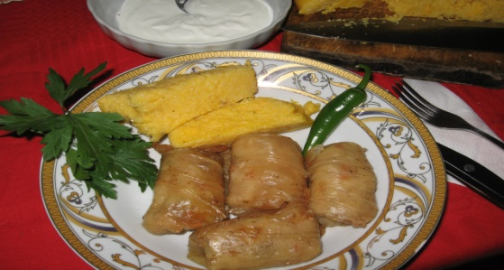 | 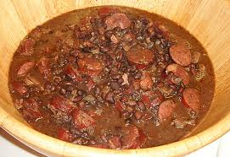
Romania (come) Sarmale (eat) | Brazil (go) Feijoada (try, definitely)
Spain (travel) Sangria (learn, make) | France (visit) Cheese&Wine (bring back, surely)
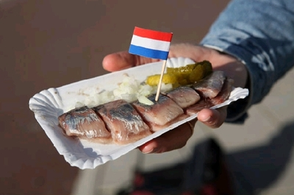 | 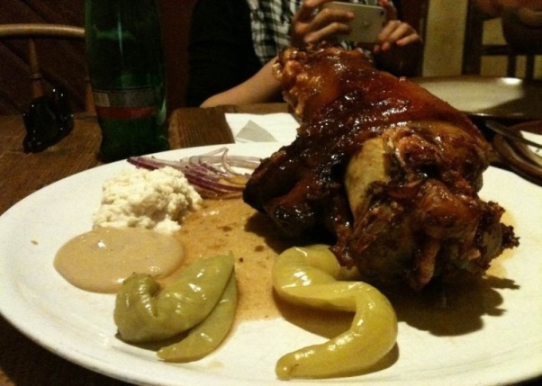
Netherlands (go, holiday) Ducth Herring(eat, lunch) | Czech (visit) Koleno(like, eat up)
SOS Activity worksheet
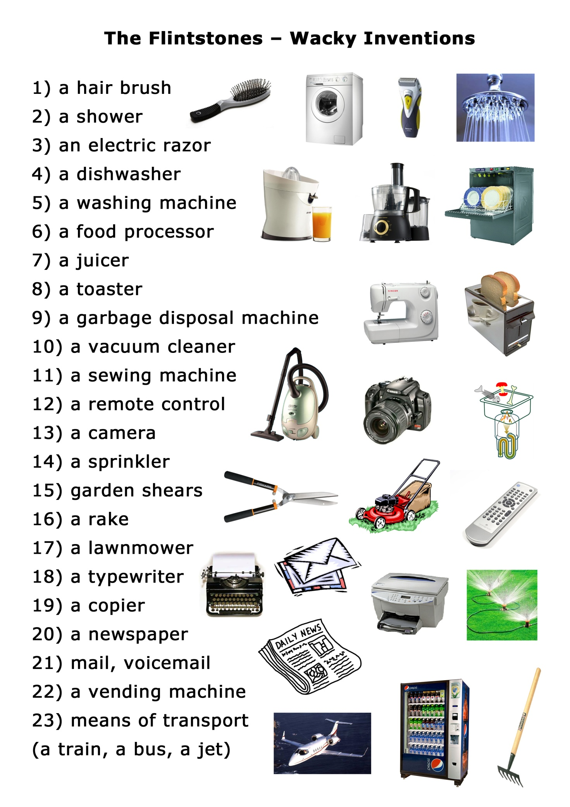
Please imagine and discuss what life would be like if we didn’t have those things to practice second conditional (e.g. If we didn’t have a hair brush, we would brush our hair with hands.)

