Grammar Lesson Plan

Ⅰ.

Title: Degrees of Comparison
INSTRUCTOR | LEVEL | STUDENTS | LENGTH
Jenna Na Hyun Jeon | Intermediate | 11-12 years old students 15 | 50 mins

Materials:
- A notebook and a projector
- WorksheetⅠ,Ⅱ,Ⅲ, Ⅳ (〃)
- Activity Worksheet Ⅰ,Ⅱ (15 copies each)
- Visual Aids
- White board & board markers

Aims:
- To be learn how to use ‘Comparative Adjectives’
- To practice speaking a whole sentence by ‘Degrees of Comparison’
- To understand application of ‘comparative-superlative ’ through activities
- To be able to make sentences by using ‘comparative-superlative’ activites
- To make students be able to use

Language Skills:
Reading: read instructions by reading worksheets
Writing: fill in the blank in the activity, make sentences in the activity
Speaking: shares idea and speaking in a group, play an game in pairs or group
Listening: teacher’s instruction, demonstration and peer’s ideas

Language Systems:
Lexis: vocabulary from the text
Grammar: check out ‘the degrees of comparison’
Functions: use right words when doing an activity, sharing opinions
Phonology: pronunciation related to vocabularies in the text
Discourse: speak coherently with appropriate cohesive features when expressing opinion

Assumptions:

Students already know
- how the class is set up and run(there will be 4 student groups at each table)
- the teacher’s style of teaching and the pace of the course
- all students are 11-12 years old students
- they are intermediate level of English proficiency
- they are presenting their work in front of class
- they actively speak out when needed

Anticipated Errors and Solutions:
- Students may not easily understand the meaning of vocabularies
→ Teacher will explain with simple and easy words and give examples if necessary
- If students finish their all tasks earlier than anticipated
→ Teacher will give more time for the debate (Production) and give all students
chances to express their opinion.
- Some students may not actively participate the group activity
→ Encourage them to present their experience
- Time may be short.
→ Teacher will reduce the number of students sharing their opinions.

References:
http://www.busyteacher.org

Notes:

If we have time left over, Plan B is Activity worksheetⅡ

Ⅱ.
1.

Pre-Task or Warmer
Title:  Introduction of  subject |  | Aims:  To elicit about title through pictures or activity | Materials:  Notebook, projector, Visual Aids  (Activity worksheet) ,Realia
Time | Set Up | Students | Teacher
6min | Whole  Class  In group | Answering teacher’s questions  Play an activity | Instructions  1. Greeting  2. Eliciting  -Elicit interests by show pictures or realia  -Elicit subject by asking questions  CCQ  Can you guess about today’s grammar topic?
Notes

2.

Task Preparation or Presentation
Title:  Degrees of  Comparison |  | Aims:  To learn ‘the degrees of comparison’ by drill substation table  To lean about making the comparative adjectives through activity | Materials:  Notebook, Projector  WorksheetⅠ  Activity WorksheetⅠ  White board, marker
Time | Set Up | Students | Teacher
16min | Whole  Class  In group | Repeat after teacher  (drilling the substitution  table)  Play an activity | Instruction  1. Studying the Degrees of Comparison  *using the comparative adjectives  -Distribute worksheetⅠ  -Repeating the substitution table  -Fill in the blank in the worksheetⅠ  -Checking answers each other  2. Doing a activity  -Distribute Activity worksheetⅠ  -Knowing to use Comparative Adjective  3. Asking a ICQ&CCQ question  ICQ  -What are you going to do now?  -Do you work in group?  -How much time do you have?  CCQ  Do you understand grammar idea?
Notes

3.

Task Realization or Practice
Title:  Practicing to use the Comparative and Superlative  Adjectives |  | Aims:  To learn about using the comparative and superlative adjectives  To apply and make the comparative and superlative sentences through drilling substitution table and playing an activity | Materials:  Notebook, Projector  Worksheet Ⅱ,Ⅲ  Activity Worksheet Ⅱ
Time | Set Up | Students | Teacher
22min | Whole  Class  In a group | Repeat after teacher  (drilling the substitution  table)  Play an activity | Instructions  1. Studying the Degrees of Comparison  *making the comparative adjective sentences  -Distribute worksheetⅡ, Ⅲ  -Repeating the substitution table  -Making the comparative and superlative adjective sentences  - worksheetⅢ: Presentation each group  2. Doing a activity  -Distribute Activity worksheetⅡ  -Knowing to use Comparative Adjective & Applying to make sentences through playing a game  3. Asking a ICQ&CCQ question  ICQ  -What are you going to do now?  -Do you work in group?  -How much time do you have?  CCQ  Do you understand grammar idea?

Notes

4.

Post Task or Production
Title:  Reviewing |  | Aims:  To review everything learned | Materials:  white board & marker
Time | Set Up | Students | Teacher
6min | Whole  Class | Reviewing by talking about  Their mistakes or errors  Listening to teacher’s talk | Error correction & Feedback  (Using the error correction techniques)  Writing student’s errors on the board  - comparative and superlative adjectives  - application of sentences  Encouragement  :If time is left over, do a SOS activity  (Activity worksheet Ⅳ)
Notes
SOS Activity: activity worksheetⅣ

Ⅲ.
Activity WorksheetⅠ
*comparison board game (1dice 1each group)
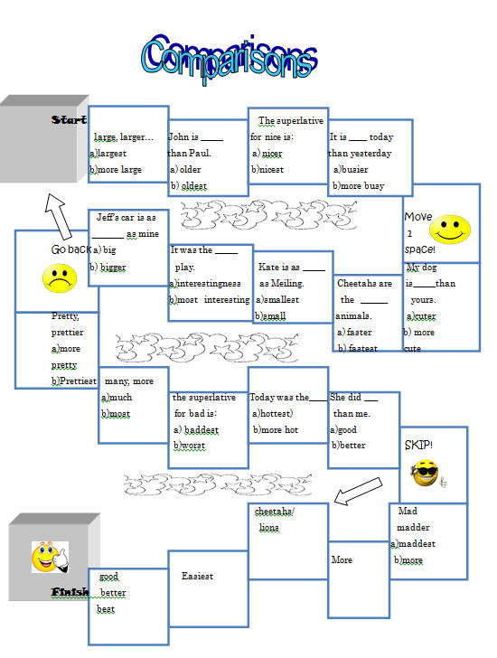Activity Worksheet Ⅱ
Comparison Battleship
The game is played in pairs. Before it begins, each player secretly arranges their ships on their grid. Each ship occupies a number of consecutive squares on the grid, arranged either horizontally or vertically. The number of squares for each ship is determined by the type of the ship. The ships cannot overlap (i.e., only one ship can occupy any given square in the grid). In this game each of the 2 partners puts 1 one-deck ship, 1 two-deck ship and 1 three-deck ship on the board. After the ships have been positioned, the game proceeds in a series of rounds. In each round, each player takes a turn to announce a target square in the opponent's grid which is to be shot at. The opponent announces whether or not the square is occupied by a ship, and if it is a "hit" they mark this on their own grid. To make a shot a student should form a question with one of the adjectives given above the battlefield and a necessary word. E.g.: Are you sexier than your wife? The answer is: "Yes, I am". If the opponent's ship is on the field, which says "your wife". IF there is NO SHIP on that field, the opponent should answer "No, I'm not", no matter if it is true or not. If all of a player's ships have been sunk, the game is over and their opponent wins.
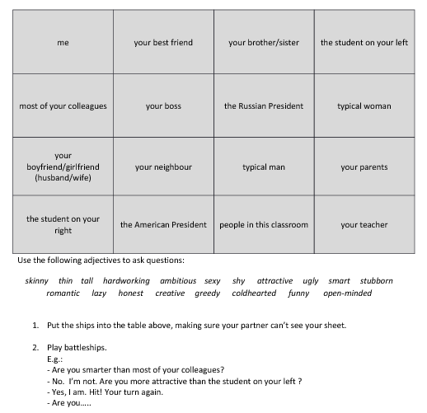
Worksheet Ⅰ
Degrees of Comparison
Comparative and superlative

* Making comparative or superlative adjectives
Use
To compare two or more thing

Formation | Adjective | Comparative | Superlative
General Rule  Short word → Adj+ -er + than  the + Adj + -est  Ending in –e → Adi + -r +than  The + Adj + -st  Ending in short vowel + consonant  → double consonant  Ending in consonant  → replace  -y → -ier or -iest | long  smart  old  tall  nice  big  lazy  funny  happy | longer  smarter  older  taller  nicer  bigger  lazier  funnier  happier | longest  smartest  oldest  tallest  nicest  biggest  laziest  funniest  happiest
General Rule  long word → more + Adj  most + Adj | popular  responsible  handsome  nervous | more popular  more responsible  more handsome  more nervous | most popular  most responsible  most handsome  most nervous
Irregular | good  bad  far | better  worse  further | the best  the worst  the furthest
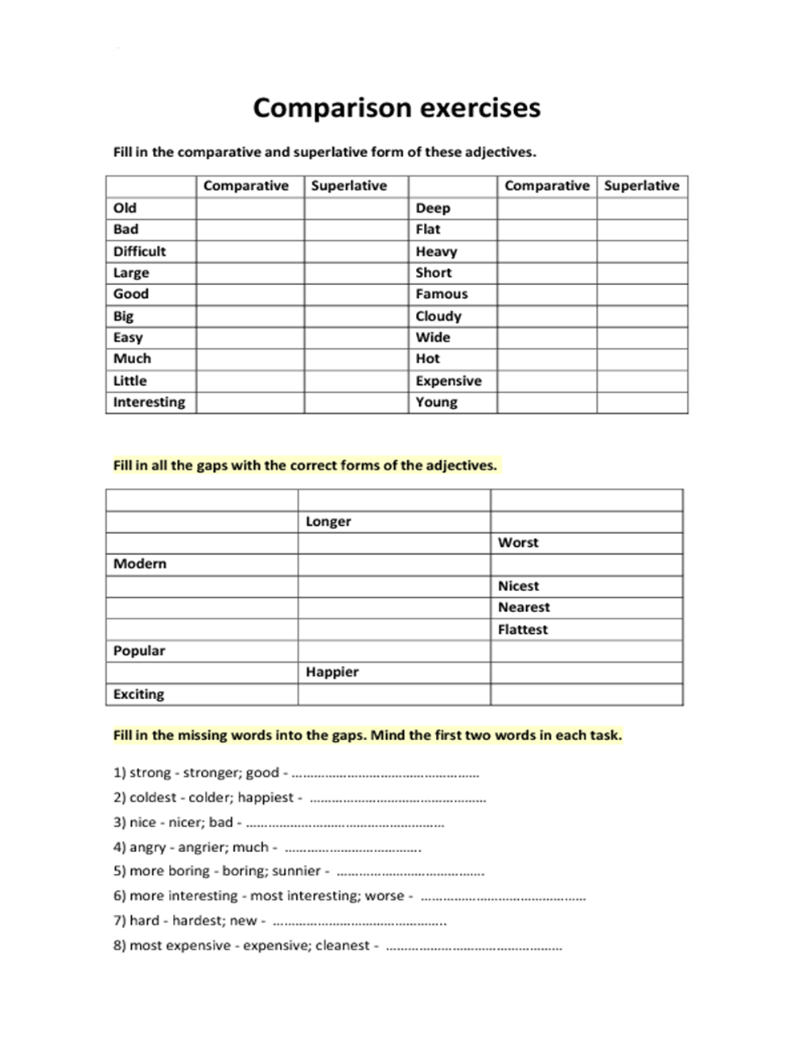
Worksheet Ⅱ

*Making the comparative or superlative sentences

<substitution table>

The airplane  car | faster  (slow)  (good)  (expensive) | than | bus  bicycle
fastest
(slow)
(good)
(expensive)

I am  She is | taller  (fat)  (thin)  (heavy)  (dilligent) | than | him  you
tallest
(fat)
(thin)
(heavy)
(dilligent)

Worksheet Ⅲ

*practicing using the comparative adjectives

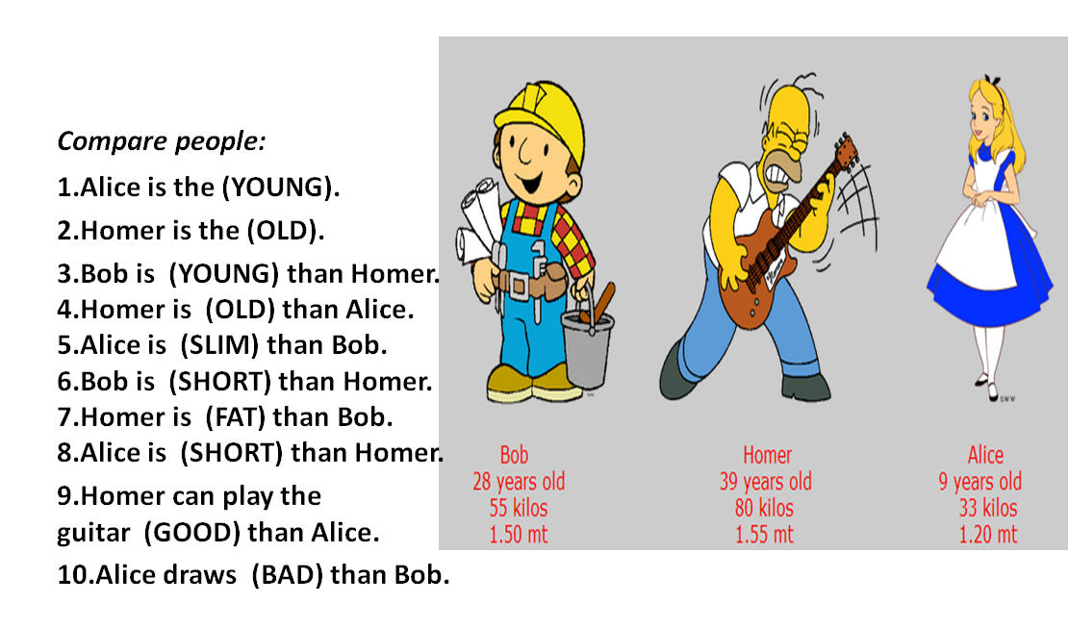

Worksheet Ⅳ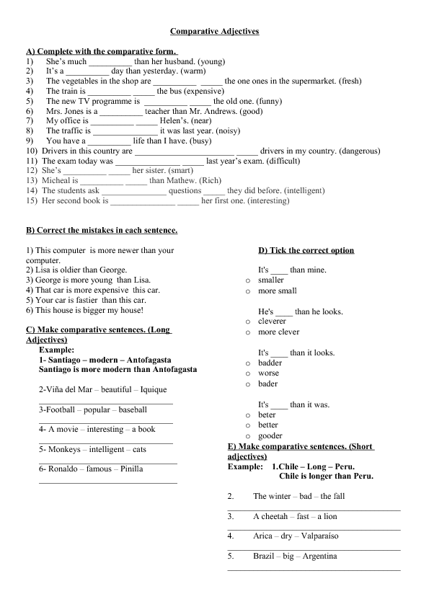

Visual Aids

