Listening Speaking Reading Grammar Writing

Topic: Fortune Telling

Instructor:  ANA | Level: Intermediate(Adult) | Students:  10 students | Length:  30 Minutes

Materials:
•White board and board markers
•Vocabulary worksheet (10 copies)
•Realia – Some pictures of fortune tellers, tarot cards and palm reading, a ball
•Three role cards (one for each group)

Aims:
•Main aim: Students will be able to improve speaking skills
•Secondary aim: Students will be able to learn vocabularies related to the topic
Students will be able to practice speaking through role play
Students will be able to practice speaking by telling their opinions in front of others
•Personal aim: I want to improve confidence & reduce my commentary to a minimum

Language Skills:
•Speaking: Students will speak while they play a role and discuss
•Listening: Students will listen the conversation in role play
•Reading: Students will read vocabularies on the worksheet and instructions on role-cards
•Writing: Students will write the answer on the worksheet

Language Systems:
•Phonology: Correct pronunciation
•Lexis: Fortune telling, palm reading, superstitious
•Grammar: Questions, future tense
•Function: Asking the questions, predicting the future
•Discourse: Conversation, discussion

Assumptions:
Ss already know :
•The set of class and the pace of course
•The teacher’s teaching skills and type
•What fortune telling is and have experience to meet a fortune-teller

Anticipated Errors and Solutions:
•Students may not be able to understand the instructions on role cards
- Ask CCQ. If they fully understand the instructions, give more time to finish it. If they don’t understand the instructions, show them how to do it.

References:
- Visual aid (Pictures on the website ‘Google’)
- English definition form ‘Dictionary.com’ mobile application and ‘Naver dictionary’

Lead-In
Materials: None
Time | Set Up | Student Activity | Teacher Talk
1 min | Whole | Answer teacher’s questions | Good morning everyone!  Do you believe in supernatural powers?

Pre-Activity
Materials: Board and Board markers, Visual aid and Worksheet#1
Time | Set Up | Student Activity | Teacher Talk
2 min  5 min | Whole  Individually | Answer elicited questions.  Do the matching activity | Procedure :  - Brainstorming  Elicit  (show 3 visual-aid pictures from Google to the Ss)  (point at the cards/crystal ball in the pictures)  Do you know what it is?  Do you know what she/they is/are doing?  (while getting the answers from Ss, write ‘Tarot card’, ‘Crystal ball’ and ‘Palm reading’ on the board)  So, can you guess what we are talking about?  Model  Write ‘Tarot card’, ‘Crystal ball’ and ‘Palm reading’ on the board  Write the topic ‘Fortune telling’ on the board  CCQ  Do fortune tellers use tarot cards?  Do fortune tellers use a rubber ball?  - Vocabularies  Instruction  I’ll give you a worksheet of vocabularies. Firstly read the definition in each row, and then find the appropriate word from the word box below, and write it in the empty box next to the definitions.  Work individually. I’ll give you 3 minutes to finish.  (Distribute the worksheet#1)  Demonstration  Does everyone have the worksheet?  Let’s look at No.1…  ICQ  Are you working with your partner?  How much time do you have?  Let’s begin.  Monitoring  Monitoring discreetly. If Ss ask questions, answer it.  2 minutes left.  1 minute left.  Give 1 minute more if Ss need it.  Time’s up.  Check answers  Does everyone finish it? Good.  Let’s check it together. Go through the vocabularies one by one  Elicit the meaning from students  Teach pronunciation  Everyone did good job.

Main Activity
Materials: Worksheet#2(role cards), Tarot cards, a ball
Time | Set Up | Student Activity | Teacher Talk
20min | Group | Role play in group | Instruction  I will be giving each of group a role card. Carefully read it and follow the instruction. Prepare the role play in 5 minutes. Work in group. You will share your acting to your classmates later.  ICQ  How much time do we have?  What should you do?  (Hand out role cards)  3 minutes left  1 minute left  Time’s up.  Ok, Team A, please come out and show us your play. You may use your role card during role play.  (Have groups perform their role play in front of the class)  Thank you for your effort.

Post Activity
Materials: None
Time | Set Up | Student Activity | Teacher Talk
2min | Whole | Answer the queations | Feedback  Did you enjoy today’s activity?  (Listen to Ss feedback on the activity)  Conclude Lesson  Elicit today’s vocabularies and expressions for students  Great job for today. I will see you next time.

SOS Activity
Materials: None
Time | Set Up | Student Activity | Teacher Talk
10Min | Group | Discussion | Instruction  Do you believe in fortune telling?  Discuss it with your group.  I’ll give you 5 minutes.  ICQ  How much time do you have?  What do we discuss?  You may begin.  Monitoring  Monitoring discreetly. If the Ss ask questions, answer it.  2 minutes left.  1 minutes left  Feedback  It’s time to listen to each group’s opinions. I need a representative from each group to tell us your opinion.

※Visual aid
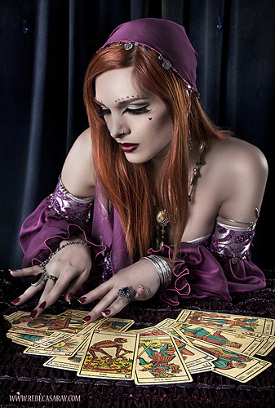


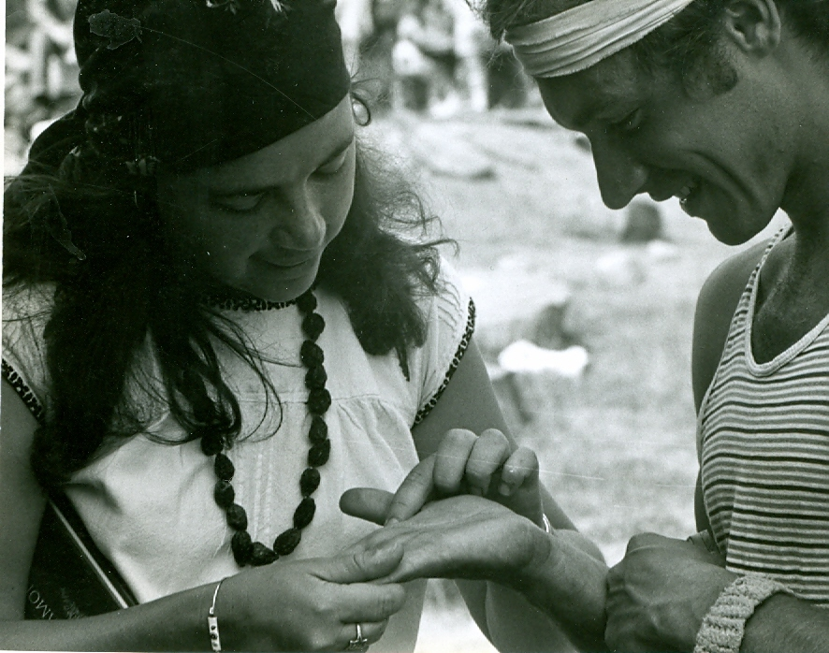
※Worksheet #1
Matching the definition
Read the definitions and write the appropriate word from the box below.
No | Definition | Word
1 | The act or practice of predicting the future / The person who claims the ability to predict the future
2 | Something that unavoidably befalls a person, destiny
3 | A ghost or supernatural being
4 | Foretelling the future through the study of the palm
5 | To declare or tell in advance, to foretell the future
6 | Believing in things that are not real or possible, for example magic.
7 | Any of set of cards that include 22 cards representing virtues, vices, death and fortune etc. Used by fortunetellers.
8 | The crime of gaining money or financial benefits by a trick or by lying / A person who deceives people in a way that is illegal or dishonest
9 | Traditionally used by fortuneteller. Fortunetellers look into it and predict the future.

fortune telling / fortune teller | palm reading | predict
fate | tarot card | spirit
crystal ball | superstitious | fraud
※Worksheet #2
Tarot card reader - Role card (Team A)
Miranda: You are 29 years old Korean. You have been a single for 5 years.
Last week, you met a perfect guy at the blind date. You fell in love at a first sight with him and
thought he liked you too. You waited for his call but to your dismay he didn’t call.
You’re eager to know his mind. So you’re meeting the famous fortune-teller to seek the answer.
Carrie: You’re Miranda’s best friend and believe in fortune telling.
You have met the fortune teller several times before and you urged Miranda to meet the fortune-teller.
You absolutely trust the fortune-teller.
Fortune-teller: You’re noting but a liar and fraud.
You use tarot cards to foretell the future, but have never seen the future.
You just want to make money. You know Carrie because she is a regular.

- Prepare the role play based on the given situation
- Play time should be less than 5 minutes
- Refer to the below phrases

Some useful phrases for the role play
What do you want to know?
Once I shuffle my tarot cards, you can ask 3 questions.
Please select 3 cards. Each card represents ………
Before you select the cards, focus for a moment on the questions you would like to ask.
I see the tall, dark man in your future.
A wish come true, this is a time of good luck and fortune.
Be cautious he may just be trying to trick you.
Follow your instincts.
Fortuneteller with a crystal ball - Role card (Team B)
Eddie: You are 32 years old Korean. You’re going to get married with your girlfriend ‘Charlotte’.
You don’t believe in fortune telling, but Charlotte insists to meet the fortune-teller.
Now you and Charlotte are meeting the famous fortune-teller.

Charlotte: You’re Eddie’s fiancé and very superstitious.
You are supposed to get married with Eddie soon.
But you’re doubtful whether Eddie is really rich like he said.
You want to know the truth.

Fortune teller: You’re very gifted fortune teller. You can see the future into the crystal ball.

- Prepare the role play based on the given situation
- Play time should be less than 5 minutes
- Refer to the below phrases

Some useful phrases for the role play
Do you really want to know? With your birthday, I can tell.
I can see your future into the crystal ball.
He will inherit buildings from his father
You will have many, many children.
Your loved one demands a lot from you.
You’re well-suited to each other.
Follow your instincts.

Palm reader - Role card (Team C)
Samantha, Miranda and Charlotte are close friends
Samantha: You’re 27 years old Korean. You’re considering change your career.
But you don’t know what you want to do.
You are meeting the palm reader and want to know what kind of job is best for you.
Miranda: You had a medical check-up last week and you’re anxiously awaiting the result of it,
because you are a chain smoker and heavy drinker too.
You want know about your health.
Charlotte: Recently, you broke up with your boyfriend, get fired from work and your car broke down.
You seem to be having a lot of bad luck. You wonder when your bad luck would end.
Fortune teller: You’re a well practiced palm reader.
You want to let your guests have positive perspective for their future.

- Prepare the role play based on the given situation
- Play time should be less than 5 minutes
- Refer to the below phrases

Some useful phrases for the role play
Give me your both hands.
For females, the right hand is what you’re born with, and left is what you’ve accumulated throughout your life.
Here’s your life line, your head line, your heart line and fate line.
See this deep cut in your life line, something happen to you when you’re fifteen?
How can you tell all that just from my hands?
Your head line is curved. It means you’re creative. So…..
Your head line is separated from life line. It means you love an adventure & a challenge.
Your life line is long and deep. It means you will lead long life. So……
Your life line is curvy. It means you have plenty of energy. So…..
Study your fate line. It’s known as the line of destiny.
Your fate line is so deep. It means your life is strongly controlled by fate.
Your fate line is changing direction, your luck will be back next year.

※Visual aid for roll play


