Listening Speaking Reading Grammar Writing

Topic: I had my hair colored!

Instructor:  Joy, Stella | Level:  Intermediate | Students:  9 | Length:  30 minutes

Materials:
Picture of a person before/after haircut & sign post of hair salon
Wall chart: 5 pictures + matching phrases ready to stick on it
Worksheet1: comprehension questions
Worksheet 2: 3 situations (one for each group)
Worksheet 3: substitution table
Board and markers

Aims:
- Primary: Ss will learn grammar “to have something done”.
- Secondary: Ss will gain freedom to use it in context.
- Personal aim: To improve skills of planning grammar lessons.

Language Skills:
- Reading: will read sentences written on wall chart and comprehension questions.
- Listening: will listen to T’s instructions, comprehension answers and presentations.
- Speaking: will speak by answering questions and in drills and in group discussion.
- Writing: Ss will write comprehension answers and compose their own sentences.

Language Systems:
- Grammar: “have/get something done”
- Lexis: color, hairdresser, pierce, pull out, fix, polish, empty, sort out
- Phonology: pierced/t/, repaired/d/, painted/id/
- Function: giving facts, describing
- Discourse: cannot/don’t want to do something by self therefore to get it done

Assumptions:
Ss already know how the class is set up and run.
Ss are used to T’s teaching style and pace of the course.
Ss know the context where the target grammar is used.

Anticipated Errors and Solutions:
- Ss may not easily recognize the target grammar.
>>> to highlight it and give as many as example sentences.
>>> to let Ss overlearn by drill.
- Ss may need more time to complete main activity.
>>> to allow more time by cutting drills short.
- Ss may finish main activity early.
>>> to allow more time for post activity.

References:
Visual aids: https://www.google.co.kr/imghp?hl=ko&tab=wi

Lead-In
Materials: none

Time | Set Up | Student Activity | Teacher Talk
1 min | Whole | To input their thoughts | How often do you go to a beauty salon (barber shop)? What do you go there for? Do you like colored hair? Do you like permed hair?

Pre-Activity
Materials:
Pictures of a person “before” and “after” haircut & a beauty salon
Board and markers
Wall chart: pictures + matching phrases

Time | Set Up | Student Activity | Teacher Talk
3 min  6 min | Whole  Whole | To brainstorm and answer  To match pictures and expressions  To speak and repeat | Elicit  To show pictures of before & after hair coloring  What has changed? (color of hair) Do you think she has been to a beauty salon? (yes)  To stick sign post of hair salon between “before” and “after”.  Who colored her hair, she herself or a hairdresser? (hairdresser) I think so, too.  Modeling  To write down on board:  “She had her hair colored.”  Note “colored” which is past participle  CCQ  Did she color her hair by herself? (no)  Did she arrange somebody to color her hair? (yes)  Instruction & Demo*  Execute & monitor*  (* To be done at the same time due to the nature of flowing activity)  There are things that you cannot or you don’t want to do by yourself, things that you need someone to do for you. Like what? Give me some examples.  To give time to think and elicit answers  To acknowledge good examples  Look at this wall chart. I need you to help me fill it out.  To put up wall chart and ask what is being done  - Ears being pierced  - A car being repaired  - A house being painted  - X-ray being taken  - Hair being cut  You will probably need some kind of specialists to do these jobs for you, right? How can we put it?  To point/remind of model sentence  To get Ss to speak  To put down sentences alongside pictures as Ss speak  - I had my ears pierced.  - I had my car repaired.  - I had my house painted.  - I had my x-ray taken  - I had my hair cut.  To get Ss to repeat 2 times.  Correction  cut-cut-cut; take-took-taken  (irregular verb)  pierced /t/  repaired /d/  painted /id/  Job well done !

Main Activity
Materials:
Worksheet 1, board & markers

Time | Set Up | Student Activity | Teacher Talk
2 min  5 min  4 min | Group  Group  Whole | To work on worksheet, comprehension questions  To repeat/drill | Instruction  Now I am going to give you a worksheet. Let’s sit in a group of 3 and work on it.  To make 3 groups  Read the sentences and re-write them using “have … pp” form. You will discuss in your group and have 5 minutes.  To hand out worksheet  Demo  To do one item as demo  ICQ  How much time do you have?  Do you rephrase using “have … pp”?  Execute and monitor  To monitor discreetly and help only when asked  To take notes of any difficulty and common errors  To draw substitution table on board while Ss are working  To give timing (1min-30sec)  Check & drill  To check together and speak aloud  To draw Ss attention to substitution table drawn on board  To let Ss repeat 2 times  Correction  pulled out, clear out, sorted out  Feedback  To feedback from notes taken during monitoring  Excellent!

Post Activity
Materials: none
Worksheet 2, board & markers

Time | Set Up | Student Activity | Teacher Talk
1 min  5 min  3 min | Group  Group  Group | To discuss situation  To prepare statements  To give oral presentation | Instruction  Now you will have a discussion in the same group. I will give each group a handout and you will find a situation of for instance “moving”. Discuss the situation and list things that you need to get done. Make sure you use today’s grammar. There are some words related to the situation in the tip box. You can use them if you like. You have 5 minutes to discuss and will present your list to class later.  Demo  To pick one handout and state just one thing to be done as demo  ICQ  How much time do you have?  Will you use “have … pp” form?  Execute & monitor  To monitor discreetly and help when asked  To encourage Ss to use expressions covered in pre-activity.  To give timing (1min-30sec)  Time is up.  To let each group present.  To get other groups to add ideas on what else can be done  Correction & wrap-up  To help Ss correct by themselves with help from other groups  Today we’ve learned “have … pp”. Was it difficult? Did you learn some new vocabulary?  OK, you’ve worked hard today and done a great job!

SOS Activity
Materials:
worksheet 3

Time | Set Up | Student Activity | Teacher Talk
1 min  4 min | Pair | To practice | Instruction  I will give you a worksheet. You need to work in pair. When one person speaks a past participle in the substitution table, the other person will speak a full sentence aloud. You have 3 min to work with your partner.  Demo  To show one as demo  ICQ  Will you work in pair?  Execute & monitor  Close monitoring not needed  To give timing (1min-30sec)  Time is up  Wrap-up  Have you gotten more confidence to use “have …pp” form? Let’s try to put this in our daily use as appropriately.

Worksheet 1
-  Rewrite the sentences using “have something pp” form.

1. I got a hairdresser to perm my hair.
>>> I had my hair permed.
2. I arranged a dentist to pull out my aching tooth.
>>>
3. He got Samsung AS staff to fix his phone.
>>>
4. We arranged somebody to clear out the basement.
>>>
5. We arranged someone to build a storage room.
>>>
6. She got a lady to polish her nails.
>>>
7. We arranged someone to deliver a basket of flowers to mom.
>>>
8. I got somebody to empty the tank.
>>>
9. She arranged a specialist to sort out her messy garden.
>>>
10. I got a doctor to take my blood test.
>>>
Worksheet 2
(Group 1)
You are going to move to a new flat. What are the things you need to get done before you move?
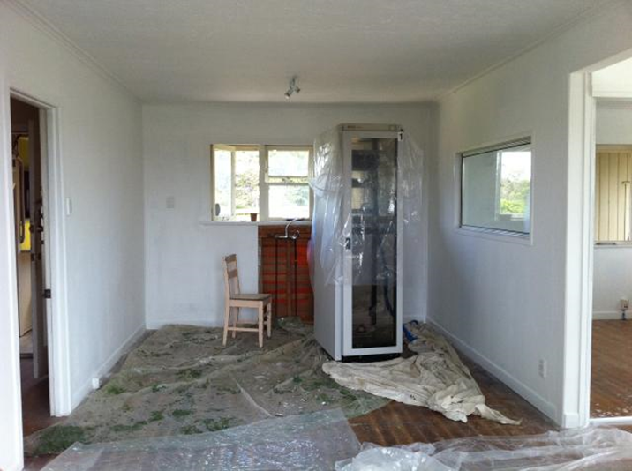

Tips :
to clean, to paint, to repair, to move…
Worksheet 2
(Group 2)
You are going to a hospital for a medical check-up. What do you think you will get tested or examined?
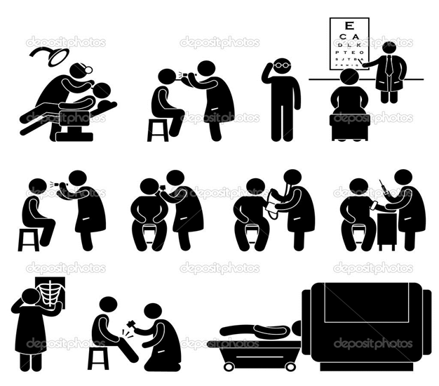

Tips :
blood pressure, x-ray, blood sample, to examine…
Worksheet 2
(Group 3)
You want to give some changes to your style. What can you think of getting done when you go to a beauty parlor?

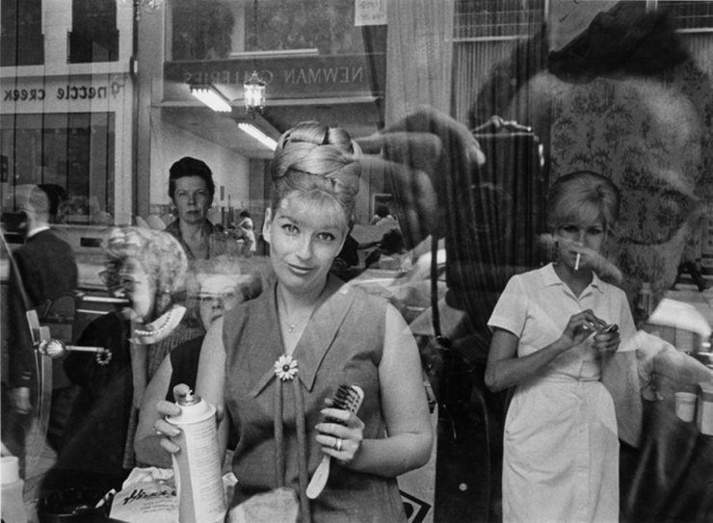

Tips :
to dye, to cut, to color, to polish…
Worksheet 3
- Substitution drill !

 | cut
I will have my hair | dyed
 | permed
 | bleached

 | my blood pressure
 | my urine test | taken.
I will have | my x-ray
 | my stomach | examined.

 | my flat | cleaned.
I will have | the living room | painted.
 | the floor | repaired.
 | my furniture | arranged.

