Listening Speaking Reading Grammar Writing

Topic: The way to make appointment by phone calling

Instructor:  Surin | Level:  Intermediate | Students:  8 students | Length:  30 Minutes

Materials:
- Realia : Smart phones, some pictures
- 4 pairs of chair and table
- Worksheets (8 copies)
Worksheet#1 vocabulary
Worksheet#2 conversation
Worksheet#3 activities ( A type / B type )
- A piece of paper and a pen (for each person)
- Board and Board markers

Aims:
- Main aim: Ss can describe the way to get where they want to get through phone calling by speaking English.
- Secondary aim: Ss can make appointment with each other in English
- Personal aim: Teach new vocabularies and key expressions by eliciting and achieve a personal goal to increase STT in this class.

Language Skills:
- Reading: Ss will read a vocabulary worksheet and scripts.
- Listening: Ss will listen to the other classmates saying, and teacher talk.
- Speaking: Ss can talk each other through the activities.
- Writing: Ss will fill out the blanks and the answers what they've got from their classmates.

Language Systems:
- Phonology: /f/, /p/
- Lexis: New vocabulary & idioms using in describing the ways and phone calling ( Take the blue line~, subway, exit, transfer, destination etc.)
- Grammar: Prepositions
- Function: Calling
- Discourse: Interview

Assumptions:
Students already know:
- They can understand the activity rules.
- How the class is set up and run.
- They can express what they think well in English.
- They can use their smart phone and make a call to somebody.

Anticipated Errors and Solutions:
- Students may not be able the rule at first time.
Set an example(demonstration) to let them understand.
- Students may feel the class is childish or get bored.
Try to encourage students to participate well.
- Students may need more time to make conversation.
Give students extra time to work

References:
- English vocabulary from : http://dic.naver.com/
- English translation from : http://translate.google.com/
- Searching for the phone calling conversations : https://www.google.co.kr/?gws_rd=cr&ei=JMsuUt_aA8mHlAWI-YDYDA#newwindow=1&q=phone+calling+conversation
- Searching for the images :
  - https://www.google.co.kr/search?q=phone&newwindow=1&biw=1366&bih=667&source=lnms&tbm=isch&sa=X&ei=hT3QUq7ABIOklQWLs4HIDw&ved=0CAcQ_AUoAQ#facrc=_&imgdii=_&imgrc=ljEBgQ3cGpCB_M%253A%3BWoJ4zcaypvdDCM%3Bhttp%253A%252F%252Fcdn-static.cnet.co.uk%252Fi%252Fc%252Fblg%252Fcat%252Fmobiles%252Fchild-phone.jpg%3Bhttp%253A%252F%252Fcrave.cnet.co.uk%252Fmobiles%252Fchildren-get-first-phone-at-7-says-survey-50011936%252F%3B620%3B449
  - http://search.naver.com/search.naver?where=nexearch&query=%EC%A7%80%ED%95%98%EC%B2%A0%EB%85%B8%EC%84%A0%EB%8F%84&sm=top_hty&fbm=1&ie=utf8

Lead-In
Materials: None
Time | Set Up | Student Activity | Teacher Talk
1min | Whole  Class | Answering teacher’s questions | Hello guys, it's glad to see you. How are you today?  Let's start the class. Have you ever made an appointment with your friends? If you have, what did you use for making that appointments? How could you contact to your friends?

Pre-Activity
Materials: Board, Board markers, Worksheet #1 ,visual aids
Time | Set Up | Student Activity | Teacher Talk
6min  5min | Whole  Class | Answers elicited questions  Students go through the worksheet  and learn the vocabulary and idioms | Procedure:  - Brainstorming  Elicit  (Show some visual aids related in phone call like numbers and many kind of models of cellular phones till the word 'phone call' would come out)  Can you guess what these pictures are related in?  What do these pictures have in common?  How can we use this for?  Model  Write the topic “The way to make appointment by phone call” on the board.  CCQ  Can we use the phone to contact somebody?  Are appointments usually made by only in person?  - Vocabulary & Idioms  Instruction  (Distribute the worksheet #1)  Before we start in earnest, we should check the vocabulary. At this time, work individually. You have 3 minutes for this activity. If you are ready, you can start.  Demonstration  Look at #1...The word '~' means.  ICQ  Are you working in groups?  How much time do you have?  "Then let's start."  Monitoring  Monitor discreetly. Answer students if they ask questions  Notice when 1minute left. Be flexible with time. Give 1 more minute if they need it.  “Time’s up”  Check answers  Let’s check the answers together.  -Ask students and let the students tell what they wrote.  -Go through the answers one by one  -Elicit the meanings from students  -Explain the meaning if necessary  Phonology : /p/ and /f/ in [frend ]  Well done!

Main Activity
Materials: worksheet #2, #3, pen and paper, smart phones
Time | Set Up | Student Activity | Teacher Talk
3min  10min | Whole Class  Group | Work on the worksheets | Instruction  Let's go through today's topic, "Making appointment by phone calling". Before we start the activity, we should share our phone numbers. Let's come out and write your phone number on the board one by one please. During you are writing, I will give you the worksheets.  (Distribute the worksheet#2 and #3)  After that, you should call your partner with opposite type and follow the conversation in the worksheet #2, try to make appointments with your partners. Then write down the information what you've got from your partner.  ICQ  What should you write on the board?  Are you sharing our home phone numbers?  Should you call to the person who has the same type of paper with you?  Monitor discreetly.  Check answers  Let’s check the answers together  - let the students tell the correct answers  - wrap up and error correction  Phonology : [frend] / eksɪt;|egzɪt]  Grammar : prepositions

Post Activity
Materials: None
Time | Set Up | Student Activity | Teacher Talk
1min  5min  1min | Group | Describe information | - Production( speaking & writing )  Instruction  Let's describe how to get the place you've decided with your partner to meet. Does anyone wants to be a volunteer to do first?  ICQ  Are we describing the appointment you've made?  Did you make the appointment with your teacher?  Are you making a description up on your own?  Let's begin to tell teacher. Start from the front line.  Monitoring  Monitor discreetly. Help Sts when they need helps.  - Conclude lesson  Elicit today’s vocabulary and idioms for students and Wrap up the grammar.  Grammar: Check the form of using prepositions.  Error correction : Check the pronunciation of /p/, /f/  Feedback  Let's make appointments with any other person like tour family members or teachers.  You guys all did a good job today. please try to understand the new vocabularies and idioms that we have learned for today. See you tomorrow!  Homework  Try to call at least 3 people and make appointments in different places and time!

SOS Activity
Materials: A piece of paper and a pen, smart phones
Time | Set Up | Student Activity | Teacher Talk
5min | Individually | Describe the situation specifically, by drawing or writing an essay | - Production( speaking & writing)  Instruction  Now, we will play a game called "Mafia game" using our smart phones. I will pick 2 mafia by sending a text message to them. The others are citizens, you should guess who is the mafia. Mafia can admit that you are a mafia also can deny. After discussion, we should vote to make the decision about people suspected as mafia dead or alive.  ICQ  How many mafia do we have?  How the teacher select the mafia?  Monitoring  Monitor discreetly. Help students when they need helps.

★ Worksheet #1 Vocabulary

Match the meaning of the words !
put the right alphabet in ( )

- subway
- metropolitan
- take
- exit
- desination
- get off
- transfer

( ) go from the first place to the second.

( ) belonging to or typical of a large busy city.

( ) to leave a bus, train, plane, etc. that you are travelling in

( ) the place to which they are going or being sent.

( ) an underground railway.

( ) the door through which you can leave a public building.

( ) to _____ the bus/plane/train
★ Worksheet #2 Conversation

A > You will be given a subway line map. Let's call up your classmates and make appointments with them. You should give your classmates some directions to get where you decided to meet at.

B > You will be given a chart to fill out with the informations that your classmates would give. They will call you up and make appointments with you.

Conversation
Take the red line to Gangnam.
A : Hello! Is < > there?
B : Hello, < >. This is < > ! What's up?
A : < >, Listen, I've got a restaurant discount coupon for 2 people. I was wondering if you'd like to join me!
B : I'd love to. Where should I go to?
A : Let's meet at ______.
B : How can I get there by subway?
A : Take the ______ line to ______ and then transfer to the ______ line. Get off at ______ and go out exit number ______. You can't miss it.
B : Then can we meet at 2 o'clock?
A : Sounds good. See you there.
★ Worksheet #3 The subway line map : Caller activity sheet A

To go to ______ station by subway,
you should take the ______ line to ______ and then transfer to the ______ line. Get off at ______ and go out exit number ______.

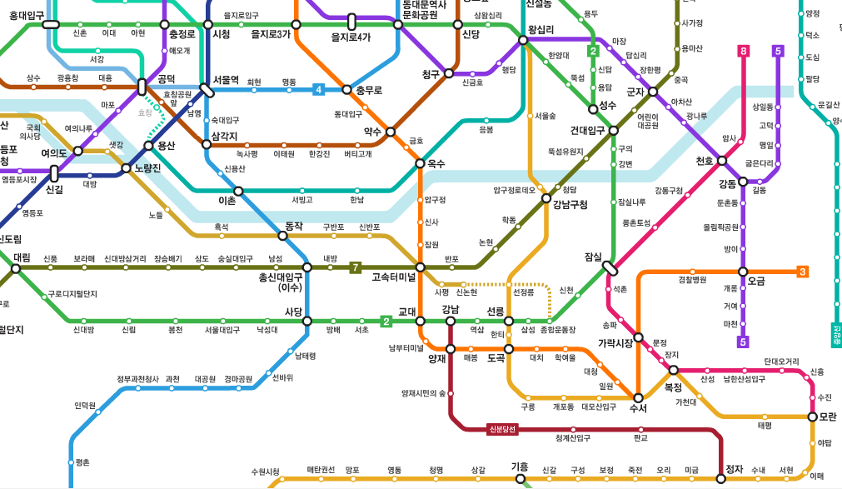

★ Worksheet #3 Receiver activity sheet B

Classmate | Destination | Directions
 |  | Take | Transfer | Get off | Exit

★ Visual aids
