Listening Speaking Reading Grammar Writing

Topic: At a restaurant

Instructor:  Kelly (Kim) | Level:  Intermediate(Adult) | Students:  8 students | Length:  30 Minutes

Materials:
  - Pictures of “ Restaurant”
  - Matching the correct word worksheet (8 copies)
  - Sample dialogue handout (8 copies)
  - Giving order strip(Post activity), Sentences card ,Word card(2set)-SOS activity
  - White board and board marker

Aims:
- Main Aim: Students will develop and improve speaking skills through dialogue
- Secondary Aim: Students will learn how to order food in English
- Personal Aim: I want to teach them fluently and not to have feeling of tension

Language Skills:
- Reading: Students will read while they play a role
- Listening: Students will listen the dialogue in role play
- Speaking: Students will speak dialogue through role play and presentation
- Writing: Students will write to match to correct word

Language Systems:
- Phonology: /A/, /P/
- Lexis: Vocabularies (Appetizer, dessert, certainly, mushroom, special)
- Function: Ordering food
- Grammar: “May I see~, Would you like~”
- Discourse: Role play

Assumptions:
Students already know:
- All students are adults(age 20 and up)
- All students might have the ideas of ordering food in a restaurant
- How the class is set up and will run (will sit in groups of 3~4 students as normally)
- The teacher’s teaching style

Anticipated Errors and Solutions:
- Students are too shy to present
- Instructors will help them feel comfortable and guide them through the
presentation.
- Activity takes longer than expected
- Instructors will cut the post activity speaking time and presentation time
- Students may need more time to work on the worksheet
- Will give students little more time to finish it
- If students finish their task earlier than anticipated
- Ask students about the main ideas of restaurant and SOS activity

References:
- Visual Aid (Pictures of google image)
- Book Title : Everyone speak 2 (Build and Grow publisher)
- http://image.slideshorecdn.com

Lead-In
Materials: None
Time | Set Up | Student Activity | Teacher Talk
1Min | Whole Class | Answering Teacher’s Questions | Hello, Everyone!  How are you doing today?  Have you ever eaten out?  What did you eat ?  Do you prefer to eat out or at home?

Pre-Activity
Materials: Worksheet #1, Visual Aid, White board and markers
Time | Set Up | Student Activity | Teacher Talk
4Mins  5Mins  4Mins | Whole Class  In  pairs  Whole Class | Answer Elicited Questions  Match the correct word with  In pairs.  Students and teacher will check answers together | Procedure  - Brainstorming  Elicit  (Show the students visual aid pictures without telling the names)  What do you see in this picture?  Can you guess what is the place?  Do you know, what is looking at the sign?  Model  Yes, That’s right!  Today we’re going to talk about at a restaurant.  Write the “At a restaurant” on the board  CCQ  Do we buy clothing at a restaurant?  Can I smoke in a restaurant?  - Matching correct word  Instruction  “I will give you a matching word worksheet. Firstly, you need to look at the menu below and then find the correct word. Please write in the right answer. You will work in pairs.  I will give you 5 minutes .  (Distribute the worksheet #1)  “Now, before you start working on it, Please look here first”  Vocabulary  What does appetizers mean?  It means before the meal.  What does desserts mean?  It means after the meal.  Demonstration  “Let’s look at the blow box together”  “Okay the first one, drink goes to coke”  Good!  ICQ  Do you work individually?  How much time do you have?  “Now, you may begin”  Monitoring  Monitor students directly and answer students if they ask questions  Time Warning  “3minutes left”, “1mintues to go”  Don’t be too strict with time. If they need little more time, give another minutes to work  “Time is up”  Check Answers  Let’s go through the answers together  - Go through the words one by one  - Ask students which desserts are appropriate to each blank  If the students cannot find the right answer, teacher will give the answer  “Good job, everyone!”
Main Activity
Materials: Worksheet #2 (Sample dialogue)
Time | Set Up | Student Activity | Teacher Talk
3Mins  3Mins | Group  In  pairs | Grouping ( 2 groups)  Read the dialogue loudly  Role play with your partner | - Role play  Instructions  Firstly, You will make two groups to role play. I will give you worksheet #2. And then you have to role play with your partner. You can use the sample dialogue in the handout. Please practice like a  real voice and situation.  Are you got it?  I’ll give you 3minutes each of them  (Distribute the worksheet #2)  Demonstration  Let’s read this dialogue together!  (Grouping)  You’re team A, You’re team B  Team A, read waiter  Team B, read customer  After repeat (Switch the role)  3, 2, 1 go!  Now, role play with your partner as  same way.  ICQ  Are you working in pairs?  How much time do you have the role play?  “Now, please begin “  Monitoring  Monitor discreetly.  Time Warning  “2mintues left”, “30senconds left”  Be flexible with time  Give little more time if students need it  “Time is up”

Post Activity
Materials: Giving order strip
Time | Set Up | Student Activity | Teacher Talk
6Mins  3Mins  1Min | Whole Class  In pairs  Whole Class | Listen to the teacher giving instructions  Students will give short presentation  Conclusion | - Question & Answer Search  Instructions  We are going to play a game called ”Question and Answer search.  Everybody had practice the dialogue before.  Some of you have question and  Others have answer strips.  Please start looking for the partners right answers. After that whoever finds the right partner. You can sit down as soon as quickly together.  I will give you 5minutes.  (Distribute the order strip)  Demonstration  I’ll show you how to play.  Everybody Stand up. Please look around and find a right answer.  Please ask using this word.  Are you a waiter?  No, I’m just looking for waiter?  ICQ  Are you working individually?  How much time do you have?  “Let’s start”  Monitoring  Monitor directly. Answer students if they ask questions  Time Warning  “3minutes left: “, “2minutes left”, “1minute left”  “Time is up”  - Short Presentation  Let me check, If you got the right partner, please read loudly together!  Lucy team, please come to front?  Is it correct? Good job.  Give them a big hands.  Thank you go back to your seat!  - Conclude Lesson  Error correction  Let’s say again “Appetizers”(pronunciation)  “Do you have any questions?  All right!  You did all excellent today.  I’m so proud of you.  All right, That’s for today.  “Good bye, See you next time”

SOS Activity
Materials: Sentences card, word card
Time | Set Up | Student Activity | Teacher Talk
3Min | Whole  Class | Listen to the teacher giving instructions | - Physical line-up  Instructions  Look at this sentence. Let’s read it together first. Now I cut each word.  Let’s put them in the right order.  Everybody will make one sentence.”  If finished, please come to the front.  Let’s show me all together!  Demonstration  For example, Firstly, If you have “I” holding the card.  Who has “will?  You can stand here.  Please remember you should go to the right place and line-up with whole members.  Then, please say the sentence out loudly.  ICQ  Do you work in pairs?  How much time do you have?  (Hand out the word card)  “Please you may start”  Monitor  Monitor directly. Answer students if they ask questions  Time Warning  “1minutes left”, “30seconds left”  “Okay, Time is up.  Everybody well done!

- Visual aid #1
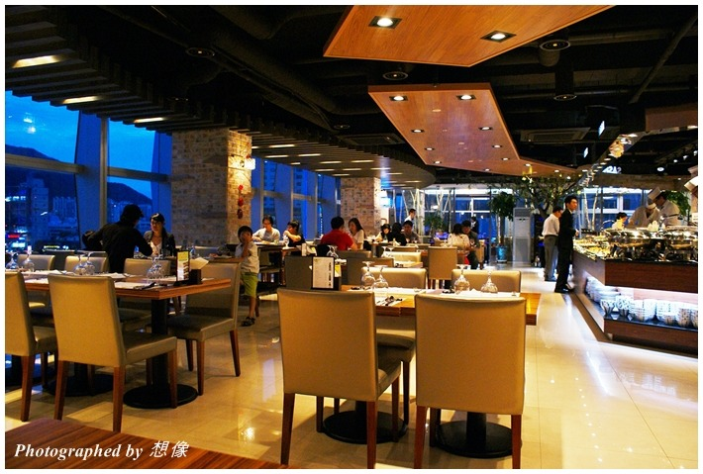

- Visual aid #2
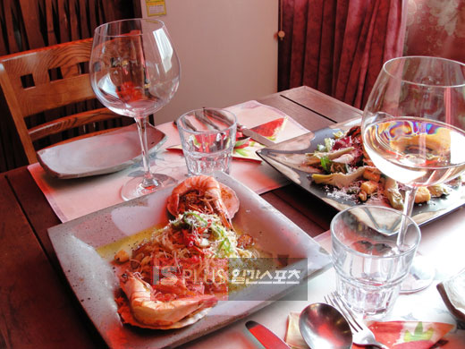

Visual aid #3


- Worksheet #1

1. Look at the menu below.
Then match the correct word to each picture.

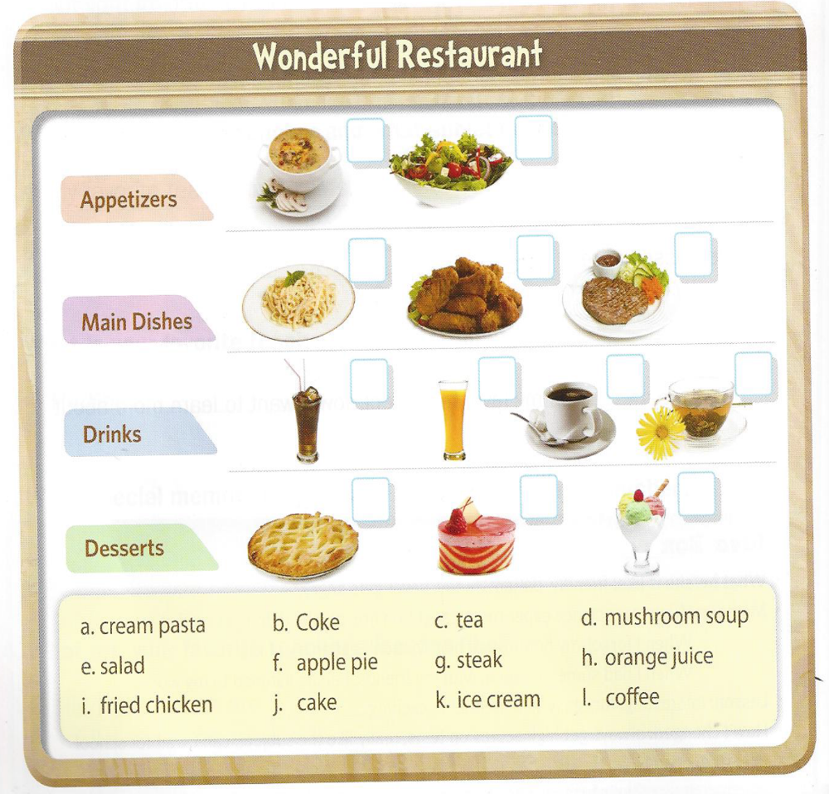

- Worksheet #2(Sample dialogue)

Use the speaking to practice with your partner and groups.

Ordering at the restaurant

Dialogue #1

Waiter: Hello. How are you doing this afternoon?
Customer : Fine, thank you. May I see a menu, please?
Waiter : Certainly, here you are.
Customer : Thank you. What is today’s special?
Waiter : Today’s special is Chicken and rice.
Customer : That sounds good. I will have that.
Waiter : Would you like something to drink?
Customer : Yes, coke please!

Dialogue #2

Waiter: Hello. How are you this evening?
Customer : May I see the menu, please?
Waiter : Sure, here it is.
Customer : Thank you.
Waiter : I will come back to take your order.
What do you want to eat?
Customer : I don’t know. I feel like eating pizza.
Waiter : Mmmmmm that sounds good, Can I take your order?
Customer : Yes, please!

Waiter
Hello. How are you this evening?

Customer
May I see the menu, please?

Waiter
Sure, here it is.

Waiter
I will come back to take your order.
What do you want to eat?
Customer
I don’t know. I feel like eating pizza.

Waiter
Mmmmmm that sounds good!
Can I take your order?

Customer
Yes, please!

Waiter
Thank you!

