Listening Speaking Reading Grammar Writing

Topic: cardiopulmonary resuscitation(CPR)

Instructor:  Sunny & Amy | Level:  Intermediate(Adult) | Students:  9tudents | Length:  30 Minutes

Materials:
- Realia: picture of collapsed person and AED
- White board and board markers
- 5steps for CPR cards
- CPR training video
- The definition of CPR’s word - worksheet #1 (9copies)

Aims:
-Main aim: Ss will be able to know how to do CPR.
-Secondary aim: Ss will be able to know the definition of CPR’s words and CPR’s order.
-Personal aim: We want to teach them fluently and not to have feeling of tension.

Language Skills:
-Reading: Ss will read the order of CPR. (main activity)
-Listening: Ss will watch CPR training video.
-Speaking: Ss will explain how to do CPR.
-Writing: Ss will fill in the blanks on worksheet #1.

Language Systems:
-Phonology: /r/ (resuscitation, CPR, airway, responsive)
-Lexis: New vocabularies for CPR. (worksheet #1)
(air way, compress, tilt etc.)
-Function: giving instruction
-Grammar: imperative sentences
-Discourse: word abbreviations

Assumptions:
Students already know
-They know what shape of our desk is and how many classmates this class has.
-What we will learn among language skills.
-They know what CPR is.

Anticipated Errors and Solutions:
-If students don’t know words which are in the cards,
-> tell them the definition of them and give some examples to help them understand.
-If students don’t understand what is CPR,
-> explain it one more time.
-If students speak with loud voice when they do worksheet #1 with their partner,
-> ask politely them keep your voice down.

References:
-Visual aid
http://ksda2.tistory.com/entry (Picture of ‘collapsed person)
lesstvmorelife.wordpress.com (picture of AED)
https://www.google.co.kr/search?q=mouth+to+mouth&newwindow=1&source=lnms&tbm=isch&sa=X&ei=uxbWUqDvFZC4iAeFg4GACA&sqi=2&ved=0CAcQ_AUoAQ&biw=1280&bih=884#facrc=_&imgdii=_&imgrc=aKSkcdVbfwRniM%253A%3B4yfyZO2oar2XVM%3Bhttp%253A%252F%252Fwww.cardiopulmonaryresuscitation.net%252Fmouth-to-mouth.jpg%3Bhttp%253A%252F%252Fwww.cardiopulmonaryresuscitation.net%252F%3B303%3B307 (picture of mouth to mouth)
http://www.msha.gov/DISTRICT/DIST_07/rescue/rescue.htm (worksheet#1)
http://www.123rf.com/photo_10110151_doctor-using-the-defibrillator-to-reanimate-an-inconscious-patient-in-the-hospital.html (worksheet#1)
http://www.zoll.com/zoll-news/2010/hospital-clinics-increase-use-of-aed-automated-external-defibrillator/ (worksheet#1)
http://blog.naver.com/PostView.nhn?blogId=nsm3789&logNo=150173184901 (Sequencing cards)

-Worksheet #1
http://endic.naver.com/?sLn=kr (definition)

- Reading part
www.americanCPR.com (5steps for CPR)

-CPR training video
http://www.youtube.com/watch?v=HWw-LngyR4A

Lead-In
Materials: None
Time | Set Up | Student Activity | Teacher Talk
1min | Whole class | Answering teacher’s questions | Good morning, everyone!  How are you today?  Have you ever called 119, 999, or 911?

Pre-Activity
Materials: Board, Board makers, Visual Aid, Worksheet #1
Time | Set Up | Student Activity | Teacher Talk
3mins  (4m)  2mins  (6m)  3mins  (9m)  2mins  (11m) | Whole  class  Whole  class  In pair  Whole class | Answers elicited questions  Listening to teacher  Fill in the blanks  Answering to worksheet #1 | Procedure:  - Brainstorming  Elicit  Have you ever had a near death experience?  What do you think she happened? (show picture1)  How can we bring her back to life?  Additional explanation  “It is defibrillation. It helps to start heart aging by applying electronic shock.(put photo of defibrillation on the board)  AED is portable device of defibrillation (picture of AED)…….  (show picture of Mouth to mouth)”  “When do you use mouth to mouth or AED?”  “If you learn about the way of CPR, you can enough save one’s life. So we will learn how to do CPR.”  Model  Write “the ways of saving people’s life and CPR” on the board.  CCQ  If you see a person having heart attack, what are you going to do?  Do we do CPR to someone’s foot?  - Idioms  Instruction  “I am going to give you a worksheet which is related to CPR. Fill in the blank with number referring to the definition which is at the bottom of paper. You can use your dictionary. Work in pairs. I will give 3mins to finish.”  (Distribute the worksheet #1)  “Look at the paper, and we solve the first part of blank together.”  Demonstration  Rescue ……  ICQ  Can we use dictionary?  Are you working individually?  How much time do you have?  “Please, start”  Monitoring  Monitor discreetly. Answers students if they ask questions.  Give time warning: 1minute; 30seconds left.  (Be flexible with time. Give 1more minute if they need it.)  “Time’s done”  Check answers  Let’s check the answers.  Go through one by one.  Explain the meaning if necessary  If needed, let them read it one by one.  Out loud.  Listen and Repeat.  After checking answer, do compliment.

Main Activity
Materials: board, board marker, cards
Time | Set Up | Student Activity | Teacher Talk
3mins  (14min)  3mins  (17m)  2mins  (19m)  1min  (20m)  2min  (22m) | Whole class  Individually  Whole class | Listening to teacher  Read the procedure of CPR  Watching the video  Check the answer again  Listen the explanation of CPR | - Prediction  “We will learn procedure of CPR in detail”  - Main Activity  Instruction  “Now, we will do a sequencing activity in three groups. From you to you is team A. From you to you is team B. And a rest of people is team C. (divide three teams) I will give you 5cards about the procedure of CPR in each group. Find the order of CPR within 2mins. After that, stick cards in order on the board.”  (Distribute the 5cards)  Demonstration  “We will give you an example. There are 5cards. I will stick this picture on the first step…..”  ICQ  How much time do we have?  How many cards do we have to sequence?  What will we do after 2mins?  “Okay, Let’s start it”  Monitor discreetly.  Help students if they have problem to order CPR’s step.  Give time warning: 1minute; 30seconds left.  Be flexible time: If they take long time to do activity.  Instruction  “Now, i will you a paper which is about the steps of CPR. Read it carefully within 2mins.”  ICQ  How much time do you have?  “Start it now”  Monitoring  Monitor discreetly. Answers students if they ask questions.  Give time warning: 1minute; 30seconds left.  (Be flexible with time. Give 1more minute if they need it.)  “Time’s up.”  Check the answer  “Ok, guys. Let’s check the answer by watching video.” (Show the video)  “If you had wrong answer, please come out and reorder it.”  After doing that some explain about CPR order.

Post Activity
Materials: none
Time | Set Up | Student Activity | Teacher Talk
2mins  (24m)  5mins  (29m)  1min  (30m) | Whole class  In group  Whole class | Listening to teacher  Answering the questions  Listen and repeat the ‘R sound words’ | 1.Free production  (Answering questions)  Instruction  “Now, we will do answering activity in three group same as before members. I will tell the question with two kinds. One is ‘True or False’ You have to answer whether the sentence is true or false within10seconds. And another is answering the question. When you know the answer, raise your hand. I will check the point in each group and give prize to winner team.”  Demonstration  “I will explain it. Number 1, how many steps in CPR?”  (Raise hand) “5steps”  ICQ  Do we have one kind of question?  How much time do you have to answer?  When you get the answer, what do you have to do?  “Number 1…..”  (Count how many they get the answer  in each team and mark it on the board)  After finishing it, do compliment.  2. Conclude Lesson  Review  “Please listen after me. ‘CPR’, ‘Airway’, ‘Responsive’, ‘Resuscitate’ (write words on the board).  And your homework is finding the full name of CPR until next class.  Thank you for participation.”

SOS Activity
Materials: Worksheet #2
Time | Set Up | Student Activity | Teacher Talk
1min  3mins  (4m)  2mins  (6m) | Whole class  In pair  Whole class | Listening to teacher  Fill in the blanks  Check the answers | - Explain CPR with motion  Instruction  “Now, we will do another activity in three group same as before members. Explain the way of CPR briefly with motion. One has to be a reporter and two have to act what reporter says. I will give 3mins for preparing it.”  Demonstration  “I will explain it. I am a reporter and #1check the person’s breathe” (another teacher shows that situation with motion)  ICQ  What will you explain?  How much time do you have to prepare it?  How many people who have to be motioned?  “Start it now”  Monitoring  Monitor discreetly. Answers students if they ask questions.  Give time warning: 1minute; 30seconds left.  (Be flexible with time. Give 1more minute if they need it.)  “Time’s up.”  Feedback  “It is time to see each group’s announcement. Please come out from team A. Other students have to pay attention to team A……….”  After finishing, do compliment.
<Visual aid>
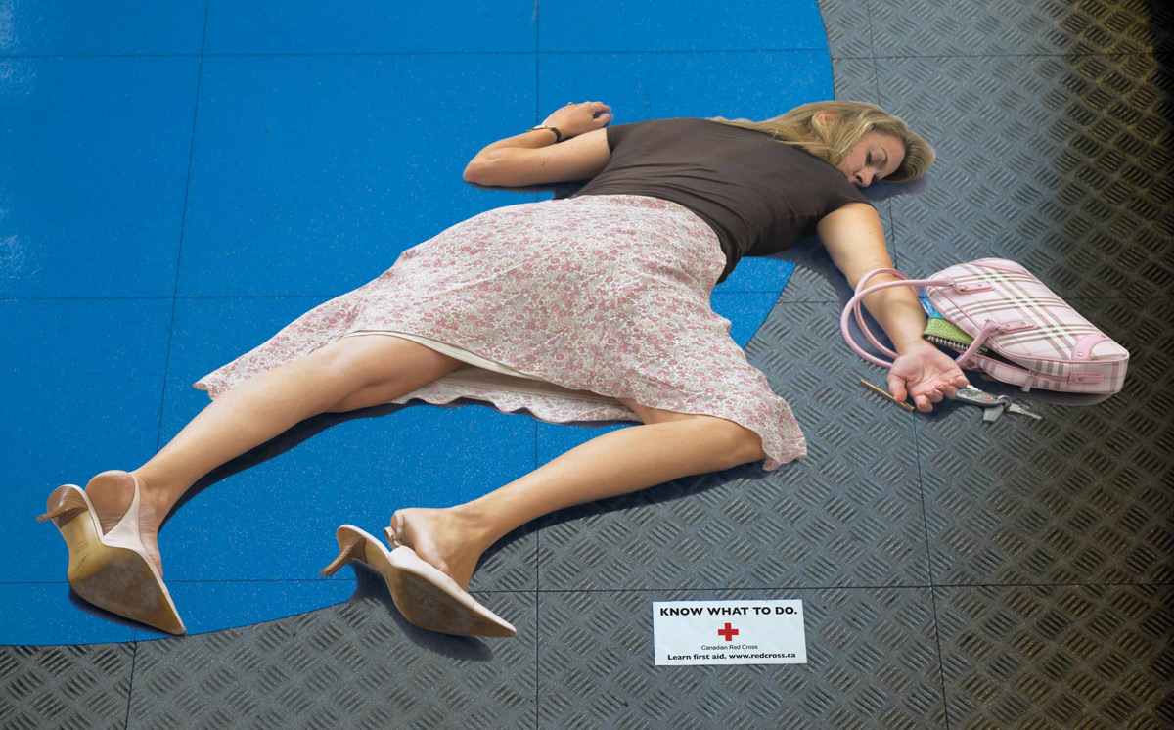
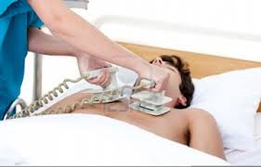
<Visual aid 2>
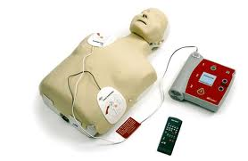
<Visual aid3>
<Visual aid4
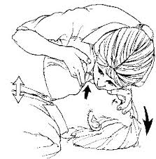
<Main activity cards>
Check for responsiveness
Call 911
Compress chest | 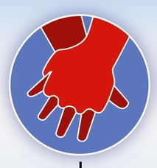
Open airway | 
Rescue breathing | 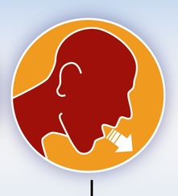
<Procedure of CPR for reading>
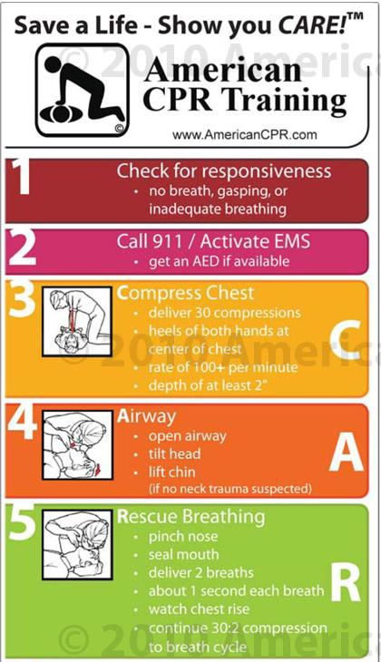
<Worksheet #1>
*Fill in the blank with number referring to the definition.
Rescue |  | Tilt
Seal |  | AED
Airway |  | Inadequate
Compress |  | Responsive
Gasp |  | Lift
Resuscitate
1. to revive, especially from apparent death or from unconsciousness.
2. A _________ person is quick to react to people or events. | 3. A short quick breath of air that you take in through your mouth, especially when you are surprised, shocked, or in pain. _____________
4. If something is __________ enough of it or it is not good enough. | 5. When you __________ something, it is pressed or squeezed so that it takes up less space.
6. A person's _______ is a passage from your nose and mouth down to your lungs, through which air enters and leaves your body. | 7. When you ________ an envelope, you close it by folding part of it over and sticking it down, so that it cannot be opened without being torn.
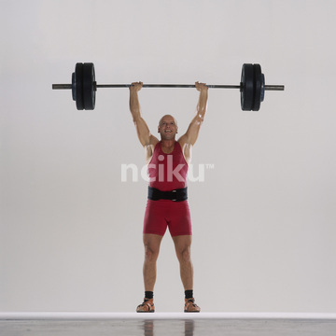  8. If you ______ something, you move it to another position, especially upwards. | 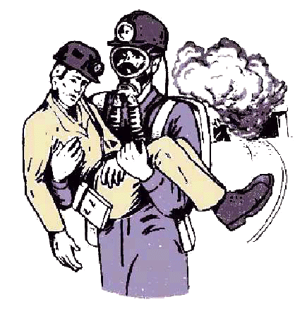  9. If you ______ someone, you get them out of a dangerous or unpleasant situation
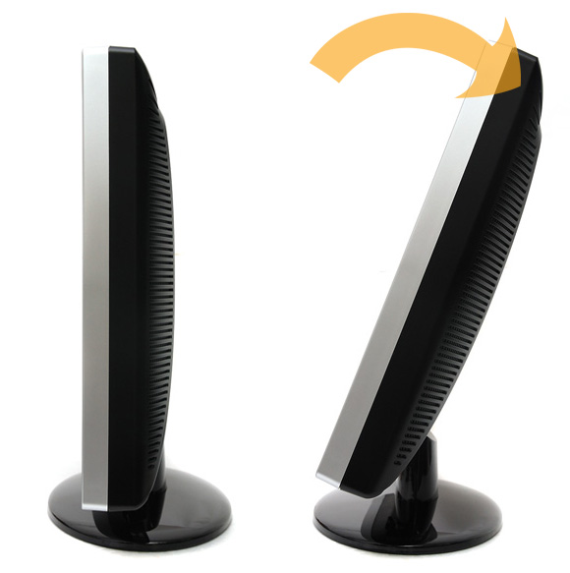  10. If you ______ an object or if it, it moves into a sloping position with one end or side higher than the other. | 11. ← portable

<Post activity>
*Answer the questions.
Ex) How many steps are there in CPR?

1. IF you see an unconscious person who suddenly collapses, you should call to 911 first. (Y/N)

2. The procedure of CPR is 'open airway- rescue breathing- compress chest'. (Y/N)

3. When you compress the chest, you should deliver 30 compressions. (Y/N)

4. When you compress the chest, the palms of both hands should be on the left of the chest. (Y/N)

5. When you do mouth to mouth, you always deliver 3 breaths. (Y/N)

6. How long will you deliver each breath with mouth when you do mouth to mouth?

7. How many time compressions should you give?

8. If you saw a person having a heart attack what would you go to do first?

9. If your pet suddenly is unconscious, can you do CPR on your pet?

