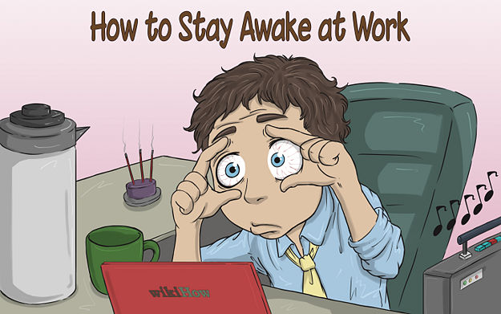
__________________________________________________________________________________________________________________________
__________________________________________________________________________________________________________________________
__________________________________________________________________________________________________________________________
__________________________________________________________________________________________________________________________
__________________________________________________________________________________________________________________________
__________________________________________________________________________________________________________________________
__________________________________________________________________________________________________________________________

Night work could damage your health

A new study suggests working shifts at night can be damaging to one's health. In particular, it ___________ the risk of several cancers, diabetes, mental illnesses, and various heart __________. Researchers from the Sleep Research Centre at the U.K.'s University of Surrey discovered that many genes in the body needed to follow a regular 24-hour cycle, during which the body sleeps at night. If this cycle is broken, up to 1,500 genes ____________ __________, eventually resulting in potentially life-threatening diseases. Professor Derk-Jan Dijk said: "The study has important ___________ because we now need to __________ why these rhythms ________ and think about the ______________ of that."
The human body has around 24,000 genes. Many of these switch off if the body does not follow a regular sleeping pattern. This can _______ parts of the immune system to become ______ __________, making us more susceptible to __________. Study co-author Dr Simon Archer said: "Over 97 per cent of rhythmic genes become out-of-sync with mistimed sleep, which really explains why we feel so bad during ____ ____ or if we have to work _________ shifts." Dr Dijk said that despite the results of the research, it would be difficult for people to change their lifestyles. He explained it was difficult for society to function without people working night shifts, but said people needed to understand the dangers and "mitigate the __________".

Increases, diseases, could get damaged, implications, discover, exist, consequences, cause, less efficient, illnesses, jet lag, irregular, impact

TRUE / FALSE
Read the headline. Guess if 1-8 below are true (T) or false (F).
1. | Night shifts increase the risk of getting diabetes. | T / F
2. | The research is from a British university. | T / F
3. | As many as 1,000 genes could be damaged by irregular sleep patterns. | T / F
4. | A professor found out why sleeping patterns that affect genes exist. | T / F
5. | The human body has about 220,000 genes. | T / F
6. | Irregular sleeping patterns can weaken the immune system. | T / F
7. | Irregular sleep affects 97% of all our genes that depend on rhythms. | T / F
8. | A doctor said it was easy for society to function without night workers. | T / F

KEY WORDS

Jet-lag
efficient
function
switch
impact
pattern
results
rhythmic
implication

discover

exist

consequence

