Listening Lesson Plan
96WD_Rosa

Listening for the song, "Let it go" (Disney's Frozen)
Teacher | Student Level& Age | No of Students | Length
Rosa | Intermediate  12 | 6 students | 50 minutes

Materials:
- 8 copies of the Bingo activity sheets
- 8 copies of the vocabulary matching worksheets
- 8 copies of the dictation worksheets
- 8 copies of the lyrics of the song, "Let It Go."
- Projector & Laptop(To show a video clip singing a song "Let It Go")
- Audio (with the song "Let It Go")

Aims: At the end of this lesson, students will have ..
- Practiced words and expressions of the song "Let It Go" by listening the song and reading the lyrics.
- Practiced listening to general story and specific information of the song by listening it several times with some activities.
- Used the relevant expressions by discussing about certain topics about the song each other.

Language Skills:
Listening: Teacher Talk, Listening to the song.
Speaking: Discussing the song's story and mood with other peers, Singing a song.
Reading: Reading lyrics of the song.
Writing: Dictation, Writing the ideas about the song.

Language Systems:
Phonology: Practicing pronunciation of the new words.
Lexis: Learning new vocabulary of the song.
Grammar: Let + objective + a verb root, Making some sentences during discussion.
Discourse: Singing, Discussion with peers
Functions: Singing, Asking & Answering

Assumptions:

Anticipated Errors and Solutions:

References:
- http://www.youtube.com/watch?v=moSFlvxnbgk ☞ video clip of "Let It Go"
- http://www.metrolyrics.com/disneys-frozen-let-it-go-lyrics-idina-menzel.html# ☞ lyrics
- http://disney.wikia.com/wiki/Let_it_Go ☞ Information about the song, "Let It Go"

Notes:

Pre Task or Warmer (7 mins)
A Bingo activity using season and weather words |  | Aims:  - To let them feel comfortable and relaxed by playing it.  - To review the season and weather words | Materials:  The sheet of bingo (with 25 squares)
Time | Set Up | Students | Teacher
2mins  2mins  2mins  1mins | Whole class  Whole class  One by one(Groups) | - Write down 25 words on bingo card randomly about the season and weather in the Bingo square.  - One student tells one word in the card to other students  - Other students search and mark the corresponding vocabulary on their card  - Continue until a student calls out, "Bingo!"  - A student may call out, "Bingo!" only if he or she has crossed off 10 squares in a row horizontally, vertically, or diagonally.  - The first student with a Bingo is the winner. | - Distribute to each student one 5X5 Bingo sheet and get them to write 25 words in Bingo square  - Explain how to play Bingo. (with demo)  - Determine the order of person to tell a word.  - When someone calls out "Bingo!", give a big applause to him or her.

Notes:
- After finishing warm-up, tell them a today's topic and what we're going to do.

Task Preparation or Presentation (16 mins)
A vocabulary matching activity and Writing the ideas about the song, "Let It Go" |  | Aims:  - To practice some key words from the song by doing a word-picture matching activity in a pair.  - To guess the song's mood and story by writing the ideas after first listening.  - To practice speaking in English by discussing with their partner while writing activity. | Materials:  - Hand-out (vocabulary matching worksheets)  - Audio
Time | Set Up | Students | Teacher
4mins  3mins  3mins  3mins  3mins | Groups  Groups  Whole class  Groups  Groups | - Match the words with the pictures by discussing in a pair.  - Ss should talk to each other to find out the proper pictures for each word and write the alphabets next to them. (Some words they already know, but the others are new.)  -If not knowing the answer, then ask to T and get feedback.  - If they finish, report the results.  - Compare what they did with other ones of peers.  - Check their own answers.  - 1st listening : just listen to the song and feel it.  - 2nd listening : Think about the questions which T asked.  (Listen carefully enough to answer the questions)  - After listening, write the ideas about the questions through discussion with their own partner.  - Report what they wrote and compare it with other teams. | Previewing key words of the songs  - Distribute to each student one vocabulary matching worksheet  - Make a pair as a team (to be 3 teams)  - Get each team to draw a line from the words below to the pictures above which matches for them. (show a demo)  (During the activity, monitor and help them if they don't know the meaning of the words)  - Get them to report their answers and check them.  - Give the instruction of words they're not sure of.  - Do some concept check questions about the words.  1st listening  - Introduce the song "Let It Go" with very few basic information about the movie, "Frozen" (without the explanation about the reason why this song appears)  - Let all the Ss listen to the song.  2nd listening  - Before 2nd listening, give them pre-questions : "Can you guess what happened to this girl?" and "How is her feeling in this song?" (Write these on the board.)  - Tell them to write the answers about the questions during listening the song one more time.  - Let all the Ss listen to the song again.  - During the discussion, T monitors them and give them some hints.  - Compare the answers and give them a general feedback.

Notes:

Task Realization or Practice (15 mins)
Listening to specific information in "Let It Go" and Understanding more about the song |  | Aims:  - To listen for the specific words and information by dictation.  - To talk in each group about the whole story and feeling of the song after listening carefully. | Materials:  - Hand-out of the dictation practice  - Audio
Time | Set Up | Students | Teacher
2mins  2mins  4mins  7mins | Whole class  Whole class  Groups  Groups | - 3rd listening : Listen & Dictate  - Dictate some specific words which they learned from Task-Preparation of this lesson.  - Listen to it one more time  - Make a group of three and talk about the whole story of the song and guess the story's feeling more deeply. (They correct some answers of the dictation each other, too)  - If they are ready, report what they wrote in the sheet and whole story of the song and explain about the feeling of the singer. | 3rd listening  - Tell them to dictate specific words during listening.  4th listening  - Let them listen to it one more time to fill all the blank of the dictation sheet.  - Give them some time to discuss the answers and make them talk about the whole story of the song more in detail in a group.  - Get them to say the words that they wrote on the sheet and correct if necessary.  - Explain the whole story of the song more in detail.

Notes:

Post Task or Production (12 mins)
Reading the lyrics and Singing the song. |  | Aims:  - To more understand the song by seeing a movie clip of singing a song, "Let It Go"  - To get to know the whole story of the song by reading the song's lyrics and practicing singing the song. | Materials:  - Hand-out of the lyrics  - Laptop & Projector
Time | Set Up | Students | Teacher
3mins  2mins  1mins  2mins  4mins | Whole class  Individually  Whole class  Groups | - See the music clip  - Read one sentence by one of the lyrics with some actions and gestures that they know the meaning and feeling of the song.  - Repeat after the song to practice the pronunciation and expressions.  - Sing a song with their group members | - Show them a video clip of the song, "Let It Go"  - Give them a paper with whole lyrics and get them to read one sentence by one with some actions and feeling of the lyrics. (If they don't know yet, show them a demo and give more instruction)  - Ask them CCQ to know whether they know the whole story of the song or not.  - Sing one sentence and make them repeat it.  - Make 2 groups and get them to sing one after the other.

Notes: Give them homework. (Singing the song, "Let It Go" 3 times)
Weather
Cloudy
Rainy
Snowy
Stormy
Sunny
Mild
Gray
Beautiful

Season
Spring
Summer
Fall / Autumn
Winter
Etc.(Noun)
Frost
Wind
Rain
Ice
Cloud
Storm
Snow
Fog
Shower
Weather
Good / Bad
Dry / Wet
Hot / Cold
Warm / Cool
You can pick some words from here.
Matching the words with the pictures & meanings.(Task-Preparation)

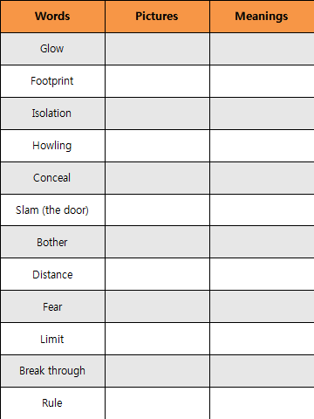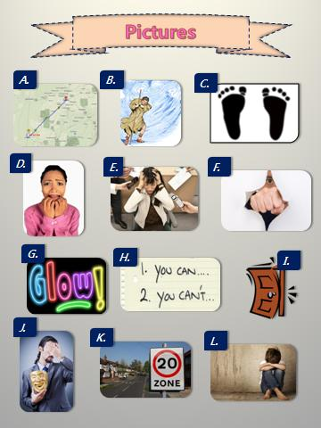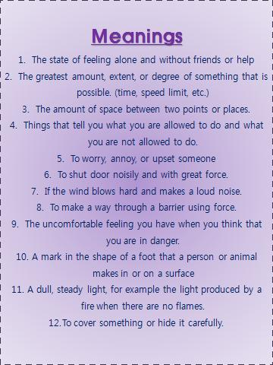

Dictation of the specific words of lyrics.(Task-Realization)

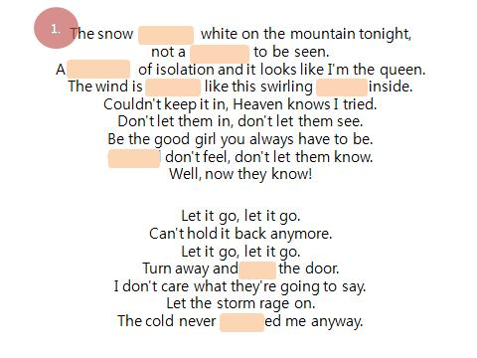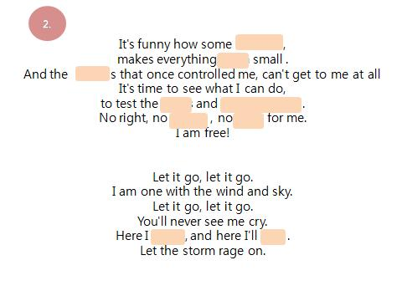
Show them the whole lyrics and get them to read & sing it.(Post-Task)
