Listening Lesson Plan

Title : Natural disasters
Teacher | Student Level & Age | No of Students | Length
YeJin Kang | Intermediate & 17 years old | 12 | 50 mins

Materials:
- movie clip and audio file
- computer and projector
- worksheet for new vocabularies and grammar (14 copies)
-

Aims: To help students:
-Improving their listening skills by listening to recording.
-learning vocabularies about natural disasters.
-discussing and sharing students’ own experience or what they’re hearing about natural disasters.

Language Skills:
Listening: listening to recording and other student’s opinion.
Speaking: participating in a discussion.
Reading: activities with worksheets and read the script.
Writing: fill in the blanks of worksheets.

Language Systems:
Phonology: practicing pronunciation of vocabularies.
Lexis: learning new words and making sentences with that.
Grammar: learning what is ‘present perfect’
Discourse: discussion about natural disasters.
Functions: describing situations about natural disasters.

Assumptions:
N/A

Anticipated Errors and Solutions:
N/A

References:
Natural disaster audio file, script: http://www.listenaminute.com/n/natural_disasters.html
Movie posters and pictures in the worksheet: google image search

Notes: N/A

Pre Task
Title:  Watching video clip&  thinking |  | Aims:  To make Ss think.  To make Ss have interest about the topic. | Materials:  Video clip (about 3 mins)
Time | Set Up | Students | Teacher
10 mins | Whole class | - Ss will watch video clip and answer questions. | -Show video clip to the Ss  -asking questions  - How do you feel after watching this video?  - Have you ever watched similar movies?

Notes: N/A

Task Preparation
Title:  Guessing &discussing |  | Aims:  To elicit what Ss already know about disasters.  To make Ss guess about the posters  To make Ss recall their experience.  To make Ss discuss together. | Materials:  Posters of movies
Time | Set Up | Students | Teacher
10  mins | Group | Ss will see the posters and answer the question.  Ss will discuss about their experience related to disaster  or news what they heard before  Ss will find the latest natural disaster in the world and talk together | -Show posters to Ss  -Asking questions  - Can you find what these have in common?  Let Ss discuss  - Have you ever heard about natural disasters?  - Have you ever experienced any disasters?  Let Ss search in the internet and discuss  - What was the latest disaster in the world?

Notes: N/A

Task Realization
Title:  Listening to the audio  Learning new words |  | Aims:  To develop Ss’ listening skill  To make Ss understand what the speaker say | Materials:  Audio file (1 min)  Worksheet #1 (about new vocabularies)
Time | Set Up | Students | Teacher
18  mins | Group | Ss will listen to the audio  Ss will find what the speaker say  Ss will answer the questions  Ss will learn new vocabularies through worksheet  Ss will discuss about the meaning of words | -Play audio file  -Asking questions, Eliciting  - What is the main topic?  - What kind of disasters did you heard?  -Make students work with worksheet  - Discuss about the meaning of words

Notes:
1min for audio, 5mins for asking questions, 12mins for worksheet & discuss

Post Task
Title:  Listen more carefully  Learning grammar |  | Aims:  To make Ss listen more carefully  To make Ss can solve the comprehension questions  To learn ‘present perfect’ and using it in the sentence  To let Ss tell about their experience using ‘present perfect’ | Materials:  Audio file  Worksheet #2 (about comprehension, grammar)
Time | Set Up | Students | Teacher
12 mins | Individual work | Ss will listen more carefully for comprehension questions  Ss will learn about ‘present perfect’  Ss will make sentences using ‘present perfect’  Ss will present sentences that they made | -give Ss worksheet #2  -make Ss scan the worksheet  -play audio file again  -let Ss answer the questions  -get Ss stand up and present  CCQ  -asking questions for CCQ  - Can you explain what drought causes another problem?  - What should we do for easing global warming?

Notes:

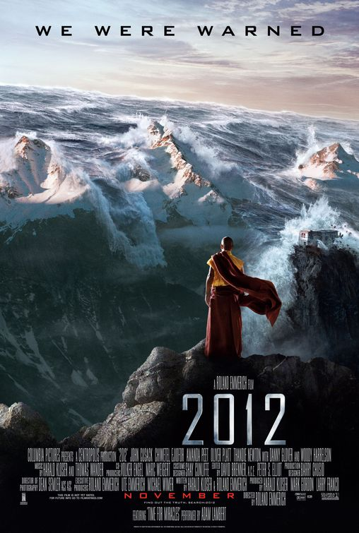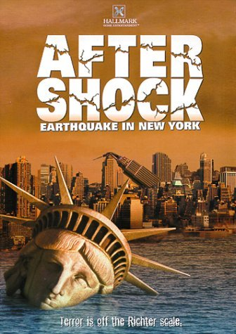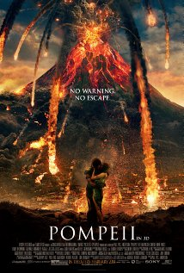

Worksheet #1
New vocabularies
-Guess and discuss about meanings of words
- Bushfire : Global warming :
- Earthquake : Typhoon :
- Hurricane : Flood :
- Drought : Volcano :

-Match words and pictures.
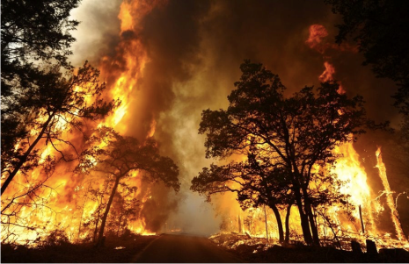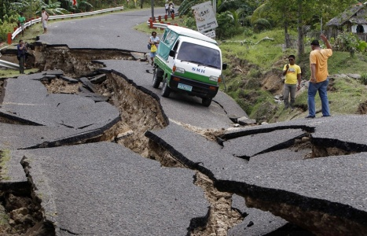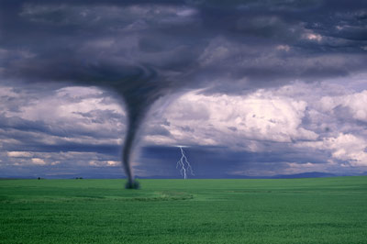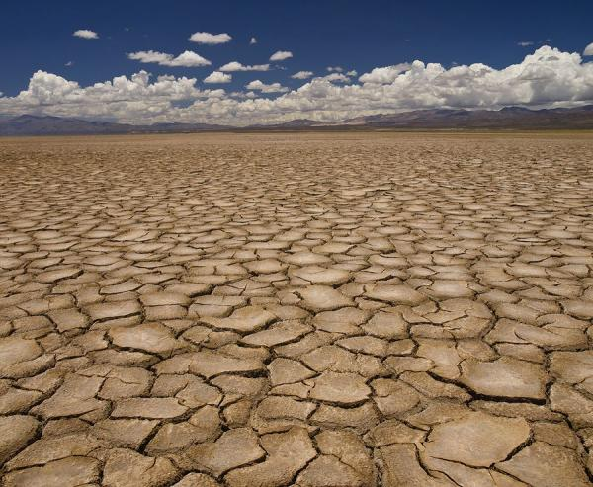
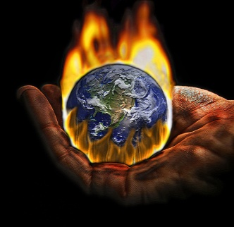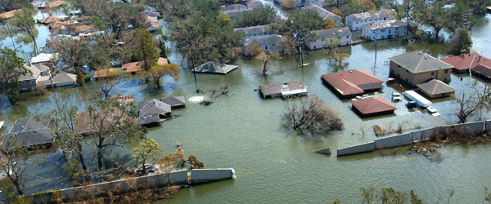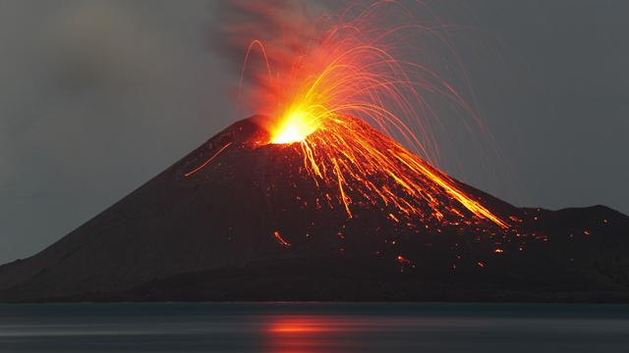
Worksheet #2
Comprehension questions (T/F)
- There are more natural disasters in the past. ( T / F )
- The speaker has experienced natural disasters. ( T / F )
- Countries that aren’t rich suffer from disasters. ( T / F )
Short answer questions
- What is the cause that creating more natural disasters?
- Why the speaker said that Japan has many natural disasters but they’re lucky?
Grammar
- Present perfect :
-make 4 sentences using present perfect and present to the class.
-
-
-
-
Teacher Script

Natural disasters

I don’t know about you, but I think there are more natural disasters now than before. Every time I turn on the news there’s some kind of disaster. There are bushfires in Australia and California, earthquakes in China, hurricanes in Mexico and droughts in Africa. I’m sure global warming is creating more natural disasters. I’m lucky. Where I live, we don’t really have natural disasters. I’ve never experienced anything like the things on TV. Japan has many natural disasters. They have earthquakes, typhoons, flooding, volcanoes, all kinds of things. They are lucky they have the money to deal with them. There are countries in Africa that aren’t rich. When a natural disaster hits them, everyone suffers terribly.

