Speaking Lesson Plan

Title: The Price (written by Arthur Miller)
Teacher | Student Level & Age | No of Students | Length
Angela Yang | Intermediate adults | 20 | 50 mins

Materials:
-4 pictures
-white board and pens
-23 pages of the original script
-23 pages of blanked paper

Aims:
-With the controversial topic in a literature, students have opportunities to debate in a class.
-Students have a chance to share their opinions with each other.
-Students will make their own adaptation from the play “The Price” and role play.

Language Skills:
Speaking: Students will discuss about a topic in a group.
Listening: Teacher’s lecture, Discussion(debate)
Reading: Students will read an original script of The Price
Writing: Students will write their own adaptation from the play The Price

Language Systems:
Phonology: listen and role-play
Lexis: learn new vocabulary
Grammar: make or edit sentences
Discourse: group discussion
Functions: work in groups to make students talk

Assumptions:

Anticipated Errors and Solutions:

References:
http://en.wikipedia.org/wiki/The_Price_(play)
http://www.goodreads.com/book/show/437961.The_Price
http://www.amazon.com/The-Price-Play-Arthur-Miller/dp/082220911X

Notes:

Pre Task or Warmer
Title:  Victor v.s. Walter |  | Aims:  -To let students guess what is the main idea of The Price  -To let students take one side(Victor or Walter) and have a little discussion | Materials:  -four pictures  -White board, markers
Time | Set Up | Students | Teacher
10  mins | In groups | -Students should guess the main story of The Price | -Teacher prepares 4 pictures which represents the main story of The Price.  -Show the pictures to the students and let them guess the whole story.

Notes: Teacher never tells the whole story before the students guess. After students have a little talk in groups, teacher tells them the story plot.

Task Preparation or Presentation
Title:  What will you do? |  | Aims:  -To let students have an opportunity to debate in groups  -To let students have a change to address their own opinion. | Materials:  White board, markers
Time | Set Up | Students | Teacher
10  mins | In groups | -After students get the main idea of the play, they need to choose one side and have a little discussion in groups. | -Teacher asks students to choose one side (Victor or Walter) and have a little debate.

Notes:

Task Realization or Practice
Title:  Make my own plot |  | Aims:  -To let students write their own script (like a real play)  -To make students cooperate and make one script in each group. | Materials:  -The original script of The Price (23 copies)  -The blanked script (23 copies)
Time | Set Up | Students | Teacher
15 mins | In groups | -Based on pre-task (discussion), students will make their own adaptation from the play “The Price”.

Notes:

Post Task or Production
Title:  Role play |  | Aims:  -To give an opportunity to students to show their own short  plays to others. | Materials:
Time | Set Up | Students | Teacher
15 mins | In groups | -Students choose two students (Victor and Walter) to role play in each group. | -Teacher gives each 4 groups about 4 minutes to role play.

Notes: If there is no enough time, students will only do role-play (not write their own edited script.)

Worksheets, handouts and lesson materials
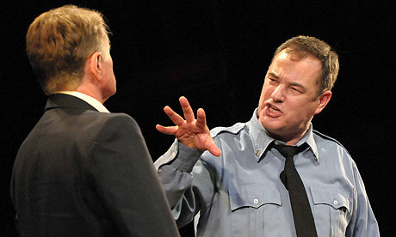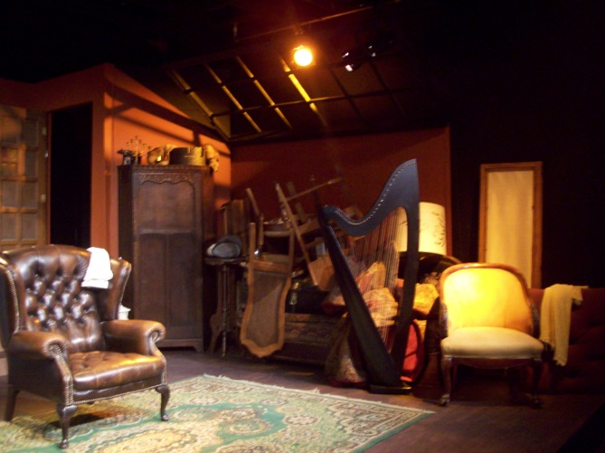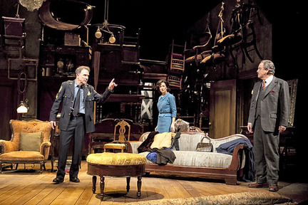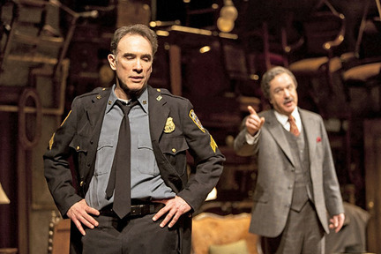

[Main plot]
Walter Franz is a successful doctor who ran away from family responsibility to make a career. Victor Franz is a police officer is a little brother who was forced to drop out of college, where he was a brilliant students studying science. In the Depression, Victor left school because he has chosen the path of family loyalty and sacrificed career and prestige. Victor could have stayed in school if his brother, Walter, already a doctor, had loaned him a mere five hundred dollars. But Walter refused. Victor has never forgiven Walter for his betrayal of trust.

[1]
Walter: Victor, that was your decision, not mine.
Victor: My decision!
Walter: I told you then that I was going to finish my schooling come hell or high water, and I advised you to do the same. I warned you not to allow dad to strangle your life.
Victor: Who the hell was supposed to keep dad alive, Walter?
Walter: He was not sick! He was perfectly fit to go to work!
Victor: Work? In 1936? With no skill, no money? I had no choice. The ice box was empty, and dad was sitting there with his mouth open!

[2]
Walter: Dad had his money. He lived on his money, believe me. I told him if he would send you to college, I would contribute properly. It is a fantasy that your father was penniless and your brother a son of a bitch.
Victor: Stop it! Dad was a beaten dog, ashamed to walk in the street! I’m not blaming you now, I can understand you walking out. I have wished a thousand times I’d done the same thing.
Walter: You have made your choice.
Victor: A choice? How?
Walter: I wanted the freedom to do my work! Does that mean I stole your life? You made those choices, Victor! And that’s what you have to face!
Victor: I thought you could come to give me something! I just didn't want dad to end up on the grass!
Walter: But your failure does not give you moral authority!

